**Plot**

Ron, the ant, got stuck in a honeycomb. He needs to get out of the honeycomb world.

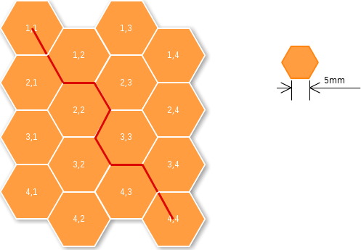

**Task**

We know the starting location and the exit point in the honeycomb as x,y co-ordinates. Need to get the minimum distance, the ant has to traverse to get out of the honeycomb, through the edges. maximum size of the bee hive is limited to 12x12. Each edge is 5mm. Input is taken in a format of x1.y1,x2,y2 from standard input and output is expected, the minimum distance to be traveled, as a integer value, in mm. Please check out the above image for more details.

**Example**

**Test Case 1**

INPUT: 1.1,4.4

OUTPUT: 45

**Test Case 2**

INPUT: 1.2,2.4

OUTPUT: 20