**Description**:

Meet Lakshya, he is one of the best cubers of the world. He has this unique talent to solve a Rubik's cube with his eyes blindfolded! He has recently been experimenting a lot to improve his timing. Lakshya has been following Singmaster's notation of moves to memorize a lot of standard solving techniques. To assist him in his pursuit, you offer to help him. Lakshya has now given you the following description of the tool that he needs:

A tool which will take the initial configuration of rubik's cube (in its solved state) followed by a set of moves, denoted in Singmaster's notation and generate as output the colors of the tiles present on the front face of the rubik's cube.

**Constraints:**

The input will always be a proper list of moves in Singmaster's notation.

Color code is a string of length 6. Moves can be of any length.

**INPUT**:

Input consists of two lines, first line will contain the configuration of the cube which has color codes for faces in the following order: Up-Left-Front-Right-Back-Down

Next line will consist of the moves in [Singmaster's notation](http://en.wikipedia.org/wiki/Rubik's_Cube" \l "Move_notation) (Only Basic)

**OUTPUT**:

A matrix of 3x3 with color code for the tiles in the front face after the moves have been made.

**Example**

**Input**

YRBOGW

R2

**Output**

B B G

B B G

B B G

**Analysis**

                Initial state                                                                      After R2 ( R applied twice )

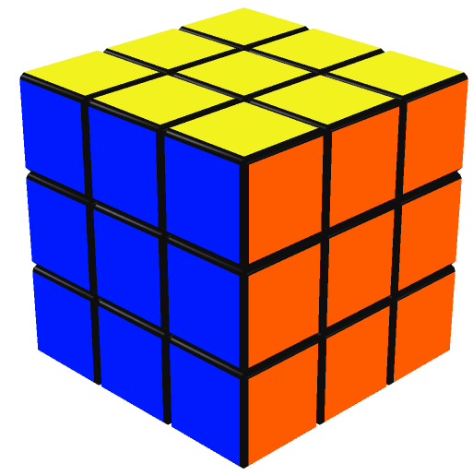                                                       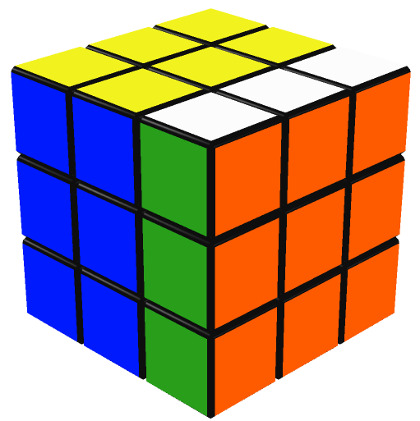

**Input 2**

YORBWG

RL'

**Output 2**

G R G

G R G

G R G

**Analysis 2**

                  Initial state                                                                After R                                                      After RL' (L applied anti-clockwise)

