Cavern Wireless Network

Vangelis the bear finally decided to properly set up the wireless network of his cavern. His cavern is composed of multiple rooms connected by corridors. Due to the thickness of the walls the access to the network is limited only to the neighboring rooms of the rooms with an access point. Neighboring rooms, we call rooms that are directly connected by a corridor.

Task

Your task is to study the blueprints of his cavern and show all possible sets of rooms where Vangelis can install an access point, while making sure that:

·           each room that has an access point, has no neighbor with an access point,

·           all rooms that do not have an access point, have at least one neighbor with an access point,

·           he installs as few access points as possible.

**Blue Print**

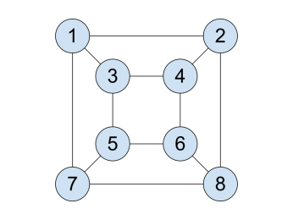

**All possible access points locations**

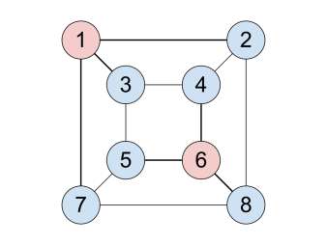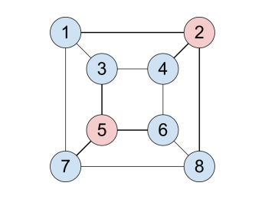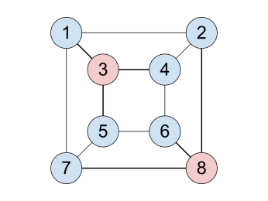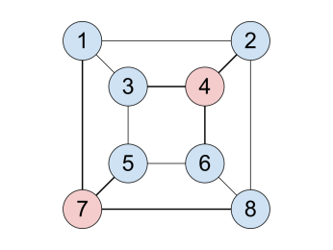

Input Format

Your program will read N lines (where 0 < N < 100).

Each line will contain two positive integer numbers (A,B, where 0 < A,B < 100) separated by one space character. Each line represents the corridor between room A and B.

Output Format

Your program should print all possible sets that match the above criteria.

Each set should be separated by one new line character.

Sets should be printed in ascending order.

Each element of the set should be separated by one space character.

Elements should be printed in ascending order.

Example

Input

1 2

1 3

1 7

2 4

2 8

3 4

3 5

4 6

5 6

5 7

6 8

7 8

Output

1 6

2 5

3 8

4 7