Wooden railway

A little boy (let's call him Tom) owns a box with a set of wooden rails (the children's toy). There are six rail types as shown in the table below. Each rail has one connector where it starts and at least one connector to further rails (*end points*). The end point locations of a rail are defined by 2D positions (*xe,ye*) and the connector's angle (tangent angle, degrees) with respect to the starting point of the rail. For curved (circular) sections the end point is defined by the rail's radius and the end point's angle.

|  |  |  |  |
| --- | --- | --- | --- |
| Sketch | Type | Description | End points  (*xe*,*ye*,angle) |
| http://linode.interviewstreet.com/AQ_IMG_1.png | 0 | Straight rail, length 20 cm | (0.2, 0, 0) |
| http://linode.interviewstreet.com/AQ_IMG_2.png | 1 | Straight rail, length 30 cm | (0.3, 0, 0) |
| http://linode.interviewstreet.com/AQ_IMG_3.png | 2 | Curved rail, angle 15° | (*xe15*,*ye15*,15)  radius = 0.58 m |
| http://linode.interviewstreet.com/AQ_IMG_4.png | 3 | Curved rail, angle 30° | (*xe30*,*ye30*,30)  radius = 0.58 m |
| http://linode.interviewstreet.com/AQ_IMG_5.png | 4 | Forward switch, angle 15° | (0.2, 0, 0)  (*xe15*,*ye15*,15) |
| http://linode.interviewstreet.com/AQ_IMG_6.png | 5 | Reverse switch, angle 15° | (0.2, 0, 0)  (0.2-*xe15*,*ye15*,165) |

All the rails can be turned on their back, a curved rail can thus be used to turn left or right.

Connecting rails to the end points of other rails (the first rail starts at (0,0,0), the origin) in varying order yields *tracks* of different shape. The end points of rails with no other rail connected to it are considered as *track end points*. Depending on the rails in use and their connections, a track has a number of *track end points* *Nt*. This number can be increased only by switches. Because a rail can be connected to several end points at the same time (thus closing a gap between other rails),*Nt* can be decrease by any type of rail.

Task

Tom is wondering how many tracks he can create of his set of rails.

Write a program that reads the number of rails of each type *Nx* from stdin. The program outputs the minimum number of *track end points* and the number of **validdifferent** tracks with this property *Ns* that can be constructed using all the rails in Tom's box.

ñ  Tracks are considered to be **different**, if they do not have the same geometrical shape. Two tracks have the same shape, if their connectors have the same positions and orientations.

ñ  Tracks with intersecting rails (except the end point connections) are **not** **valid**. For simplicity, two rails are assumed to intersect, if the straight lines between their start/end points intersect.

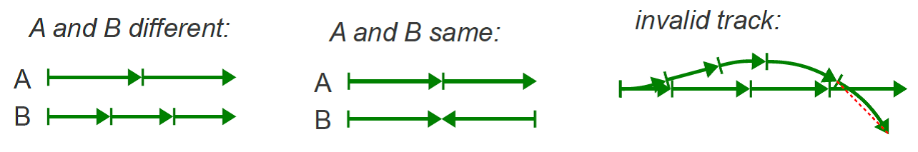

Input / Output format

All numbers are comma separated without any white space characters and on a single line. Rails are given in ascending order (*N0*,*N1*,*N2*,...,*N5*). The result is expected in the same format: (*Nt*,*Ns*).

Example 1: Two 30° rails

**Input:**

0,0,0,2,0,0

**Output:**

1,4

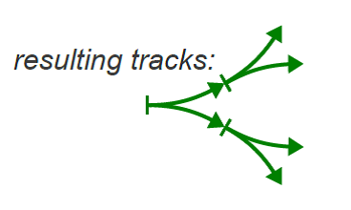

Connecting the two curved rails in every possible way yields **four** tracks with **one** *track end point* each.