Secure SaaS AWS Environment
Portfolio Project Documentation
Rabih Chahine | March 2026 | AWS Cloud Engineering

1. Project Overview
This project demonstrates the design and deployment of a production-grade, secure AWS environment for a SaaS platform. The environment was built following AWS Well-Architected Framework principles with a focus on security, high availability, and centralized observability.
The project brief called for a clean, well-architected AWS setup with strong security controls, centralized logging, encryption at rest and in transit, and monitoring. Every component was provisioned with security as a first-class concern rather than an afterthought.

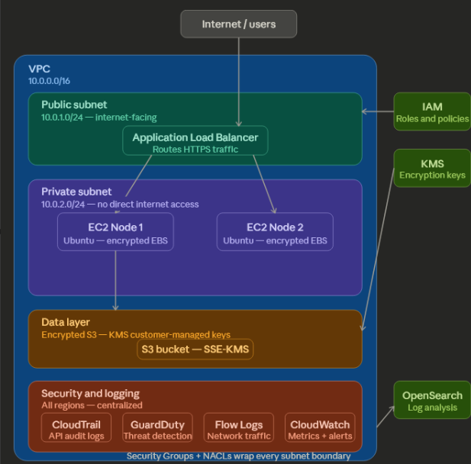
2. Architecture

2.1 Core Infrastructure
- 1 VPC (10.0.0.0/16) with segmented public and private subnets across multiple Availability Zones
- Public subnet hosts the Application Load Balancer — the only internet-facing entry point
- Private subnet hosts both EC2 application nodes — no direct internet access
- Security Groups chained so EC2 nodes only accept traffic originating from the ALB
- NACLs configured at the subnet boundary as an additional network control layer

2.2 Compute
- 2x EC2 instances (Ubuntu Server 24.04 LTS, t2.micro) in the private subnet
- Each instance uses an encrypted EBS gp3 volume with AWS-managed KMS keys
- No public IP addresses assigned — all access routes through the load balancer

2.3 Storage
- S3 bucket with all public access blocked
- Server-side encryption using SSE-KMS with S3 Bucket Keys enabled
- Bucket Keys reduce KMS API call costs while maintaining encryption guarantees

2.4 Load Balancing
- Application Load Balancer deployed across two public subnets in separate Availability Zones
- Target group routes HTTP traffic to both EC2 nodes
- Multi-AZ deployment ensures high availability — if one AZ fails, traffic routes to the other

3. Security Configuration

3.1 Identity and Access Management
All infrastructure was built using a dedicated IAM user (not the root account) with MFA enabled. Root account MFA was also configured and root credentials are not used for day-to-day operations. IAM roles follow least-privilege principles — each role grants only the permissions required for its specific function.

3.2 Network Security
- Security Group chaining: ALB security group accepts HTTPS/HTTP from 0.0.0.0/0. EC2 security group accepts traffic only from the ALB security group, not from the open internet.
- VPC Flow Logs enabled with filter set to ALL — capturing both accepted and rejected traffic for threat detection
- Private subnet has no internet gateway route — instances cannot initiate or receive direct internet connections

3.3 Encryption
- EBS volumes encrypted at rest using KMS
- S3 bucket encrypted using SSE-KMS with Bucket Keys
- All data in transit protected via HTTPS through the load balancer

4. Logging and Monitoring

4.1 CloudTrail
CloudTrail enabled across all regions, logging both read and write API events to a dedicated S3 bucket and CloudWatch Logs group (/saas/cloudtrail). This provides a complete audit trail of every action taken in the AWS account — who did what, when, and from where.

4.2 VPC Flow Logs
Flow Logs configured on the VPC with ALL traffic captured (accepted and rejected) and streamed to CloudWatch Logs group (/saas/flowlogs). Capturing rejected traffic is critical for detecting port scanning attempts and unauthorized access attempts against the EC2 nodes.

4.3 CloudWatch
CloudWatch alarm configured on EC2 CPU utilization with SNS notification to a verified email endpoint. Alerts trigger when CPU exceeds 80%, enabling proactive response to performance issues or potential cryptomining activity.

4.4 GuardDuty and OpenSearch
GuardDuty (automated threat detection) and OpenSearch (log analysis and dashboards) are configured and ready for deployment. Activation is pending full AWS account verification. Both services will ingest CloudTrail and Flow Log data to provide real-time threat detection and log search capabilities.

5. Architecture Decisions and Trade-offs
The following table documents the key architectural decisions made during this engagement and the reasoning behind each choice.

Decision | Choice | Rationale
EC2 vs Lambda | EC2 | SaaS platform requires persistent compute with predictable performance. Lambda cold starts unsuitable for application servers with stateful connections.
Single vs Multi-AZ ALB | Multi-AZ | High availability requirement. ALB spans two AZs so a single AZ failure does not take down the application.
Public IP on EC2 | Disabled | Security. No direct internet access to application nodes. All traffic must route through ALB, reducing attack surface.
Security Group source | SG reference | Used ALB security group as source instead of IP CIDR. This ensures only traffic from the ALB can reach EC2, regardless of IP changes.
EBS volume type | gp3 | Better baseline performance than gp2 at the same or lower cost. gp3 decouples IOPS from storage size.
S3 encryption | SSE-KMS + Bucket Keys | Bucket Keys reduce KMS API calls and cost while maintaining strong encryption. Appropriate for a SaaS platform handling user data.
Flow Log filter | ALL traffic | Capturing rejected traffic enables detection of port scanning and brute force attempts, not just successful connections.

6. Deliverables
Component | Status | Notes
VPC + Subnets | Complete | Public and private subnets, internet gateway, route tables
Security Groups | Complete | ALB and EC2 SGs chained, least privilege
EC2 Nodes (x2) | Complete | Ubuntu, encrypted EBS, private subnet, no public IP
S3 Bucket | Complete | Public access blocked, SSE-KMS encryption
Application Load Balancer | Complete | Multi-AZ, internet-facing, routes to both EC2 nodes
CloudTrail | Complete | All regions, read+write events, S3 + CloudWatch destination
VPC Flow Logs | Complete | ALL traffic, CloudWatch destination
CloudWatch Alarm | Complete | EC2 CPU > 80%, SNS email notification
GuardDuty | Pending | Configured, pending AWS account full activation
OpenSearch | Pending | Configured, pending AWS account full activation
Infrastructure Diagram | Complete | Full architecture diagram produced
This Documentation | Complete | Configuration overview and decision log

7. About This Project
This project was built as a portfolio piece simulating a real client engagement for a secure SaaS AWS environment setup. The brief was sourced from an active Upwork posting to ensure the work reflects real-world requirements rather than tutorial exercises.
Built by Rabih Chahine — BS Computer Science, WGU (2026). AWS Solutions Architect (in progress). LinkedIn: linkedin.com/in/rabih-chahine-5b3b78186

