Deploying the WashWorld frontend on Render
Deployed and checked on 30 October 2026
Live site: washworldvalde-fe.onrender.com
The live site runs the Next.js frontend from WashWorldValde (main, commit 41c8bf6). The Flask backend and database are not part of this deployment.
The service was set up through the Render integration. To try it yourself, use the settings below in the Render Dashboard.

1 Create the service
Sign in to Render. Open your workspace (EK for this example) and choose New > Web Service. Connect the Valde1998/WashWorldValde repository.
Setting | Value
Name | washworldvalde-fe
Branch | main
Runtime | Node
Region | Frankfurt
Instance type | Free
Root directory | Leave empty
Auto-deploy | Off
For your own copy, choose a different service name.
Build command
cd frontend && npm ci --include=dev && npm run build
Start command
cd frontend && npm start -- -H 0.0.0.0 -p $PORT
Both commands first switch to the frontend folder. npm ci installs the package versions listed in package-lock.json, including TypeScript. npm run build prepares the site. npm start runs it on the port Render provides.

2 Add environment variables
Name | Value
NODE_VERSION | 24.14.0
CYPRESS_INSTALL_BINARY | 0
NEXT_TELEMETRY_DISABLED | 1
NEXT_PUBLIC_API_URL | Empty value
These settings use Node 24.14.0, skip the Cypress download and turn off Next.js usage reporting.
Add NEXT_PUBLIC_API_URL but leave its value blank. Do not enter quotes. This keeps API requests on the Render site instead of sending them to localhost. If you deploy the Flask backend later, enter its URL here and rebuild the frontend.

3 Deploy
Click Deploy Web Service. Watch the build log. When the status says Live, open the site's HTTPS link. Auto-deploy is off, so deploy again manually after any changes.
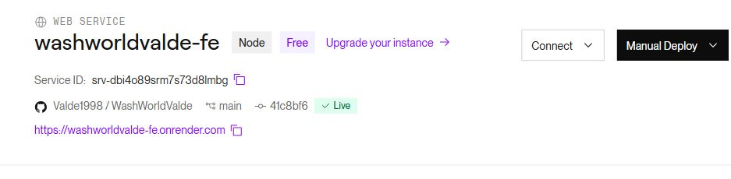
The service is live on the Free plan. Screenshot from 30 October 2026.

4 Check the result
The local build finished without errors. On Render, the site returned HTTP 200 and the page title was WashWorld.
The welcome page showed the logo and photos. Clicking Log ind opened /login, and the page still worked after a refresh. Submitting the empty form showed “Indtast en gyldig emailadresse.” Opening /hjem while logged out led back to /login.
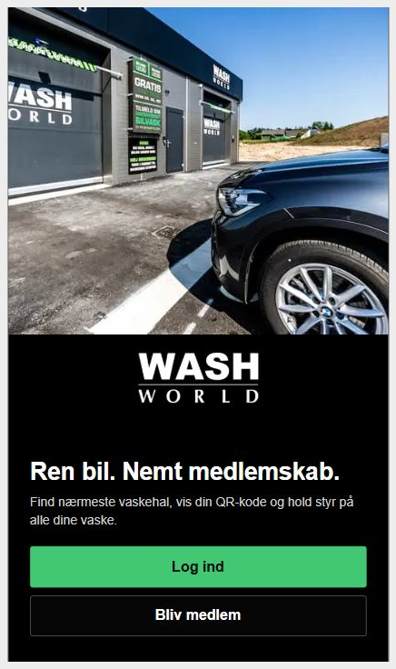
The welcome page online. Screenshot from 30 October 2026.
The login check only tested the form. Signing in, creating an account and viewing membership data need the Flask backend and database.
After 15 minutes without a visit, the free service goes to sleep. The next visit can take about a minute to load.
References: Render Next.js guide and Free service limits.

Use of AI
OpenAI Codex was used to set up and test the deployment and draft this guide.
Reference: OpenAI (2026). Codex, AI coding assistant. Used 30–31 October and 2 November 2026.

