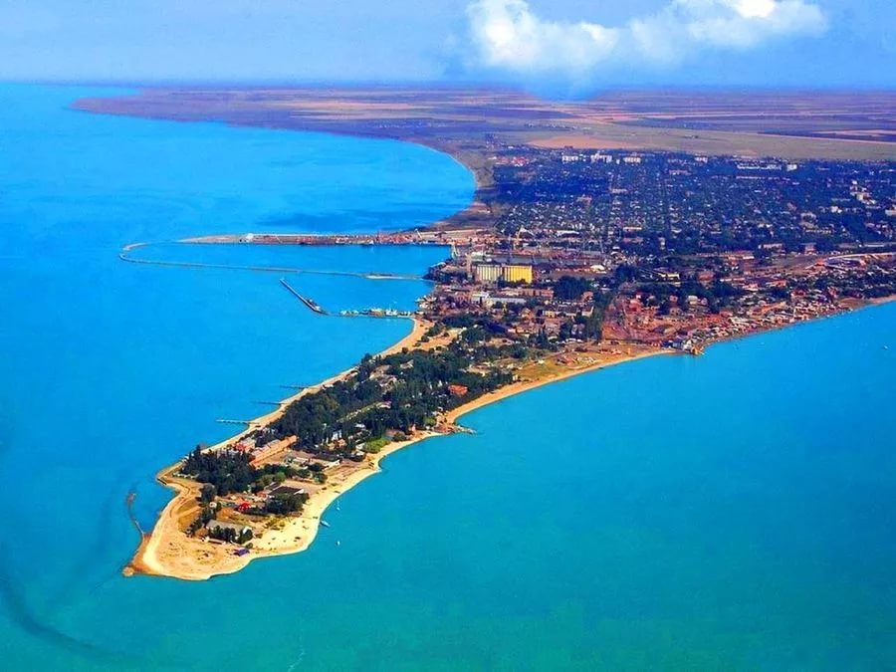 **Yeisk**

*Prepared by student of “Ш-11” group  
Yatsenko Angelina*

**GENERAL INFORMATION**

In the North-East of the Yeysk Peninsula, at the very beginning of the Yeysk spit stretches a small urban settlement — Yeysk. A cozy seaside town with a fairly "young" history has long earned a reputation as a well-known commercial sea port and occupies not the last place among the famous Azov resorts of Kuban.

August 19, 1848, is considered the official birthday of the city, when the solemn opening of the city-port Yeysk took place under the festive volleys of cannons and the roar of the orchestra of the Cossacks of the black sea army.

**THE CLIMATE AND ECOLOGY**

The climate of Yeysk is the same as in the entire coastal territory of Krasnodar region: hot summer, warm sea, short, almost snowless, winter without much frost. In mid-April, the city is already in full bloom spring, and the cold rainy autumn comes only in October, after the Sunny "Babi summer". Rains in warm season are rare, mainly in the form of short showers. Some inconvenience is caused by strong winds, but you get used to them quickly.

As well as in all actively developing port cities, in Yeysk there are problems connected with pollution of environment by port industrial enterprises and frequent accidents on the vessels making transportation of oil, and others dangerous from the point of view of ecologists, products. A lot of protest from local residents was the discovery in the city oil loading terminal. In November 2011. in Yeysk, there was a leakage of fuel oil from the tanker, not cleaned from the remnants of previously transported liquefied gas, and at the time of refueling, these residues were weathered into the atmosphere. This incident, unfortunately, is not unique.

**POPULATION**

The population of the town increases every year. The number of residents in the city is about to reach the hundred thousand mark. Children under 17 and pensioners account for almost 40 per cent of the total population. Growth, unfortunately, is not yet natural, although the birth rate is at a high level, is carried out mainly at the expense of migrants. Some people move to Yeysk because of the climate and therapeutic muds. Many migrate from the far North closer to the heat and the sun.

**INFRASTRUCTURE**

Urban infrastructure in the main areas of the town is developed properly. The city has a number of landscaped parks and squares, playgrounds and sports fields. In summer, the city is literally buried in greenery and flowers. The streets look clean and tidy. The road surface on most streets is in a satisfactory condition. During the winter, however, the asphalt is broken, but the resort season gently patted. In some areas, people complain that road pits are covered with stones due to lack of funds for repairs, but this is an exception rather than a rule. Several streets in the center have been paved since time immemorial.

The city has an airport, which is a joint-based airport: in addition to civil aviation, it is used by the Russian air force and Navy aircraft. However, it is now closed for the reconstruction of the runway. Local people say that it will be another long-term, as it closed in 2011. Railway station Yeysk has cargo and passenger destination. The bulk of passenger traffic is carried out in the suburbs and in the area, there is a direct train to Moscow. Railway communication in all other directions is carried out from the station Starominskaya-Timashevskaya, located 70 km to Yeysk. You can get to this station by train or bus.

From Yeysk bus station every day sent a large number of buses to cities such as Anapa, Tuapse, Rostov, Novorossiysk, Krasnodar, Gelendzhik, Armavir, Taganrog, as well as all directions Yeysk district.