**Toronto Bar Supplier**

**-**

**Coursera Capstone Project**

# Table of Content

Table of Content 2

1. Introduction and business problem 3

2. Data and methods 3

3. Results 3

4. Discussion 4

5. Outlook 4

# Introduction and business problem

The globally operating bar equipment supplier "Bar10der" is entering the Canadian market and is targeting large Canadian cities to supply local bars with bar equipment (e.g. chairs, beer taps). Bar10der is a young, asset-light business reducing operational cost by delivering bar supply without a truck or car fleet. Bar10der reduces the distance between warehouse and bar by renting a multi-purpose location serving as office space and warehouse in the city center. In order to determine the optimal warehouse location, Bar10der looks for the city area that contains the highest bar density.

# Data and methods

By identifying those Toronto postal codes that have the highest bar density (determined by the number of bars), the ideal Toronto area (as postal code) will be identified and visualized on a Folium map based on geolocation data.

* Foursquare API – location data and information about bars
* Wikipedia – scraped data to identify neighborhoods
* Geocache – additional geospatial data, such as latitude and longitude

# Results

The analysis shows that postal code M5H has the highest bar density with 6 bars. In the following, the

result is visualized:

|  |  |
| --- | --- |
| **Postal Code** | **Bar density** |
| M5H | 6 |
| M5B | 5 |
| M5V | 4 |
| M5J | 2 |

Figure 1: Comparison of Toronto areas on bar density

# Discussion

M5H (in blue) is the highest bar density area in Toronto:

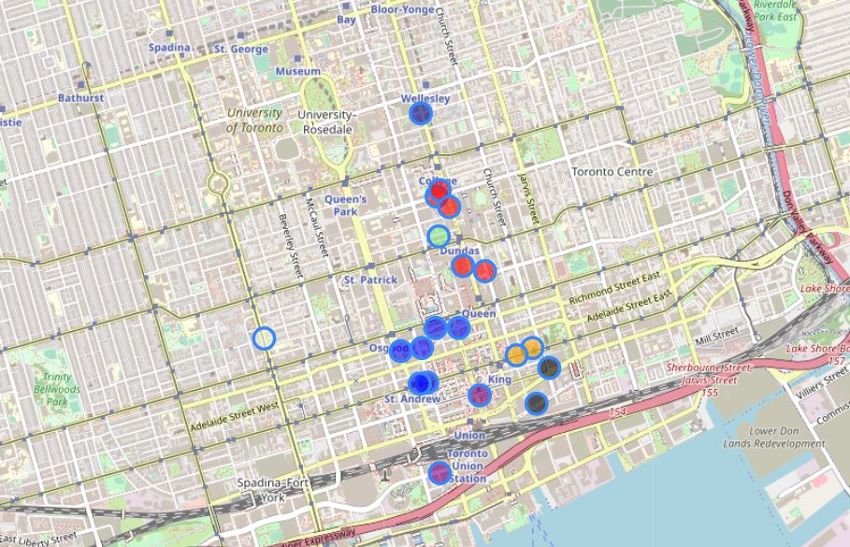

Figure 1: Bars of Toronto per area

# Outlook

Further analysis could reveal which radius (independent of postal code) has the highest bar density and how Bar10der could best (as in most efficiently) serve those bar locations.