**Summary findings**

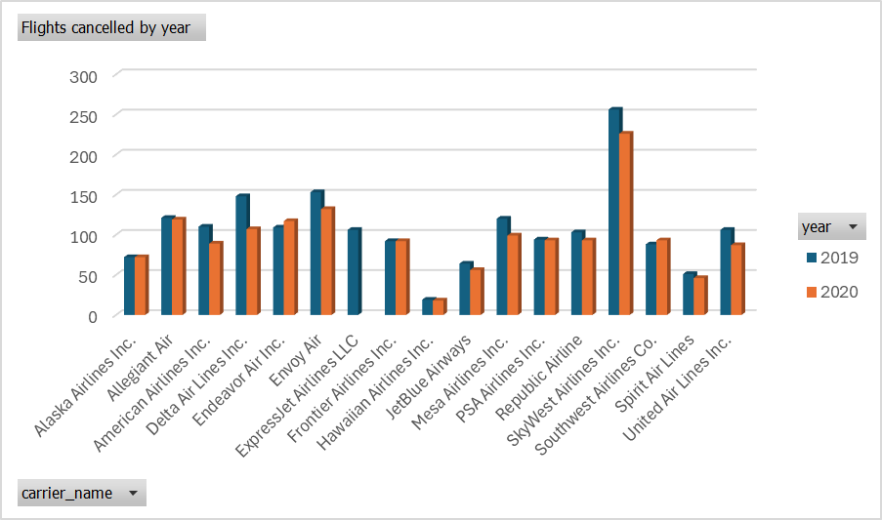

Figure

Sky west airlines inc, was the airline with the most flights cancelled by a significant distance with more than 250 in 2019.However like all the airlines in this dataset the number of flights cancelled decreased from 2019 to 2020.

Equally important, Southwest airlines was the exception because in 2020 they more flights cancelled than in 2019.

Figure

To confirm the data presented in figure 1, Sky West Airlines s was also the airline with the most flights more than 15 minutes late with 256 throughout the two years as seen in Figure 2.

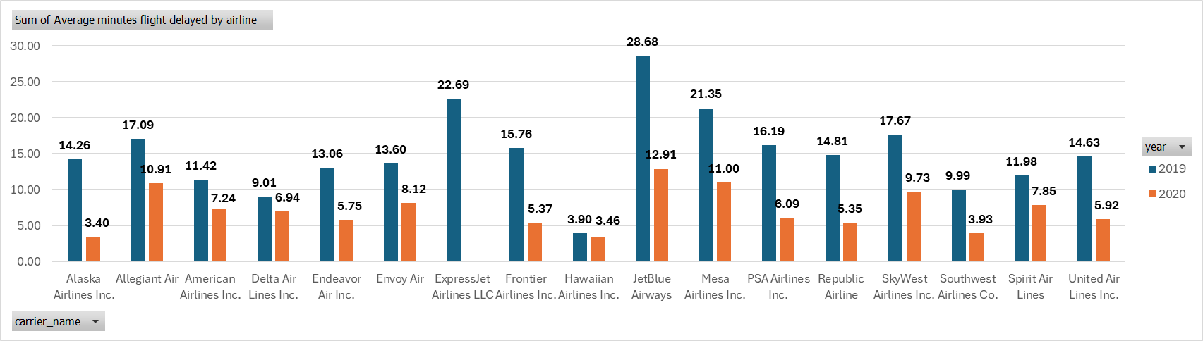

Figure 3

JetBlue airways was the airline with the higher average minutes delayed with 28.68 in 2019 and 12.91 minutes in 2020.Again, JetBlue Airways had the highest average minutes delay in both years .

In contrast, the Hawaiian airlines had average minutes delay of 3.90 in 2019 and 3.46 in 2020.Also Alaska airlines had 14.26 in 2019 and 3.40 in 2020.

Table



The table clearly shows that Alaska airlines had the biggest percentage decrease in average minutes delayed of 76.19% from 2019 to 2020. On the other hand, Hawaiian Airlines Inc. had the lowest percentage decrease in average minutes delayed from 2019 to 2020 with only 11.27%.

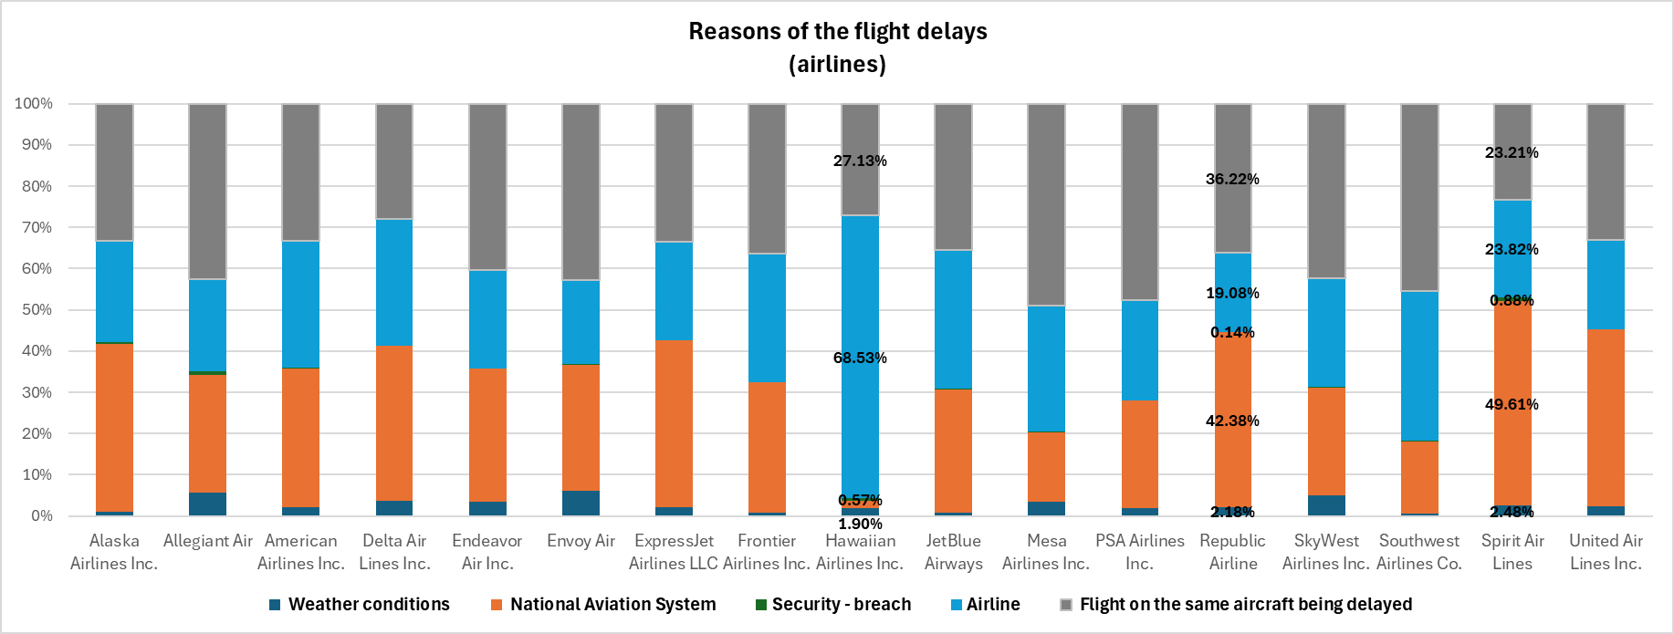

Most of the reason why they were late according to the graph shown, is due to the flight on the same aircraft being delayed.

Important to mention in Hawaiian airlines 68.53 % of their flights being delayed is due to the airline itself. Despite they be one of the best airlines in terms of performance, they could have had even better outcomes because 68 % of their delays is due to their management, crew management , pilot , control etc…

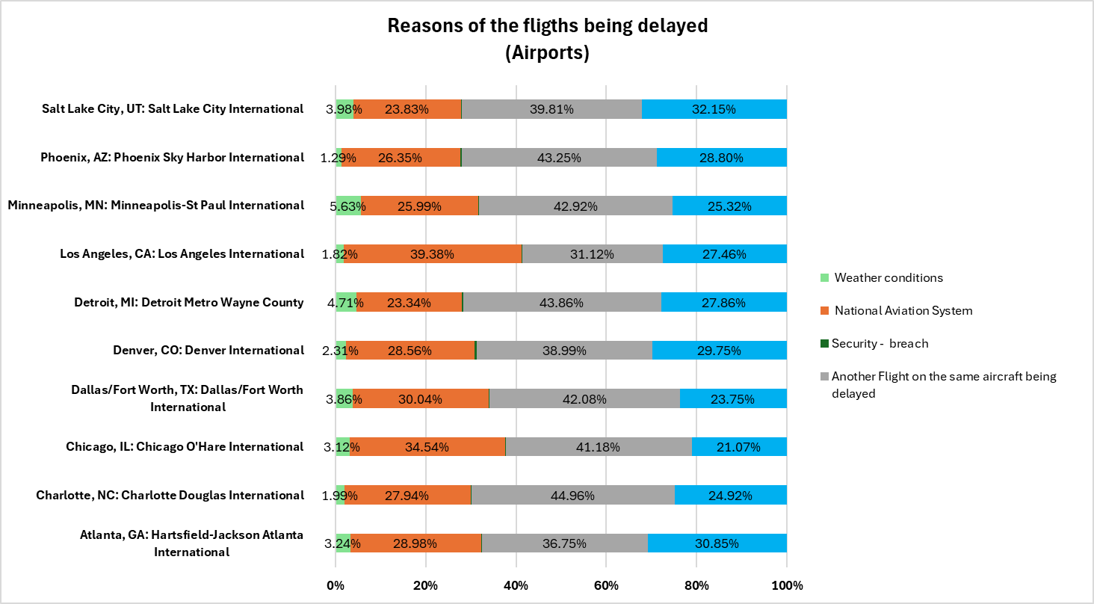

Looking at the top 10 airports with more flights arrived, the main reason of the delays of the flights in all airports it’s because, another flight of the same aircraft being delayed.