**I. HOW TO USE THIS SMART CONTRACT**

This smart contract is used for payment on delivery / logistics / courier services. The steps for using this smart contract are as follows:

1. Enter the ***paymentAddress*** of the shipping service agency.
2. Enter the ***deliveryDeadline*** in POSIX-time format. In this simulation the current time is Wednesday, July 29, 2020 9:44:52.999 PM GMT (POSIX-time : 1596059092999). For example the deadline have been set at  Wednesday, July 29, 2020 9:45:01 PM (POSIX-time : 1596059101000) then the transaction from wallet-1 (Customer) to wallet-2 (Shipping Delivery) **will be successful if the timeslot is greater than or equal 10 seconds** in simulation.
3. Enter ***deliveryStart***location / city where the stuffs will depart for delivery and then enter ***deliveryDestination*** location / city where the stuff will arrive. The name of the city entered must be based on the route list as follows :

|  |  |  |
| --- | --- | --- |
| ***deliveryStart*** | ***deliveryDestination*** | ***shippingCost (Lovelace)*** |
| BANDUNG | JAKARTA | 1000000 |
| JAKARTA | BANDUNG | 1000000 |
| BANDUNG | SURABAYA | 3000000 |
| SURABAYA | BANDUNG | 3000000 |
| BANDUNG | DENPASAR | 7000000 |
| DENPASAR | BANDUNG | 7000000 |
| BANDUNG | MEDAN | 10000000 |
| MEDAN | BANDUNG | 1000000 |
| JAKARTA | SURABAYA | 4000000 |
| SURABAYA | JAKARTA | 4000000 |
| JAKARTA | DENPASAR | 8000000 |
| DENPASAR | JAKARTA | 8000000 |
| JAKARTA | MEDAN | 9000000 |
| MEDAN | JAKARTA | 9000000 |
| SURABAYA | DENPASAR | 4000000 |
| DENPASAR | SURABAYA | 400000 |
| SURABAYA | MEDAN | 130000000 |
| MEDAN | SURABAYA | 130000000 |
| DENPASAR | MEDAN | 155000000 |
| MEDAN | DENPASAR | 155000000 |

Note : Name of the city is not case sensitive

1. Enter the ***weight_kg*** with number. It is the weight of the stuff that will be deliver. The final calculation for payment can be calculated by the following formula, **Payment =** **(1000000 Lovelace * weight_kg + shippingCost)**
2. The last step is to enter the ***receiptNumber*** in the form of a random number for example 2352536646. **receiptNumber will be a confirmation along with paymentAddress, and deliveryDeadline as a datum parameter that will be validated in onchain.**

**II. TESTING SCENARIO**

1. Funds Sent successfully

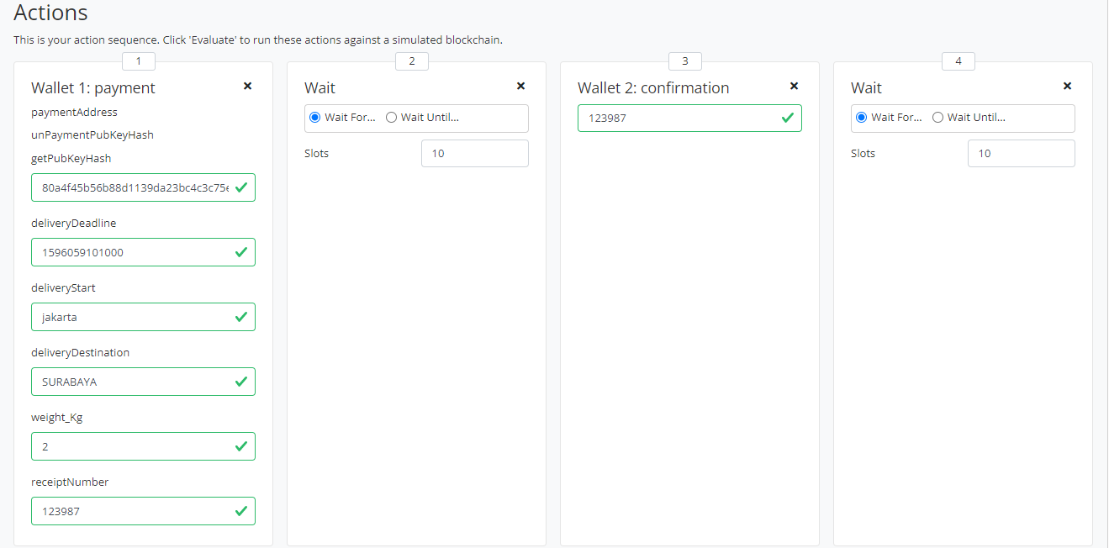

(Picture 1.0)

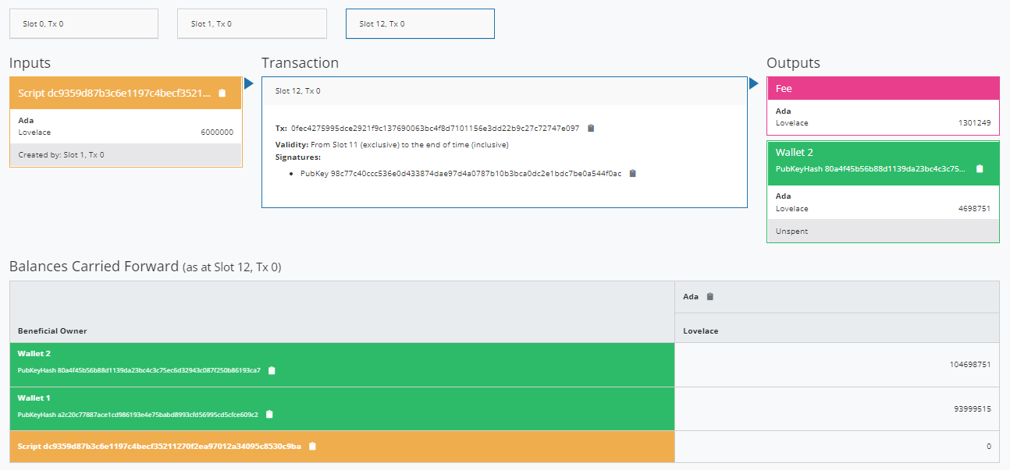

(Picture 1.1)

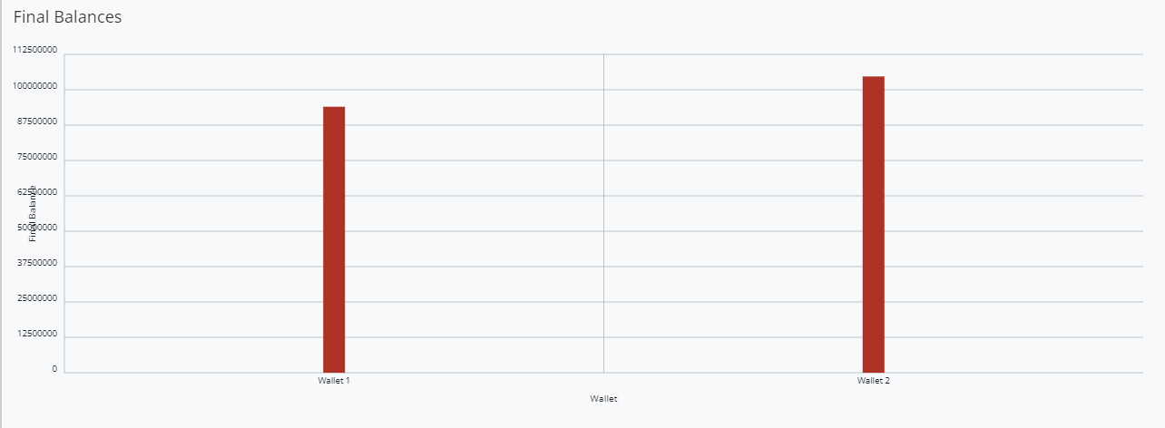

(Picture 1.2)

1. Funds Sent Failed Because Delivery Passed The Deadline / In Simulation TimeSlot Below 10

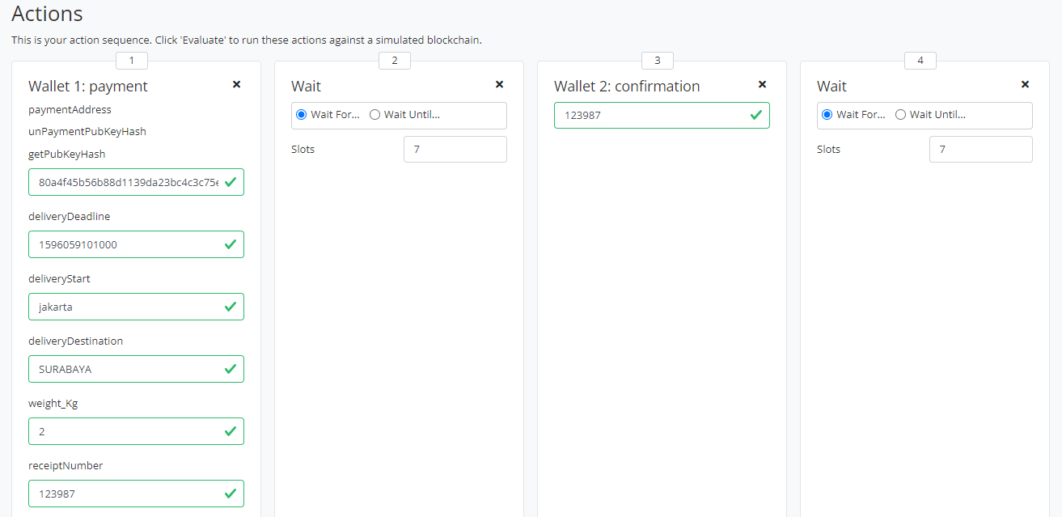

(Picture 2.0)

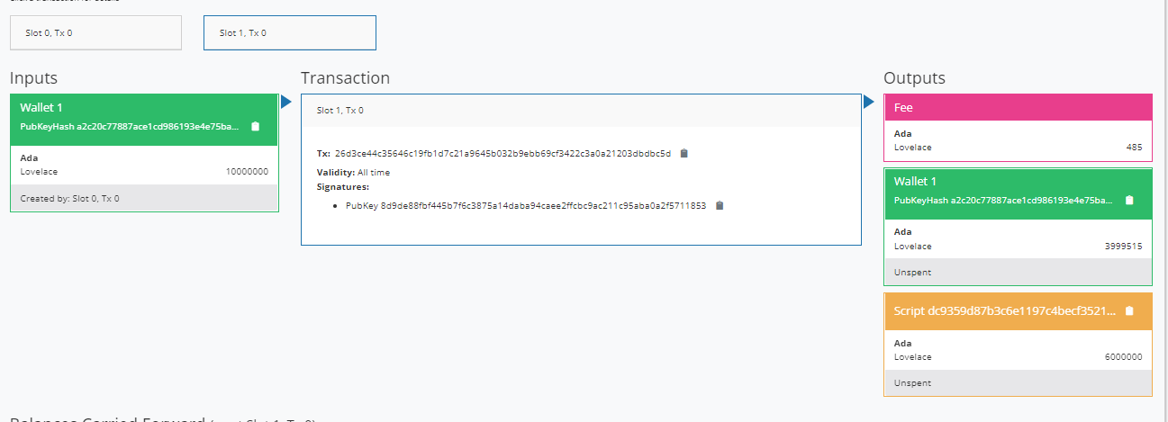

(Picture 2.1)

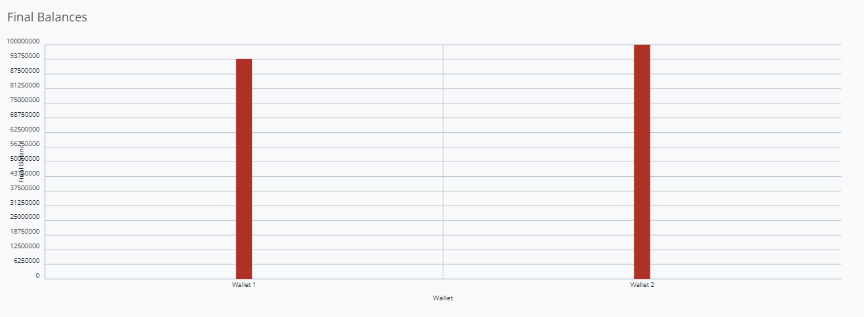

(Picture 2.2)

1. Funds Sent Failed Because ReceiptNumber Confirmation Did not Match

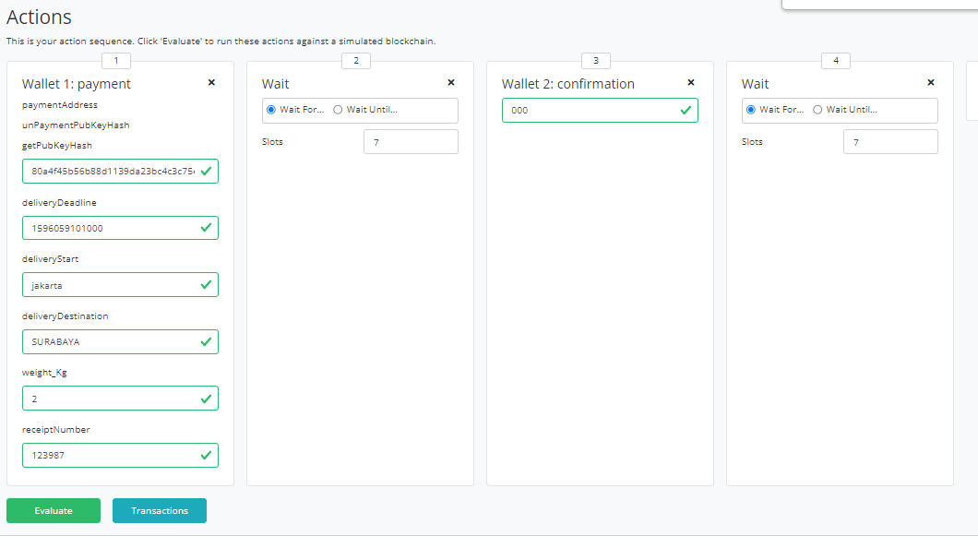

(Picture 3.0)

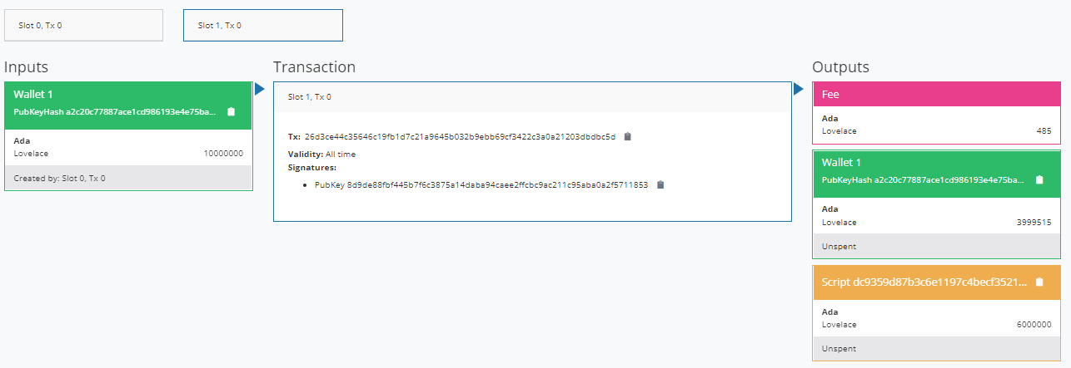

(Picture 3.1)

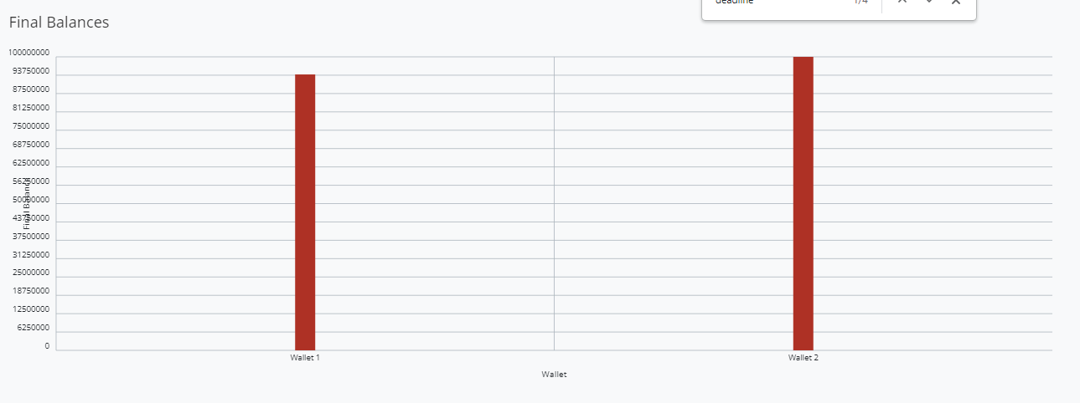

(Picture 3.2)

Note : There are data sample for testing scenarios in file ***DataSample.txt***