Mini-project for User Centred Design 2012-13

Memory Aid - Remembering and Finding Things

Place Spotter

Lecturers: Denis Lalanne & Agnes Lisowska Masson

Designers:
Jerald James Capao Samaneh Soleimani Valentina Coletti
jeraldjames.capao@unifr.ch sami.soleimani@gmail.com valentina.coletti14@gmail.com

Département d’Informatique - Departement für Informatik • Université de Fribourg - Universität Freiburg • Boulevard de Pérolles 90 • 1700 Fribourg • Switzerland
phone +41 (26) 300 84 65 fax +41 (26) 300 97 31
Diuf-secr-pe@unifr.ch
http://diuf.unifr.ch

1. Introduction

The purpose of this report is to describe the design process we used to build our application.
Our application is a memory aid application to help users who want to trace their favourite places within or out of a city and then track their way back. These so-called "users" are especially: people who travel a lot, people who has moved to a new geographic location, people who are not familiar with the structure of the city or people who have difficulties to remember different locations such as parking lots, shopping centre’s and so on. An example of such places could be monuments, museums, shops, cafés, pubs, restaurants and sightseeing.

2. Exploratory study

We decided to make our application for smartphones because these devices are playing an important role in our daily life including important factors such as business, knowledge, technology and so on. More than 75% of our questioned users have smartphones. Moreover, these days we contact our friends through social networks and integrated application into those digital devices.
Along with the idea of making our application consistent for smartphones, we made our key ideas based on simplicity, visibility and affordance. Since this application will be applied portably, we aimed to put as less and fast as possible steps through the process of getting the result in user view.

In order to get a detailed inspection that how usable our application is, we surveyed our study through using questionnaires on different group of people between 12 and 65 age. Answers to those questions gave us enough motivation to design this application. But still we need to mention that our study lacks of complete efficiency, because the observation is done on small number of people (10) who may yield biased and incomplete results.

Here is an overview of our survey: about 50% of questioned people usually forget the detailed addresses and tourists locations and shopping centres are most likely places. The results also show that about 37% of surveyed people don’t have a good sense of orientation. At the end we concluded that this application is suit for bookmarking different places and retrieving them afterwards.

We found some technical constraints such as the limitation on GPRS connections, the user has to have a smartphone (with Google Maps installed) and finally, the user is meant to be in the place he want to bookmark.

2) Personas and Scenarios

In this section, two types of personas in different situations are defined:
Shirley is a 51 years old married woman. She loves shopping and she just stops by wherever she finds an interesting shopping area. She parks her car in a certain street or parking slot and she goes to a shopping centre. After coming back he needs to find the exact location where the car is parked. This application provides the required functionality to remind her the way to reach the car. The only thing that is needed to be done by her is to save the location of the car after being parked. The location address is supplied by the use of Google Maps, which is integrated into the application.

The next persona is John 28 year old and he works as a reporter for a famous weekly magazine. He usually needs to go to different areas and towns for job reasons. In between he finds a nice restaurant where food is delicious and cheap. In order to he remember this place afterwards again, it won’t be easily possible, as he may not remember or even don’t know the structure of the city very well. With Place Spotter application it is possible to mark that restaurant by recording the location and some notes describing why it is a good place to stop by again! (e.g. “any kind of pizza costs only 10$”).

3) Design choices and Low-fidelity prototype

The application starts with the aim of bookmarking the favorite places. In order to do that, when the user is at the certain place and he would like to mark the spot to be able to remember it later, the first thing he/she needs to do is, after opening up the Place Spotter, on the starting page, tap the “Bookmark here” button. With doing so, the application is connected to the Internet and with the use of Google Maps, he/she will be able to get the geographic coordinates. As a result the map of the noted place is shown on the screen. Then the user can confirm it through tapping the “OK” button. By doing so, the retrieved address is saved and the user will be faced with the following question “Do you want to add some information about this place?”. According to his answer there are two possible procedures to be followed; By answering “Yes” user will be guided to next pages for further steps, while by answering “No” the remained steps delayed for later time and the application ends. So we will have two procedures according to two these flows. In this report we will call them procedure A and B.

3.1) Bookmark a place

3.1.1) Procedure A
We assumed that user taps “Yes” Button, so in the next screen a form will be appeared containing the following steps. First of all, the category of the place needs to be chosen by user. Examples of categories are Restaurants, hotels, museums, shopping centers and so on. Next, he needs to give a name to the place then he could retrieve it later easily. The next input is “Comment” input box where user can write his personal opinions about the place e.g. “Happy hour 17h-20h”. An overview of these tasks can be schematized as in figure 1. Moreover, he can also rate the place with giving stars. This screen is augmented with the possibility of adding photos and or videos by tapping the plus “+” button next to “Add photo” and “Add video”.
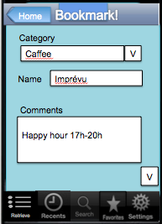
The inserted information is stored through the submitting “OK” button. The next screen is the summery of what have been filled in the previous form plus the options to edit or delete the inserted items.
Figure 1

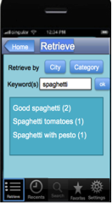
All those pages are equipped with four more buttons. The “Setting” button that provides different options for user to modify the default settings and make them customized based on his desires. Examples of these options are making changes in “User Language”, ”Background color”, giving an overview about and instructions for the application through the “Help” and “About” menu. The other three buttons provide the functionality to retrieve the places and their related information that have been already saved. And they help user to retrieve those information through different procedures.
The “Retrieve” button is the main way to get the information about denoted places. It comes up with a screen containing two buttons “City” and “Category”. Any of them helps the user to find the intended place either by the city that the place is located or the kind of category that it has been grouped into it. The other retrieving way is through a normal search way. The user inserts a keyword, then the application starts searching into its database to bring up the matched items. The “Recent” button shows the 10 top recent bookmarked places. The “favorite” button returns the most rated places in an descending order. For example the place has the most stars lays first and then next one with less number of stars. Figure 2 schematized the retrieving procedure through the normal search method.
Figure 2

3.1.2) Procedure B:
This procedure is equipped with the all functionalities that procedure A provides, but the only difference is, this way is designed to provide a shorter number of steps for bookmarking. In this way, after getting the geographical information through Google Maps, user can close the application and all these information are stored in the memory. This time, the application will be marked with a small notification to remind the user to insert the rest of the required information later. So any time that user looks at the list of his smartphone application, he will see the “Place Spotter Application” with a small notification over the application icon as soon as he/she has not insert more information about that place.

3.2) Retrieve a place

As it is mentioned before, the place or address retrieving functionality is provided through three different ways. These ways except the alternative characteristics behaves the same in their major goal which will be described as following:
After finding the name of the place, the user navigated to a page, that first through connection to Internet the standing location is retrieved then direction from standing place to desired spot shown on the screen automatically.

4) Evaluation plan

As said so far, we support the philosophy to have a simple and intuitive user-friendly interface of our application. That is because its purposes is to bookmark and retrieve places easily and fast as we suppose that the user prefers to enjoy the place he/she is bookmarking (e.g. an evening in a good restaurant with friends) than spending time using the smartphone entering data.

Dependent variables
To evaluate our prototype, considering intuitiveness and speed, some measures have been fixed:
- Number of clicks (taps) required to reach a goal
- Number of error clicks (accuracy)
- Time to complete assigned task (efficiency)
- Satisfaction score (i.e. if user liked the interface and if he/she is satisfied)

Independent variables
We created two different prototypes for task 1 and one for task 2 to test which one is the most effective in terms of speed, intuitiveness and satisfaction of the users:
- Prototype
  - A: classical (s. Annexe “A_Bookmark”)
  - B: improved (s. Annexe “B_Bookmark”) “Optioned” page added
  - Retrieve (s. Annexe “Retrieve”)
- Subject
The users were average people from different fields (musicians, bachelor math, computer scientists, singer, cinema critic) and one expert in UCD. All of them own a smartphone.

For the evaluation, we didn’t give the entire prototype but we restrict it in only two tasks considering the two main functionalities of the application:
- Task 1: bookmark a place (without putting extra info such as rating, photos and videos)

- Task 2: get direction to that place through “Retrieve” button and not through “Favourite” and “Recents”.

We fixed two hypotheses:
- Task 1: There is no significant difference in user performance (in terms of n° of clicks, errors and time) when computing task 1 between prototype A and B, without considering the subject’s previous expertise of using smartphone at .05 level
- Task 2: It needs 4 clicks, 1 error (if user doesn’t find the button), 20 seconds to compute this task

Performing the evaluation with the users

We performed the evaluation with 8 people and decided to adopt the within subjects assignment (because we have a small sample size). We split them in two groups of 4 people and assigned to all users the two prototypes in a different order (because of learning effects). We tried also to create small tasks to avoid impact of fatigue.

In order to avoid biased results, firstly we gave to each user the same paper with instructions where it has been explained the application and the tasks they had to execute (s. Annexe “Instructions”).
Then we gave them an interactive interface through Power Point where we enabled only the buttons needed to perform the tasks. In this way, the user was leaded to tap on the right buttons and we could count the errors they made when clicking in the wrong place. For technical reason of Power Point, when user has to fill the form of the place (insert the name and some comment of it) we put some name options instead of let the user input through a keyboard (we didn’t count these clicks).
For the first task, we gave them two different prototypes, and for the second only one. After the tasks, we gave a final questionnaire (S. Annexe “Evaluation Questionnaire”) and then we discussed with each of them to exchange some opinions and relieved some problems.

By acting in this way, we could do two types of evaluation:
- Qualitative: through the questionnaire and talking with them and see their reaction live (satisfaction)
- Quantitative: by counting the number of clicks (efficiency), the errors (accuracy) and the time. This was possible thanks to the fact that we recorded the performance (only the screen and the clicks) of the users with QuickTime and reviewing it later. By recording, it was also possible to not put users under pressure and don’t let them feel as if they were under observation. We wanted them to feel at ease without stress.
N. clicks
 | user1 | user2 | user3 | user4 | user5 | user6 | user7 | user8 | Avg
A: Classical | 13 | 7 | 7 | 8 | 8 | 7 | 8 | 7 | 8.125
B: Improved | 10 | 9 | 8 | 9 | 8 | 3 | 3 | 9 | 7.375

5) Results of the evaluation

Before analysing the results, we should mention that there are some limitations to be considered of the data we gathered that can influence the results and can be biased: we had only 8 users that performed our evaluation and the task of getting direction was performed only once while the first task was performed twice where it will be considered the learning factor.

TASK 1: Bookmark a place
Time (sec)
 | user1 | user2 | user3 | user4 | user5 | user6 | user7 | user8 | Avg
A: Classical | 14 | 14 | 35 | 16 | 50 | 41 | 52 | 45 | 33.375
B: Improved | 82 | 37 | 53 | 43 | 41 | 10 | 11 | 32 | 38.625
Here below are shown the tables and the plots with the number of clicks and the time users took to perform the first task with the prototype A and B.

User 1-4 performed with prototype B and then A.
User 5-8 performed with prototype A and then B.

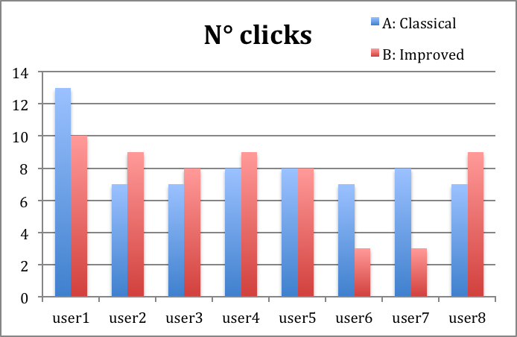
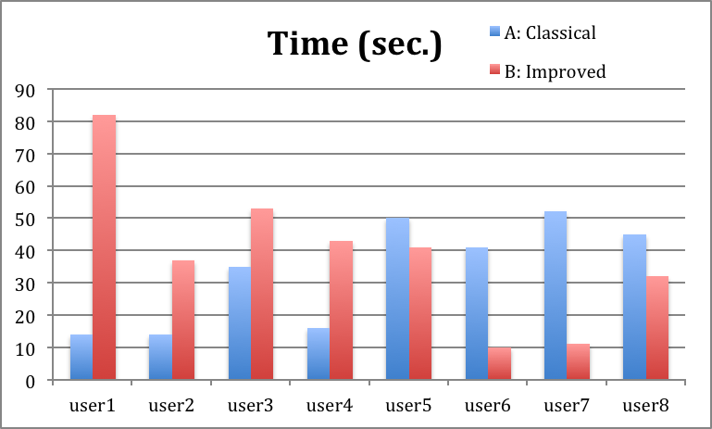
Firstly, we can observe that the first group that experienced first the prototype B and then the A, have less clicks in prototype A than B comparing with the other group. That’s because of the learning influence: when the task is done once, the second time is done with less clicks, errors and time because users get used to the interface and it is more familiar to them.
Secondly, we can say, as in our hypothesis n° 1, that there is not significant difference between the two prototypes in terms of number of clicks (~1 click of difference in the average) and time (~5 seconds of difference).
Only two users did the performance within only 3 clicks and in 10 seconds in the second prototype by tapping “no” to put some information to the place.

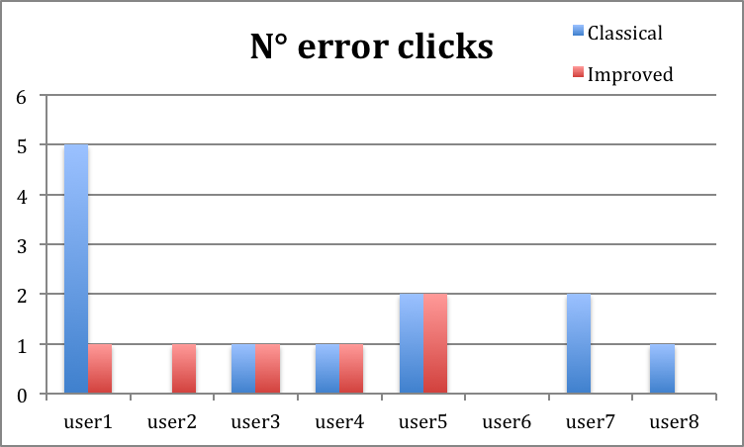
Concerning the number of error clicks, we can see that the users did in avarage more or less only one error in both prototypes.

N. error clicks
 | user1 | user2 | user3 | user4 | user5 | user6 | user7 | user8 | Avg
A: Classical | 5 | 0 | 1 | 1 | 2 | 0 | 2 | 1 | 1.5
B: Improved | 1 | 1 | 1 | 1 | 2 | 0 | 0 | 0 | 0.75

TASK 2: Get direction
Here below are shown the tables with the number of clicks and the time users took to perform the second task with the prototype A and B.
N. clicks
 | user1 | user2 | user3 | user4 | user5 | user6 | user7 | user8 | Avg
Retrieve | 5 | 4 | 4 | 4 | 4 | 4 | 3 | 4 | 4

Time (sec)
 | user1 | user2 | user3 | user4 | user5 | user6 | user7 | user8 | Avg
Retrieve | 10 | 29 | 29 | 27 | 17 | 16 | 51 | 23 | 25.25
From these tables we can see that in avarage we need only 4 taps and more or less 25 seconds to reach the target information (the directions). Mainly only one error it has been done.
N. error clicks
 | user1 | user2 | user3 | user4 | user5 | user6 | user7 | user8 | Avg
Retrieve | 0 | 2 | 5 | 1 | 0 | 0 | 2 | 3 | 1.625

___________________________

All this analysis confirm that the two prototypes are simple and intuitive because it takes little time, few clicks and few errors to accomplish the two tasks That means that our hypothesis that between the two prototypes there were not significant difference in performing the first task and that it needs only 4 clicks, 1 possible error and around 20 seconds to compute the second task.

6) Statistical analysis

We would like to test if our claims are correct through a statistical analysis. By this way, we can confirm that there is no statistically significant difference between the two prototypes. In this case, we will use a simple statistical test: the T-test.
We fix the null hypothesis:
“There is no difference exists between the means of two sets of collected data”
Our hope is that we can’t reject this hypothesis, meaning that the means are likely the same, which will confirm our previous analysis.
The paired observation conforms to our procedure (within-group) where the users studied under both experimental conditions and the data points of one subject are treated as a pair. Moreover, we will consider our type of test as non-directional (two-tailed) where there are no expectations that the direction of difference matters.
For the number of clicks we got the t ration t = 0.476 and the critical value for the degree of freedom df = 14: cv = 2.145. Because 0. 476 < 2.145, there is no significant difference. That means that we cannot reject the null hypothesis confirming our hypothesis that there is no difference between the means.

7) Satisfaction score of the users

From the discussion and questionnaires we gave at the end with the users, we gather some good information: positive and negative opinions and suggestions to improve our application. We put some of them here below.

Positive opinions that confirm our philosophy of intuitiveness and speed:

“It’s easy to understand the flow, the structure is good”
“it’s a nice idea, easy to use”
“simple to do the two tasks, very quick”

“It is also a way to know new places with other friends”
“yes I would download it and recommend to my friends”
“Very quick to accomplish the tasks, useful for travelling in a new city, I’d recommend it!”

Negative opinions

“the retrieve button is hard to be found”
“too big button, I don’t like it”
“the instructions of the prototype B asking if we want to add information, is not clear”
“I wouldn’t download it because I won’t use it, but that’s because I don’t travel a lot and I don’t download many applications”

Recommendations

“It was good to share the bookmark with other people”
“for getting the direction, you should put some options like in Google Maps where you can choose car, walking, train etc.”
“one button for bookmark, one button for retrieve”
“to avoid one step, I would do as when I tap on the app, it bookmark by itself, without the bookmark button at the beginning, the first page will display the map where you are”
“Instead of pressing OK to bookmark, press directly the location on the map”

8) Final prototype (s. Annexe “Final prototype”)

Even if there is no significant difference in terms of number of clicks, errors and time, we decided to choose the prototype B for this reason: 6 up to 8 users prefers this prototype (“it’s better to have the possibility to decide, so maybe once I’m busy during the evening, I can postpone filling the form when I have time”). The other two people prefer the prototype A because “I would surely forget to fill the form, and I will forget the things to write…I prefer to do it when I bookmark and anyway it is quick to do!”. So the satisfaction factor let us decide in this way.

From the negative opinions we saw that the retrieve button was a bit hard to be found. In fact in the recorded video we saw that some users had hesitation to find the retrieve button and also they clicked in the wrong places. For that reason, we changed this button and make it bigger in the centre as they are the two main functions.

Moreover, the instructions of the prototype B when asking if we would like to add some information to this place are not clear. For this reason we change it in this way:

Old version:
Do you want to add some information about this place?
Yes No

New version
Would you like to add some information about this place now?
Yes No, later!

9) Future improvements

Some possible future improvements of this application could be the following features:

- The possibility to share the places with friends (Facebook, Twitter,…)
- Finalise the “Home” and “Back” buttons
- Call button in each place form, so that it’s easier the next time to call it
- Improve the aesthetic, design, graphic (colors, buttons,…)
- A “Sum-up” map where bookmarked places are all gathered on it
- To evaluate the ways to retrieve (through “Retrieve”, “Favourite” and “Recents” button)
- To solve one of the constraints we have (user must be in the place to bookmark it): give the possibility to the user to put the place himself on the map
- Better instructions and questionnaires for study case and for the evaluation (ex. Did you find any difficulties?)

A possible prototype, more developed than the ones we have been showed so far, has been annexed named “Developed Prototype”. For sure, it needs a lot of improvements, but we are trustful ☺

The survey can be consulted from these websites: http://www.surveymonkey.com/s/8J5Y399 and http://www.surveymonkey.com/s/8J65ZJ8

