**Objective: Front-End Developer**

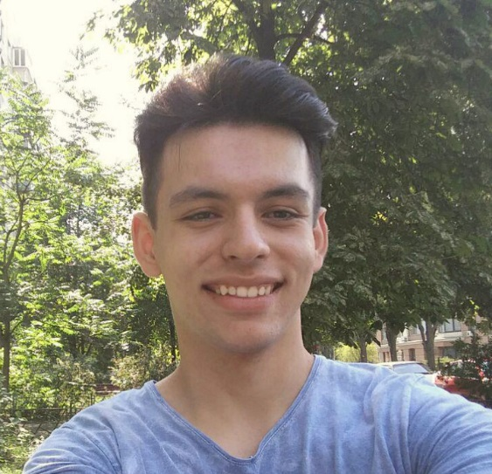

Personal information: Vladyslav Yudashkin

Birthdate: 19.05.1997

Residence : Kyiv

Contact information: **https://valedus.github.io** skype: valedus97@gmail.com

**phone number: (063) 929-81-07; email:** [**valedus97@gmail.com**](mailto:valedus97@gmail.com)

**Personal qualities: •**Punctual

•Comunicative

•Disciplined

•Responsible

•Passionate

•Purposeful

•Without bad habits

**Skills:** Expert: Intermediate: Familiar/Learning:

HTML5/CSS3 C#, Unity3D PHP

Bootstrap 4 SASS Node.js

Javascript JSON

JQuery Git

Photoshop

WordPress

Gulp

**Experience:** I used to develop games with C# on Unity3D. Recently decided to start working in web-design since I had a good experience with it in highscool (second place at city Olympics).

**Languages:** English (conversational)

Hebrew (beginner)

**Education:** Incomplete higher education (National Aviation University);

Technological college ORT (Kyiv)

**Hobbies:** ThaiBoxing, Mnemonics (art of memorizing), Go (Chinese chess).