Assignment 2


Course Instructor: Dr. Atif Mughees
Section: MS DS A

__________________________________________________________
Submitted By:
Valeena Afzal
25I-8023

Table of Contents
Part 0 - Dataset Overview 3
Part 1 - Projection Challenge 3
Mercator Projection 3
Equirectangular Projection 6
Robinson Projection 7
Albers Equal-Area Projection 9
Comparison Table 11
Discussion 11
Part 2 - Part 2 – Choropleth Map and Its Pitfalls 11
Classification method 11
Quantile Classification 11
Equal Interval Classification 12
Classification Comparison 13
Choropleth Maps Are Misleading 13
Why Ratio/Rate Data Should Be Used 13
Effect of Region Size and Visual Bias 13
Discussion and Limitation 13
Part 3 – Proportional Symbol Map 13
Proportional Symbols 14
Reducing Overlap 14
Proportional Symbol vs Choropleth 14
Part 4 - Flow Map / Movement Analysis 14
Discussion 14
Part 5 - Continuous Field Mapping 15
Assumptions and Limitations 15
Discussion 16
Part 6 – Cartogram or Alternative “Area Correction” Map 16
Part 7 – Case-Based Map Design Challenge 18
Scenario A – Public Health 18
Scenario B – Urban Services 18
Scenario C – Climate Risk 18
Minimum Technical Requirements Check List 18
Bonus Checklist 18
Ending Notes 19

Part 0 - Dataset Overview
Dataset Name | Source | File Type | Geometry Type | Spatial Extent | Variables Used
World Countries Boundaries | Natural Earth | Shapefile (.shp) | Polygon | Global | Country name, ISO code, area
Why Selected | Provides administrative boundaries required for choropleth maps, projections, and cartogram analysis.
Global Airport Locations | OpenFlights | CSV | Point | Global | Airport name, latitude, longitude, city, country
Why Selected | Used for point-based visualization and proportional symbol maps. Discrete spatial locations for showing distribution and magnitude.
Airline Routes Dataset | OpenFlights  Routes | CSV | Flow (Origin-Destination pairs) | Global | Source airport, destination airport, number of routes/flights
Why Selected | Allow create flow maps to visualize movement between locations.
Global Temperature Data | WorldClim | Raster / CSV | Continuous Field (Interpolated Surface) | Global | Temperature (°C), latitude, longitude
Why Selected | Continuous spatial phenomena. Good for interpolation and contour mapping to show spatial gradients and patterns.

Part 1 - Projection Challenge
Dataset: ne_50m_admin_0_countries.shp (Natural Earth)
A map projection is a way to convert the 3D Earth (sphere) into a 2D map (flat surface). All map projections introduce distortion; the choice depends on what property we want to preserve. Natural Earth dataset is used for the following projections.

Mercator Projection
It is used for Navigation (ships, GPS). It preserves shape and direction but distorts area making Greenland looks as big as Africa. Because straight lines = constant direction (important for navigation)
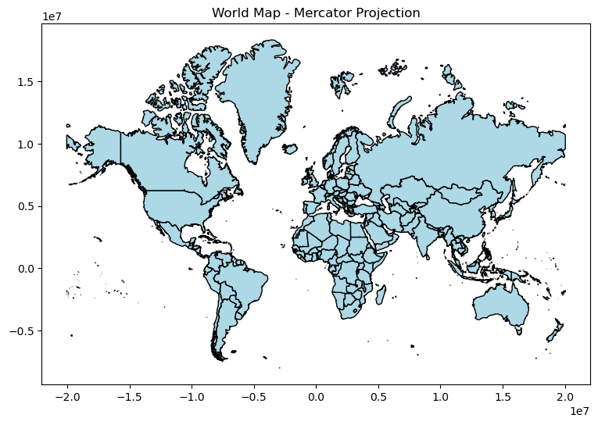
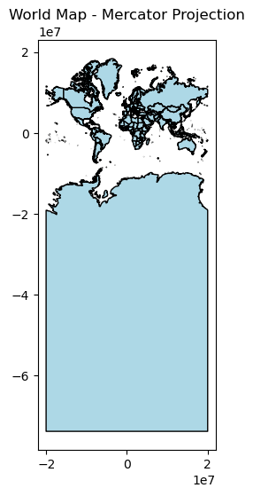
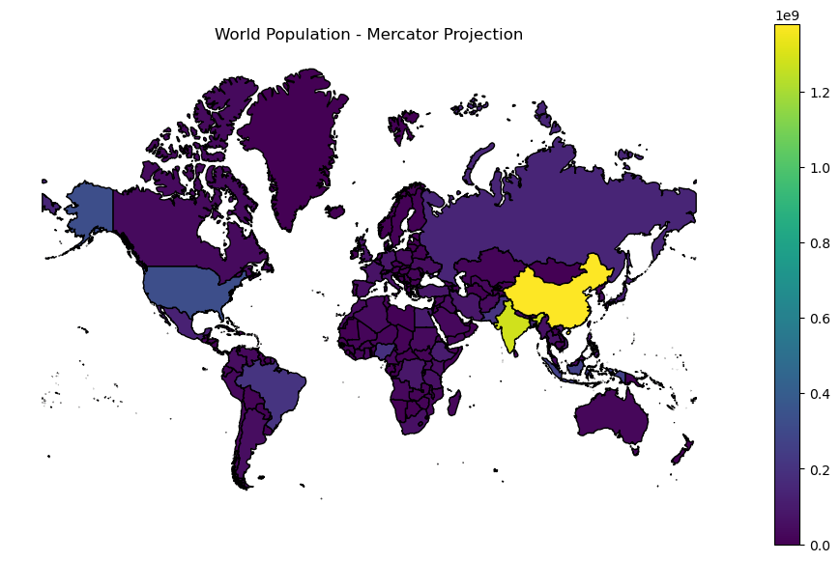

Equirectangular Projection
It is used for simple maps. It preserves nothing perfectly and distorts area and shape.
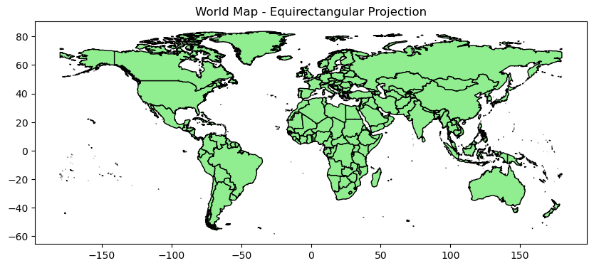
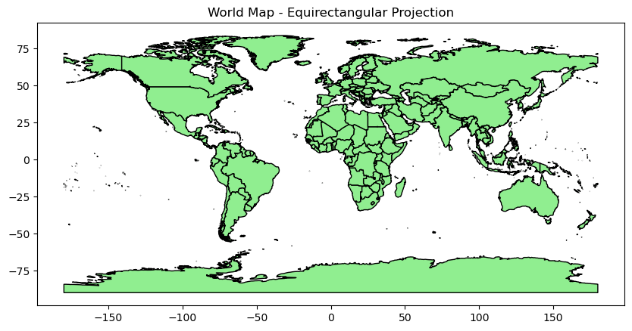
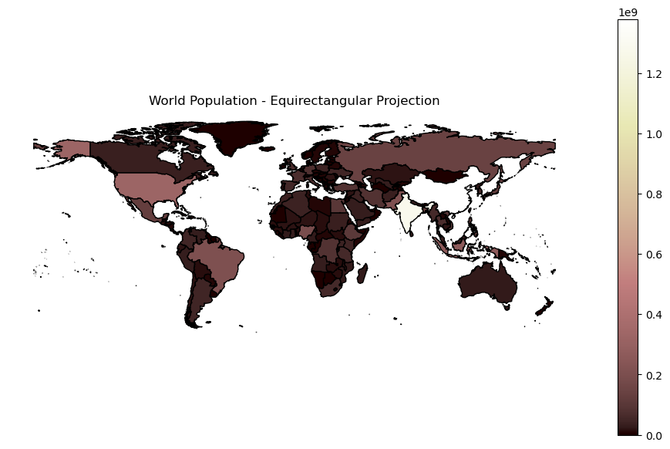

Robinson Projection
It is used in World maps because it Balances area and shape and has less distortion overall.

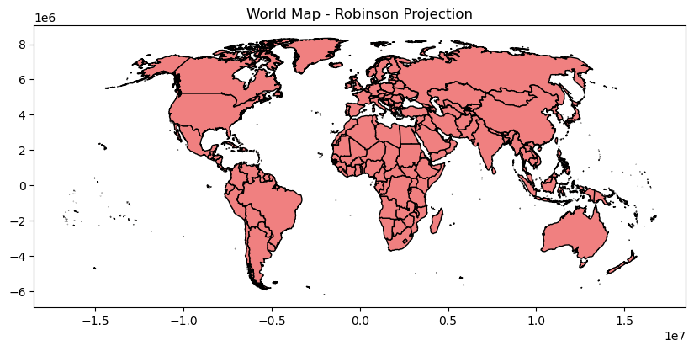

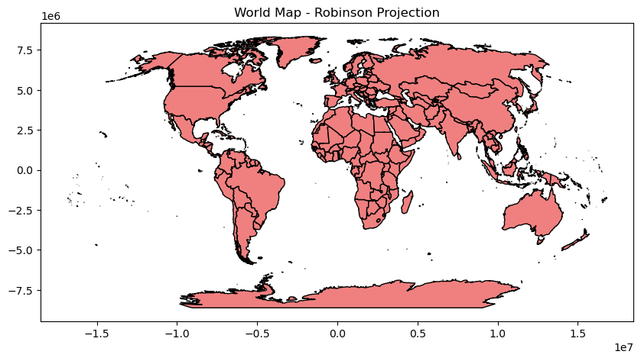
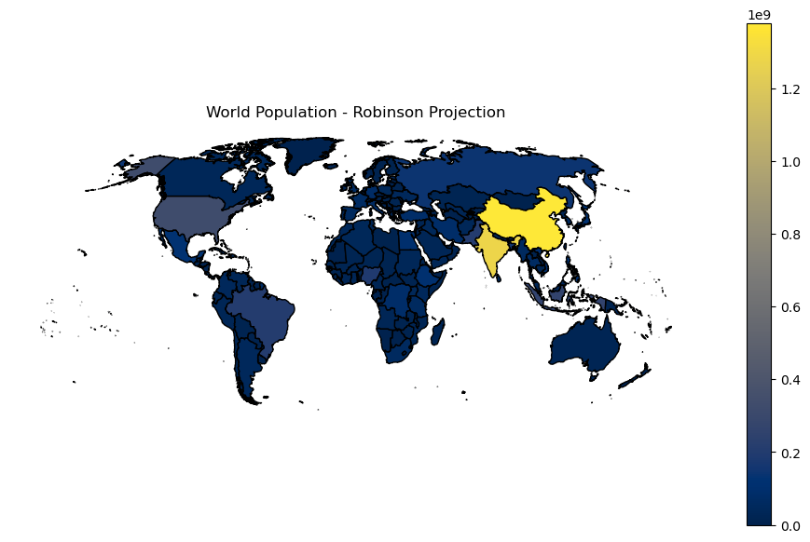

Albers Equal-Area Projection
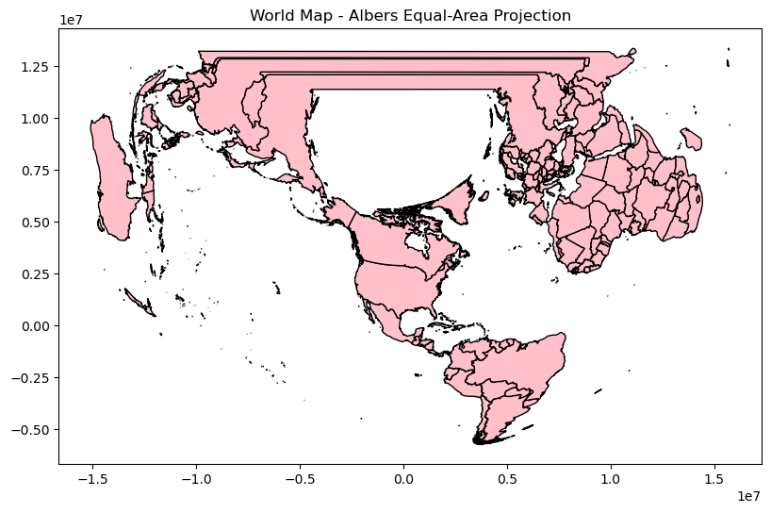
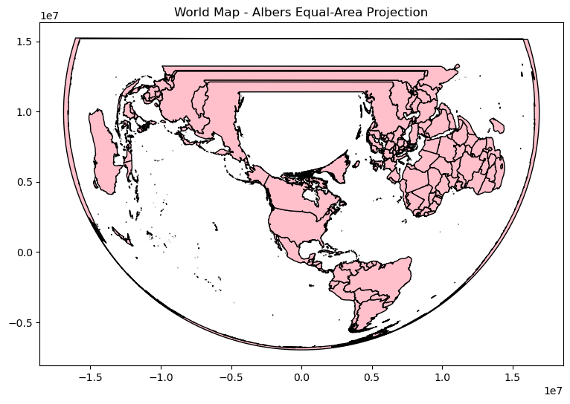
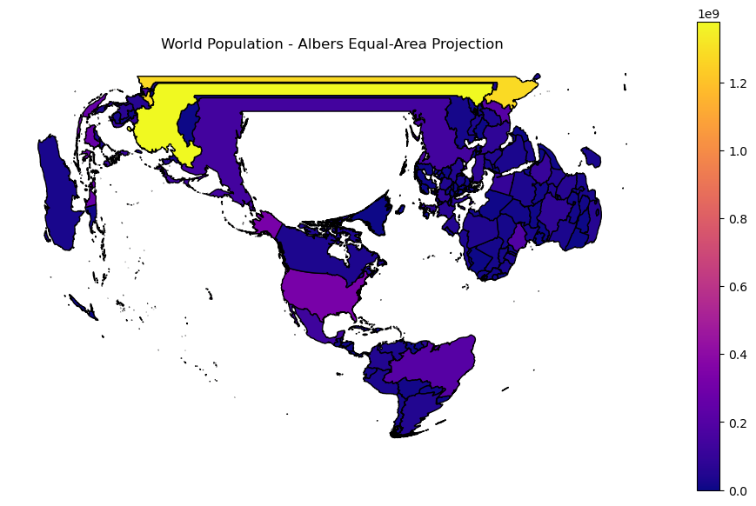

Comparison Table
Projection | Preserves | Distorts | Best Use Case | Reason
Mercator | Angles / local shape | Area near poles | Navigation, maritime maps. | Maintains compass angles directions can be plotted accurately.
Albers Equal-Area | Area (true proportional size) | Shape & angles | Thematic maps by population or land area | Accurately represents relative sizes useful for population or land use comparisons.
Robinson | General shape balance | Neither area nor angles perfect | General educational world maps | Balanced view, visually pleasing, and minimizes extreme distortions.
Equirectangular | Simple rectangular grid | Area and shape at high latitudes | Easy plotting, GIS reference, global raster alignment

Discussion
Projection choice is critical when mapping thematic data like population, greenhouse gases, or resource distribution. Misleading projections can distort interpretation.

Part 2 - Part 2 – Choropleth Map and Its Pitfalls
Dataset: ne_50m_admin_0_countries.shp (Natural Earth)
Variable: Population density (POP_EST / area)
Data is normalized to get Population density using Population and area. Albers Equal-Area projection preserves the true relative size of regions, making it more suitable for choropleth maps based on area-dependent variables like population density. It ensures that comparisons between regions are fair and visually accurate. As a result, high-density small countries are not visually overshadowed by large but sparsely populated regions.

Classification method

Quantile Classification
- Data divided so each class contains approximately the same number of countries
- Highlights relative ranking of density
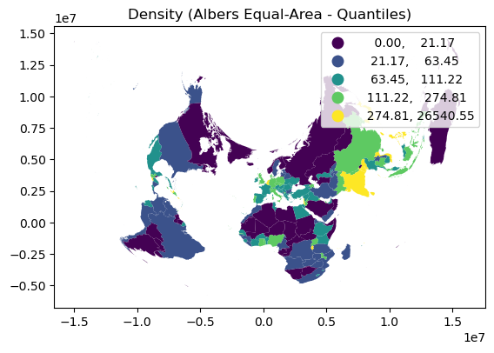

Equal Interval Classification
- Data divided into equal value ranges
- Highlights the actual magnitude differences between regions
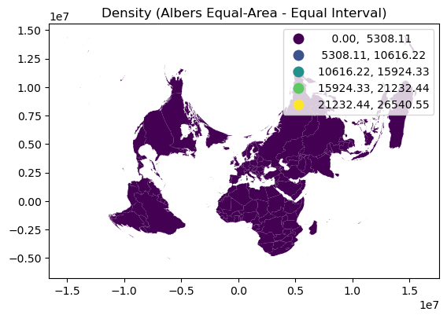

Classification Comparison
Classification | Observation | Strengths | Weaknesses
Quantiles | Equal number of countries per class | Balanced visualization emphasizes relative ranking | Can exaggerate minor differences
Equal Interval | Equal value ranges | Shows actual differences in density | Outliers may cluster most countries in a single class

Choropleth Maps Are Misleading
- Large countries appear dominant regardless of their actual population density when raw counts used.
- Large but sparsely populated regions visually dominate the map, masking small high-density areas due to region size bias.
- Different schemes (quantile, equal interval, natural breaks) can produce different visual impressions from the same data.
- Darker colours may imply importance even when absolute differences are small due to Colour perception bias.

Why Ratio/Rate Data Should Be Used
Raw counts depend on population size and area, making comparisons unfair. Ratio or rate data standardizes comparisons across regions.
Effect of Region Size and Visual Bias
Larger countries occupy more space and attract more attention, even if their density is low. Smaller but highly dense countries may be visually overlooked. This creates visual bias where map prominence ≠ actual significance.

Discussion and Limitation
Using normalized data ensures meaningful comparisons. Classification methods affect how patterns are perceived: quantiles emphasize relative ranking; equal intervals show actual differences. Choropleth assumes uniform distribution within region

Part 3 – Proportional Symbol Map
Dataset: OpenFlights airports and Natural Earth (ne_50m_admin_0_countries.shp)
- Point locations: Latitude and Longitude of each airport.
- Converted to a GeoDataFrame to plot correctly on the map.

Proportional Symbols
Symbol size was scaled proportionally to Altitude (circle radius proportional to magnitude). Since area ∝ radius², radius scaling visually represents magnitude effectively. Radius proportional to magnitude.

Reducing Overlap
Static map: Transparency alpha=0.6 reduces visual clutter.
Interactive map: MarkerCluster groups nearby airports.

Proportional Symbol vs Choropleth
Proportional symbol maps are better than choropleths for point data like airports because they show the magnitude at each specific location rather than aggregating by country. Choropleths can hide local variation and misrepresent unevenly distributed points. Here each airport's size represents its Altitude.
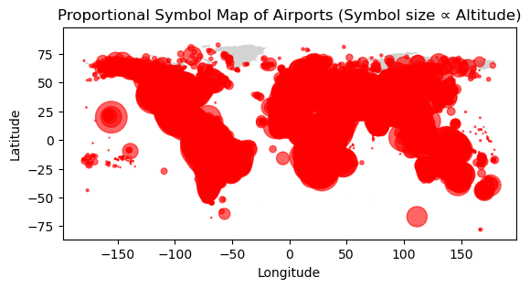

Part 4 - Flow Map / Movement Analysis
Mapped airline routes.
Dataset: Natural Earth + AirLine Routes

Discussion
The network shows hub-and-spoke structure major international airports connect many smaller airports. Routes with high flow indicate major corridors (like North America → Europe). Red hub markers identify top inflow/outflow nodes, which dominate connectivity. Filtering top N flows reduces clutter while preserving key patterns. Static map gives overview, but interactive map allows exploration of individual connections.

Part 5 - Continuous Field Mapping
Dataset: WorldClim Annual Mean Temperature + Natural Earth
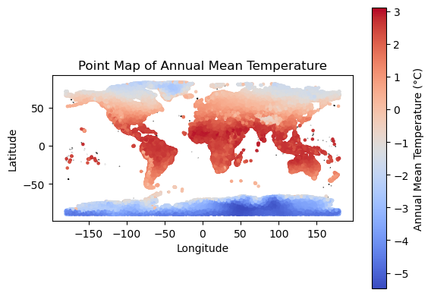
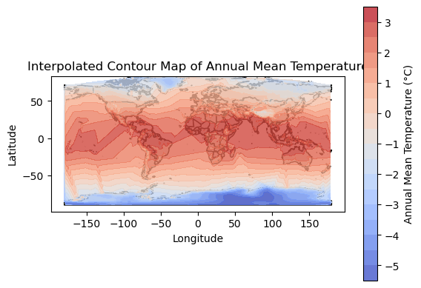

Assumptions and Limitations
Assumptions:
- Temperature varies smoothly between measured points.
- Interpolation assumes no sudden discontinuities (e.g., local microclimates).
Limitations:
- Sparse points leading to unreliable interpolation in some regions (e.g., oceans, deserts).
- Complex terrain (mountains, coastlines) may cause abrupt changes that interpolation cannot capture.
Unreliable Areas:
- Oceans (few/no data points)
- Remote or mountainous regions
- Edges of the raster grid

Discussion
Contour / isopleth maps are ideal for continuous variables like temperature etc and do not work for categorical variables because categories cannot be interpolated. Areas with dense data points (most land regions) produce reliable contours. Interpolation may be unreliable in Oceans or areas with few/no stations and Mountains or regions with abrupt temperature changes.

Part 6 – Cartogram or Alternative “Area Correction” Map
Dataset: population by region natural earth
Original Geographic Map shows true land area large countries like Canada and Russia dominate visually despite small populations. In Population-Scaled Cartogram countries are scaled by population around their centroid. India, China, Nigeria appear larger and Canada, Russia shrink providing visual importance according to population rather than land area. In Tile Grid Map each country's width represents its population. Countries with large populations like India, China, and Nigeria appear larger, while low-population large countries shrink. Provides a clearer view of human impact vs land area. Continuous field represents gradual variation in space.
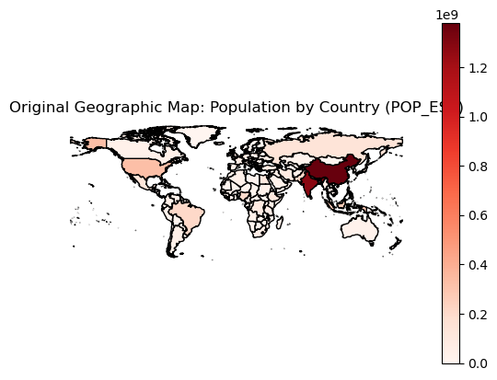
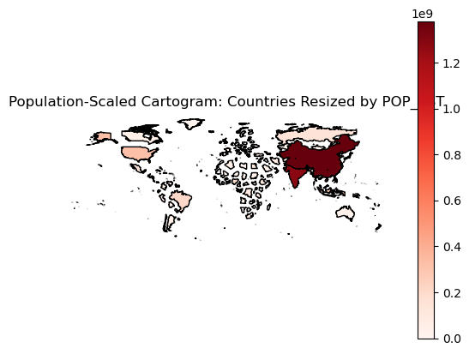
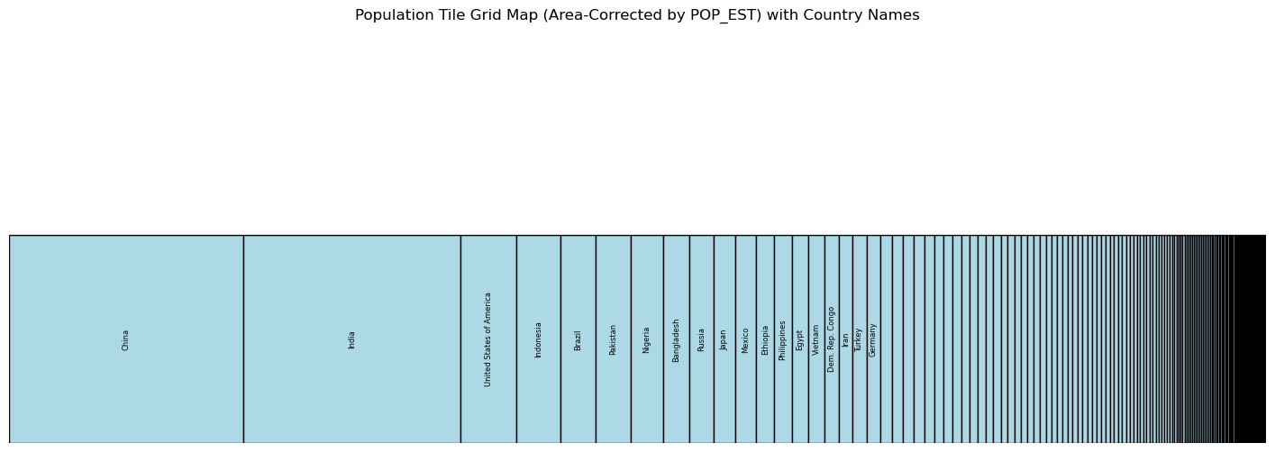

Part 7 – Case-Based Map Design Challenge

Scenario A – Public Health
A choropleth map combined with point (cluster) mapping was used. Choropleth highlights regional burden effectively points show clustering.

Scenario B – Urban Services
A network-based service area map using OSMnx, combined with point markers. The network-based service area map models realistic accessibility by considering the actual road network.

Scenario C – Climate Risk
A combined choropleth and proportional symbol map. The choropleth map is used to represent flood risk levels across regions, while proportional symbols (circles) are used to represent population exposed to risk.

Minimum Technical Requirements Check List
- Read at least 4 different spatial datasets ✅
- Perform at least 2 dataset joins ✅
- Handle at least 2 geometry types ✅
- Reproject data at least 3 times ✅
- Create at least 6 distinct maps ✅
- Save high-resolution outputs ✅
- Include legends, titles, source labels, and coordinate/projection notes ✅
- Document assumptions and limitations ✅

Bonus Checklist
• build an interactive dashboard
• add hover tooltips ✅
• use animation for temporal flows
• compare multiple basemaps ✅
• create a live web map
• implement a custom tile map or hex map
• use OSMnx for routing/network analysis ✅
• compute spatial autocorrelation (Moran’s I)

Ending Notes
World countries shapefile, Airports, Airline routes, and Temperature datasets were used. Open flights data was cleaned to handle missing values and get standard format. Data was normalized to get population density using raw population and area count. More than 3 joins were added to combine datasets.

