Data Science Tools and Techniques



ASSIGNMENT 3

Course Instructor: Dr. Mateen Yaqoob
Section: MS DS A

__________________________________________________________
Submitted By:
Valeena Afzal
25I-8023
Contents
Preprocessing Steps 2
Stemming vs Lemmatization 3
Bag-of-Words Analysis 3
TF-IDF Results 3
Visualization Insights 3

Preprocessing Steps
Primary column, content, contained unstructured text typical of web-crawl data. All text was lowercased, punctuation removed, and tokenized using nltk’s word_tokenize. Stopwords from the provided file were removed, along with some URL-related words like “http”, “www”, and “com”, which appeared frequently but carried no semantic meaning.
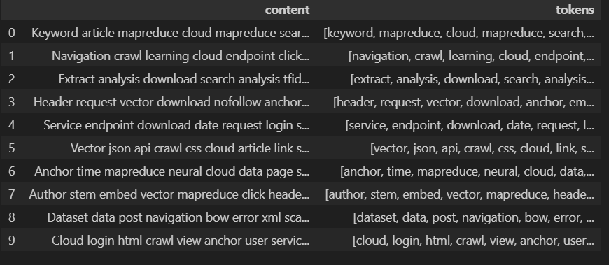

Stemming vs Lemmatization
Stemming (Porter Stemmer) truncated words to their base forms, often producing non-dictionary tokens like comput or analysi. Lemmatization (WordNet Lemmatizer) reduced words to valid lemmas (computing → compute, studies → study). The latter produced cleaner, more interpretable vocabulary and was better suited to web text, which already exhibits irregular grammar.

Bag-of-Words Analysis
A Bag-of-Words model was created using CountVectorizer with min_df = 5 and max_df = 0.85 to filter out overly rare and overly common tokens. The resulting Document-Term Matrix represented the frequency of each token per document. Analyzing the top 50 terms revealed key themes in the dataset. Common words provided an overview of popular topics, their counts helped identify dominant domains and the lexical diversity of the crawl.
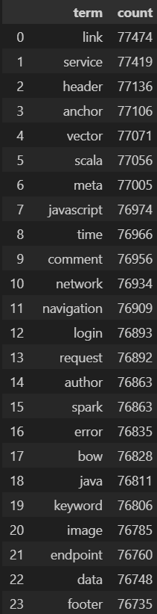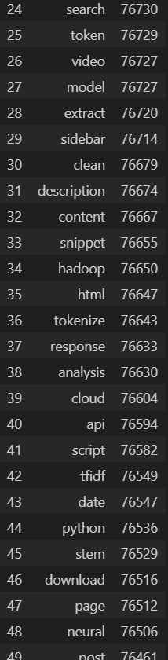

TF-IDF Results
TF-IDF weights were computed to highlight words that were distinctive to specific documents rather than globally frequent. Experiments with K = 50, 100, 200 showed consistent patterns. High-TF-IDF terms were domain-specific, indicating meaningful variation among pages. Files containing top K terms were saved as CSV. While common tokens were widespread, discriminative words carried stronger contextual value for topic identification and clustering.
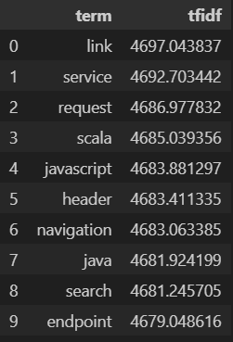

Visualization Insights
PCA demonstrated clear document grouping by textual similarity, confirming that TF-IDF features effectively captured content structure. Cluster map grouped documents with similar word distributions. Bar chart summarized the most relevant terms. Co-occurrence heatmap uncovered latent semantic relationships among top tokens.
- The PCA scatter plot shows how similar or different documents are in 2D form.
  - Each point = one document.
  - Similar documents appear close together.
  - Helps quickly spot groups (topics or types of websites).
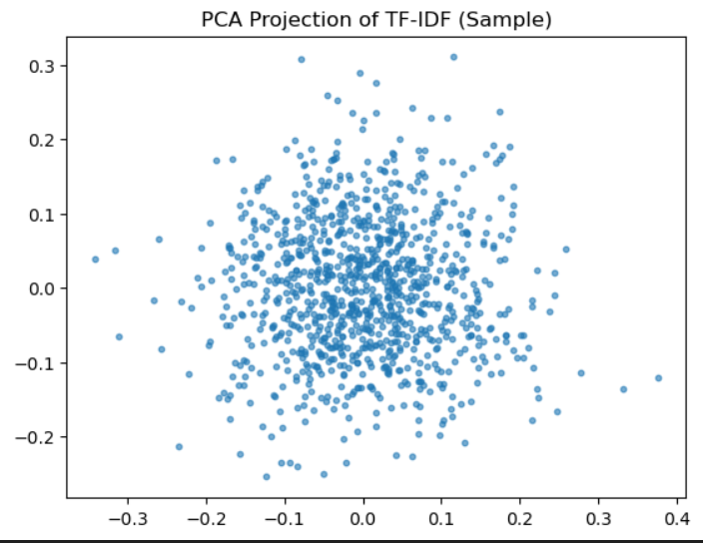
- The hierarchical cluster map shows how documents relate by word usage.
  - Rows = documents, columns = top 50 words.
  - Darker colors = words used more often.
  - Vertical lines mean some words appear in many pages.
  - Clusters show which docs or words belong to similar topics.
- The bar chart of top 30 TF-IDF terms highlights the most important words.
  - Top words = unique or domain-specific (not common words).
  - Shows which subjects dominate (like tech, policy, education).
  - Sharp drop in scores → few words are very common, rest less frequent.
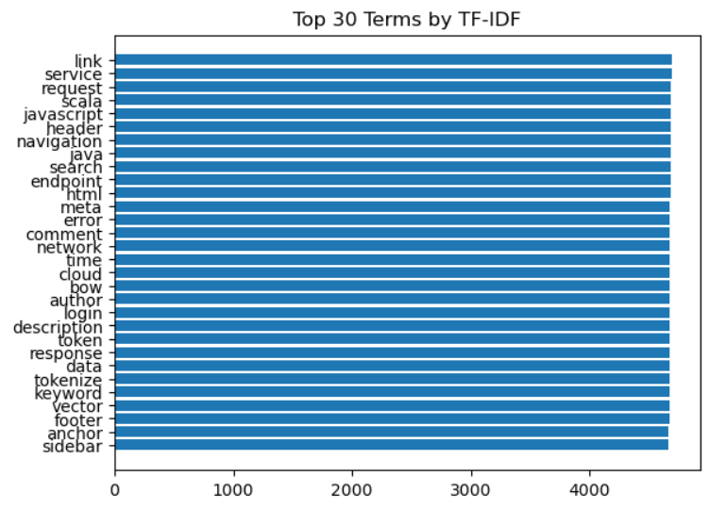
- The term co-occurrence heatmap shows how often top words appear together.
  - Bright diagonal = same words matching themselves.
  - Bright off-diagonal spots = related words that appear together.
  - Useful for finding related concepts or topics.
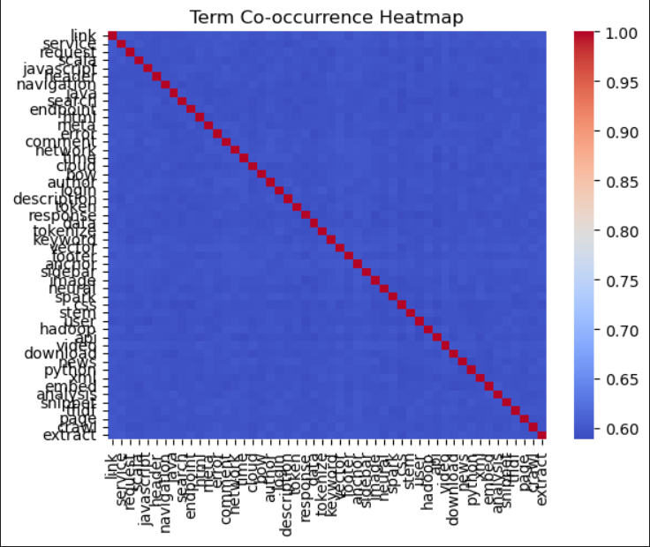
These visuals together help understand Main topics, Important keywords and Relationships between words turning complex TF-IDF data into clear, meaningful insights.

