**PROGRAM FLOW EXPLAINATION**

1. Wait 85ms so DMEM are loaded. Here model ~10 cycles, but in real design, 42500 cycles of 500kHz

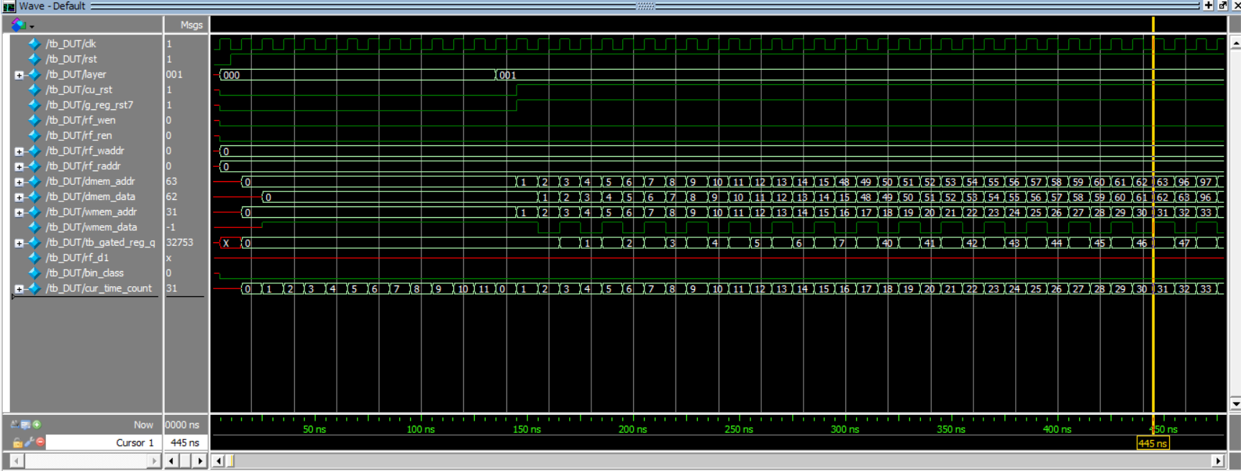

1. Memory

* WMEM [4605:0] access pattern: from 0 to 4605,
* DMEM [1007:0] access pattern: block-of-16 9-bit data, in the cycle of 0 3 6, 1 4 0, 2 5 1, 3 6 2, 4 0 3, 5 1 4, 6 2 5

1. First layer

* Read DMEM for d9, Read WMEM for w
* After each ~60 cycles, we complete the convolution for 1 neuron. Set rf_wen to 1 to write to 84-bit RF, set g_reg_rst to 0 to reset the gated register for new convolution of next neuron.
* Repeat previous step for 48 times

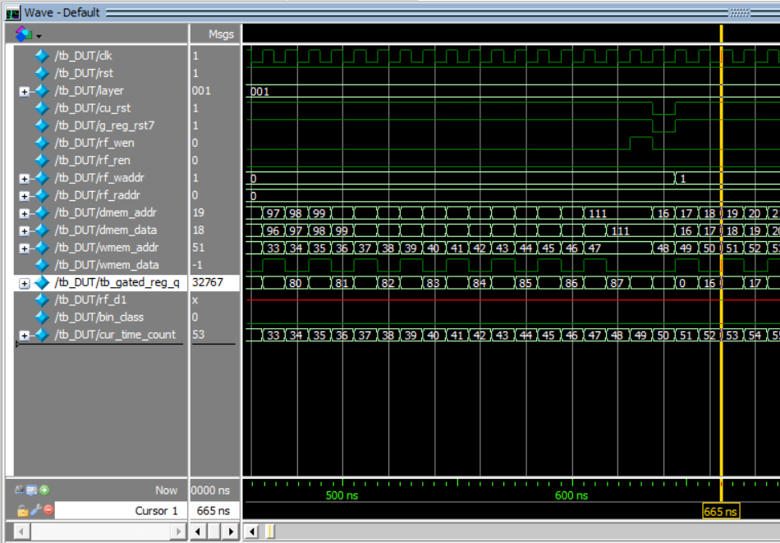

1. Second layer

* Read RF from 0 to 59 for d1
* Repeat step 2 and 3 of first layer, but numbers are 48 and 24

1. Third layer

* Read RF from 60 to 83 for d1
* Repeat step 2 and 3 of first layer, but numbers are 24 and 11

1. Output layer

* Read RF from 0 to 10 for d1
* First half, add to gated register. Second half, subtract from gated register. Note that value at rf_addr = 0 and wmem_addr = 4594 was used for 2 times, but one with lo2 = 0 and one with lo2 =1, thus they will cancel each other.

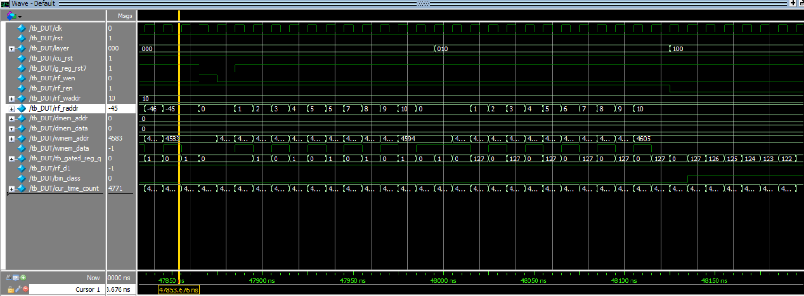

1. Classification
2. Wait for 10ms for the next classification. Repeat step 1 to 6.

