Florida Atlantic University

CEN 4010 Principles of Software Engineering Fall 2019

Milestone 2 GUI Mockup with Balsamiq Tool

**Team Name**

Navigators

**Project Name**

Campus Snapshots

**Team Number**

16

**Students**

Alexandra Solares Ojopi

Dalton McClain

Emmanuel Sowunmi

Jim Brockley

Luis Gustavo Grubert Valensuela

**Documentation Date**

September 21, 2019

**History Table**

|  |  |
| --- | --- |
| **Date** | **Version** |
| 09/21/2019 | 1 |

**First Time Registration**

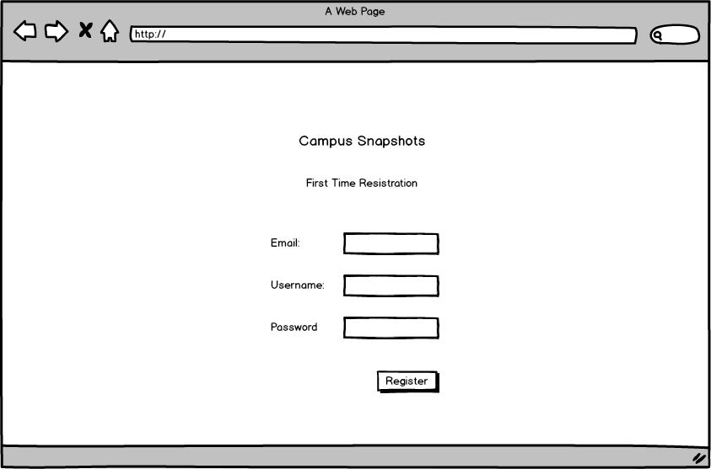

**Login Page**

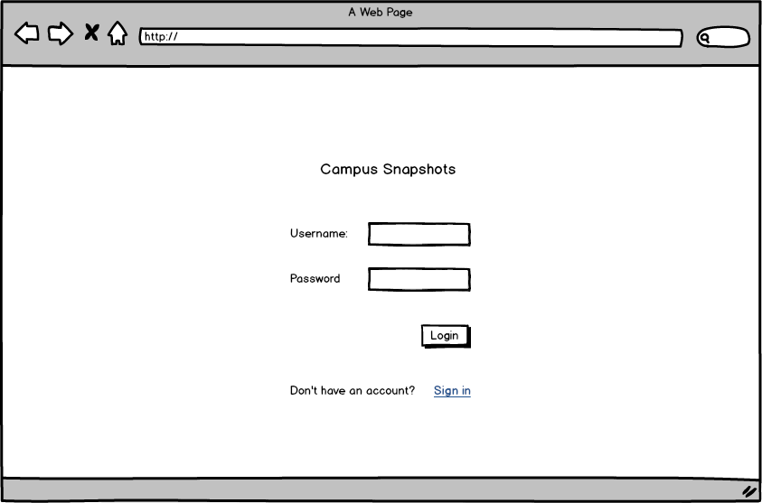

Welcome Page Presentation

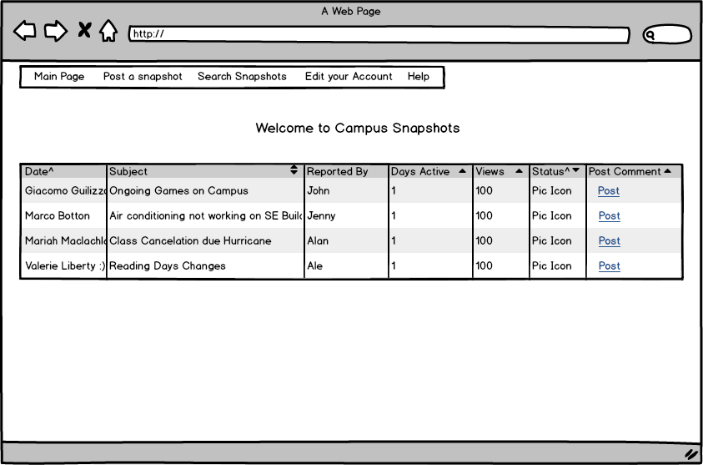

**Search for a post**

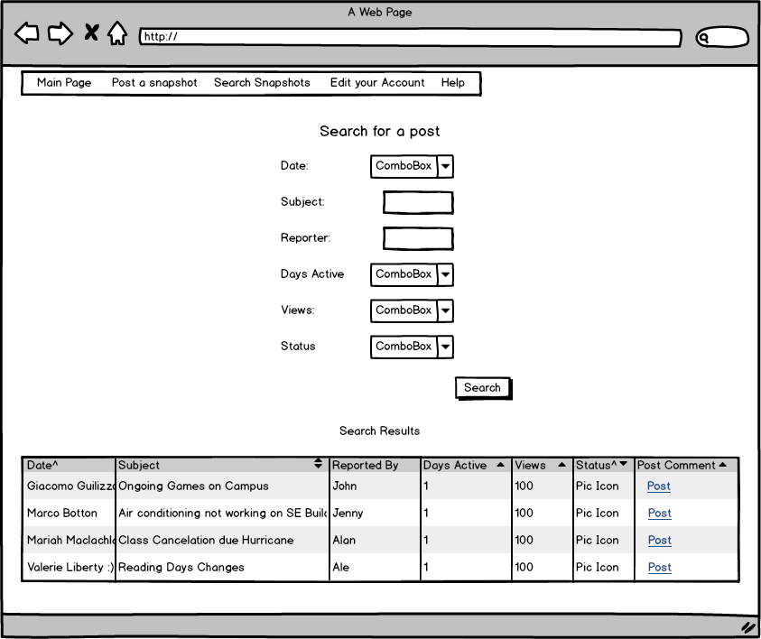

**Search Result**

