+--------------------------------------------------+
| SE223 |
| Assignment 1: Introduction |
| DESIGN DOCUMENT |
+--------------------------------------------------+

---- Information ----

>> Fill in the name and email address of you.

王文茏 <1509563478@qq.com>

---- PRELIMINARIES ----

>> If you have any preliminary comments on your submission, notes for the
>> TAs, or extra credit, please give them here.

>> Please cite any offline or online sources you consulted while
>> preparing your submission, other than the Pintos documentation, course
>> text, lecture notes, and course staff.

HELLO, PINTOS Again
=============

---- DATA STRUCTURES ----

thread.h
……
95 int64_t wake_time;
……
123 void thread_sleep(int64_t ticks);

125 bool sleep_list_short_cmp (const struct list_elem *a,
126 const struct list_elem *b, void *aux);

128 bool ready_list_short_cmp (const struct list_elem *a,
129 const struct list_elem *b, void *aux);

---- ALGORITHMS ----

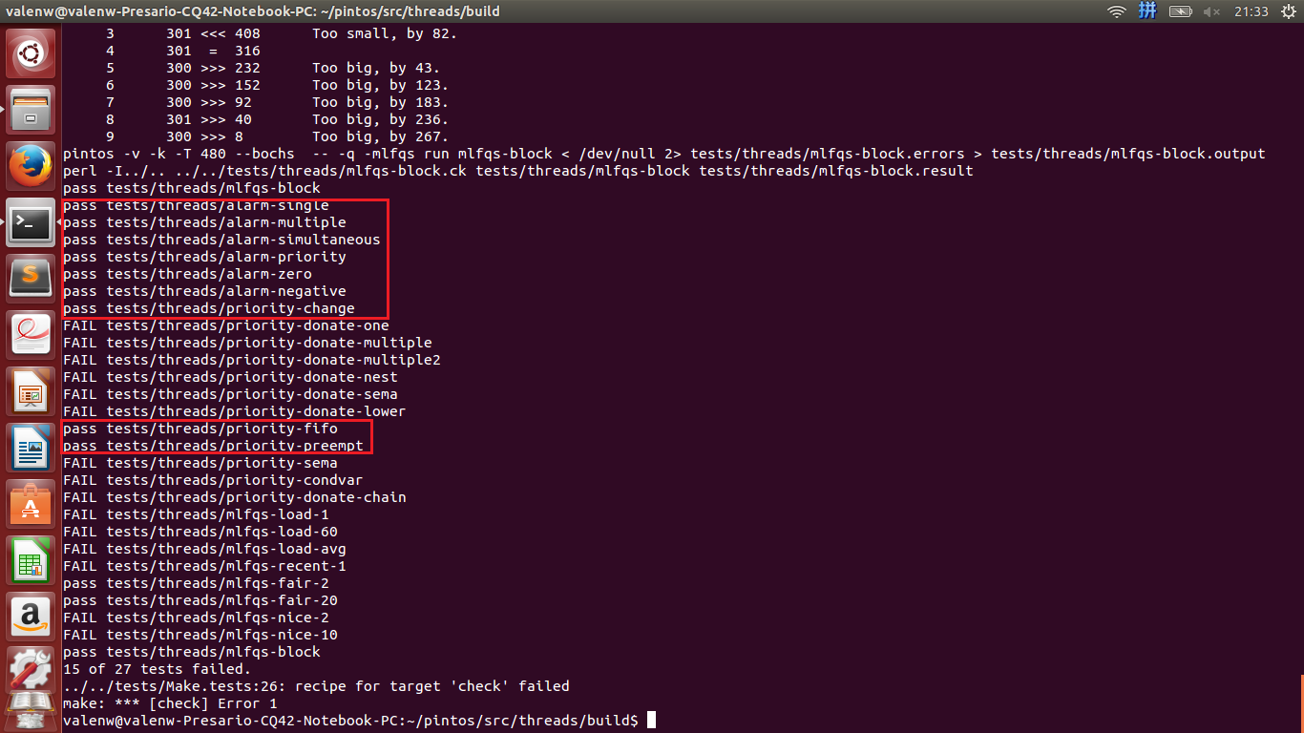

---- Questions -----
>> A2: Describe the sequence of events when a call to thread_create()
>> causes a thread preemption.

首先会通过palloc_get_page为即将创建的进程开拓内存空间并得到内存的地址，然后通过init_thread函数初始化进程，allocate_tid为进程分配tid。之后通过intr_disable无效中断，再通过alloc_frame为进程运行的函数，内核进程和switch_entry分配内存。最后通过thread_unblock将进程加入ready_list中。改进后还会判断该进程和当前正在运行的进程的优先级的高低，如果该进程优先级较高，则会通过thread_yield直接运行该进程。

>> A3: Describe a potential race in thread_set_priority() and explain
>> how your implementation avoids it. Can you use a lock to avoid
>> this race?
当执行thread_set_priority时，有可能在未更改进程的priority前就被中断了，然后又有可能恰巧ready_list中的进程比当前进程优先级高，然后当前的进程就悲催的被yield掉了，但它要更改到的优先级比ready_list中的更高……又有可能反过来，ready_list中的进程比当前进程低，但更改后的当前进程的优先级其实更低……这个问题可以简单的通过无效中断来避免。
设置锁的话意味着每次time_interrupt都要执行lock_acquire()，实现应该还是可以的但有可能性能会降低。

