Procedure Followed for Universal STR Marker Development
1. Genome Collection
Hybrid genome assemblies of four Cyberlindnera jadinii strains (barcode67, barcode68, cuti_ref, and cybja_ref) were obtained in FASTA format.
2. STR Discovery
Each genome was independently screened for STR loci using MISA and Tandem Repeat Finder (TRF). MISA detected perfect microsatellites, whereas TRF identified both perfect and imperfect tandem repeats.
3. Merging and Deduplication of STRs
The STR loci identified by MISA and TRF for each genome were merged into a single dataset. Duplicate loci detected by both programs were removed to generate a non-redundant STR dataset for each genome.
4. Extraction of Flanking Sequences
Approximately 300 bp upstream and 300 bp downstream flanking sequences were extracted for each STR locus. STRs located near contig ends, where complete flanking regions could not be obtained, were excluded from further analysis.
5. Cross-Genome Homology Search
A genome was sequentially used as the query genome, while the remaining three genomes were formatted as BLAST databases. The extracted flanking sequences from the query genome were aligned against each of the three databases using BLASTn. This process was repeated until each of the four genomes had served as the query genome. Only STR loci that produced a single high-confidence orthologous match in all four genomes were retained.
6. Repeat Number Comparison
For each conserved STR locus, the repeat motif and repeat copy number were compared across all four genomes. Loci exhibiting identical repeat numbers in every genome were discarded, while polymorphic loci showing variation in repeat copy number were retained.
7. Polymorphic Information Content (PIC) Analysis
PIC values were calculated for all polymorphic STR loci based on allele frequencies across the four genomes. Markers with higher PIC values were considered to possess greater discriminatory power and were prioritized for primer development.
8. Primer Design
Primer pairs were designed for the selected polymorphic STR loci using Primer3. Conserved flanking regions were used as primer binding sites, while standard primer design parameters, including primer length, GC content, melting temperature, and expected amplicon size, were maintained.
9. Multiple Sequence Alignment of Primer Binding Sites
The primer binding regions were aligned using MAFFT to verify sequence conservation across all four genomes. Only primer pairs with completely conserved binding sites were retained to ensure universal amplification.
10. In Silico PCR Validation
The final primer pairs were evaluated using in silico PCR against all four genome assemblies to verify specific amplification, expected amplicon sizes, and the ability to distinguish strains based on STR length polymorphism.

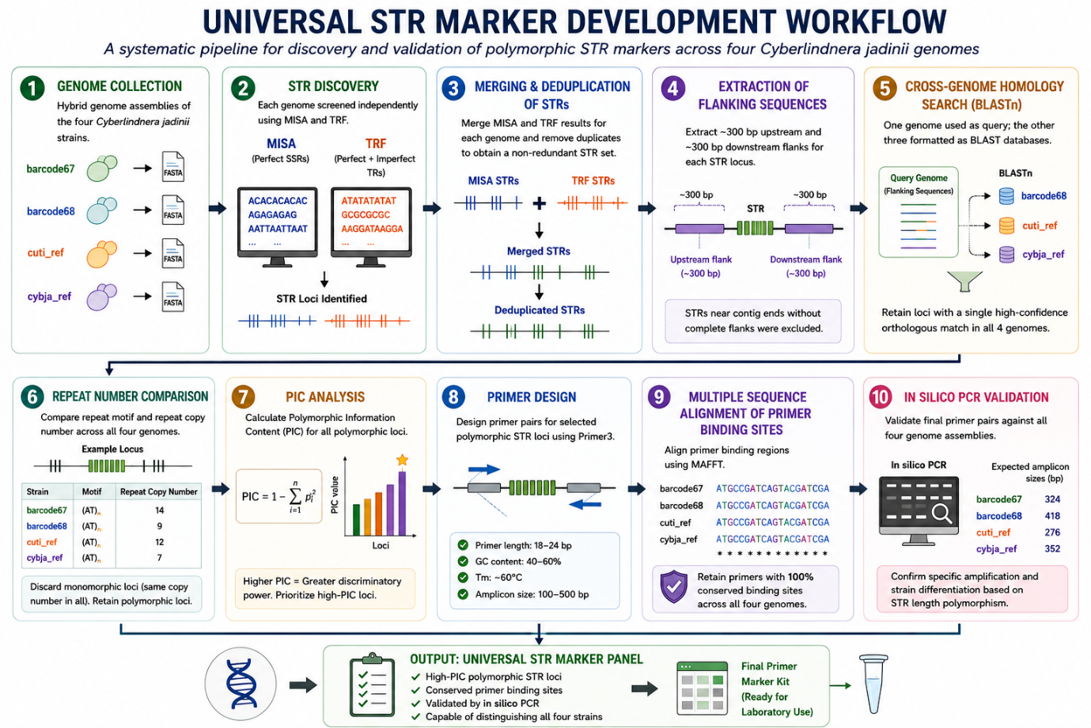

1. Turudić A, Liber Z, Grdiša M, et al. Dig-up Primers: A Pipeline for Identification of Polymorphic Microsatellites Loci within Assemblies of Related Species. Int J Mol Sci. 2024;25(6):3169. doi:10.3390/ijms25063169

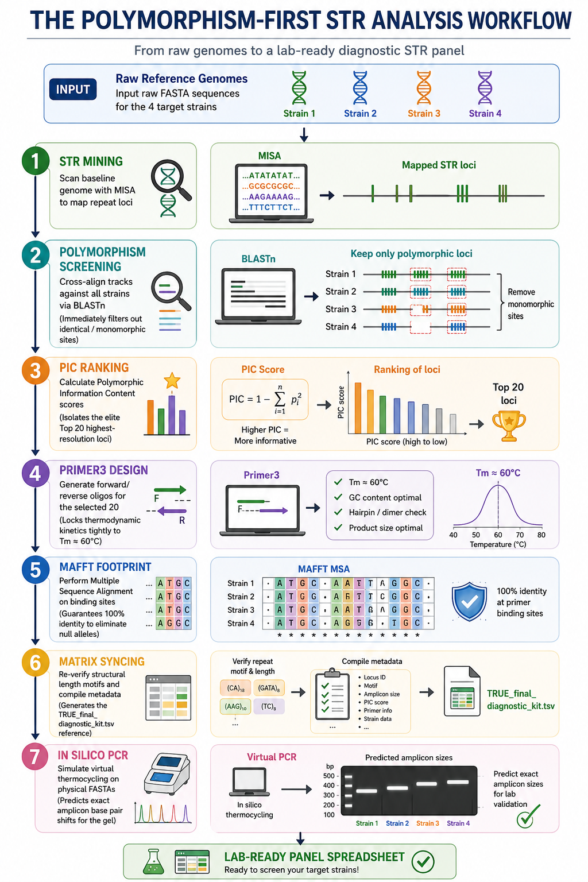
SSR_marker_design/misa.pl at master · cfljam/SSR_marker_design · GitHub

