Hello.

Hello.

Frontend Developer

"Code meets design "

Adetoun Olayemi

My name is

An innovative Front- End Developer with about 3 years’ experience building and maintaining responsive websites. Proficient in HTML, CSS and JavaScript plus, modern libraries and frameworks. Passionate about usability and possess working know ledge Adobe Photoshop.

**Tel**: 07057824862

**Email**: olayemi.toun2@gmail.com

**01.**

**01. EXPERIENCE**

**Jan 2018 - Present**

**Oct 2018 - Present**

**Feb 2014 - Jan 2018**

**Supreme Education Foundation Schools**

**Computer Educator & Database Admin**

Teaching students how to develop websites (HTML5, CSS, JS).

Managing the school’s website

**Tech 9** **Frontend Developer (Remote)**

Converting Mockups to actual code Fetching, Consuming APIs and DOM Manipulation. ReactJS, Angular etc

**New Horizons Instructor/Web Designer**

Web design and Advanced Web development (Using PHP, JavaScript MySQL, JQuery and WordPress)

M C SD Developing in HTML5 with JavaScript and CSS3 using VisualStudio

**02.**

**02.** **EDUCATION**

**2008 - 2012 Bacbcock University**

**Department of Computer Science**

Bachelor of Science - Computer Science

|  |  |
| --- | --- |
| **2002 - 2008** | **Mater Christi Girls High School** |

WASSCE / NECO - Sciences

**03.**

03. **TECHNOLOGIES**

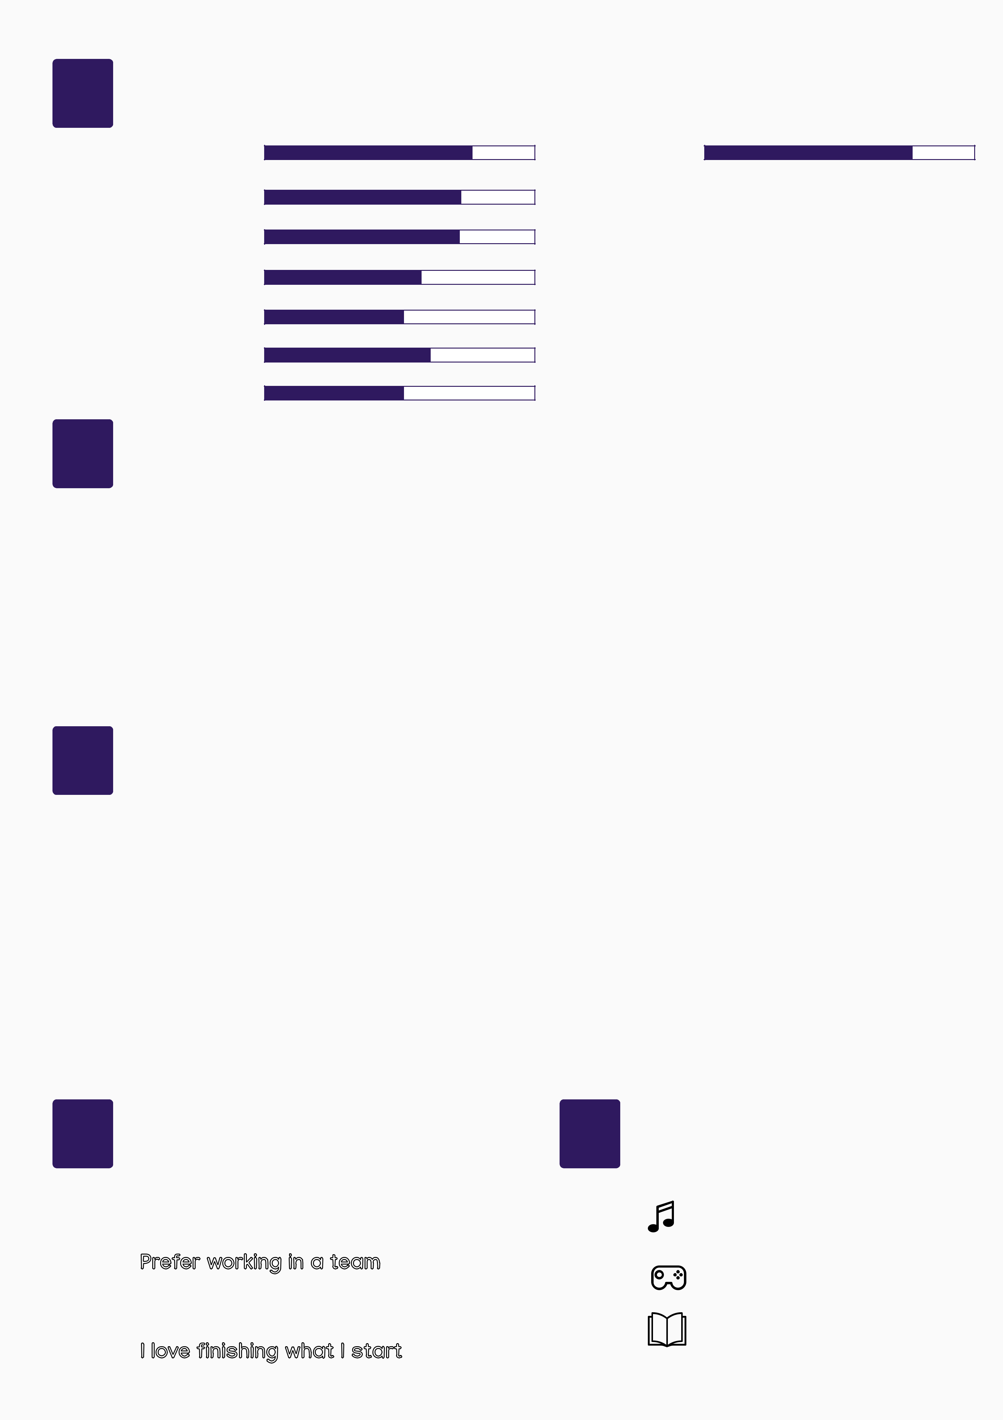

**HTML5 JQuery**

**CSS 3 AngularJs**

**JS VueJs**

**ReactJS GIT**

**04.**

04. **LEARNING**

**Python**

**Ruby**

**Node JS**

**Mongo DB**

**05.**

**PROJECTS**

**Four Card Feather Section**

https://valenteeena.github.io/project2/index.html

**Base Apparel Coming Soon Page**

https://valenteeena.github.io/Project%201/index.html

**Pricing Component with Toggle**

https://valenteeena.github.io/project6/index.html

**Project Tracking Intro Component**

https://valenteeena.github.io/project3/index.html

**APIN Health portal**

<https://jobapplication.apin.org.ng/application/index.php>

**Orion Invest**

<https://orioninvest.netlify.app>

**06.**

**07.**

05. **ATTITUDE** 07. **INTEREST**

|  |  |
| --- | --- |
| **Always willing to Learn** | Blog Icon PNG Images, Free Transparent Blog Icon Download - KindPNGOpen Vintage Book Drawn Clipart - Png Book Reading Icon Transparent Png -  Full Size Clipart (#1305079) - PinClipart **Music Addict** |
| **Prefer working in a team** |  |
| **Emotionally Intelligent** | **Reading** |
| **love finishing what I start** |  |
|  | **Blogging** |