Readings 1 : Some considerations on Data, information, and knowledge

Table of Contents
Introduction 1
The nature of data 2
The data analysis process 3
The problem 3
Data preparation 4
Data exploration 4
Predictive modeling 4
Visualization of results 5
Quantitative versus qualitative data analysis 5
Importance of data visualization 5
What about big data? 6
Sensors and cameras 7
Social networks analysis 8

Introduction

Data are facts of the world. For example, financial transactions, age, temperature, number of steps from my house to my office, are simply numbers. The information appears when we work with those numbers and we can find value and meaning. The information can help us to make informed decisions.

We can talk about knowledge when the data and the information turn into a set of rules to assist the decisions. In fact, we can't store knowledge because it implies theoretical or practical understanding of a subject. However, using predictive analytics, we can simulate an intelligent behavior and provide a good approximation. An example of how to turn data into knowledge is shown in the following figure:

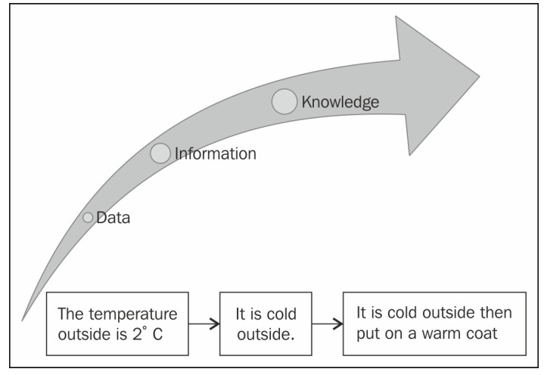

The nature of data

Data is the plural of datum, so it is always treated as plural. We can find data in all the situations of the world around us, in all the structured or unstructured, in continuous or discrete conditions, in weather records, stock market logs, in photo albums, music playlists, or in our Twitter accounts. In fact, data can be seen as the essential raw material of any kind of human activity.

According to the Oxford English Dictionary:
Data are known facts or things used as basis for inference or reckoning.

As shown in the following figure, we can see Data in two distinct ways: Categorical and Numerical.

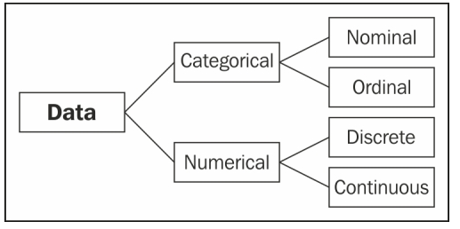
Categorical data are values or observations that can be sorted into groups or categories. There are two types of categorical values, nominal and ordinal. A nominal variable has no intrinsic ordering to its categories. For example, housing is a categorical variable having two categories (own and rent). An ordinal variable has an established ordering. For example, age as a variable with three orderly categories (young, adult, and elder).

Numerical data are values or observations that can be measured. There are two kinds of numerical values, discrete and continuous. Discrete data are values or observations that can be counted and are distinct and separate. For example, number of lines in a code. Continuous data are values or observations that may take on any value within a finite or infinite interval. For example, an economic time series such as historic gold prices.

The kinds of datasets used in our lessons are as follows:
- E-mails (unstructured, discrete)
- Social media friends and relationships (unstructured, discrete)
- Tweets and trending topics (unstructured, continuous)
- Sales records (structured, continuous)

The data analysis process

When you have a good understanding of a phenomenon, it is possible to make predictions about it. Data analysis helps us to make this possible through exploring the past and creating predictive models.

The data analysis process is composed of the following steps:
- The statement of problem
- Obtain your data
- Clean the data
- Normalize the data
- Transform the data
- Exploratory statistics
- Exploratory visualization
- Predictive modeling
- Validate your model
- Visualize and interpret your results
- Deploy your solution

All these activities can be grouped as shown in the following figure:

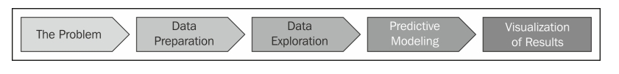

The problem

The problem definition starts with high-level questions such as how to track differences in behavior between groups of customers, or what's going to be the gold price in the next month. Understanding the objectives and requirements from a domain perspective is the key to a successful data analysis project.

Types of data analysis questions are listed as follows:
- Inferential
- Predictive
- Descriptive
- Exploratory
- Causal
- Correlational

Data preparation

Data preparation is about how to obtain, clean, normalize, and transform the data into an optimal dataset, trying to avoid any possible data quality issues such as invalid, ambiguous, out-of-range, or missing values. This process can take a lot of your time. Analyzing data that has not been carefully prepared can lead you to highly misleading results.

The characteristics of good data are listed as follows:
- Complete
- Coherent
- Unambiguous
- Countable
- Correct
- Standardized
- Non-redundant

Data exploration

Data exploration is essentially looking at the data in a graphical or statistical form trying to find patterns, connections, and relations in the data. Visualization is used to provide overviews in which meaningful patterns may be found.

Predictive modeling

Predictive modeling is a process used in data analysis to create or choose a statistical model trying to best predict the probability of an outcome.

Another important task we need to accomplish in this step is evaluating the model we chose to be optimal for the particular problem.
The No Free Lunch Theorem proposed by Wolpert in 1996 stated:

"No Free Lunch theorems have shown that learning algorithms cannot be universally good."

The model evaluation helps us to ensure that our analysis is not over-optimistic or over-fitted.

Visualization of results

This is the final step in our analysis process and we need to answer the following questions:

How is it going to present the results?
For example, in tabular reports, 2D plots, dashboards, or infographics.

Where is it going to be deployed?
For example, in hard copy printed, poster, mobile devices, desktop interface, or web.

Each choice will depend on the kind of analysis and a particular data.

Quantitative versus qualitative data analysis

Quantitative and qualitative analysis can be defined as follows:
- Quantitative data: It is numerical measurements expressed in terms of numbers
- Qualitative data: It is categorical measurements expressed in terms of natural language descriptions

As shown in the following figure, we can observe the differences between quantitative and qualitative analysis:

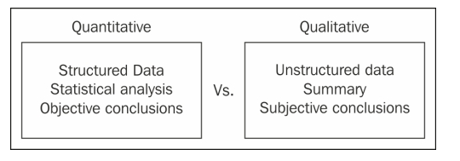
Quantitative analytics involves analysis of numerical data. The type of the analysis will depend on the level of measurement. There are four kinds of measurements:

- Nominal: Data has no logical order and is used as classification data
- Ordinal: Data has a logical order and differences between values are not constant
- Interval: Data is continuous and depends on logical order. The data has standardized differences between values, but does not include zero
- Ratio: Data is continuous with logical order as well as regular interval differences between values and may include zero

Qualitative analysis can explore the complexity and meaning of social phenomena. Data for qualitative study may include written texts (for example, documents or email) and/or audible and visual data (for example, digital images or sounds).

Importance of data visualization

The goal of the data visualization is to expose something new about the underlying patterns and relationships contained within the data. The visualization not only needs to look good but also meaningful in order to help organizations make better decisions. Visualization is an easy way to jump into a complex data set (small or big) to describe and explore the data efficiently.
Many kinds of data visualizations are available such as bar chart, histogram, line chart, pie chart, heat maps, frequency Word (as shown in the following figure) and so on, for one variable, two variables, and many variables in one, two, or three dimensions.

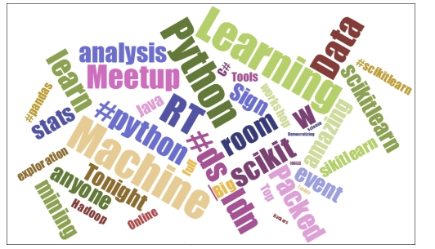
Data visualization is an important part of our data analysis process because it is a fast and easy way to do an exploratory data analysis through summarizing their main characteristics with a visual graph.

The goals of exploratory data analysis are listed as follows:
- Detection of data errors
- Checking of assumptions
- Finding hidden patterns (such as tendency)
- Preliminary selection of appropriate models
- Determining relationships between the variables

What about big data?

Big data is a term used when the data exceeds the processing capacity of typical database. We need a big data analytics when the data grows quickly and we need to uncover hidden patterns, unknown correlations, and other useful information.

There are three main features in big data:

- Volume: Large amounts of data
- Variety: Different types of structured, unstructured, and multi-structured data
- Velocity: Needs to be analyzed quickly

As shown in the following figure, we can see the interaction between the three Vs

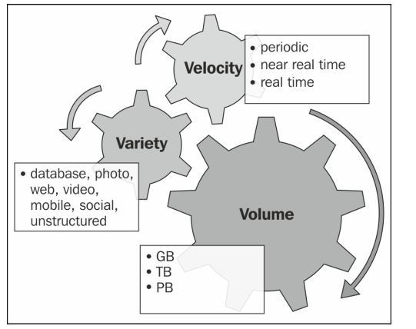
Big data is the opportunity for any company to gain advantages from data aggregation, data exhaust, and metadata. This makes big data a useful business analytic tool, but there is a common misunderstanding about what big data is.

The most common architecture for big data processing is through MapReduce , which is a programming model for processing large datasets in parallel using a distributed cluster.

One of the main challenges for big data is how to store, protect, backup, organize, and catalog the data in a petabyte scale. Another main challenge of big data is the concept of data ubiquity. With the proliferation of smart devices with several sensors and cameras the amount of data available for each person increases every minute. Big data must process all this data in real time.

Sensors and cameras

Interaction with the outside world is highly important in data analysis. Using sensors such as RFID (Radio-frequency identification) or a smartphone to scan a QR code (Quick Response Code) is an easy way to interact directly with the customer, make recommendations, and analyze consumer trends.
On the other hand, people are using their smartphones all the time, using their cameras as a tool. This can be used, for example, in face recognition or to find reviews of a restaurant just by taking a picture of the front door.
The interaction with the real world can give you a competitive advantage and a real-time data source directly from the customer.

Social networks analysis

Formally, the SNA (social network analysis) performs the analysis of social relationships in terms of network theory, with nodes representing individuals and ties representing relationships between the individuals, as we can see in the following figure. The social network creates groups of related individuals (friendship) based on different aspects of their interaction. We can find important information such as hobbies (for product recommendation) or who has the most influential opinion in the group (centrality).

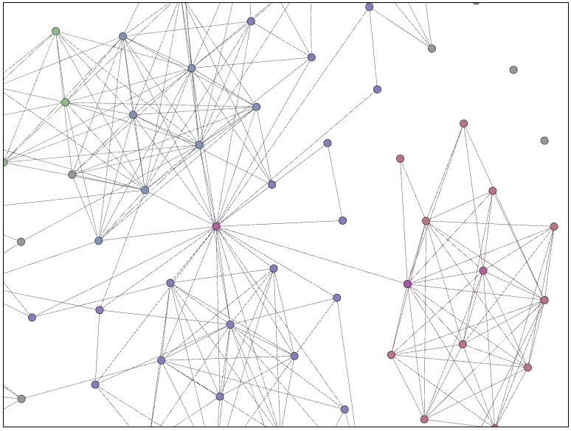
Social networks are strongly connected and these connections are often not symmetric. This makes the SNA computationally expensive, and needs to be addressed with high-performance solutions that are less statistical and more algorithmic.

The visualization of a social network can help us to get a good insight into how people are connected. The exploration of the graph is done through displaying nodes and ties in various colors, sizes, and distributions.

Practical Data Analysis, Hector Cuesta, Packt Pulishing 2013

