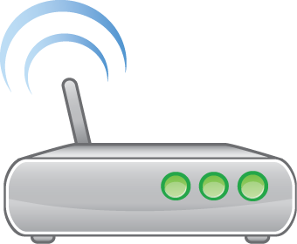
A
Internet
Client (Privé)
Serveur (DMZ)
164.42.128.3/17
164.42.128.0/17
164.42.0.3/17
164.42.0.0/17
212.212.212.2/24

