**Vanier College**

**Computer Science Department**

**Intro to Computer Science (420-121-VA)**

**Fall 2020**

**Lab/Assignment Number and Title: 03**

**Submitted by**

**Student Name: Valentin Georgiev**

**Student ID: 2083910**

**Table of content**

Summary…………………………………………………………………………………………………………3

August and legend…………………………………………………………………………………………..4

September………………………………………………………………………………………………………5

October……………………………………………………………………………………………………………6

November……………………………………………………………………………………………………….7

December……………………………………………………………………………………………….………8

LAB03: My study plan

In this document, I will create a study plan for this semester in a table which has to contain all the important dates for this semester.

The courses that I am taking are:

* Math concepts
* Programming 1
* Intro to computer science
* Game programming 1
* Le journal personnel (French)
* Introduction to college English

August

|  |  |  |  |  |  |  |
| --- | --- | --- | --- | --- | --- | --- |
| Sun | Mon | Tue | Wed | Thu | Fri | Sat |
| 23 | 24 | 25 | 26 | 27 | 28 | 29 |
| 30 | 31 |  |  |  |  |  |

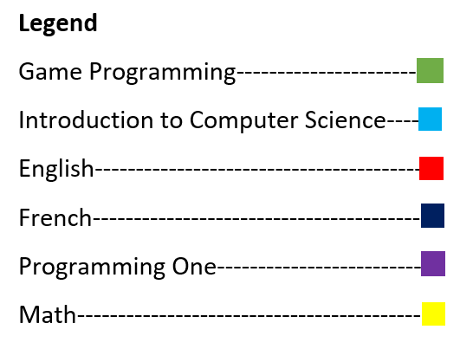

September 2020

|  |  |  |  |  |  |  |
| --- | --- | --- | --- | --- | --- | --- |
| Sun | Mon | Tue | Wed | Thu | Fri | Sat |
|  |  | 1 | 2 | 3 | 4 | 5 |
| 6 | 7 | 8 | 9 | 10 | 11 | 12 |
| 13 | 14 | 15 | 16 | 17 | 18  Lab03-Word and Git  Lab1  Text”Boy” | 19 |
| 20 | 21  System of equation (HW) | 22  Conprehension  de lecture | 23  Assignment : Flowcharts  Exam 1 | 24 | 25 | 26 |
| 27 | 28  Word Essay  500 word | 29 | 30 |  |  |  |

October 2020

|  |  |  |  |  |  |  |
| --- | --- | --- | --- | --- | --- | --- |
| Sun | Mon | Tue | Wed | Thu | Fri | Sat |
|  |  |  |  | 1 | 2 | 3 |
| 4 | 5  Vector (HW)  Exam 1(Week 6) | 6  TP1 | 7 | 8 | 9 | 10 |
| 11 | 12 | 13  Test 1 | 14 | 15 | 16 | 17 |
| 18 | 19 | 20  TP2 | 21 | 22 | 23 | 24 |
| 25 | 26 | 27 | 28 | 29 | 30 | 31 |

November 2020

|  |  |  |  |  |  |  |
| --- | --- | --- | --- | --- | --- | --- |
| Sun | Mon | Tue | Wed | Thu | Fri | Sat |
| 1 | 2  Test 2( week 10) | 3  compréhension de l’écrit | 4 | 5 | 6 | 7 |
| 8 | 9 | 10 | 11 | 12 | 13 | 14 |
| 15 | 16  Exam 2(Week 12) | 17  création littéraire | 18  Grammar Quiz | 19 | 20 | 21 |
| 22 | 23 | 24 | 25 | 26 | 27 | 28 |
| 29 | 30 |  |  |  |  |  |

December 2020

|  |  |  |  |  |  |  |
| --- | --- | --- | --- | --- | --- | --- |
| Sun | Mon | Tue | Wed | Thu | Fri | Sat |
|  |  | 1 | 2 | 3 | 4 | 5 |
| 6 | 7  Test 3 (Week 15) | 8  expression de l’écrit | 9  Team Project(End of the term) | 10 | 11 | 12 |
| 13 | 14 | 15  Test 2 | 16  750-word analytical essay on poetry | 17 | 18 | 19 |
| 20 | 21 | 22 | 23 | 24 | 25 | 26 |
| 27 | 28 | 29 | 30 |  |  |  |