Automatic Backup
Version 1.9

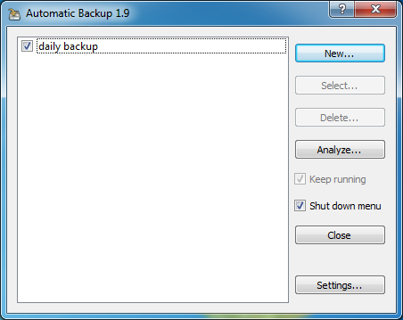
© 2012-2013 Valentin Illich
Valentin.Illich@web.de
Contents
1 Introduction 3
1.1 The Automatic Backup concept 3
1.2 Backup configurations 3
1.3 Dealing with removable media 3
1.4 Dealing with moved files inside the source 4
1.5 Verifying the files in the backup 4
2 Automatic Backup reference 5
2.1 The main dialog 5
2.1.1 The main dialog buttons 5
2.1.2 The main dialog checkmarks 6
2.2 The operating modes 6
2.2.1 Startup mode 6
2.2.2 Background mode 7
2.2.3 Shutdown mode 8
2.3 The backup configuration dialog 9
2.3.1 The Settings tab 9
2.3.2 The Options tab 10
2.3.3 The Maintenance tab 11
3 The file system analyzer 13
4 Filter Conditions 16
4.1 Getting started with filters 16
4.2 Filter examples 17
4.3 Complete filter syntax diagram 18

Introduction
The Automatic Backup tool is intended for users who want to have a small application which can copy changed files out of a source directory to a destination. Most people want this process to be automated by the tool. In contrast to several backup solutions available around the world, this tool does not consume large memory, does not slow down start up and does not consume any CPU load if specified to run a backup in the background.

The Automatic Backup concept
Automatic backup is a tool which is intended to be executed in the auto start. After installation, it runs in the so called “Startup mode” and shows a little start up message box which will dismiss after 5 seconds:

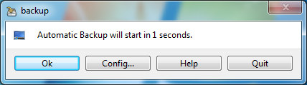
The default operation if no button is pressed will be to check the configured backups whether one has to be executed. This is the same as if the “OK” button is pressed. The “Quit” button allows a user to cancel the process, the tool will be quit without any action.
Pressing the “Config” button results in opening the main dialog where the operation mode can be changed and different backup configurations can be maintained.

Backup configurations
A backup configuration is a set of a source directory (where the original files are) and a destination directory (where they should be copied). Each configuration has some additional properties like “automatic execution” and its time interval or the “compress” option. Each configuration is independent from each other and has its own time stamp of the last execution.
A user can specify a backup not to be executed automatically, this makes sense if the destination is a quite slow medium and the user wants do the backup at an exact time. Such a configuration may be executed manually out of the main dialog after pressing “Config” in the start up box.

Dealing with removable media
The main purpose for a backup process is to copy the data onto an external medium which normally will be an USB stick or an external hard disk. The concept of Automatic Backup here is quite simple: If a backup configuration has to be executed and the source or destination directory is not found, the tool assumes that the given path is a removable medium. Then it shows a message box declaiming this and waits for the destination path to become available. Of course, this message box may be canceled and the backup configuration is stopped.
Everyone who has already been angry about the fact, that USB sticks sometimes get different drive letters on subsequent usage gets a good message here: Automatic backup will check for the destination directory not only in the original given drive but also in all possible drives which are available. The only thing a user has to take into account is that each destination directory on a removable media should start with a unique name in the root.

Dealing with moved files inside the source
Every time when the backup tool creates a new directory in the destination path, it will automatically scan all files in the destination path. If files with same name and size are found in different locations, their counterpart in the source path are checked. All files with a source equivalent are always kept in the destination. For the rest, only the newest file without a source equivalent is kept in the destination.
This method ensures that at least one instance of each file in the backup is kept. Doing the duplicate check only upon new directories is a good compromise between execution speed and backup size.

Verifying the files in the backup
On manual execution, a verify of all files inside the backup is done at the end of the process. Verifying is done by building up a checksum over the complete file and comparing against the checksum of the last verify run. When doing backups automatically, the verify process will be executed according to following table.
Backup interval | Verify interval
Daily | Weekly
Weekly | Monthly
2 weeks | Monthly
Monthly | Quarter of year
Quarter of year | Half a year
Yearly | Yearly

This method insures that each file will be completely read out of the backup storage medium and problems with the backup storage will be recognized early.

Dealing with long backup times
One method for dealing with long execution times is the shutdown mode of the Automatic Backup tool. With this mode, execution is done without further interaction of the user and after that the PC is shut down automatically.
In addition for this, the user can specify a maximum execution time for a backup configuration. If this time is reached, the backup will be suspended until next (automatic) execution where all remaining files will be copied / checked / verified. In case of automatic execution, the interval timer will not be reset when suspending a backup.
With this feature, a backup storage may be driven by a power timer, for example powering off after 2 hours. Backups may be done in shutdown mode with a total suspend time for all backup configurations of not more than 3 ½ hours.

Automatic Backup reference
This chapter explains the user interface and the functionality behind it.

The main dialog

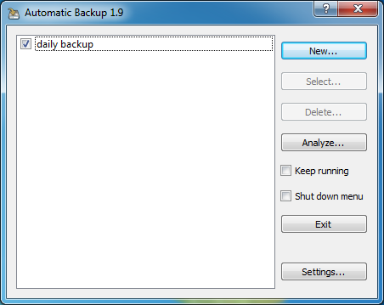

The main dialog has a list of all backup configurations on the left hand side. On the right hand side, some buttons reside which allow the handling of the backup configurations.
Please note that the function and state of these buttons depends on the amount of selected items inside the list – this keeps the user interface simple and easy.
- If no item is selected, a new configuration can be created or the file system analyzer can be opened
- If one item is selected, this backup configuration may be edited, deleted or cleaned up directly.
- If more than one item is selected, these backups can be executed directly.

The main dialog buttons

“New” creates a new, empty backup configuration in the list.
“Select/Execute” opens the settings dialog of the selected configuration / executes the selected configurations directly.
“Delete” removes the selected configuration from the list
“Analyze/Cleanup” allows the user to analyze a given starting directory. Please refer to an own chapter in this documentation.
While a backup configuration is selected, this button allows a direct analysis of files which are no longer in the backup but older than a given date. These files may be deleted interactively from within the context menu.
“Exit/Close” in Startup mode, quits the tool. In the other modes, closes the configuration dialog and shows the tool icon again.
“Settings” allows the user to change some basic settings of the tool. The settings menu is shown with following entries:
“Change Config file” allows the user to change name and location of the tool configuration file which is used to store all backup configurations. The default is “backup.cfg”, located in the current useres home directory. Normally, this should not be changed.
“Change log file” allows the user to change name and location of the tool log file which is used in debug mode when creating a new backup configuration. The default is “backup.log”, located in the current useres home directory. Normally, this should not be changed.
“'keep running' icon position” selects the screen corner for the disk icon in background and shutdown mode. The default poistion is the lower left corner.

The main dialog checkmarks

“Keep running” if this checkmark is off, the Automatic backup tool runs in “Startup mode”. If it is set to on, the Automatic backup tool runs in “Background mode”.
“Shut down menu” if this checkmark is on, the Automatic Backup tool runs in “Shutdown mode”.

The operating modes

Startup mode
This mode is the default operation mode after installation. Its the most simple to use mode. During the login process, the tool is executed in the auto start section. The tool automatically checks for pending backups and executes them. After executing these backups, it automatically quits. The initial dialog allows the user to skip the backup process for this time, but the tool will come op again during the next login. Its main dialog configuration shows like this:

Background mode
The Background mode allows using this tool if the system never gets shut down but instead of this will be put into sleep. Then the tool does not quit if the main dialog is closed. Instead a little disk symbol which is on top of all other windows is shown in the selected screen corner. A context menu inside this symbol allows the user to quit the tool or to open the main dialog again. In this state, the Automatic Backup tool will check for execution of backups every hour.
When a backup has to be executed, the tool will copy the changed files in the background, that means it will decrease its CPU load and hard disk activity. The progress window of the backup will be sized down and shown in the same corner like the disk symbol. The tooltip of the progress window will be updated continuously so that the current action may be seen. The main dialog of the background mode shows like this:

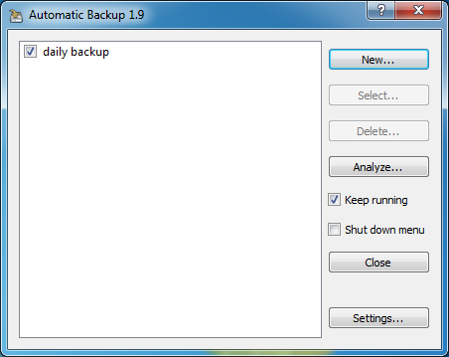

Shutdown mode
The Shutdown mode allows using this tool if the configured backups are running for a longer time or if the user does not accept the delay during the login process in the Startup mods. In this mode, the tool does not quit if the main dialog is closed. Instead a little disk symbol which is on top of all other windows is shown in the selected screen corner. A context menu inside this symbol allows the user to execute all pending backups before the system is shut down or to open the main dialog again. In this state, the Automatic Backup tool will give a warning when it is quit without using the shutdown menu entry. Its main dialog shows like this:
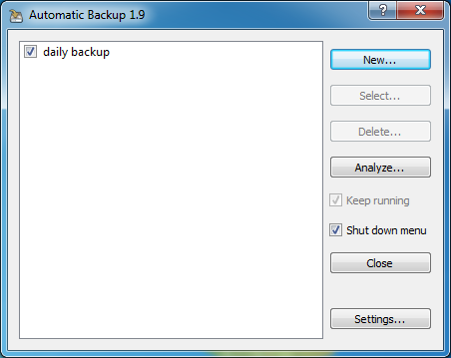

The backup configuration dialog
Selecting a backup in the main dialog will open the configuration dialog for this backup. This dialog contains all settings which may be changed for the backup. It has three tabs.
In the lower part, there is the progress bar for execution and the buttons “Execute” (for immediate execution) and “OK” which closes the configuration dialog and saves all settings.

The Settings tab
This tab contains the basic settings for the current backup: The description which is shown in the main dialog and which is used in the logging.

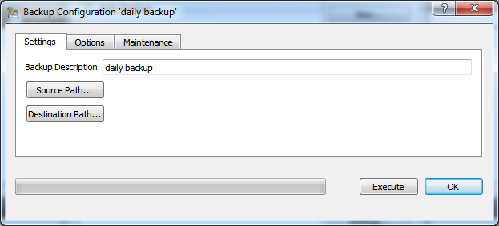
“Source Path” is the directory which contains the original files.
“Destination Path” is the directory which contains the copies of the files.

The Options tab
This tab contains all settings which have to do with the execution of the current backup.

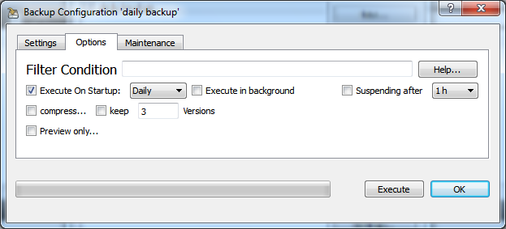
“Filter Condition” optionally contains information about files or folders which should be excluded from the backup configuration. For example, a user normally doesn't want that disk images are copied into the backup directory. For a more detailed explanation, please refer to the chapter Filter Conditions.
“Help...” opens a detailed description of the filter syntax. For a more detailed explanation, please refer to the chapter Filter Conditions
“Execute On Startup” If checked, this backup will be executed every time the Automatic Backup checks for pending backups and the given time period is elapsed since the last execution.
“Execute in background” If checked, the backup will be executed in background mode for this time if “Execute” is pressed. This setting may be useful when having a backup configuration which needs some time for execution and you don't want the computer to be blocked (see above).
“Suspending after” If checked, this backup will execute no longer than the given maximum time. All remaining copy actions, finding of duplicates or verify operations will be done on the next execution time. The interval for automatic execution will not be reset after a suspend.
“Compress” If checked, all files in the backup will be compressed. The file names int the backup directory keep the same like the originals but they will get an extra underscore sign '_'.
“Keep” If checked, more than one version of an original file are kept in the backup directory. The file names int the backup directory keep the same like the originals but they will get an extra extension which shows the creation time stamp of them. The amount of versions to be kept is given in the “versions” input field.
“Preview” If checked, no files will be copied on execution. Instead of this, a detailed logging will be shown what would happen on a real execution. Use this if you are developing filter conditions and want to be sure that everything goes right.

The Maintenance tab
This tab contains all settings and operating elements which are used to maintain the current backup. Mainly restoring (compressed) files and folders and cleaning up the contents of the destination directory have to be mentioned here.

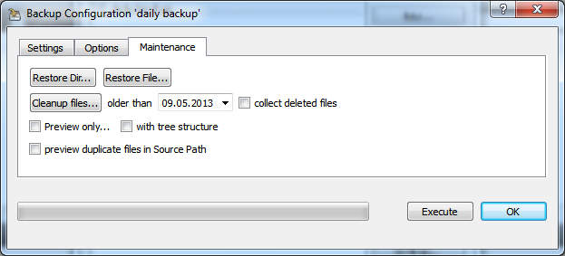
“Restore Dir” copies back the (possibly compressed) contents of a selected directory inside the destination directory into its counterpart of the source directory.
“Restore File” copies back a (possibly compressed) selected file inside the destination directory and replaces its counterpart in the source directory.
“Cleanup Files” will delete all files in the destination directory of the current backup which are older than the given time span and which don't have a counterpart in the source directory any longer. After that, the backup tool searches for duplicate files in the destination directory and automatically removes the older versions of them. This is useful for keeping the backup path clean after changing the source directory structure.
Please note that an interactive method of cleaning up directories is given in the main dialog.
“Collect Deleted Files” If checked, all files which have to be deleted upon “Cleanup” will be stored inside a separate destination path before deleting them. The path will be asked before cleanup is running.
“Preview Only...” If checked, no action will be done upon cleaning up. Instead of this, a logging will be shown with detailed information what would happen on a real clean up.
“With Tree Structure” If checked, not only a summary for the deletion process will be shown but also a detailed information about the scanned sub directories.
“Preview Duplicates” If checked in conjunction with “Preview Only”, the destination will be scanned for duplicate files which will be listed in the preview, too.

The file system analyzer
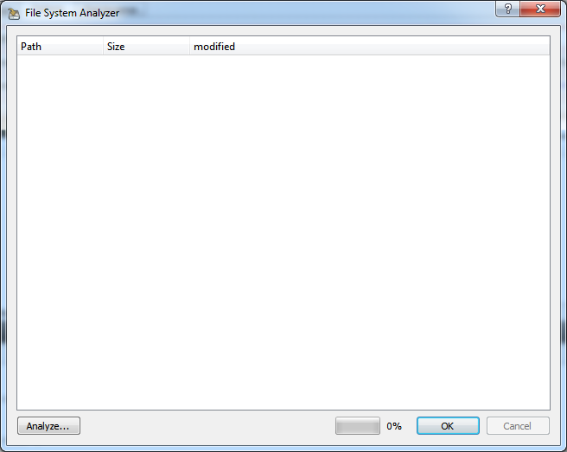
With the file system analyzer, the user has a powerful tool for finding out where space of his hard disk is lost. He can start an analysis as often as needed, every time starting in another directory or / and selecting another limit for the modification date.
After selecting a starting directory, the user is asked for the last modification date the files should have to be listed in the tree view. If this dialog is aborted with the “Cancel” button or the ESC key, then all files will be listed. The selection dialog of the date has some additional buttons for quick selection of a desired date:

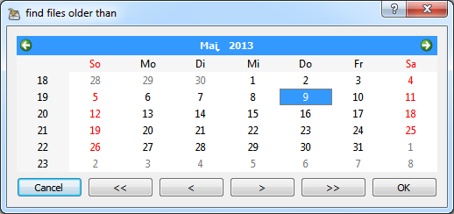
“<<” Select the previous year
“>>” Select the next year
“<” Select the previous month
“>” Select the next month

Of course, the built in mechanism of the operating system ma be used as well. If “OK” is pressed, the scan starts and as a result a reduced directory tree is shown where all files newer than the given date don't occur.

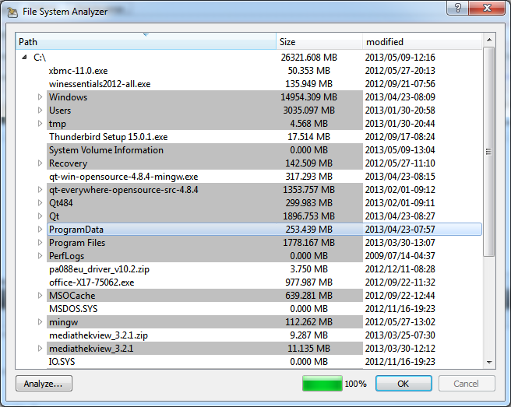
In contrast to the Windows Explorer, each node shows the exact summarized sizes of all it children. As a second difference, only three levels below the starting directory are resolved into nodes and leafs. If there are more than three levels inside a directory, only the summary file size of all children found is calculated. This is done because of speed and resource reasons.
The tree supports following user interaction:

Clicking on a row will sort all leafs in a tree node with the given criteria (size or modification date). A second click reverses the sort direction.

Right click will open a context menu with additional functions:
menu “Collapse All” will collapse all tree nodes
menu “Expand All” will expand all tree nodes
menu “Reveal in Shell” will show the selected item in its parent directory
menu “Clean Up” will delete the selected node and its children. Of course, all files which were not displayed because they are younger than the selected date, will be not affected!

Filter Conditions
The syntax of the filter definition field defines two sections for include and exclude definitions. The include section begins with '+', the exclude section with '-'. Both sections may be omitted but the include section has to be defined first. If a part of or the whole include section is empty all directories/files are taken. If a part of or the whole exclude section is empty nothing will be exluded.
All directories to be included/excluded are listed with the ';' separator. Behind the last named directory there may be a list of files in brackets, again separated by ';'.
The filter algorithm will include/exclude directories and files if the specified string is part of the full path name.

Getting started with filters
For simplicity, let us assume that you want to backup your personal documents on a windows machine. Typically, there are Word documents, spread sheets, images, audio files and perhaps videos. Normally, there is no need for a frequent backup of photos and videos: it is quite time consuming and typically one doesn't want to keep a copy of each of them. On the other side, the documents and Excel sheets should be backed up quite often since they are the “real” work.
Possible solution 1):
One backup strategy here could be to create two configurations for the same source directory and to use filter conditions for a detailed specification:
The following example configuration would omit all typical image and video formats when the daily backup is running:

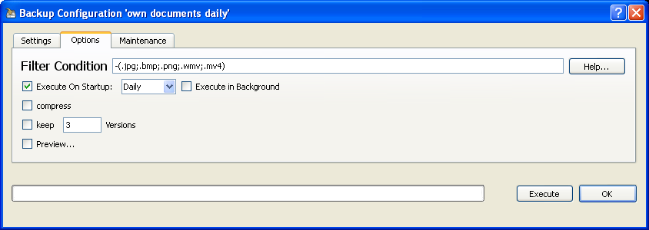
A second (for example weekly) configuration on the same directories would take the images and videos, too:

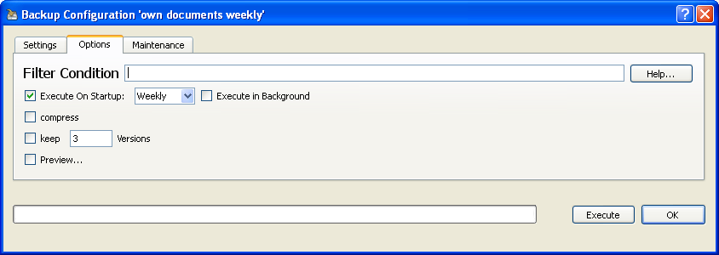
Possible solution 2):
All photos and videos are put into a sub directory called “no_backup” of the own documents folder and in general will be excluded from the backup. This might look like this:

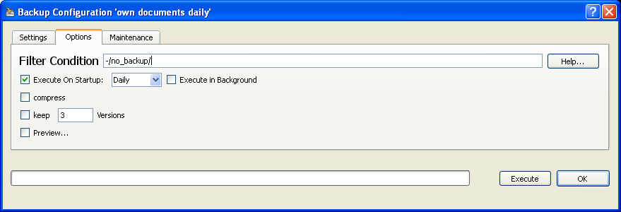

Filter examples
Here are some examples for typical filter conditions:

-/temp/ | will exclude everything inside folders named 'temp'
-temp | will exclude every folder with 'temp' in its name. So the folder 'templates' will be excluded as well!
-/cache/;/Cache/(.tmp) | will exclude all files inside cache folders and all files with the extension 'tmp' regardless where they are.
+(.jpg;.bmp)-/temp/ | will backup only JPEG and BMP images outside any 'temp' folders.

Complete filter syntax diagram

The full syntax is given in the table below.

filter | := | [ [+]includelist ] [ -excludelist ]
includelist | := | [ directorylist ] [( filelist )]
excludelist | := | [ directorylist ] [( filelist )]
directorylist | := | directory [; directory [ ... ] ]
filelist | := | file [; file [ ... ] ]
directory | := | directoryname | part of directoryname | relative path
file | := | filename | part of filename | relative path

