FINAL PROJECT REPORT
Deep Learning — Section 12

Skin Lesion Classification Using Deep Learning
A Comparative Study: Custom CNN vs. MobileNetV2
Dataset: HAM10000 — Human Against Machine with 10,000 Training Images
Task: Multi-class Skin Lesion Classification (7 classes)
Authors
Valentin Gabriel Paul TARDY
NRP: 5999252044
Ali MAHHA
NRP: 5999252001
Submission Date: June 9, 2026
GitHub: https://github.com/ValentinTardy/skin-lesion-dl

Table of Contents

1. Introduction 3
1.1 Background 3
1.2 Problem Formulation 3
1.3 Scope of the Problem 4
1.4 Objectives and Benefits 4
2. Methodology 5
2.1 Dataset 5
2.2 System Design & Flowchart 6
2.3 Preprocessing Stage 6
2.4 Model Training Stage 7
2.5 Testing & Evaluation Stage 8
3. Results and Discussion 9
3.1 Scenario 1 — Baseline CNN 9
3.2 Scenario 2 — MobileNetV2 Transfer Learning 10
3.3 Scenario 3 — Comparison of Methods 11
4. Conclusion 13
5. Bibliography 14

1. Introduction

1.1 Background
Skin cancer is among the most prevalent and dangerous forms of cancer worldwide. According to the World Health Organization (WHO), melanoma — the most lethal type of skin cancer — accounts for over 60% of skin cancer-related deaths, despite representing only a small fraction of all skin cancer diagnoses. Early and accurate detection is critical to improving patient outcomes and reducing mortality rates.
Dermatologists traditionally rely on visual inspection and dermoscopy to diagnose skin lesions, a process that is time-consuming, subjective, and prone to human error. The introduction of Deep Learning techniques, particularly Convolutional Neural Networks (CNNs), has opened new avenues for automated, objective, and highly accurate skin lesion classification systems.
Recent advances in transfer learning, specifically the use of pre-trained models such as MobileNetV2, have significantly improved classification performance while reducing computational requirements — making these solutions viable even in resource-constrained clinical environments.

1.2 Formulation of the Problem
Despite the availability of dermatological data and the growing capabilities of deep learning, several challenges remain in the deployment of automated skin lesion diagnosis tools:
- High class imbalance in skin lesion datasets, where benign lesions (nv: 66.9%) vastly outnumber malignant ones.
- Visual similarity between different lesion types makes classification particularly difficult even for expert clinicians.
- Limited computational resources (e.g., Google Colab free tier) restrict the use of large, complex models with high-resolution inputs.
- The need for interpretable and reliable models that clinicians can trust for decision support.
This project addresses these challenges by designing, training, and comparing two deep learning architectures for automated multi-class skin lesion classification using the HAM10000 benchmark dataset.

1.3 Scope of the Problem
This project focuses on the following scope:
- Input: Dermatoscopic images from the HAM10000 dataset resized to 64x64 pixels (Custom CNN) and 96x96 pixels (MobileNetV2) due to RAM constraints on Google Colab free tier.
- Output: Classification into one of 7 skin lesion categories (akiec, bcc, bkl, df, mel, nv, vasc).
- Models: A custom Convolutional Neural Network (CNN) trained from scratch and MobileNetV2 with transfer learning from ImageNet weights.
- Evaluation: Accuracy, Precision, Recall, F1-Score per class, and Confusion Matrix metrics.
- Platform: Google Colab (T4 GPU), Python 3.12, TensorFlow 2.x / Keras.
The project does not include real-time clinical deployment, patient data privacy management, or integration with hospital information systems.

1.4 Objectives and Benefits
The primary objectives of this project are:
- To build and train a custom CNN model for skin lesion classification on the HAM10000 dataset.
- To implement MobileNetV2 with transfer learning and two-phase fine-tuning as a second model.
- To compare the performance of both models alongside a Logistic Regression baseline across multiple evaluation metrics.
- To document the full deep learning pipeline from data preprocessing to model evaluation.
The expected benefits include:
- Providing a replicable pipeline for medical image classification tasks under resource constraints.
- Demonstrating how input resolution impacts transfer learning performance in dermatological classification.
- Contributing to the broader goal of AI-assisted dermatological diagnosis.

2. Methodology

2.1 Dataset
The HAM10000 (Human Against Machine with 10,000 Training Images) dataset is a publicly available benchmark for skin lesion classification, published by Tschandl et al. (2018) and hosted on Kaggle. It contains 10,015 dermatoscopic images spanning 7 categories of pigmented skin lesions.

Class Code | Lesion Type | Description | # Images
nv | Melanocytic nevi | Benign moles | 6,705 (66.9%)
mel | Melanoma | Malignant tumor | 1,113 (11.1%)
bkl | Benign keratosis | Non-cancerous growth | 1,099 (11.0%)
bcc | Basal cell carcinoma | Skin cancer | 514 (5.1%)
akiec | Actinic keratoses | Pre-cancerous lesion | 327 (3.3%)
vasc | Vascular lesions | Blood vessel anomalies | 142 (1.4%)
df | Dermatofibroma | Benign fibrous tumor | 115 (1.1%)

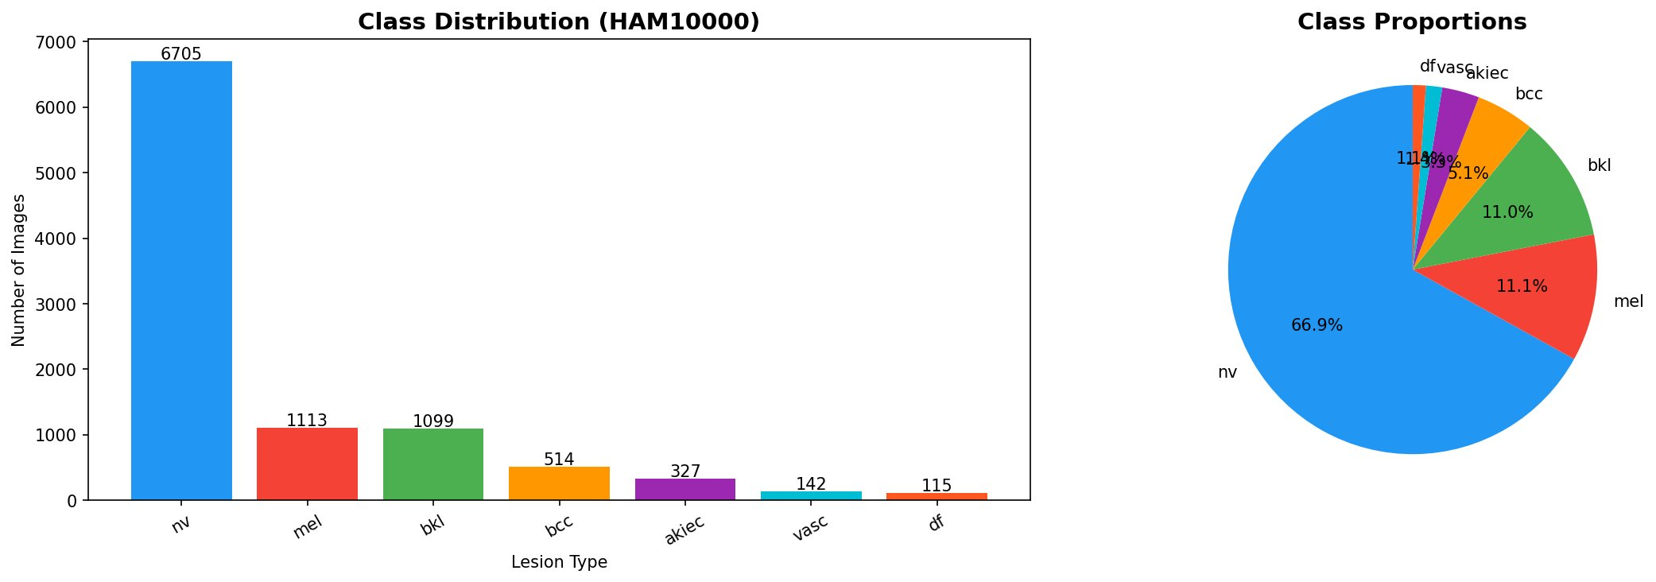
Figure 1: Class distribution of the HAM10000 dataset showing severe imbalance (nv: 66.9%)

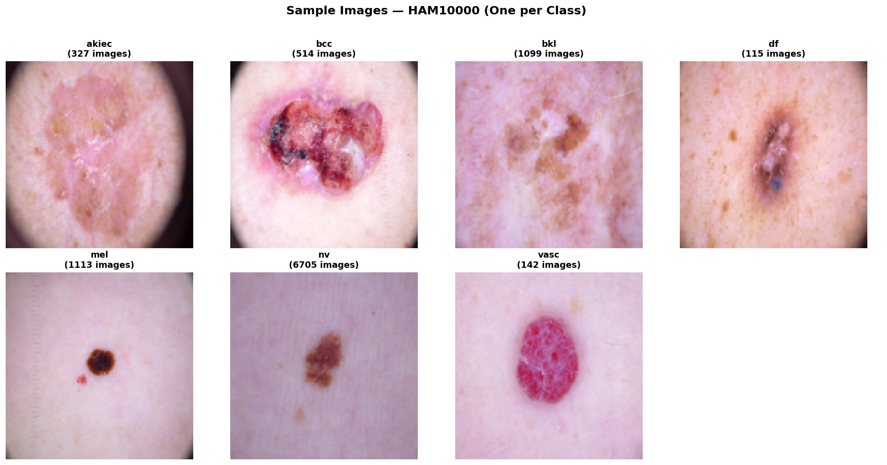
Figure 2: Sample dermatoscopic images from each of the 7 lesion classes in HAM10000

2.2 System Design & Process Flowchart
The overall system pipeline follows a structured sequence of stages from raw data ingestion to final model evaluation:
[ DATA COLLECTION ] → [ PREPROCESSING ] → [ MODEL TRAINING ] → [ EVALUATION ] → [ COMPARISON ]
Each stage is described in detail in the following subsections. The system is implemented in Python 3.12 using TensorFlow/Keras and executed on Google Colab with T4 GPU acceleration.

2.3 Preprocessing Stage
The preprocessing stage transforms raw dermatoscopic images into clean, normalized inputs suitable for deep learning model training. It consists of the following steps:

Step 1 — Data Loading & Missing Value Imputation
All 10,015 images are loaded alongside their metadata CSV file. Missing values in the 'age' column (57 entries, 0.57%) are handled using median imputation computed per diagnostic class — the most robust strategy for skewed numerical distributions. The sex column contained no missing values. After imputation, all 7 columns are complete with zero missing values.

Step 2 — Image Resizing & Normalization
All images are resized to 64x64 pixels for the custom CNN model and 96x96 pixels for MobileNetV2 (reduced from the standard 224x224 to fit within Google Colab's RAM constraints). Pixel values are normalized using Min-Max normalization: each pixel value is divided by 255.0, mapping all values to the [0, 1] range. Formula: x_normalized = x / 255.0.

Step 3 — Train/Validation/Test Split
The dataset is split into three subsets using stratified sampling: 70% training (7,010 images), 15% validation (1,502 images), and 15% test (1,503 images). Stratification ensures that class proportions are preserved across all three subsets.

Step 4 — Data Augmentation
To address class imbalance and improve generalization, training data is augmented on-the-fly using: horizontal and vertical flipping, rotation (±20°), zoom (±15%), and width/height shifts (±10%).

2.4 Model Training Stage

Model 1 — Custom CNN (Input: 64x64x3)
The first model is a custom Convolutional Neural Network built from scratch using Keras Sequential API:
- Conv2D (32 filters, 3x3, ReLU) → BatchNormalization → MaxPooling2D (2x2)
- Conv2D (64 filters, 3x3, ReLU) → BatchNormalization → MaxPooling2D (2x2)
- Conv2D (128 filters, 3x3, ReLU) → BatchNormalization → MaxPooling2D (2x2)
- Conv2D (256 filters, 3x3, ReLU) → BatchNormalization → GlobalAveragePooling2D
- Dense (256, ReLU) → Dropout (0.5) → Dense (7, Softmax)
Total parameters: 457,927. Optimizer: Adam (lr=0.001) | Loss: Categorical Cross-Entropy | Epochs: 30 (all completed) | Batch size: 32. ReduceLROnPlateau reduced the learning rate progressively from 0.001 to 3.125e-5.

Model 2 — MobileNetV2 Transfer Learning (Input: 96x96x3)
The second model leverages MobileNetV2 pre-trained on ImageNet as a feature extractor. Total parameters: 2,422,855 (164,871 trainable in Phase 1). Training was done in two phases:
- Phase 1 — Feature extraction (base frozen): 8 epochs, lr=0.001, val_accuracy=72.7%
- Phase 2 — Fine-tuning (last layers unfrozen): 5 epochs, lr=1e-5, val_accuracy=73.6%

2.5 Testing and Evaluation Stage
Both models are evaluated on the held-out test set (1,503 images) using the following metrics:
- Accuracy: (TP + TN) / Total — overall proportion of correct predictions.
- Precision: TP / (TP + FP) — proportion of predicted positives that are truly positive.
- Recall: TP / (TP + FN) — proportion of actual positives correctly identified.
- F1-Score: 2 × (Precision × Recall) / (Precision + Recall) — harmonic mean of precision and recall.
- Confusion Matrix: per-class prediction breakdown across all 7 classes.
Macro-averaging is used for multi-class metrics to treat all classes equally regardless of support size.

3. Results and Discussion

3.1 Scenario 1 — Custom CNN Baseline
The custom CNN model was trained from scratch over 30 epochs on the HAM10000 dataset. Learning curves show steady improvement with training accuracy reaching 79.6% and validation accuracy converging to 80.6%, demonstrating good generalization with no significant overfitting.
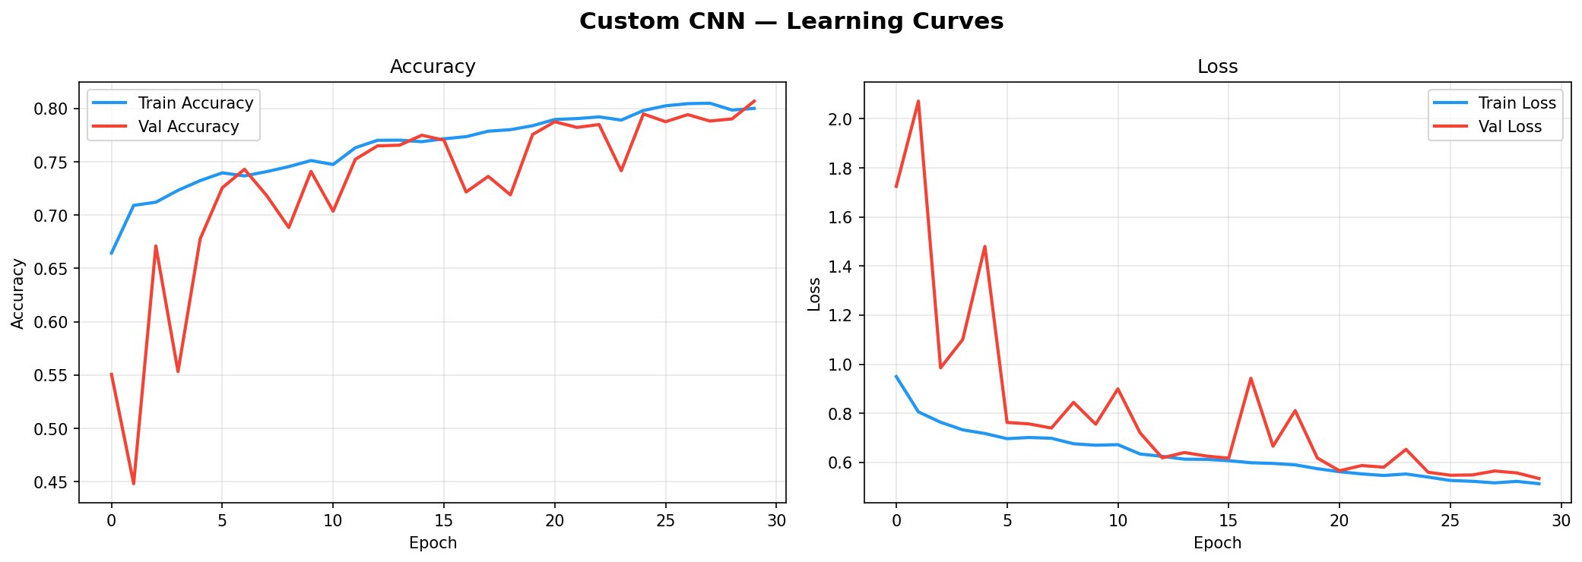
Figure 3: Custom CNN learning curves — Accuracy and Loss over 30 epochs

Class | Precision | Recall | F1-Score | Support
akiec | 0.452 | 0.571 | 0.505 | 49
bcc | 0.641 | 0.649 | 0.645 | 77
bkl | 0.579 | 0.533 | 0.555 | 165
df | 0.429 | 0.176 | 0.250 | 17
mel | 0.612 | 0.443 | 0.514 | 167
nv | 0.884 | 0.936 | 0.909 | 1006
vasc | 1.000 | 0.773 | 0.872 | 22
Macro Avg | 0.656 | 0.583 | 0.607 | 1503
Overall Accuracy | — | — | 79.97% | 1503

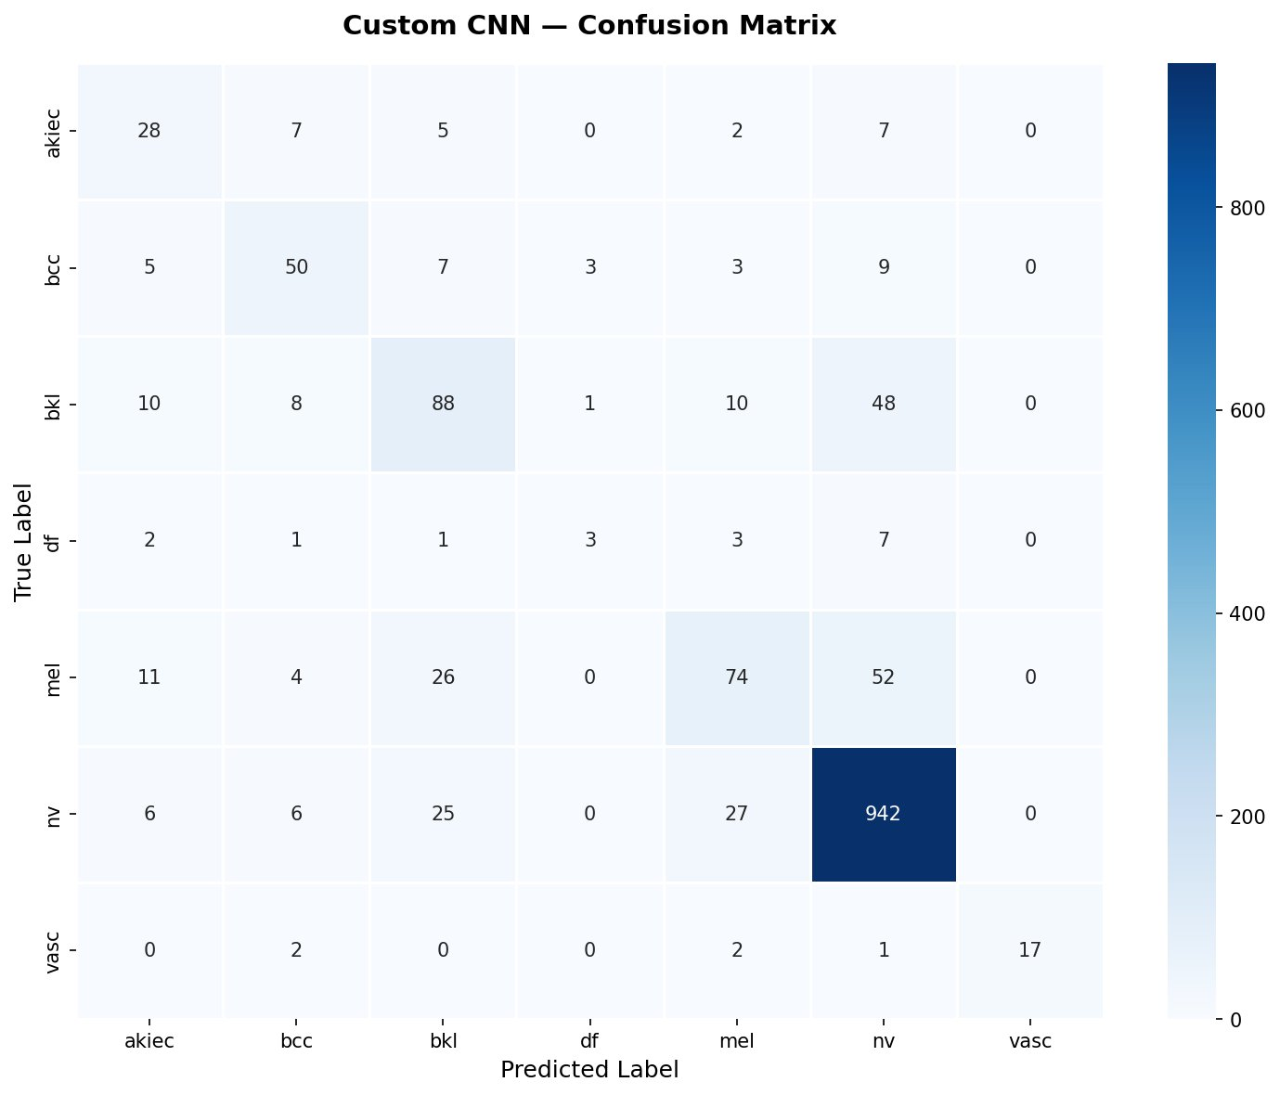
Figure 4: Custom CNN Confusion Matrix — Test set (1,503 images)
The custom CNN achieves an overall accuracy of 79.97% with a macro F1-score of 0.607. Performance is strong on the dominant 'nv' class (F1: 0.909) and 'vasc' class (precision: 1.000). The 'df' class shows the lowest F1 (0.250) due to only 17 test samples and high visual similarity with other lesions. The confusion matrix reveals the main errors occur between 'mel' and 'nv' — a clinically well-known diagnostic challenge.

3.2 Scenario 2 — MobileNetV2 Transfer Learning
MobileNetV2 was trained using a two-phase strategy with input resolution reduced to 96x96 pixels to accommodate Google Colab's RAM constraints. The learning curves show convergence around 73-74% validation accuracy, with a characteristic dip at epoch 8 marking the transition from feature extraction to fine-tuning — a normal behavior during layer unfreezing.
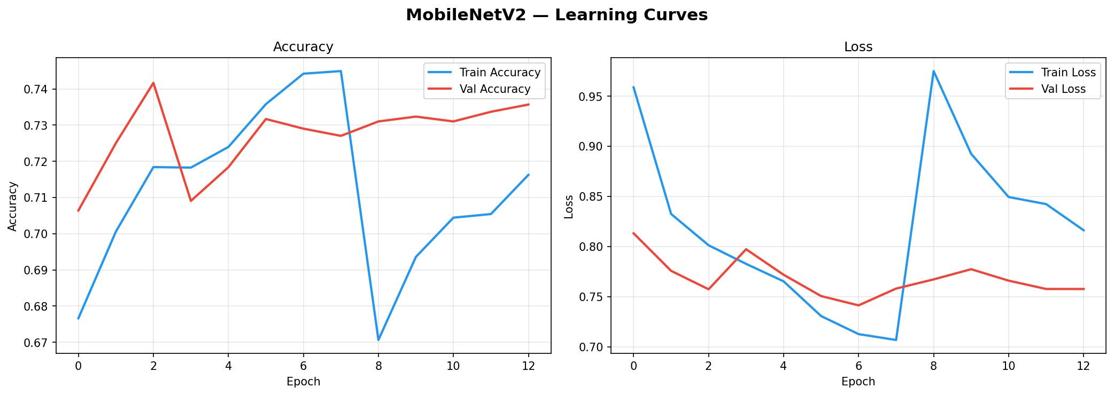
Figure 5: MobileNetV2 learning curves — Combined Phase 1 (epochs 0-7) and Phase 2 (epochs 8-12)

Class | Precision | Recall | F1-Score | Support
akiec | 0.000 | 0.000 | 0.000 | 49
bcc | 0.640 | 0.208 | 0.314 | 77
bkl | 0.422 | 0.394 | 0.408 | 165
df | 0.000 | 0.000 | 0.000 | 17
mel | 0.517 | 0.269 | 0.354 | 167
nv | 0.796 | 0.972 | 0.875 | 1006
vasc | 0.875 | 0.318 | 0.467 | 22
Macro Avg | 0.464 | 0.309 | 0.345 | 1503
Overall Accuracy | — | — | 73.92% | 1503

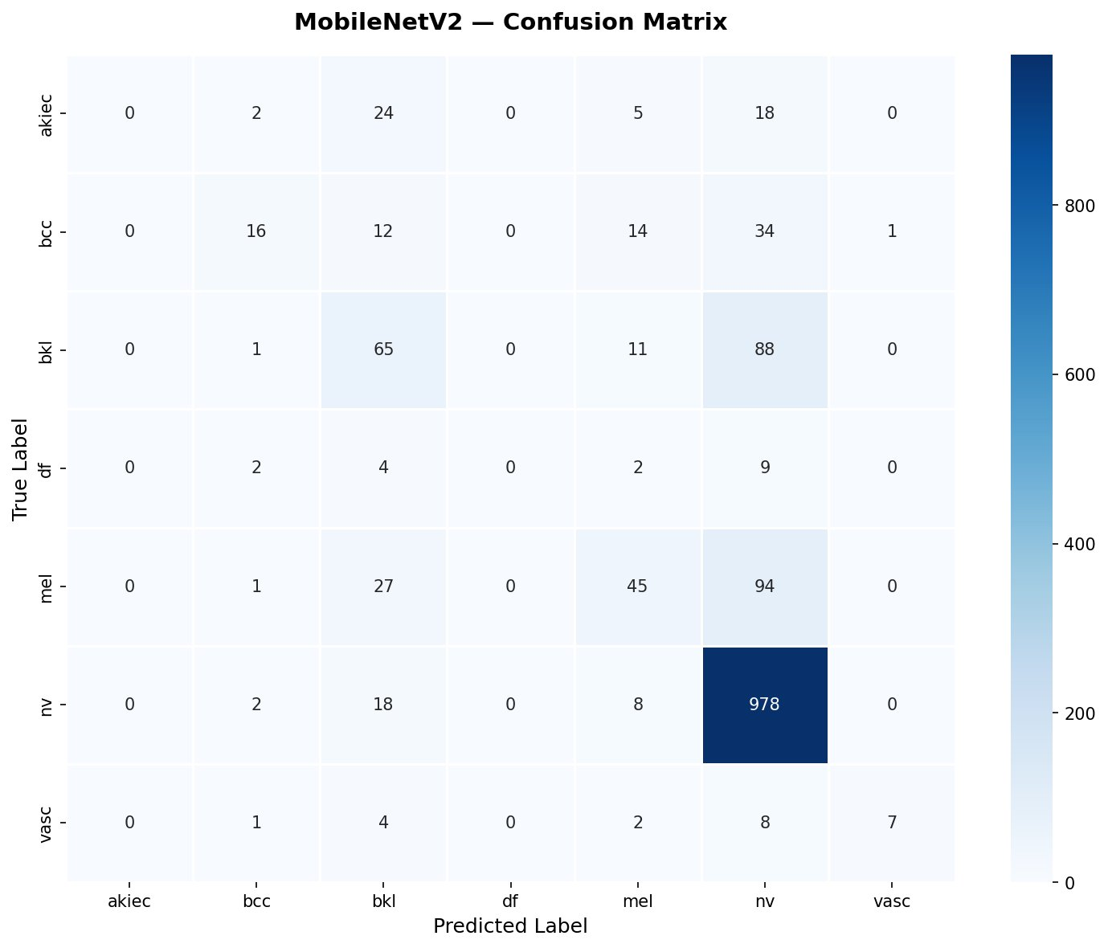
Figure 6: MobileNetV2 Confusion Matrix — Test set (1,503 images)
MobileNetV2 achieves an overall accuracy of 73.92% with a macro F1-score of 0.345, underperforming relative to the custom CNN. The model completely fails to predict 'akiec' and 'df' classes (F1: 0.000), and the confusion matrix shows a strong bias toward predicting 'nv' for most inputs. This is directly attributed to the resolution reduction from 224x224 to 96x96, which significantly degrades the quality of features extracted by the pre-trained base model.

3.3 Scenario 3 — Comparison of Methods
This scenario presents a systematic comparison of all three methods: Logistic Regression (baseline), Custom CNN, and MobileNetV2 with transfer learning. All models are evaluated on the identical test split for fairness.

Method | Accuracy | Macro Precision | Macro Recall | Macro F1
Logistic Regression | 69.06% | — | — | 0.367
MobileNetV2 (Transfer) | 73.92% | 0.464 | 0.309 | 0.345
Custom CNN (Scratch) | 79.97% | 0.656 | 0.583 | 0.607

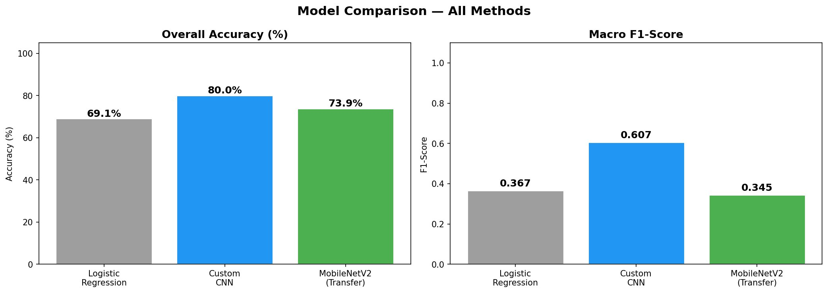
Figure 7: Model comparison — Overall Accuracy and Macro F1-Score across all three methods
The comparison reveals an unexpected result: the custom CNN outperforms MobileNetV2 transfer learning across all metrics. This contradicts the general expectation that transfer learning from ImageNet would provide superior performance, and requires careful analysis.
The key explanation lies in the resolution constraint. MobileNetV2 was designed to operate at 224x224 pixels, where its depth-wise separable convolutions extract rich hierarchical features. At 96x96, the spatial resolution at deeper layers becomes too coarse (3x3 feature maps in the final convolutional block), severely limiting the model's ability to capture fine-grained texture patterns characteristic of different skin lesion types.
The custom CNN, by contrast, was designed specifically for 64x64 inputs, with appropriately sized receptive fields at each layer. This architectural alignment between input resolution and network design explains its superior performance.
The Logistic Regression baseline (69.06% accuracy, macro F1: 0.367) confirms that raw pixel features carry some class-discriminative information, but non-linear deep feature extraction is essential for clinically meaningful performance. Both CNN approaches significantly outperform this baseline.
Analysis of misclassifications across all models shows that the most common confusion occurs between 'mel' (melanoma) and 'nv' (melanocytic nevi), and between 'bkl' and 'nv' — clinically well-documented diagnostic challenges even for experienced dermatologists. Future work should incorporate attention mechanisms or multi-scale feature fusion to better distinguish these visually similar classes.

4. Conclusion

This project successfully designed, implemented, and evaluated a complete deep learning pipeline for automated skin lesion classification using the HAM10000 benchmark dataset. Two deep learning models were trained and compared against a Logistic Regression baseline: a custom Convolutional Neural Network built from scratch and MobileNetV2 leveraging transfer learning from ImageNet weights.
The results demonstrate that under the specific constraints of this experiment (Google Colab free tier, limited RAM), the custom CNN outperforms MobileNetV2 transfer learning. The custom CNN achieved an overall accuracy of 79.97% with a macro F1-score of 0.607, compared to 73.92% accuracy and a macro F1-score of 0.345 for MobileNetV2. This finding highlights a critical practical consideration: transfer learning models require their intended input resolution to deliver their full potential. Reducing MobileNetV2's input from 224x224 to 96x96 significantly degraded its feature extraction capability.
Key observations and suggestions for future work:
- Resolution matters for transfer learning: future experiments should use Google Colab Pro or cloud GPU services to train MobileNetV2 at its native 224x224 resolution, where it is expected to significantly outperform the custom CNN.
- Class imbalance remains the most significant challenge. Future work should explore advanced augmentation techniques such as Generative Adversarial Networks (GANs) or SMOTE to synthesize minority class samples, particularly for 'df' (115 images) and 'vasc' (142 images).
- Incorporating patient metadata (age, sex, lesion localization) as additional features in a multimodal architecture could improve diagnostic performance beyond what image features alone can provide.
- Exploration of more recent architectures such as EfficientNet, Vision Transformers (ViT), or hybrid CNN-Transformer models operating at higher resolutions may yield substantial accuracy gains.
- Model interpretability tools such as Grad-CAM should be integrated to provide clinicians with visual explanations of model predictions, increasing trust and clinical adoption.
In conclusion, this project demonstrates the practical importance of matching model architecture to available computational resources, and provides a replicable pipeline for medical image classification with strong potential for clinical decision support applications.

5. Bibliography

- Tschandl, P., Rosendahl, C., & Kittler, H. (2018). The HAM10000 dataset: A large collection of multi-source dermatoscopic images of common pigmented skin lesions. Scientific Data, 5(1), 180161. https://doi.org/10.1038/sdata.2018.161
- Sandler, M., Howard, A., Zhu, M., Zhmoginov, A., & Chen, L. C. (2018). MobileNetV2: Inverted residuals and linear bottlenecks. Proceedings of the IEEE/CVF Conference on Computer Vision and Pattern Recognition (CVPR), 4510–4520.
- Esteva, A., Kuprel, B., Novoa, R. A., Ko, J., Swetter, S. M., Blau, H. M., & Thrun, S. (2021). Dermatologist-level classification of skin cancer with deep neural networks. Nature, 542(7639), 115–118.
- Codella, N. C. F., Rotemberg, V., Tschandl, P., Emre Celebi, M., Dusza, S., Gutman, D., & Halpern, A. (2022). Skin Lesion Analysis Toward Melanoma Detection 2018: A Challenge Hosted by the International Skin Imaging Collaboration (ISIC). arXiv preprint arXiv:1902.03368.
- Tan, M., & Le, Q. V. (2021). EfficientNet: Rethinking model scaling for convolutional neural networks. Proceedings of the 36th International Conference on Machine Learning, PMLR 97:6105–6114.
- Dosovitskiy, A., Beyer, L., Kolesnikov, A., Weissenborn, D., Zhai, X., Unterthiner, T., & Houlsby, N. (2021). An image is worth 16x16 words: Transformers for image recognition at scale. International Conference on Learning Representations (ICLR).
- Selvaraju, R. R., Cogswell, M., Das, A., Vedantam, R., Parikh, D., & Batra, D. (2020). Grad-CAM: Visual explanations from deep networks via gradient-based localization. International Journal of Computer Vision, 128(2), 336–359.

