How the Web works

Clients and servers
Computers connected to the web are called clients and servers. A simplified diagram of how they interact might look like this: 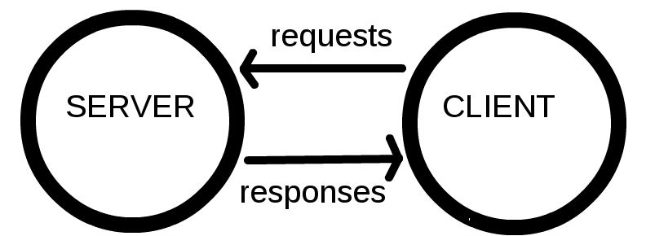
- Clients are the typical web user's internet-connected devices (for example, your computer connected to your Wi-Fi, or your phone connected to your mobile network) and web-accessing software available on those devices (usually a web browser like Firefox or Chrome).
- Servers are computers that store webpages, sites, or apps. When a client device wants to access a webpage, a copy of the webpage is downloaded from the server onto the client machine to be displayed in the user's web browser.

The other parts of the toolbox
In addition to the client and the server, we also need to say hello to:
- Your internet connection: Allows you to send and receive data on the web.
- TCP/IP: Transmission Control Protocol and Internet Protocol are communication protocols that define how data should travel across the web.
- DNS: Domain Name Servers are like an address book for websites. When you type a web address in your browser, the browser looks at the DNS to find the website's real address before it can retrieve the website. The browser needs to find out which server the website lives on, so it can send HTTP messages to the right place (see below).
- HTTP: Hypertext Transfer Protocol is an application protocol that defines a language for clients and servers to speak to each other.
- Component files: A website is made up of many different files. These files come in two main types:
  - Code files: Websites are built primarily from HTML, CSS, and JavaScript.
HTML (Hypertext Markup Language) is the fundamental technology used to define the structure of a webpage. HTML is used to specify whether some web content should be recognized as a paragraph, list, heading, link, image, multimedia player, form, or one of many other available elements.
While HTML is used to define the structure and semantics of the content, CSS (Cascading Style Sheets) is used to style it and lay it out. For example, you can use CSS to alter the font, color, size, and spacing of the content, split it into multiple columns, or add animations and other decorative features.
JavaScript is a scripting language that enables to create dynamically updating content, control multimedia, animate images, and pretty much else. Every time a web page does more than just sit there and display static information for you to look at — displaying timely content updates, interactive maps, animated 2D/3D graphics, etc. — you can bet that JavaScript is probably involved.
  - Assets: This is a collective name for all the other stuff that makes up a website, such as images, music, video, Word documents, and PDFs.

So what happens, exactly?
When you type a web address into your browser:
- The browser goes to the DNS server, and finds the real address of the server that the website lives on
- The browser sends an HTTP request message to the server, asking it to send a copy of the website to the client. This message, and all other data sent between the client and the server, is sent across your internet connection using TCP/IP.
- If the server approves the client's request, the server sends the client a "200 OK" message, which means "Of course you can look at that website! Here it is", and then starts sending the website's files to the browser as a series of small chunks called data packets.
- The browser assembles the small chunks into a complete website and displays it to you.

DNS explained
Real web addresses aren't the nice, memorable strings you type into your address bar to find your favorite websites. They are special numbers that look like this: 63.245.215.20.
This is called an IP address, and it represents a unique location on the web. However, it's not very easy to remember, is it? That's why Domain Name Servers were invented. These are special servers that match up a web address you type into your browser (like "example.com") to the website's real (IP) address.
Websites can be reached directly via their IP addresses.

Packets explained
Earlier we used the term "packets" to describe the format in which the data is sent from server to client. What do we mean here? Basically, when data is sent across the web, it is sent as thousands of small chunks, so that many different web users can download the same website at the same time. If websites were sent as single big chunks, only one user could download one at a time, which obviously would make the web very inefficient and not much fun to use.

Internet and the web
As you might notice, when we browse the Web with a Web browser, we usually use the domain name to reach a website. Does that mean the Internet and the Web are the same thing? It's not that simple. The Internet is a technical infrastructure which allows billions of computers to be connected all together. Among those computers, some computers (called Web servers) can send messages intelligible to web browsers. The Internet is an infrastructure, whereas the Web is a service built on top of the infrastructure. It is worth noting there are several other services built on top of the Internet, such as email.

