What you need to know to use silbido
Release date: 2022-03-06
Note that the setup instructions must be followed before instructions in any of the guides will work. Most of the instructions in this guide need only be done once, except for calling “silbido_init” which must be done each time Matlab is started if silbido is to be used.

Introduction
Silbido is a software system that consists of several components:
- An automatic contour detector developed for odontocete whistle detections.
- Annotation tools for manual annotation of tonal signals and/or viewing/editing automatically detected tonals.
- A scoring module to permit comparison between a reference “ground truth” set of detections and another set of detections.
Silbido is the Spanish word for whistle. The name for the system came about when several of John Hildebrand’s lab members thought that I needed a snappier name than “graph search whistle detector.” I’ve since started thinking of silbido as referring to the collection of algorithms we have developed for annotating and detecting frequency modulated tonal calls as well as analyzing the performance of detectors of. Please note that in its current form silbido is not appropriate for closely spaced pulsed calls that exhibit closely spaced harmonics or harmonic artifacts. In other words, silbido will not work well on burst pulses or other calls that exhibit rich harmonic patterns in a spectrogram such as many primate vocalizations.
Recent work on the automated detector has focused on using contextual cues to perform better peak identification. The basic ideas used in this collection of algorithms can be found in the following publications:
Roch, M.A., T.S. Brandes, B. Patel, Y. Barkley, S. Baumann-Pickering, M.S. Soldevilla (2011) Automated extraction of odontocete whistle contours. J. Acous. Soc. Am., 130(4), 2212-2223.

Li, P., Liu, X., Palmer, K. J., Fleishman, E., Gillespie, D., Nosal, E.-M., Shiu , Y., Klinck, H., Cholewiak, D., Helble, T. et al. (2020). Learning Deep Models from Synthetic Data for Extracting Dolphin Whistle Contours. In Intl. Joint Conf. Neural Net., pp. 10. Glasgow, Scotland.

Many of silbido’s parameters can be set via extended markup language files that can be edited by a standard text editor although in many cases they can be overridden by command line parameters (see the Detector documentation for details on command line parameters). The XML files are located in src/matlab/lib and all end in the extension .xml. By default, silbido will use odontocete_deep.xml which uses Li et al. (2020) for detecting peaks and the graph whistle extraction algorithm of Roch et al. (2011), but one can use an arbitrary XML file by placing it in the src/matlab/lib directory and using the detector’s ParameterSet keyword argument.
Best regards,
Marie Roch
e-mail: usefirstnameDOTuselastname @ sdsuDOTedu

For the short of patience
The original silbido was written for Matlab 2008b. The deep learning peek detection requires a newer Matlab. We have tested this with Matlab 2021b and it is likely to work with Matlab 2019b and later although these have not been explicitly tested. It requires the following toolboxes:
- DSP
- image processing
- neural network - required to use the Li et al. 2020 deep neural network peak detection.
- In addition to the neural network toolbox, you will need to install an add-on to read ONNX format neural networks. The easiest way to do this is to type importONNXNetwork at the command prompt and click on the link that is provided in the error message:
> importONNXNetwork
Error using importONNXNetwork
importONNXNetwork requires the Deep Learning Toolbox Converter for
ONNX Model Format support package. To install this support package,
use the Add-On Explorer.
You will likely need to increase your Java heap space and must invoke a software tool called triton or manually set up both Matlab and Java paths before using any of the tools. Continue reading for a gentler introduction to the tool set.

Software requirements
Silbido is written in a combination of Matlab and Java. Some of the noise routines using the Matlab API for C/C++ and require either a C/C++ compiler or a precompiled version which is provided with this distribution.
Recent version of silbido have been tested with Matlab 2019a and some versions after that. The signal and image processing toolboxes are required; although the detector can be used without the image processing toolbox if a different noise removal technique than the default median filter is specified.

Setup
Silbido is distributed with a modified copy of Triton, a software package used at the Scripps Whale Acoustics Lab. Triton is authored primarily by Sean Wiggins, but the version distributed here has been heavily modified by Melissa Soldevilla and myself. Silbido is not integrated into triton but this is expected to happen in the future. You are welcome to use triton, but the mainline code maintained by Sean Wiggins may have features not supported in our derivative version and vice versa.
Silbido requires a larger Java heap space than Matlab provides by default and it is recommended to provide at least 1 gigabyte of heap space (preferably two if running on a 64 bit operating system) to Java. Note that Java shares the process space with Matlab and memory allocated to Java is memory that Matlab cannot use for storing data.
In modern versions of Matlab, this can be done via the General/Java Heap Memory dialog under FilePreferences and requires a restart of Matlab before changes take effect:
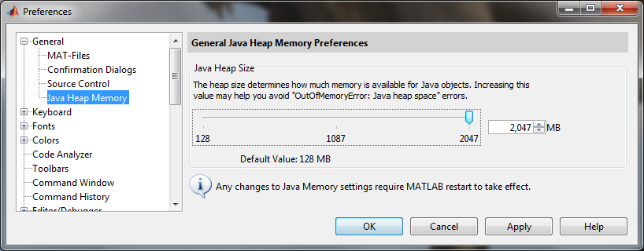
Alternatively, one can increase Java heap memory by editing a java.opts file. To do this for all users of a machine, type the following:
>> edit(fullfile(matlabroot, 'bin', computer('arch'), 'java.opts'))

Note that you must have appropriate permissions to modify this file.
For a single user, create the java.opts file in the Matlab startup directory. If you wish to change the directory where Matlab starts in Windows, you can create a shortcut and edit the Start in property of the shortcut. No special permissions are required for this.
Contents of java.opts file:

Type “ver java” at the Matlab prompt to determine your version of Java.
For Java virtual machines 1.2.2 and newer, use the following:
-Xmx1024m

For earlier Java virtual machines (up to 1.1.8) use:
-mx2048m

java.lang.Runtime.getRuntime.maxMemory/(1024^2) will display the amount of memory allocated to Java’s heap in megabytes.

Using silbido
To use silbido, several directories must be added to the MATLAB and java paths. A convenience script has been provided to properly setup the silbido environment. To initialize silbido execute the following command at the MATALB prompt.
silbido_init
This will add the appropriate paths for both Java and Matlab to your instance of Matlab. Afterwards, follow the instructions in one of the following instruction manuals:
- Annotation – Second generation annotation tool for producing ground truth detections or viewing/editing detections. This one is not as well tested as the first generation tool and likely to still contain serious flaws. We use it in production mode for viewing annotations, but still use the older dtPlotUIGroundTruth tool for serious annotation. Use it for annotating at your own risk. If you find reproducible problems, we are interested in fixing them. If you find fixes, even better.
- GroundTruth –First generation tool for producing ground truth tonals.
- Detector – Automated detection of tonal signals.
- ManipulatingTonals – Information on accessing the data contained in a set of detections.
There is also a slightly out of date copy of the Triton manual modified in the triton directory. For the most recent copy of Triton (that does not contain our modifications, but has some new functionality and bug fixes), visit http://www.cetus.ucsd.edu and follow the technologies link.

Compiling silbido
If silbido was downloaded as a compressed archive (zip/gz), the above instructions should suffice and you should not need to compile unless you are using an operating system for which we have not compiled mex files (an error indicating that you need to do this will make this obvious). If this is the case, follow the instructions for compiling C++ from the Build document.
If you are downloading a copy of silbido for development from our code repository site, then you will need to compile Java and C++. Read the Build document for instructions on how to do this.

