Untitled

Valentina

05/06/2019

# Top level title/section Title

## Sub-section title

### Sub-sub-section

#### Really not important

Paragraph of something **text.** Highlight the word and press shift 8. *italics* **bold** Make a list with an * or a dash - to create a bullted list of points. Stay consistent with one sign.

* Item 1
* Item 2
* Item 3

To write a code think of slack use backticks codeand it gets marked-up

For numbered lists, start with numbers

1. Step 1
2. Step 2
3. Step 3

if u use random numbers

1. Step 1
2. Step 2
3. Step 3

it still gives the right number order bc R recognises the number as such

# Links

here is a link to the [coursenotes](https://csiro-data-school.github.io/rmarkdown/02-Writing-Rmarkdown/index.html)

## How to add images

### Of funny cats for examples



Funny cat

**cats** are nice funny *animals*. Everyone should have

* 1 cat
* yummy food
* a fireplace

F2 good to do some exercise [1]. You can write the food note here next to the text. But it will appear at the end!

# Getting files from your computer

it depends on how the file path is written in windows. Use these forward slashes / not these  for the file path. And add .png

No spaces after r

#to apply the same rules to all the chunks, to set default values  
knitr::opts_chunk$set(echo = FALSE, fig.width = 3, fig.height = 2)

echo= FALSE controls whether or not the code will be hown in the document eval=FALSE doesn’t run the code e.g. if the code takes a long time to run to show it just set echo=TRUE results= how the results of the code are shown, at all or hidden, in disperse or hold i.e. wait until the very end of the block and print eveerything message = true will show also the packages; so in the final version the packages are gone to get rid of the warning write “warning=FALSE” R chunks allow us to customise ho the code etc are displayed in the final document

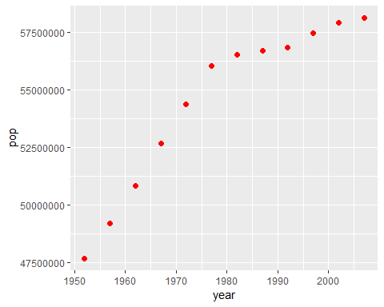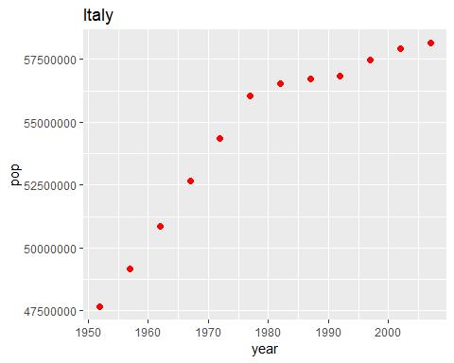

to update a text. E.g. we are working with Australia data only because 142 is too many. What if the number gets updated?

so it becomes we are working with Italy data only because 142 is too many

the code needs to be small. if not possible then use a code chunk on its own

code won’t be shown but run

we are working with Italy data only because 142 is too many.

This document was created with R Studio 3.6.0 version and the package tidyverse 1.2.1

NOPE!

The right way is

This document was created with R Studio 3.6.0 version and the package tidyverse 1.2.1

1. remember that speace and lines are quite important in RMarkdown