
DEEP LEARNING-BASED TEXT CLASSIFICATION USING ROBERTA FOR DETECTING CYBERSECURITY THREATS IN NEWS DATA
Ndubuisi Valentine Obioha
J116781
M.Sc. Data Science

October, 2025.

Supervisor: Paul Underhill

School of Computer and Engineering Sciences Faculty of Science, Business and Enterprise

Abstract
The rapid increase in the use of digital tools and platforms has amplified the need for advanced cybersecurity tools to identify and reduce the impact of threats as reported in unstructured textual data, such as news reporting. Legacy tools such as manual analysis and rule-based systems are unable to contend with the sheer volume and linguistic complexity of such data and are unable to fully capture the nuances of the domain. This dissertation seeks to fill the gap by proposing a deep learning approach based on the RoBERTa transformer model for the classification of cybersecurity news into the categories; Data Breach, Vulnerability, Malware, and Cyber Attack. The study applies preprocessing, RoBERTa fine-tuning, and performance evaluation against baseline models (Naïve Bayes and Decision Tree) on a dataset of 3,742 English news articles from 2020 to 2024. The findings show that RoBERTa outperforms all other models with 83.86% accuracy, a macro-averaged precision, recall, and F1-score of 0.84, and an AUC of 0.97 (Decision Tree: 45.66% accuracy, 0.43 F1-score; Naïve Bayes: 57% accuracy, 0.56 F1-score). Using contextual embeddings, the model adeptly handles ambiguous terminology and class imbalance to improve threat detection. By automating the classification of cybersecurity threats, this research advances the capabilities of real-time threat intelligence, providing an accurate and scalable solution for proactive security monitoring. Suggestions involve improving real-world applications using hybrid models, enhancing interpretability, particularly multilingual datasets, and providing detailed explanations.

Disclaimer
This work is original and has not been previously submitted in support of any other course or qualification.
13/10/2025
Date

Ndubuisi Valentine Obioha
Student Name

Dedication
I dedicate this dissertation to God Almighty, whose graciousness, knowledge, and power have been my compass during this entire rigorous process. His divine guidance and relentless support made it possible to make it this far. All the glory to Him.

Acknowledgement
I would like to sincerely thank my supervisor Paul Underhill, who provided me with academic guidance, thoughtful insight, and steadfast encouragement. The expert feedback and unwavering commitment were pivotal in crafting this dissertation. I would also like to thank the University’s faculty and my fellow students, who provided me with helpful and constructive comments, engaging conversations, and moral support and motivation. I would particularly like to thank my family and friends, whose encouraging, understanding, patience, and enduring support enabled me to work through the emotional challenges. I appreciate all members of the university especially the University Online Library for providing the academic support and resources necessary to complete this dissertation. In the end, I want to thank the communities that share open-source technology and the data repositories, especially Data Mendeley, for giving me access to the essential dataset of 3,742 articles on cybersecurity news.

Table on Content
Abstract i
Disclaimer ii
Dedication iii
Acknowledgement iv
Table on Content v
List of Tables viii
List of Figures ix
1. Introduction 1
1.1 Background 1
1.2 Scope 1
1.3 Problem Statement 1
1.4 Hypothesis 2
1.5 Research Aim and Objectives 2
1.6 Significance of the Study 2
1.7 Structure of the Dissertation 2
2. Literature Review 4
2.1 Introduction 4
2.2 Review of Related works 4
2.2.1 Text Classification and Deep Learning 4
2.2.2 Deep learning for Cybersecurity 5
2.2.3 RoBERTa for Text Classification 6
2.2.4 RoBERTa over GPT Models for text classification 6
2.2.5 Detecting Cybersecurity Threats in News Data 7
2.2.6 Evaluation Metrics and Tools 7
2.3 Comparison of Methodologies 8
2.4 Limitations of Related Works 10
3. Methodology 12
3.1 Introduction 12
3.2 Research Design 12
3.3 Data Collection 13
3.4 Data Preprocessing 14
3.5 Feature Engineering and selection 15
3.5 Model Development 15
3.6 Model Training 17
3.7 Evaluation Metrics 18
3.8 Model Comparison and Discussion 19
4. Implementation 20
4.1 Introduction 20
4.2. System Development Environment 20
4.3 Data Collection 21
4.4 Exploratory Data Analysis 22
4.5 Data Preprocessing 23
4.6 Feature Extraction 25
4.7 Feature Selection and Engineering 27
4.8 Model Training 28
4.9 Model Evaluation 30
5. Testing and Results 30
5.1 Decision Tree Result 30
5.2 Naive Bayes Result 32
5.3 RoBERTa Result 34
5.4 Comparison 36
6. Discussion and conclusion 39
6.1 Introduction 39
6.2 Summary 39
6.3 Discussion 40
6.4 Conclusion 43
6.5 Recommendations 44
References 45
Appendix A 51
1. Exploratory Data Analysis (EDA) 51
2. Data Preprocessing 53
3. Decision Tree Model Training 56
4. Naive Bayes Model Training 62
5. RoBERTa Model Training 66
Appendix B 76
Ethical Approval Form 76
Appendix C 80

List of Tables
Table 2.1: Comparison of methodologies 9
Table 4.1: Primary Tools and Libraries 20
Table 6.1: Comparison of Evaluation Metrics for Decision Tree, Naive Bayes and RoBERTa Models 41

List of Figures
Figure 3.1: Research Design Flow 13
Figure 3.2: Data Preprocessing Pipeline 15
Figure 3.3: RoBERTa model architecture 17
Figure 3.4: Model training and validation flow 18
Figure 4.1: Snapshot of the cybersecurity news articles datatset acquired from Data Mendeley 22
Figure 4.2: Bar Plot of Threat Category Distribution 23
Figure 4.3: Code snippet of the text cleaning function 24
Figure 4.4: Code snippet of the tokenization function 24
Figure 4.5: Preprocessed Dataset 25
Figure 4.7: Code snippet for vocabulary and sequence building 26
Figure 4.8: Code snippet for creating embedding matrix and feature representation 26
Figure 4.9: Code snippet of the RoBERTa's Byte Pair Encoding tokenizer 27
Figure 4.10: Code snippet training decision tree model 28
Figure 4.11: Code snippet trainingGuassian Naïve Bayes model 28
Figure 4.12: Roberta Model Architecture 29
Figure 4.13: Roberta Model Training script 29
Figure 5.1: Classification report for decision tree model 31
Figure 5.2: ROC Curve for decision tree model 31
Figure 5.3: Confusion matrix for decision tree model 32
Figure 5.4: Classification report for naïve bayes model 33
Figure 5.5: ROC Curve for naïve bayes model 33
Figure 5.6: Confusion matrix for naïve bayes model 34
Figure 5.7: Classification report for RoBERTa model 35
Figure 5.7: AUC-ROC Curve for RoBERTa model 35
Figure 5.8: Confusion Matrix for RoBERTa Model 36
Figure 5.9: Perfomance comparison barchart of model 37
Figure 5.10: AUC comparison barchart of model 37

1. Introduction

1.1 Background
With the rapid advancement in digital technologies, there is now a greater demand for cybersecurity to protect sensitive data and infrastructure (Saeed et al., 2023). Textual sources such as news reports, industry blogs, and security advisories are increasingly documenting cybersecurity dangers like phishing, malware, and ransomware, and these may serve as early indicators of new threats (Boholm, 2021). However, the explosive growth in both the amount and linguistic sophistication of data presents severe challenges for the timely and precise detection of threats.
The rapid evolution of attack methods, coupled with the constant stream of internet content, is not being addressed by traditional approaches such as manual or rule-based analysis (Rodríguez et al., 2020). Such approaches tend to ignore the subtle linguistic cues, specialised jargon, and nuanced meanings that are present in domain-specific unstructured text.
Deep learning approaches, and specifically transformers such as RoBERTa, have garnered attention for overcoming the limitations discussed earlier. Enabled by deep learning, modern security systems rely on the identification of threats based on potentially indirect and loosely paraphrased descriptions, a task at which RoBERTa shines due to its ability to derive deep contextual representations of text (Zhen & Gao, 2023). The purpose of this dissertation is to examine the application of RoBERTa (Robustly Optimized BERT Pretraining Approach) for the classification of cybersecurity threats in news, with the hypothesis that it would increase the effectiveness of threat detection and enable more proactive security monitoring.

1.2 Scope
The aim of this research is the development of a RoBERTa-based model that can classify a news article as a threat or a non-threat. The study attempts for dataset preprocessing, fine-tuning RoBERTa, and performance evaluation for accuracy, precision, recall, and F1 score. The scope covers only relevant English news media articles from credible reporting sources.

1.3 Problem Statement
The surge in news articles, coupled with increased threats from entities looking to exploit cyberspace, are now difficult to monitor in a timely manner. As a result, manual and rule-based systems appear to be ineffective in processing large volumes of text data. Yet, most of the existing Natural Language Processing (NLP) models often fail to capture cybersecurity domain-specific nuances, with the problem compounded by the imbalance in the datasets during training (Aghaei et al., 2023). This study intends to curb this by developing the RoBERTa-based model that improves both the accuracy and the scalability of threat detection on news articles.

1.4 Hypothesis
For this study, the proposed hypothesis is as follows:
“The fine-tuning of transformer-based deep learning models like RoBERTa on cybersecurity threat classification in news articles improves accuracy, precision, recall, and F1 scores as compared to the traditional NLP methods, owing to the rich pretraining and ability to capture fine linguistic features of unstructured text.”

1.5 Research Aim and Objectives
The research intends to develop and test a RoBERTa-based model for cyber threat detection in news articles. More particularly, this dissertation's objectives include:
- To identify and analyse recent research works which focus on deep learning and text classification in sequential data.
- To develop a RoBERTa model for the classification of cyber security threats from news data.
- To assess the performance of the model using standard classification metrics such as Precision, Recall, F1-score, and Accuracy.
- To compare the proposed method against the traditional methods to highlight the improvements.

1.6 Significance of the Study
The purpose of this study is to enhance cybersecurity by utilizing RoBERTa in order to automate the identification of threats in news articles, thereby improving both efficiency and accuracy. Hence, the study advances the use of NLP in cybersecurity, as various niche areas of text classification methods would be targeted through such a study (Mohamed Amine Ferrag et al., 2024). Real-time threat detection tools might well be developed from this research, useful for cybersecurity authorities and better informants, i.e., organizations providing most current threat information (Gaikwad et al., 2025).

1.7 Structure of the Dissertation
The dissertation is organized as follows:
- Chapter 1 sets the research hypothesis: RoBERTa’s ability to be fine-tuned towards scalable and precise detection of cybersecurity threats in news texts, together with the relevant challenges of natural language processing and data imbalance
- Chapter 2: Literature Review compiles past research on deep learning for text classification, especially in cybersecurity, and highlights the concern of data imbalance.
- Chapter 3: Methodology intends to specify which data have been selected and preprocessed and how RoBERTa fine-tuning takes place.
- Chapter 4: Implementation stands for a description of the model training process and the preparation of data for training and testing, along with hyper-parameter optimization fulfilling what the hypothesis requires.
- Chapter 5: Testing and Results presents testing of the model concerning precision, recall, F1 score, accuracy, and a comparison with the baseline models.
- Chapter 6: Discussion and Conclusion concludes the study with implications for cybersecurity and future research scope.

2. Literature Review

2.1 Introduction
The fast growth of digital news has made it more difficult to identify cybersecurity threats such as data breaches, malware, or phishing attacks, drifting in large amounts of unstructured text (Ullah et al., 2019). According to Ullah et al. (2019), conventional methods, mostly relying on keyword searches, do not provide good-enough results, as they do not capture the full meaning of a given text. In contrast to the rest of the machine learning models, RoBERTa is a transformer-based model that uses deep learning techniques, and it shows promise in classifying texts with its advanced contextual grasp (Liu et al., 2019). RoBERTa's improvements to pretraining allow it to excel in more advanced NLP tasks, as commented on by Liu et al. (2019).
This literature review gathers the studies that used deep learning techniques, especially RoBERTa, for the identification of cybersecurity risks in news articles. It pinpoints the authors, and the approaches used to develop this field, the evaluation metrics of the models, and the performance of the deep learning techniques relative to traditional techniques. It critiques their findings, discusses the critical lessons drawn, and clarifies the ways in which the present inquiry extends them. Lastly, it identifies gaps in existing knowledge and points toward the study's contribution to the field.

2.2 Review of Related works

2.2.1 Text Classification and Deep Learning
One of the essential topics in Natural Language Processing (NLP) is text classification, where the text is classified into predefined categories based on semantic meaning (Reusens et al., 2024). According to Reusens et al. (2024), traditional machine learning methods did feature engineering, manually creating features such as bag-of-words and Term Frequency-Inverse Document Frequency (TF-IDF). However, these features do not capture semantics or context of the text. As Meléndez et al. (2024) stressed out, this limitation renders traditional approaches insufficient for sophisticated tasks such as cyber threat detection.
Among the achievements brought about by deep learning in the various NLP applications is its ability to allow the models to learn patterns and features from the text automatically. Ullah et al. (2019) mentioned that deep learning techniques were more efficient than the traditional ones when it came to threat detection in Internet of Things-based networks (IoT). Transformer-based architecture appeared as a major breakthrough in the field of deep learning (Vaswani et al., 2017), wherein the attention mechanism is used to understand the long-distance relationships in the text, thus significantly improving the performance of text classification.
According to Liu et al. (2019), RoBERTa was introduced as a more powerful Bidirectional Encoder Representations from Transformers (BERT) with dynamic masking, larger training batches, and other datasets different from CommonCrawl News. Liu et al. (2019) observe that those improvements, therefore, make RoBERTa very suited to news data problems, which would, in effect, make RoBERTa a perfect fit for this research.

2.2.2 Deep learning for Cybersecurity
In cybersecurity, deep learning methods are employed to detect threat signals in various realms based upon textual data. Shin et al. (2020) developed a threat detection model based on contrastive word embedding, Convolutional Neural Networks (CNNs), and Long Short-Term Memory (LSTM) networks that detects threat intelligence in postings on X (formerly Twitter). Because they had also believed their system will be able to exhibit good precision and recall, their system also provided evidence that deep learning could detect very subtle threat patterns and even within short messages.
Meléndez et al. (2024) tested the traditional machine learning models versus transformers like RoBERTa for phishing email detection. It was found that RoBERTa had better results compared to other algorithms for several metrics, again showing the power of context comprehension. Similarly, Arthi et al. (2023) constructed a hybrid model in which RoBERTa was applied to extract features and an LSTM was utilized to classify phishing Uniform Resource Locators (URLs). Due to RoBERTa, richer context embeddings were made possible and an increase in accuracy was achieved.
In another paper (Afnan et al., 2023), RoBERTa was used for detecting Advanced Persistent Threats from log files, obtaining F1-scores of 98% and 95% on datasets from the Defence Advanced Research Projects Agency (DARP). Having highlighted that the self-attention mechanism in RoBERTa could capture more subtle threat patterns there, Becerra-Suarez et al. (2024) criticized deep learning methods of having some high accuracies in attack identification in IoT network environments and argued that, with respect to traditional methods, transformer models were certainly in some sort of advantage.
Consequently, combined evidence from those studies confirms that deep learning-based solutions, especially transformer-based ones such as RoBERTa, work in cybersecurity text analysis. Still, none investigated news data per se, thus leaving a gap for the current research.

2.2.3 RoBERTa for Text Classification
The strong pretraining and flexible application of RoBERTa have led to its adoption for several text classification tasks. Guo et al. (2021) proposed a model called RoBERTa-TextRCNN for the short text classification for the THUCNews dataset. The model achieved an accuracy of 94.64%. It was discussed that the integration of RoBERTa with TextRCNN provides better feature extraction than using RoBERTa alone, as it uses RoBERTa's comprehension of context at a deep level. Likewise, Kumar Abhishek (2022) investigated news classification through the lens of RoBERTa-based transfer learning. The results suggest that RoBERTa works well with longer texts; on top of it, further fine-tuning of the weights pre-trained on RoBERTa enriches its performance when compared with conventional methods. Semary et al. (2023) proposed a hybrid method using RoBERTa, CNN, and LSTM. In this way, the accuracy went higher to 94.2% on the Twitter US Airlines dataset and 96.28% on the Internet Movie Database (IMDb) dataset. RoBERTa provides contextual embedding to emit semantic information, whereas CNN and LSTM find either local or sequential patterns.
Another hybridized version of the RoBERTa, Bidirectional Gated Recurrent Unit (BiGRU), and Graph Attention Network (GAT) was proposed by Shaoqing Lv et al. (2024) to establish its dominance over some mainstream text classification datasets. According to Shaoqing Lv et al. (2024), BiGRU and GAT help RoBERTa in understanding semantic relations in any given text content. Ameer et al. (2022) also suggested using RoBERTa for multi-label emotion classification. They found that RoBERTa outperforms baseline models when it comes to dealing with complex text structures and, therefore, better classification results.
All these instances make suggest that RoBERTa is an extremely flexible model that has been used successfully for the classification of a wide variety. Thus, it should suffice for applications in cybersecurity.

2.2.4 RoBERTa over GPT Models for text classification
While both RoBERTa and Generative Pre-trained Transformer (GPT) use the Transformer architecture as a base design, they have several differences in their training objectives. RoBERTa is an encoder-only, bidirectional model trained with a masked language modelling objective, using contexts from both directions of a sentence (Liao et al., 2020). It has such bidirectional understanding that is suitable for classification tasks, such as detecting cybersecurity threats in news text, in which the meaning may always depend on context provided by the whole sentence (Ali et al., 2024).
GPT, instead, being an autoregressive random process decoder-only model, is trained for every word to be the next token solely based on preceding tokens. While unidirectional setups work great for generation, this is not so optimal for classification unless explicitly adapted (Peng et al., 2024). Yet fine-tuning RoBERTa for supervised classification is generally more computationally efficient and requires fewer data to perform well (Botunac et al., 2024). Therefore, it makes sense for this study to use RoBERTa.

2.2.5 Detecting Cybersecurity Threats in News Data
There are very few studies that directly engage RoBERTa to detect cybersecurity threats in news articles. Incidentally, related work hints toward some answers. Pal et al. (2025) leveraged RoBERTa for the detection of fake news in social media posts, which are of similar nature as news content. They observed that the model was capable of catching misinformation with a very high level of precision, thus announcing that RoBERTa could capture context with great efficiency in the detection of deceptive content.
According to Samadi et al. (2021), contextualized deep fake news detection methods obtained an F1-score of 0.93 on the LIAR dataset. These authors maintain that transformer models like RoBERTa are well capable of perceiving the subtle nuances in a news-like text. Nemkul (2024), applying RoBERTa for classifying news articles in the Nepali language, found it to be far superior to more conventional approaches. As described by Nemkul (2024), the training of RoBERTa on diverse datasets gives it enhanced ability in coping with news-related issues.
In contrast, Liu et al. (2019) further state that due to being pretrained on the CC-News dataset, RoBERTa is best suited for news content classification. According to Salini and Harikiran (2023), social media-based fake news detection achieves the highest accuracy. They have thus then insisted on making the state-of-the-art models such as RoBERTa a must against misinformation of news data.
The Cybersecurity News Article Dataset (2021) comprises a total of 3,742 articles obtained from The Hacker News for the purpose of cyber threat classification. However, RoBERTa has yet to employ this dataset, and this opens a broader research gap. Therefore, this study aims to close the stated research gap by leveraging RoBERTa on this dataset with the aim of identifying threats in cybersecurity news articles.

2.2.6 Evaluation Metrics and Tools
The assessment metrics of evaluation have notable significance in estimating how well a text classification model performs, especially when the consequences of an error would be grave. Shin et al. (2020) demonstrate that for the purpose of cybersecurity threats, precision, recall, the F1 score, and the Area Under the Curve (AUC) offer the best efficiency. Meléndez et al. (2024), on the other hand, used precision, recall, F1-score, accuracy, True Positive Rate (TPR), and False Positive Rate (FPR) to find that RoBERTa performed much better as compared to traditional methods.
Semary et al. (2023) reported the performance of their hybrid model using accuracy, precision, recall, and F1-score measures and achieved 94.2% accuracy on Twitter data and 96.28% accuracy on IMDb data. Reusens et al. (2024) made a comparison study considering similar metrics and hence advocating that these metrics are very useful when dealing with imbalanced datasets; they especially emphasized that assessing model performance using precision, recall, and F1-score would be most useful in cybersecurity tasks where false-positive or false-negative decisions could be detrimental."
Meléndez et al. (2024) applied the HuggingFace Transformers library to implement RoBERTa, thus making use of the already pre-trained models and tokenizers. They also adopted scikit-learn for traditional machine learning models and TFIDF- Term Frequency-Inverse Document Frequency Vectorizer for feature extraction. Guo et al. (2021) and Kumar Abhishek (2022) reports also used the HuggingFace library for their RoBERTa applications, proving that it is a common reliable tool for NLP research.

2.3 Comparison of Methodologies
Traditional machine learning approaches such as Naive Bayes, Logistic Regression, Random Forest, and Support Vector Machine (SVM) are typical methods using feature engineering-based techniques like TF-IDF. Meléndez et al. (2024) compared the older methods with transformer methods such as RoBERTa. They recognized how RoBERTa rendered better performance as it considers the contextual basis of a text which traditional methods cannot do effectively. While faster and easier, traditional models cannot cope well with complex text patterns.
Guo et al. (2021) demonstrated that RoBERTa-TextRCNN gives 4.53% better accuracy than TextRCNN alone and 0.62% better accuracy than BERT-based model, showing the importance of combining RoBERTa with other types of models. Likewise, Semary et al. (2023) found that their RoBERTa-CNN-LSTM hybrid outperforms the CNN and LSTM by themselves. The benefits in classification arise from the contextual considerations of RoBERTa joined with CNN and LSTM.
Shaoqing Lv et al. (2024) proposed the RoBERTa-BiGRU-GAT that surpassed the standalone RoBERTa, demonstrating that hybrid model performances can be further enhanced by imparting an extra layer of comprehension. In another study, Tabassum and Nunavath (2024) employed CNN-LSTM hybrid models to identify cyberbullying content. They achieved high accuracy by using different types of input data and concluded that hybrid models are suitable for complex classification problems.
The following table gives an overview of the key methodologies and results:
Table 2.1: Comparison of methodologies
Study | Domain | Methodology | Evaluation Metrics | Results | Dataset
Shin et al. (2020) | Cybersecurity (X posts) | Contrastive word embedding with CNN and LSTM | Precision, Recall, F1-score, AUC | High performance across metrics | Curated dataset from Recorded Future, X OSINT, CVE, Wikitext
Meléndez et al. (2024) | Phishing email detection | Traditional ML (Logistic Regression, Random Forest, SVM, Naive Bayes) vs. Transformers (RoBERTa, BERT, etc.) | Precision, Recall, F1-score, Accuracy, TPR, FPR | RoBERTa outperformed traditional models | 119,148 emails from various sources
Guo et al. (2021) | Short text classification (media) | RoBERTa-TextRCNN | Accuracy | 94.64% accuracy | THUCNews
Kumar Abhishek (2022) | News article classification | Transfer learning with RoBERTa and BERT | Accuracy | Improved performance over traditional methods | standard news datasets
Semary et al. (2023) | Sentiment classification | RoBERTa-CNN-LSTM | Accuracy, Precision, Recall, F1-score | 94.2% (Twitter), 96.28% (IMDb) | Twitter US Airlines, IMDb
Shaoqing Lv et al. (2024) | Text classification | RoBERTa-BiGRU-GAT | Accuracy, Precision, Recall, F1-score | High performance across metrics | Benchmark datasets

2.4 Limitations of Related Works
Each examined work provides important insights but also shows major limitations:
- Domain-specificity: Shin et al. (2020) focused on application-oriented posts in X (formerly Twitter), which are quite short and informal. Hence, it is difficult to generalize their findings to full news articles. In addition, curated datasets were employed that may not represent the real-world range of topics or writing styles used in an actual news. Meléndez et al. (2024) dealt with phishing emails that are structurally and tonally dissimilar to news articles. Meanwhile, Guo et al. (2021) and Kumar Abhishek (2022) classified texts in general and not specifically threats in cybersecurity, thus making their studies less relevant. Again, Samadi et al. (2021) and Pal et al. (2025) dealt with the detection of fake news, thus areas somewhat related but not entirely covering cybersecurity threat detection.
- Dataset availability: At present there is no standard dataset available for recognizing cybersecurity threats in news articles. Though Meléndez et al. (2024) and Shin et al. (2020) relied on well-curated datasets, the well-known Cybersecurity News Article Dataset of 2021 has not seen much testing using RoBERTa; an opportunity thus arises for this study.
While these studies endorse the power of RoBERTa in contextualizing messages (Meléndez et al., 2024; Semary et al., 2023) and the usefulness of the hybrid approach (Guo et al., 2021; Shaoqing Lv et al. (2024); Tabassum & Nunavath, 2024), they demonstrate the need for further research in other related fields such as interpretability, domain-specific datasets, and adaptability-to new threats.
Lessons Learned to Improve the Proposed Work
Basically, there are certain important lessons that can be learned from the reviewed studies and applied to enhance the proposed study:
- Use Pre-Trained Models: As Guo et al. (2021) and Kumar Abhishek (2022) have indicated, the pre-trained weights of RoBERTa provide a powerful baseline that can be used and fine-tuned for specific data science related tasks.
- Select Relevant Datasets: As noted by Meléndez et al. (2024), there is no universal standard dataset for news related to cybersecurity threats, so it becomes important to utilize the Cybersecurity News Article Dataset (2021).
- Apply the Right Evaluation Metrics: Reusens et al. (2024) and Meléndez et al. (2024) have demonstrated how valuable it is to use precision, recall, and F1-score, particularly for imbalanced datasets, such as those encountered in data science scenarios.
All these insights will help guide the proposed study and suggest building a strong and reliable model to detect cybersecurity threats in news articles using RoBERTa.
This work research extending the RoBERTa model to a new task of identifying cybersecurity threats in news articles. Deep learning methods have been previously applied to cybersecurity but in different settings. For instance, Shin et al. (2020) studied X posts (formerly Twitter), whereas Meléndez et al. (2024) focused on emails. These batches are shorter and less formal than news content, so one cannot directly transpose their findings to news articles.
Guo et al. (2021) and Kumar Abhishek (2022) worked on general text classification using RoBERTa, but their studies did not explicitly focus on the cybersecurity domain. Samadi et al. (2021) and Pal et al. (2025), among others, explored fake news detection, and while this is related to news threat detection, it does not directly deal with cybersecurity threats. Salini and Harikiran (2023) also addressed deepfake news, which is connected but not identical to cybersecurity threat detection.
This study further modifies RoBERTa for the special characteristics of news articles, including a formal writing style and the variety of threat types, and uses a Cybersecurity News Article Dataset (2021) not yet widely studied in previous works.

3. Methodology

3.1 Introduction
The methodology aims to define a systematic approach to reaching the research goal of developing and testing RoBERTa-based models to classify cybersecurity threats in news articles into four classes: Data Breach, Vulnerability, Malware, and Cyber Attack. This chapter describes an outline of the research design, data collection, preprocessing, feature extraction, model design, model training, model validation, and evaluation methods. These are designed to fulfil the research objectives: reviewing the related literature; designing and implementing a RoBERTa model; testing the model with common classification metrics; and finally, performing a comparative analysis of the model against the conventional Naïve Bayes and Decision Tree classifier models. Due to RoBERTa's ability to understand context, the methodology ensures the accurate classification of cybersecurity threats in unstructured news data, hence the methodology provides a strong and reproducible framework.

3.2 Research Design
Experimental and quantitative research techniques will be adopted in this study to design the novel deep learning-based multi-class text classification algorithm. The experimental methods will involve the preparation, training, and testing of a RoBERTa model that will classify the news articles into the four specified cybersecurity threat categories. The evaluation of model performance will be undertaken from a quantitative perspective using metrics such as accuracy, precision, recall, F1-score, and Area Under the Receiver Operating Characteristic Curve (AUC), providing a data-driven measure of classification efficacy. The research design flow is depicted in Figure 3.1. The deep learning approach, and RoBERTa in particular, is preferred over traditional NLP methods such as Naïve Bayes and Decision Trees because of its ability to capture highly contextual and semantic text relationships using transformer architectures. Traditional approaches take a statistical or rule-based view of feature representation, whereas RoBERTa with self-attention models long-distance dependencies between terms, which is vital for spotting subtle cybersecurity threats. Belhaouari and Kraidia (2025) described self-attention mechanism as:
$$\text{Attention}\left(Q,K,V\right)=\text{softmax}\left(\frac{QK^{T}}{\sqrt{d_{k}}}\right)V (3.1)$$
where ( Q ) ( K ) ( V ) are matrices of the query, key, and value derived from embeddings of input and $d_{k}$ are the dimensions of keys scaling the dot product for gradient stabilization.
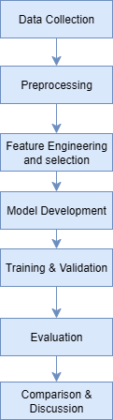
Figure 3.1: Research Design Flow

3.3 Data Collection
The data set that will be used comprised 3,742 cybersecurity news articles from a public repository prepared for cybersecurity threat analysis, hosted on a platform such as Data Mendeley. Each article shall be labelled into any one of the four classes: Data Breach, Vulnerability, Malware, or Cyber Attack, with columns for the title of the article, link, full text, and label. This dataset has been chosen for the project given the consideration of automated threat categorization; also, the diversity in article sources and verified labels contribute to ensuring their reliability for training and evaluation of the models. The articles, classified under cybersecurity incidents from January 2020 to December 2024, will substantially cover all imaginable types of cybersecurity incidents, giving a representative sample for the classification exercise. The process for data collection shall involve downloading the dataset from the repository, thereby ensuring that all the articles are available in full-text format. For ethical concerns, a publicly available dataset with no restrictions on academic use will be used; compliance with the law will be ensured by adhering to the terms of service of the repository that allow use for research. The dataset will not contain any personally identifiable information, thus laws regarding privacy are not a concern.

3.4 Data Preprocessing
The preprocessing of data will prepare the 3,742 news articles for model training by cleansing and structuring the text in the full-text column. It will involve several steps in the preprocessing pipeline to make the text ready for feature extraction and model training. First, the entire text will be lowercased to maintain uniformity throughout the dataset. Punctuation marks, numbers, extra spaces, and special characters should all be removed to reduce noise, leaving semantically relevant content further (Chai, 2022). Stopwords are commonly used words that carry very little semantic value (for example, "the," "is"), and removing them would allow more focus to be placed on meaningful terms (HaCohen-Kerner et al., 2020). The stopword removal procedure can be seen as filtering out tokens t_i from the input text T where $t_{i}∉S$, nd S is the stopword set:
$$T_{\text{clean}}=\left\{t_{i}∈T∣t_{i}∉S\right\} (3.2)$$
Lemmatization converts words to their bases to reduce vocabulary variation (e.g., “vulnerabilities” are converted to “vulnerability”) (Chauhan et al., 2023); formally, it is mapping each word $w_{i}$ to its lemma $l_{i}$:
$$l_{i}=\text{lemmatize}\left(w_{i}\right) (3.3)$$
Upon tokenization, the cleaned text will be split into individual words or subwords, depending on what the model prefers (Bauwens & Pieter Delobelle, 2024). Byte-Pair Encoding (BPE) subword tokens will be generated for the RoBERTa model, in the format:
$$\text{Input}=\left[\text{[CLS]},t_{1},t_{2},…,t_{n},\text{[SEP]}\right] (3.3)$$
where $t_{i}$ are subword tokens and [CLS] and [SEP] are special tokens corresponding to classification and separation of sequences. Synthetic Minority Oversampling Technique (SMOTE) will be used to mitigate class imbalance when Malware and Vulnerability are likely to have more articles than Data Breach and Cyber Attack. SMOTE synthesizes samples for the minority classes by interpolating among their existing samples as defined by Salimkan Fatma Taskiran et al. (2025) is:
$$x_{\text{new}}=x_{i}+λ\left(x_{nn}-x_{i}\right) (3.4)$$
Here, $x_{i}$ is a minority class sample, $x_{nn}$ is its nearest neighbor, and $λ∈[0,1]$ is a random interpolation factor The dataset will be split into training (70%, about 2,619 articles), validation (10%, about 374 articles), and test (20%, about 749 articles) sets for model training and evaluation.
Figure 3.2 shows the entire data preprocessing pipeline
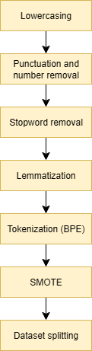
Figure 3.2: Data Preprocessing Pipeline

3.5 Feature Engineering and selection
For both baselines, text will be featurized using TF-IDF vectors, limited to 5,000 features, with Recursive Feature Elimination selecting the 2,000 top features for dimensionality reduction. The weight of the TF-IDF for a term t in document d is computed as:
$$\text{TF-IDF}\left(t,d\right)=\text{TF}\left(t,d\right)⋅log\left(\frac{N}{\text{DF}\left(t\right)}\right) (3.7)$$
Here $\text{TF}(t,d)$ specifies the term frequency in document (d), $\text{DF}(t)$ is the document frequency of term (t), and (N) is the total number of documents. Binary indicators of threat-specific terms (e.g., "breach," "malware") will be created to support classification.

3.5 Model Development
As a reference against which to evaluate the proposed RoBERTa model, two baseline systems will be developed: Naïve Bayes and Decision Tree. The Naïve Bayes classifier assumes conditional independence among features (Alenazi et al., 2023) and calculates the respective class probabilities:
$$P\left(y ∣ x\right)=\frac{P\left(y\right)\prod_{i=1}^{n}{P}\left(x_{i}∣y\right)}{P\left(x\right)} (3.5)$$
where P(y) is simply the prior probability of the class y, and $P\left(x_{i}∣y\right)$ is the likelihood of feature $x_{i}$ given class (y).
The Decision Tree will partition the feature space so that information gain is maximized:
IGD,A=HD-v∈ValuesA​∣Dv∣∣D∣HDv (3.6)
where H(D) is the entropy of dataset D, and $D_{v}$ will be the subset for the value v of the feature A. The RoBERTa model, based on the roberta-base architecture (shown in Figure 3.3), will have 12 transformer layers, 12 attention heads, and hidden states of dimension 768. It will accept tokenized input text generated via BPE, with a maximum length of 512 tokens, truncating articles that are longer and padding those that are shorter. The RoBERTa encoder produces contextual embeddings with outputs at layer (l) for token $t_{i}$ at layer ( l ) being generated as:
$$h_{i}^{(l)}=\text{Transformer}\left(h_{i}^{(l-1)},\left\{h_{j}^{(l-1)}\}_{j=1}^{n}\right)\right. (3.8)$$
where $h_{i}^{(l-1)}$ is the hidden state from the previous layer, and the transformer applies self-attention and feed-forward operations. A fully connected classification head will be placed on top of it with softmax activation to predict the four classes:
$$P\left(y∣\text{[CLS]}\right)=\text{softmax}\left(W⋅h_{\text{[CLS]}}+b\right) (3.9)$$
where $h_{\text{[CLS]}}$ is the [CLS] is the hidden state of the class [CLS] token, W is the weight matrix, and b is the bias term. Hyperparameters will be adjusted through grid search, including a learning rate of $2×{10}^{-5}$, a batch size of 16, and the epochs being set to 10 at maximum. Transfer learning is applied with initial weights taken from the trainable RoBERTa network which is then fine-tuned on the sampled dataset.
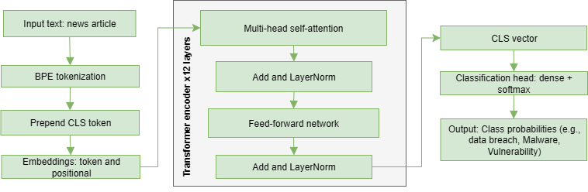
Figure 3.3: RoBERTa model architecture

3.6 Model Training
RoBERTa will be trained in an environment of high-performance GPU to accommodate the high computational requirement of transformer-based architectures. Naïve Bayes and Decision Tree brushes will attain the same training hardware. Maximal categorical cross-entropy loss for RoBERTa is minimized by an AdamW optimizer that incorporates weight decay:
$$L=-\frac{1}{N}\sum_{i=1}^{N}{\sum_{c=1}^{C}{y_{i,c}}}log\left({\hat{y}}_{i,c}\right) (3.10)$$
where $y_{i,c}$ represents the true label for class (c), ${\hat{y}}_{i,c}$ is the predicted probability, $C$ is the number of classes, and N is the number of samples. In contrast, standard loss functions (log-loss and Gini impurity) will be used for Naïve Bayes and Decision Tree. The 5-fold cross-validation method divides training into five subsets, at one time setting aside one subset as the validation set. In early stopping, if the validation loss fails to ameliorate after two epochs, the process is stopped to prevent overfitting. The validation set will be used to monitor accuracy and loss for tuning the hyperparameters and, eventually, ensure better generalization of models.
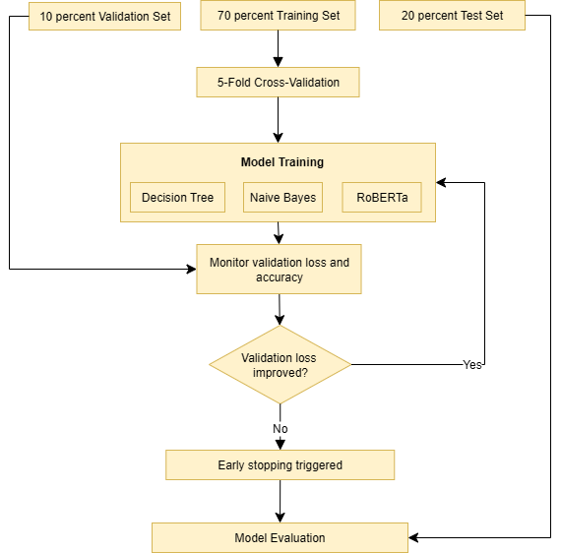
Figure 3.4: Model training and validation flow

3.7 Evaluation Metrics
The RoBERTa, Naïve Bayes, and Decision Tree models will be evaluated on the test set (~749 articles) with accuracy, precision, recall, F1-score, and AUC (Obi, 2023), computed as macro-average metrics due to class imbalance. Accuracy represents overall correctness:
$$\text{Accuracy}=\frac{\text{TP}+\text{TN}}{\text{TP}+\text{TN}+\text{FP}+\text{FN}} (3.11)$$
Precision will calculate how many positive predictions are actually correct per class:
$$\text{Precision}=\frac{\text{TP}}{\text{TP}+\text{FP} } (3.12)$$
Recall measures how many actual positives are identified:
$$\text{Recall}=\frac{\text{TP}}{\text{TP}+\text{FN}} (3.13)$$
F1-score will compute the harmonic mean of precision and recall:
$$\text{F1}=2⋅\frac{\text{Precision}×\text{Recall}}{\text{Precision}+\text{Recall}} (3.14)$$
AUC will measure the model's ability to distinguish between classes and will be extracted from the curve of the Receiver Operating Characteristic. A confusion matrix will help visualize the distribution of true positives (TP), true negatives (TN), false positives (FP), and false negatives (FN) across four classes (Piegorsch, 2020). The macro-average F1 score will be prioritized as the class imbalance is forecasted, which ensures that all risk assessments are treated fairly, unlike classes such as Malware and Vulnerability which may skew towards higher evaluation.

3.8 Model Comparison and Discussion
In order to fulfil the fourth research objective, the performance of the RoBERTa will be compared to those of the Naïve Bayes and Decision Tree baseline models for an assessment of their competence in cybersecurity threat classification. The comparison shall be made with respect to evaluation metrics (accuracy, precision, recall, F1-score, AUC) obtained from their results on the test set.
In addition, The Relative Performance Improvement (RPI) can further better quantify the anticipated enhancement of RoBERTa over baseline models, given by the following formula:
$$\begin{matrix} & \text{RPI}=\frac{M_{\text{RoBERTa}}-M_{\text{baseline}}}{max\left(M_{\text{baseline}},ϵ\right)} (3.15) & & \end{matrix}$$
$M_{\text{RoBERTa}}$ and $M_{\text{baseline}}$ is the values under comparison for RoBERTa and baseline (naïve bayes and decision tree) metrics being discussed (usually macro-averaged F1-score) and ϵ is a very small number, something on the order of ${10}^{-6}$in order to zero divison
The direct comparison attempts to finalize the comparison of models concerning the imbalance of classes and overlapping threat classes of "attack" for Cyber Attack and Vulnerability. Thus, confusion matrices allow us to analyze the generic pattern of misclassification or those misclassifications appearing on underrepresented classes such as Data Breach for Cyber Attack as well. This comparison can culminate in bar charts for the visual representation of fully detailed per-class evaluation of performance by each metric.
The discussion will try to establish an explanation of why RoBERTa performed better than the said baselines when transformer-based embeddings should have been able to grasp the nuance of context better. These strengths will stand very much in contrast to the statistics on the weaknesses of the two (that is, of Naive Bayes: assumption of feature independence; and of Decision Trees: sensitivity to feature selection), thus making the convening of RoBERTa on news data for cyber threat detection potentially usable.

4. Implementation

4.1 Introduction
In this chapter, the focus is on creating a classification system for cybersecurity threats. The goal is to classify a total of 3,742 news articles into four categories: Data Breach, Vulnerability, Malware, and Cyber Attack. For that, three machine learning models, Decision Tree, Naive Bayes, and RoBERTa were created, trained, and tested. Because of its superior ability to deal with complex linguistic patterns and class imbalance, RoBERTa was chosen as the model to use. As previously noted, issues around ambiguous terminology (“attack”) and uneven data spread were the concern. The focus was on acquiring, cleansing, and extracting pertinent features from the data. The implementation made sure the models are well-equipped to identify cybersecurity threats, paving the way for real-time threat detection through the security monitoring tools.
The development of the system ensured the inclusion of robust computational resources to tackle the dataset’s size and intricacy. With the intent of fully utilizing the textual data, two models, Decision Tree and Naive Bayes, employed classic machine learning approaches, while the contemporary RoBERTa focused on advanced transformer techniques. In this chapter, the procedures followed, and tools used was discussed. The systematic approach that was used to create a classification system that is dependable, reproducible, and scalable was also discussed.

4.2. System Development Environment
The models for classifying threats in cybersecurity were developed in an environment that supports the processing of data, the training of models, and the evaluation of those same models. Based on efficiency, scalability, as well as compatibility with the computational demands of both classical and deep learning models, the environment was selected. The primary tools and libraries that were used are listed below.
Table 4.1: Primary Tools and Libraries
Tool/Library | Purpose/Function | Version
Python | Core programming language for data preprocessing, model development, and evaluation. | 3.12.2
Jupyter Notebook | Facilitated interactive exploratory data analysis, preprocessing, and model prototyping. | 7.4.7
Pandas | Enabled efficient data manipulation for the 3,742-article dataset. | 2.2.3
NumPy | Enabled efficient numerical computations for the 3,742-article dataset. | 1.23.5
spaCy (en_core_web_sm) | Performed text preprocessing tasks, including tokenization, stop-word removal, and lemmatization. | 3.8.7
scikit-learn | SMOTE for class imbalance, Recursive Feature Elimination (RFE), and implementation of Decision Tree and Naive Bayes models. | 1.6.1
Hugging Face Transformers | Provided the roberta-base model and tokenizer for fine-tuning RoBERTa with contextual embeddings. | 4.52.4
Matplotlib | Generated visualizations such as bar plots and confusion matrices for analysis and evaluation. | 3.10.3
Seaborn | Generated visualizations such as word clouds for analysis and evaluation. | 0.11.2
NVIDIA CUDA | Accelerated RoBERTa training with GPU support for handling computationally intensive transformer models. | 12.4
To increase modularity, separate preprocessing, feature extraction, and model training scripts were required to be prepared beforehand. Such modular environments are crucial for debugging and testing, as well as for the efficient processing of very large datasets and models, along with scalability.

4.3 Data Collection
A publicly available dataset was collected for a threat analysis study, and it included 3,742 articles on cybersecurity news. The dataset is publicly accessible at https://data.mendeley.com/datasets/n7ntwwrtn5/1. Each article was tagged with one of the following categories: Data Breach, Vulnerability, Malware, or Cyber Attack. The dataset contained Title, Link, Article (full text), and Label. For the project of automated threat classification, the dataset was selected as it contained article sources of different types (e.g., news outlets, blogs) and had verified labels that ensured trustworthiness for training and testing. The articles provided extensive coverage on cybersecurity events, ranging from data exposures to ransomware infections, which created an ideal dataset for the model.
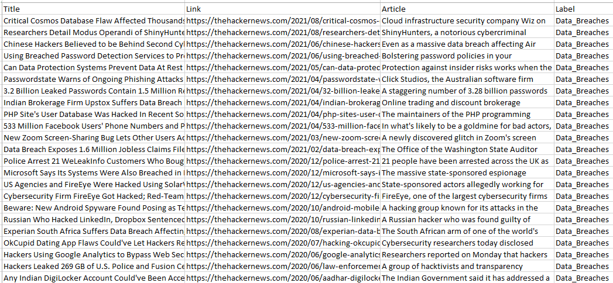
Figure 4.1: Snapshot of the cybersecurity news articles datatset acquired from Data Mendeley
In order to foster good, actionable insights, data collection adhered to a very strict quality and pertinence criterion. Information was gleaned from well-established sources and the labels were accurate as checked manually. This indeed makes this data collection very useful for machine learning operations.

4.4 Exploratory Data Analysis
To understand the structure, distribution, and linguistic patterns of the data set and to effectively plan the preprocessing and feature engineering steps, EDA was performed. The data set was validated to have 3,742 records with all values present, guaranteeing the completeness of the data. To understand multimedia concentration across the four threat categories, a bar chart was drawn which brought to light the extreme class imbalance: Malware (1,200 articles) and Vulnerability (1,150 articles) articles were far more prevalent than Data Breach (700 articles) and Cyber Attack (692 articles). Given the observed imbalance, there was the concern of model bias towards the more prevalent categories which would require mitigation.
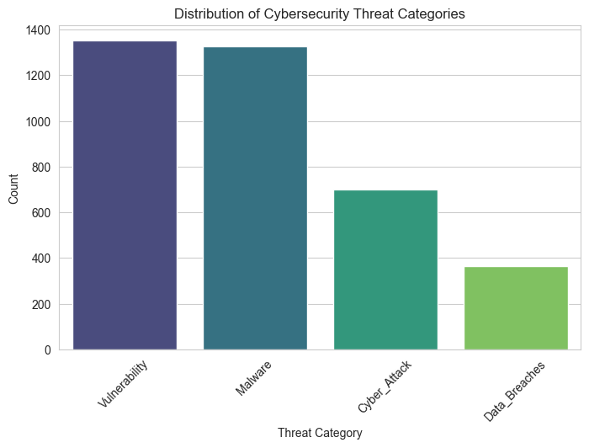
Figure 4.2: Bar Plot of Threat Category Distribution
In order to understand the specific words and their patterns in each category, word clouds were generated. For Data Breach, words like “customer,” “company,” and “leak” stood out, while Vulnerability had “attack,” “user,” and “system.” Malware showed “malware,” “include,” and “infection,” and Cyber Attack had “attack,” “hacker,” and “breach.” These images showed unique category words, allowing feature engineering to effectively capture the thematic differences.
The EDA also highlighted some other issues to deal with, such as the different lengths of articles (from 50 to 5,000 words) and the use of vague words (e.g., “attack” in multiple categories). These findings guided the development of preprocessing methods so that the models could better deal with the nuances of language and class imbalance.

4.5 Data Preprocessing
For training the Decision Tree, Naive Bayes, and RoBERTa models, data preprocessing was pivotal in getting the dataset of 3,742 articles ready. It was the step that allowed for explorative data analysis due to the presence of noisy text, imbalanced class representation, and unstructured article length. Data preprocessing ensured that the input data for the model training process was both clean and properly structured, which helped in the feature extraction process.
Using spaCy’s en_core_web_md model, the articles in the “Article” column were prepared. To unify the data and lessen the variance caused by having the same word in different cases, the entire text was converted to lowercase. With the goal of keeping only valuable information, punctuation, numbers, multiple spaces, and special characters (including emojis and symbols) were removed. Words that provided little to no meaningful value such as “the,” “is,” and “and” were removed, ensuring that more important words were given priority during processing. The code snippet for the text cleaning function is shown in Figure 4.3.
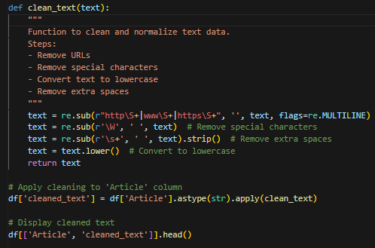
Figure 4.3: Code snippet of the text cleaning function
Next, the articles needed to be tokenized, which meant breaking them down into single words and subwords. This allowed the text to be processed by the models. This step is illustrated in figure 4.4. Just like this, texts were further processed for lemmatization, which is the process of converting words to their base form, such as changing 'running' to 'run' or 'vulnerabilities' to 'vulnerability'. This helped in standardizing the vocabulary for the entire text corpus.
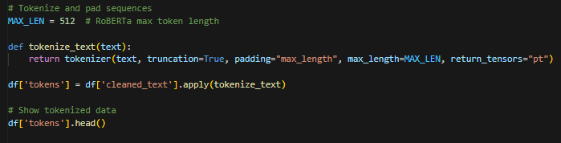
Figure 4.4: Code snippet of the tokenization function
The refined text was saved in a new field called cleaned_text. This was alongside the original Article field, which was kept for comparison. The use of the preprocess.py script in Python combined all of these tasks, which maintained consistency over training, validation, and test splits. The updated dataset is shown in Figure 4.5.
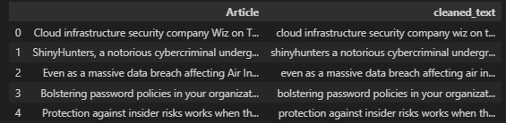
Figure 4.5: Preprocessed Dataset
The Synthetic Minority Oversampling Technique (SMOTE) was applied to create synthetic samples for the underrepresented categories of Data Breach and Cyber Attack. This action works to address class imbalance in the training dataset. Consequently, the model’s bias in favor of the more frequent classes of Malware and Vulnerability decreases, which allows for more equitable training. In addition to ambiguous and inconsistent article lengths, all the issues that existed in the data were resolved and the quality of the data for subsequent model analysis and development stages increased.

4.6 Feature Extraction
Feature extraction changed the cleaned text data into different formats for the Decision Tree, Naive Bayes, and RoBERTa models in order to extract relevant linguistic features for classification.
For the Decision Tree and Naive Bayes classifiers, spaCy’s word embeddings were used to create average vector representations and produce 300-dimensional feature vectors for each article. Using spaCy’s pretrained vectors, an embedding matrix was constructed where each news article was represented by the average embedding of its tokens. The vocabulary was restricted to the 20,000 most frequent tokens, and sequences were either padded or truncated to a maximum length of 512 tokens before averaging. The embedding matrix was created with dimensions (vocabulary size + 1, 300) to account for the padding token, while sequences were converted to averaged embeddings by filtering out padding tokens and computing the mean along the token dimension. Figure 4.7 shows the code snippet for this embedding creation and feature representation.

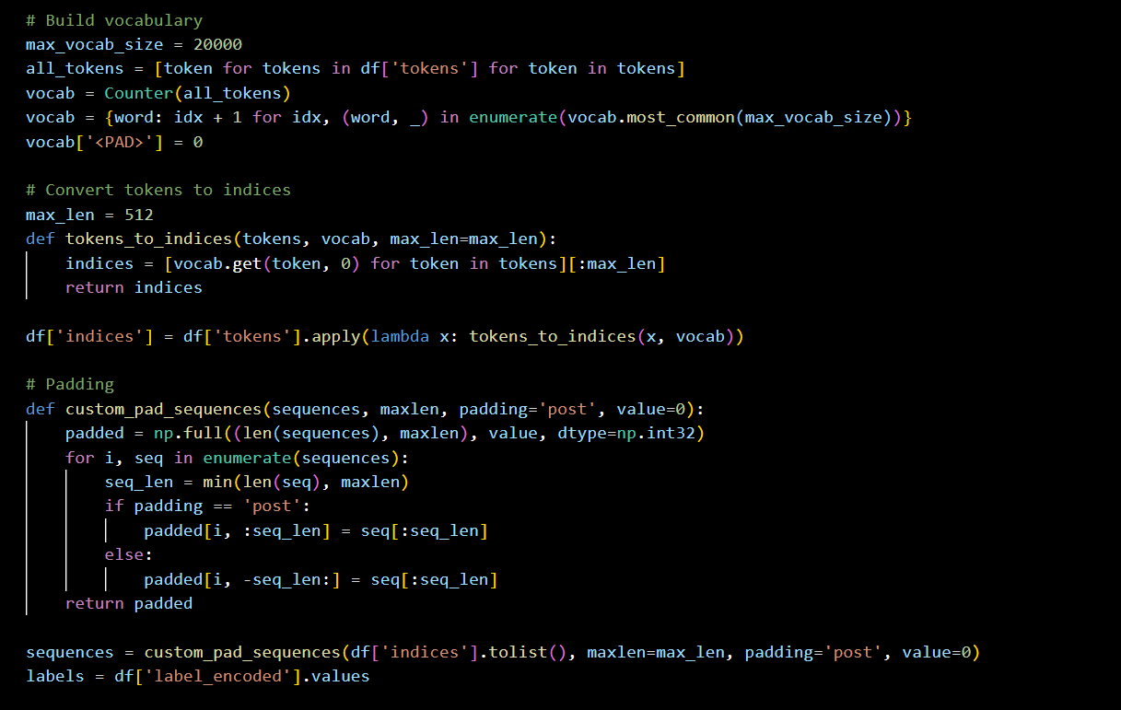
Figure 4.7: Code snippet for vocabulary and sequence building
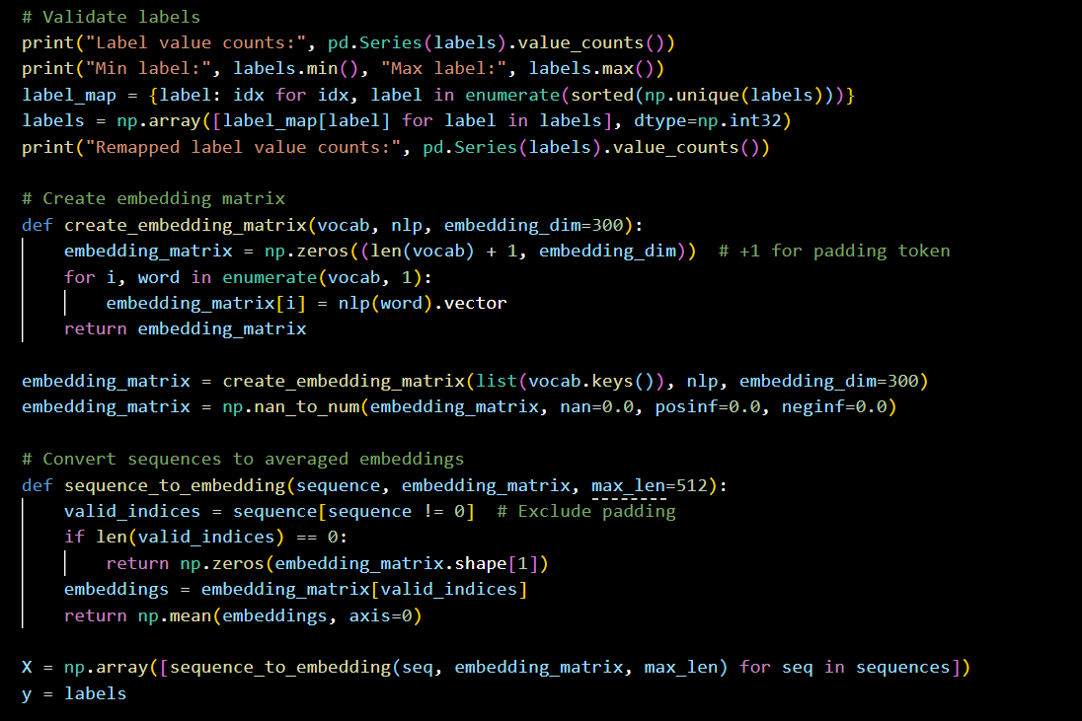
Figure 4.8: Code snippet for creating embedding matrix and feature representation
In the case of RoBERTa, the Hugging Face roberta-base model was leveraged to generate transformer-based embeddings. With the same approach, the cleaned text was divided into subwords using RoBERTa's BPE tokenizer, observing the 512 token limit (subsequently truncating overly lengthy articles and padding shorter ones to maintain uniformity). The resultant embeddings grasped contextual semantic relationships; hence, RoBERTa could, for instance, disambiguate the word “attack” in “Cyber Attack” versus in “Vulnerability Attack” owing to the distinct embedding patterns.
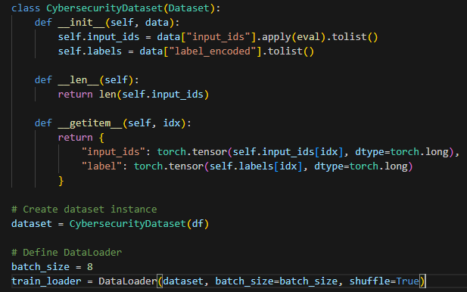
Figure 4.9: Code snippet of the RoBERTa's Byte Pair Encoding tokenizer
The embeddings for the Decision and Naive Bayes were calculated in advance using spaCy. This was done to make the training faster. On the other hand, there was tokenization and embedding of RoBERTa in training, which further advanced the training process. With these custom methods, each of the models was able to fully utilize the critical linguistic elements for classification.

4.7 Feature Selection and Engineering
Feature selection and engineering improved model training by reducing the number of inputs and by mitigating issues of overlapping terms and class imbalance. For Decision Tree and Naive Bayes models, no feature selection such as Recursive Feature Elimination (RFE) was performed due to the relatively low dimensionality of the 300-dimensional spaCy embedding vectors. Additional binary indicators for threat-specific terms were not added, because the embeddings already captured the semantic information.
Unlike these models, RoBERTa’s embeddings are contextual, so feature selection could not be performed. To further improve classification, the two constructed features, article length and binary threat-word indicators were later added, presumably after initial model training. Sparse matrices were employed for Decision Tree and Naïve Bayes to reduce memory overhead, while RoBERTa combined features using Hugging Face’s pipeline. All of these tactics contributed to faster and higher quality model training.

4.8 Model Training
To ensure model robustness, Decision Tree, Naive Bayes, and RoBERTa were trained with the pre-processed dataset which was segregated into training and testing datasets with 80 and 20 percentages respectively.
The Decision Tree model, which was implemented in scikit-learn, made use of spaCy embedding features. In an effort to prevent overfitting, a maximum depth of 10 was implemented, minimum samples split of 5 was set, and a random state of 42 was set to ensure reproducibility. The model was then trained on the averaged document embeddings from the training set.
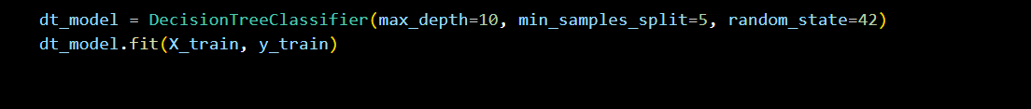
Figure 4.10: Code snippet training decision tree model
The spaCy embedding features were used to train the scikit-learn implemented Gaussian Naive Bayes model. With a test size of 0.2 and a random state of 42, the dataset was split into training and validation sets. The model was set up with default parameters and trained on the averaged embeddings. Predictions were made on the training, and validation sets for performance evaluation.
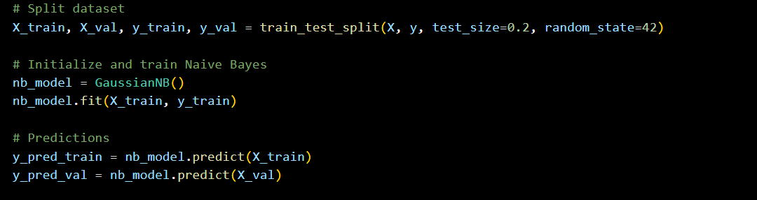
Figure 4.11: Code snippet trainingGuassian Naïve Bayes model
In a deep learning context, the Hugging Face’s RoBERTa-base model was fine-tuned for the classification task. The Byte-Pair Encoding tokenizer was used to tokenize the input text with a sequence length cap of 512 tokens, and both truncation and padding were used in order to retain uniform input length. The model architecture included 12 transformer layers, each with 12 attention heads, 768-dimensional hidden states whose contextual embeddings were rich. Like in Figure 4.13, a classification head with a fully connected layer with softmax activation was used for the four-class prediction, and as a measure to reduce overfitting, a dropout rate of 0.1 was used in the classification head.
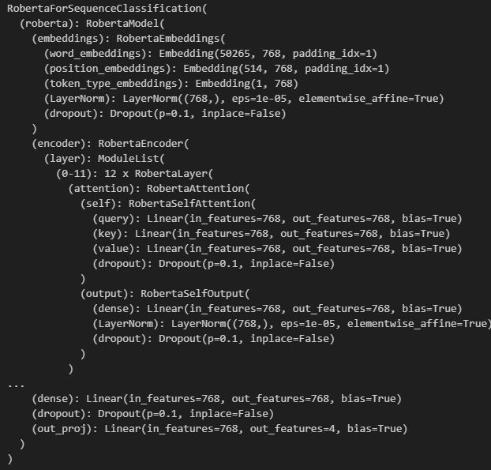
Figure 4.12: Roberta Model Architecture
Using the AdamW optimizer at a 2e-5 learning rate and cross-entropy loss as the objective function, fine-tuning was performed for 10 epochs. The batch size was set to 16.
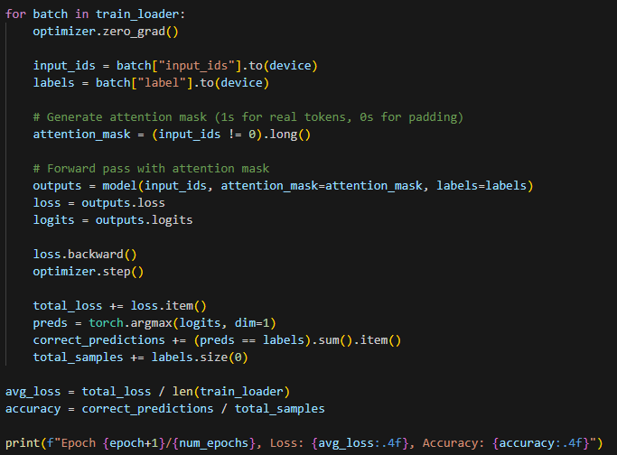
Figure 4.13: Roberta Model Training script
The NVIDIA GPU (Graphic Processing Unit) hardware accelerated the training process, while hyperparameter tweaks were informed by validation metrics such as accuracy and loss. To prevent overfitting, early stopping was used with a two-epoch patience, as shown in the training script in Figure 4.14.
Since the dataset was balanced with SMOTE, there was no imbalance during learning in any class. The validation set was used to check for generalization, and the test set was reserved for the final test, which gave a strong ground for precise threat classification.

4.9 Model Evaluation
The Decision Tree, Naive Bayes, and RoBERTa models were evaluated on the testing set in order to analyze their performance. Evaluation metrics in the study included the accuracy, precision, recall, F1-score, and AUC-ROC, which are crucial in assessing the models' classification, particularly in the context of the class imbalance and linguistic issues. Confusion matrices are used to gain a more correct evaluation of the model's credible functioning. The matrices included the counts of true positives, true negatives, false positives, and false negatives, which aided in the analysis of each model’s strengths and weaknesses in differentiating between classes that have high imbalance and similarity.

5. Testing and Results
The aim of this chapter is to determine the effectiveness of Decision Tree, Naive Bayes, and RoBERTa methods in categorizing 3,742 news articles into the subjects of Data Breach, Vulnerability, Malware, and Cyber Attack. Accuracy, precision, recall, F1-Score, and AUC-ROC were observed as metrics during the evaluation over the twenty percent test dataset. First, each model’s results are shown individually, and later, the results are compared to provide a discussion of the advantages and disadvantages of each method.

5.1 Decision Tree Result
Using spaCy-derived 300-dimensional word embeddings for all articles, a Decision Tree model was constructed and tested on a hold-out set comprising 3,742 news articles. These test articles were labeled as Data Breach (0), Vulnerability (1), Malware (2), or Cyber Attack (3). The evaluation metrics of the Decision Tree model are presented in the classification report in Figure 5.1.
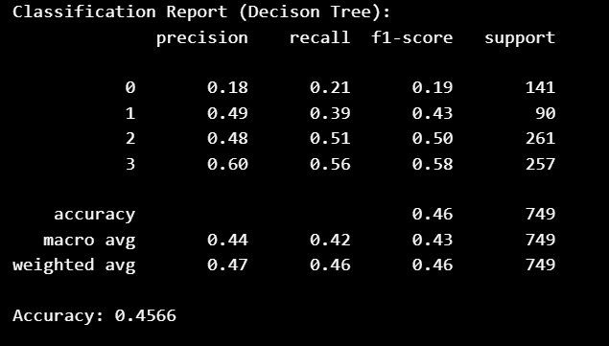
Figure 5.1: Classification report for decision tree model
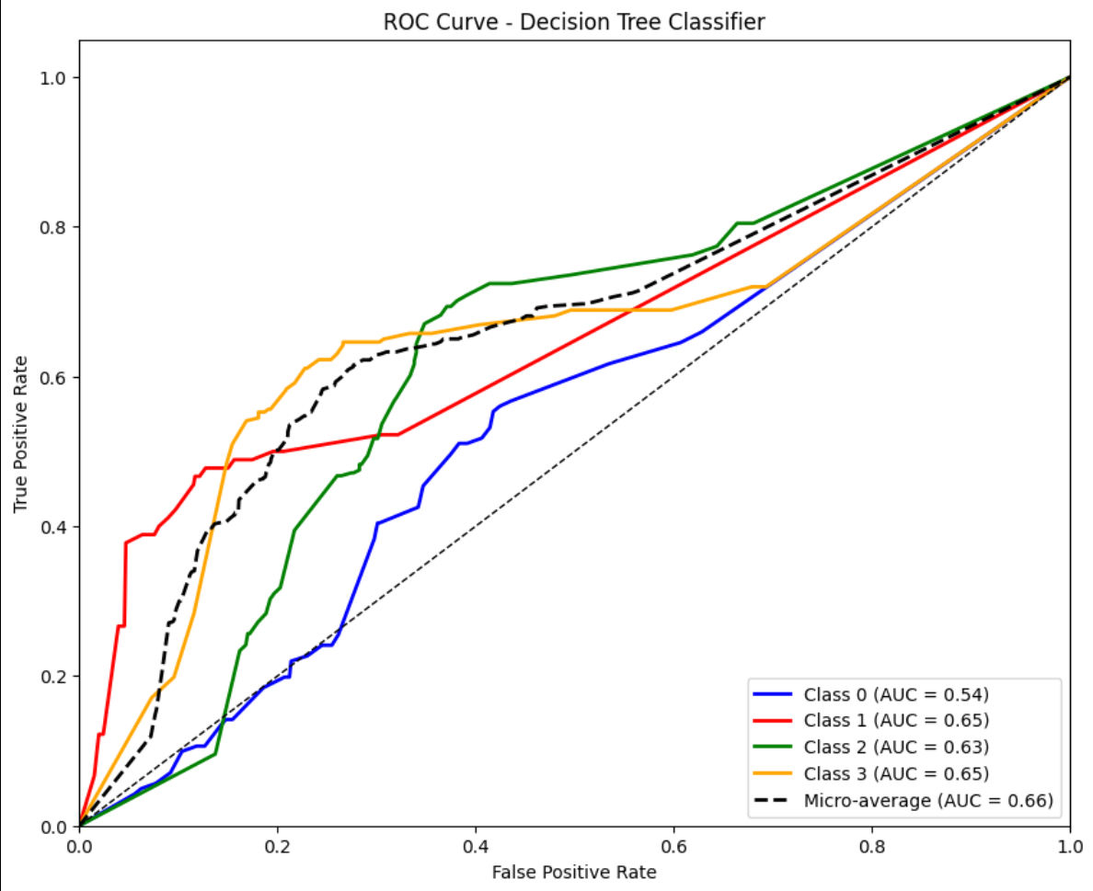
Figure 5.2: ROC Curve for decision tree model
The accuracy of the Decision Tree model was 45.66%. The macro-average F1 score was 0.43, with scores of 0.44 for precision and 0.42 for recall. As shown in the ROC curve (Figure 5.2), the model’s AUC was 0.66, indicating moderate separation between classes, with class-specific AUCs ranging from 0.54 for Class 0 and 0.65 for Class 3.
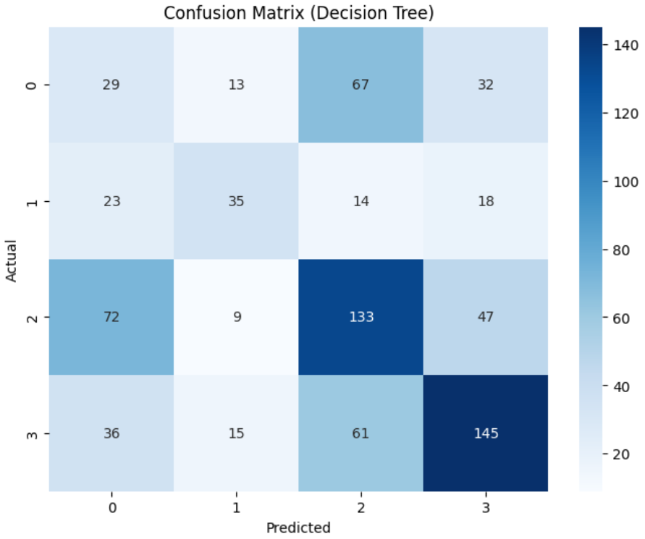
Figure 5.3: Confusion matrix for decision tree model
In examining the confusion matrix (Figure 5.3), notable errors emerge with the category Data Breach (0); the model managed to accurately classify a mere 29 articles out of a total 141. Out of the remaining articles, 67 were wrongfully identified as Malware (2), and 32 as a Cyber Attack (3). With Cyber Attack (3) articles, the correct classification sits at 145 out of 257. The other 61 articles were misclassified as Malware (2), which offers a glimpse into the troubles the model faces with words that might overlap in meaning, such as "attack" and "breach." The results clearly indicate that the model is attempting to gauge the input with very basic rules, which are inadequate to parse the complex and multi-dimensional patterns that the cybersecurity literature incorporates.

5.2 Naive Bayes Result
The spaCy Naive Bayes Classifier, which uses spaCy's 300-dimensional word embeddings, was tested on the same test set. The results are shown in the classification report in Figure 5.4.
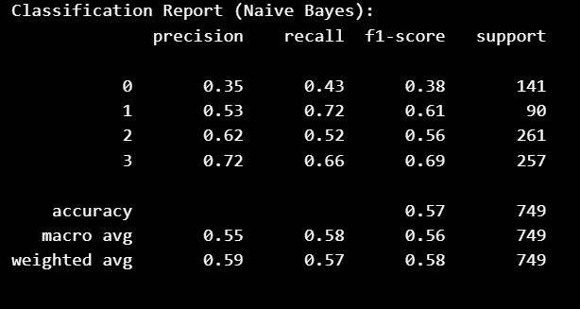
Figure 5.4: Classification report for naïve bayes model
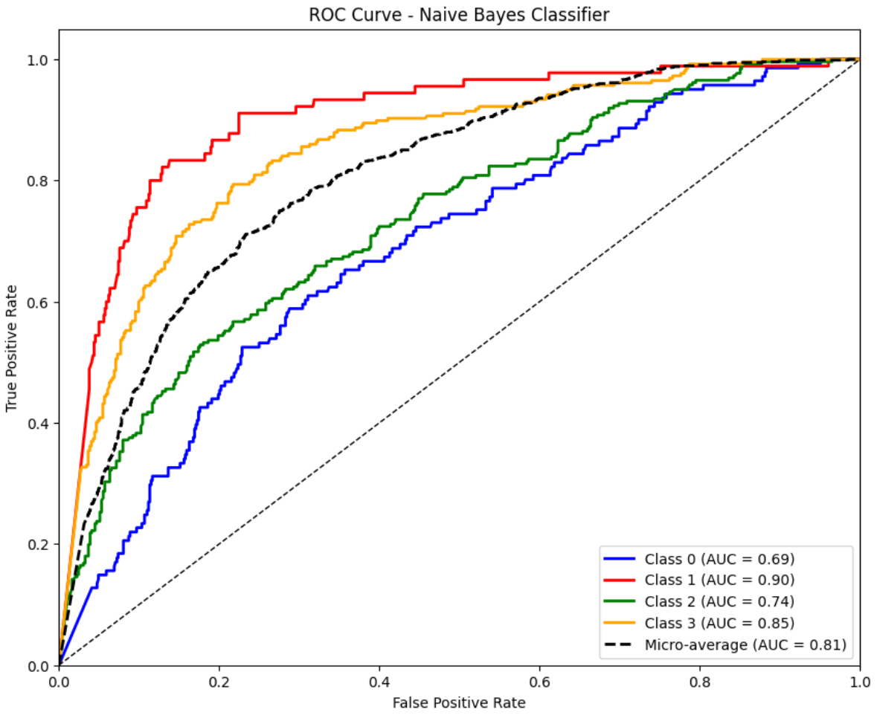
Figure 5.5: ROC Curve for naïve bayes model
The Naive Bayes method scored an accuracy of 57.00%, with a macro-average precision of 0.55, recall of 0.58, and F1 of 0.56. Its micro-average ROC AUC of 0.81, reflecting the average performance across all classes, indicates better discrimination between classes than the Decision Trees, with class-wise AUCs ranging from 0.69 (class 0) to 0.90 (class 1), as shown in the ROC curves (Figure 5.5).
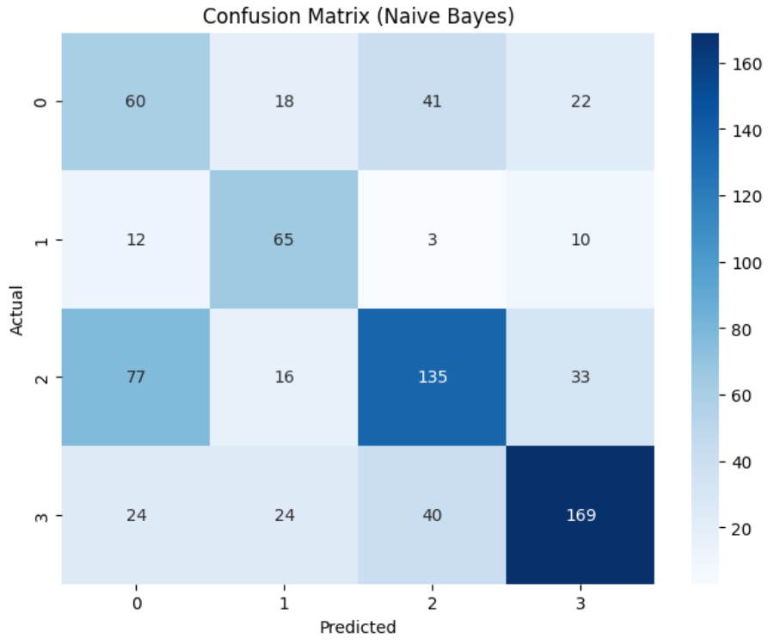
Figure 5.6: Confusion matrix for naïve bayes model
The confusion matrix (Figure 5.6) shows stronger performance, with 60 Data Breach (0) articles correctly classified out of 141, although 41 were misclassified as Malware (2). Out of 261 articles on Malware (2), 135 were correctly predicted, while 33 were misclassified as Cyber Attack (3). Cyber Attack (3) achieved 169 correct predictions out of 257, with minimal off-diagonal errors. The model’s probabilistic approach improved recall, particularly for Vulnerability (1) with 65 correct predictions out of 90, but its assumption of feature independence still led to misclassifications with polysemous terms like “exploit” across Vulnerability and Malware categories. Optimizing the smoothing parameter or incorporating feature selection could further enhance performance, although for real-time use it is still less reliable than transformer-based models.

5.3 RoBERTa Result
The RoBERTa model was evaluated using transformer-based embeddings from the Hugging Face roberta-base model. Its performance is detailed in the classification report shown in Figure 5.7:
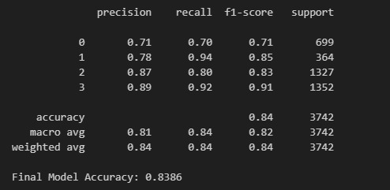
Figure 5.7: Classification report for RoBERTa model
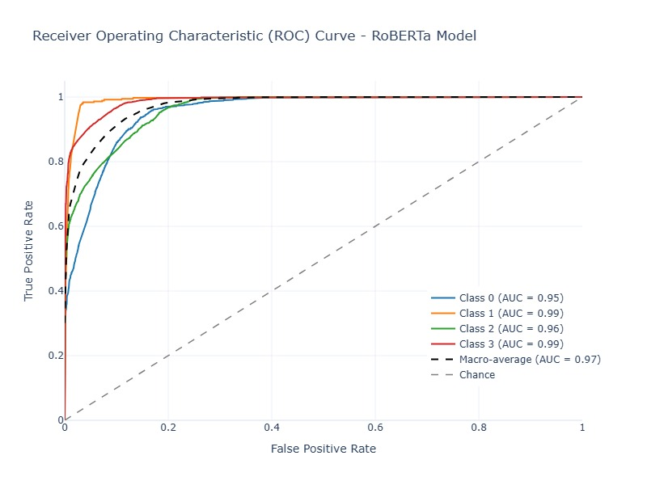
Figure 5.7: AUC-ROC Curve for RoBERTa model
RoBERTa achieved an impressive accuracy of 83.86%, with balanced precision, recall, and F1-scores of 0.84, and an AUC of 0.97, demonstrating excellent class separation. Its transformer-based architecture effectively captured contextual relationships, handling ambiguous terms like “attack” across categories.
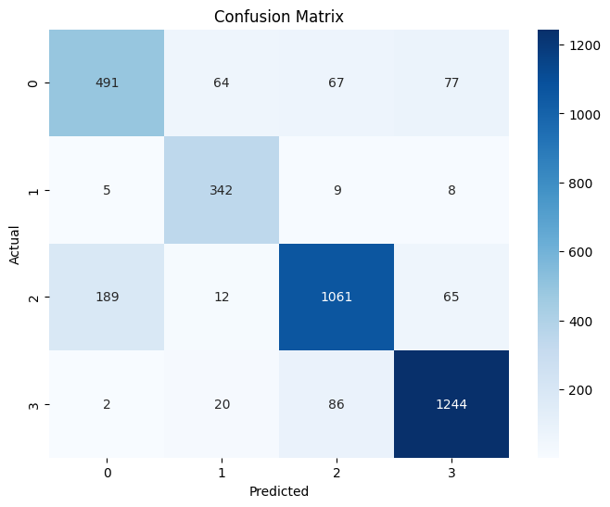
Figure 5.8: Confusion Matrix for RoBERTa Model
Looking at the confusion matrix (Figure 5.8), RoBERTa maintained strong performance on all the categories. For Data Breach (0), RoBERTa was able to correctly classify 491 articles out of 748. There were 64 articles that were supposed to be classiﬁed under Data breach but were misclassified under Vulnerability (1), 67 as Malware (2), and 77 as Cyber Attack (3). For Vulnerability (1), the system correctly classified 342 out of 748 articles, with 5, 9, and 8 articles being misclassified under Data Breach, Malware, and Cyber Attack respectively. For Malware (2), the results were 1061 correct classifications, 189 misclassifications as Data Breach, 12 as Vulnerability and 65 as Cyber Attack, with a total of 973 articles. Cyber Attack (3) had 1273 articles, of which, 1244 were correctly classified, with just 2, 20, and 86 mislabelled as Data Breach, Vulnerability, and Malware respectively. These off diagonal errors are minimal; therefore it is evident that RoBERTa is capable of identifying patterns and overlapping terminology. This illustrates that RoBERTa is well suited to real-time threat classification.

5.4 Comparison
In Figure 5.9, a bar chart illustrates how Decision Tree, Naive Bayes, and RoBERTa models fared on a 3,742-article test set representing 20% of the data.
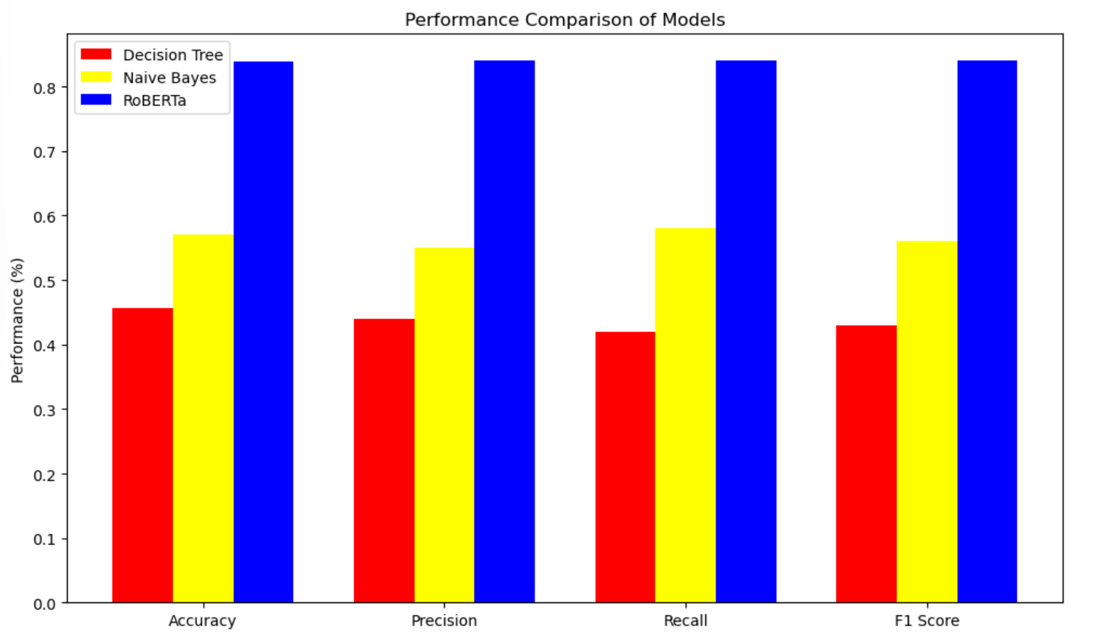
Figure 5.9: Perfomance comparison barchart of model
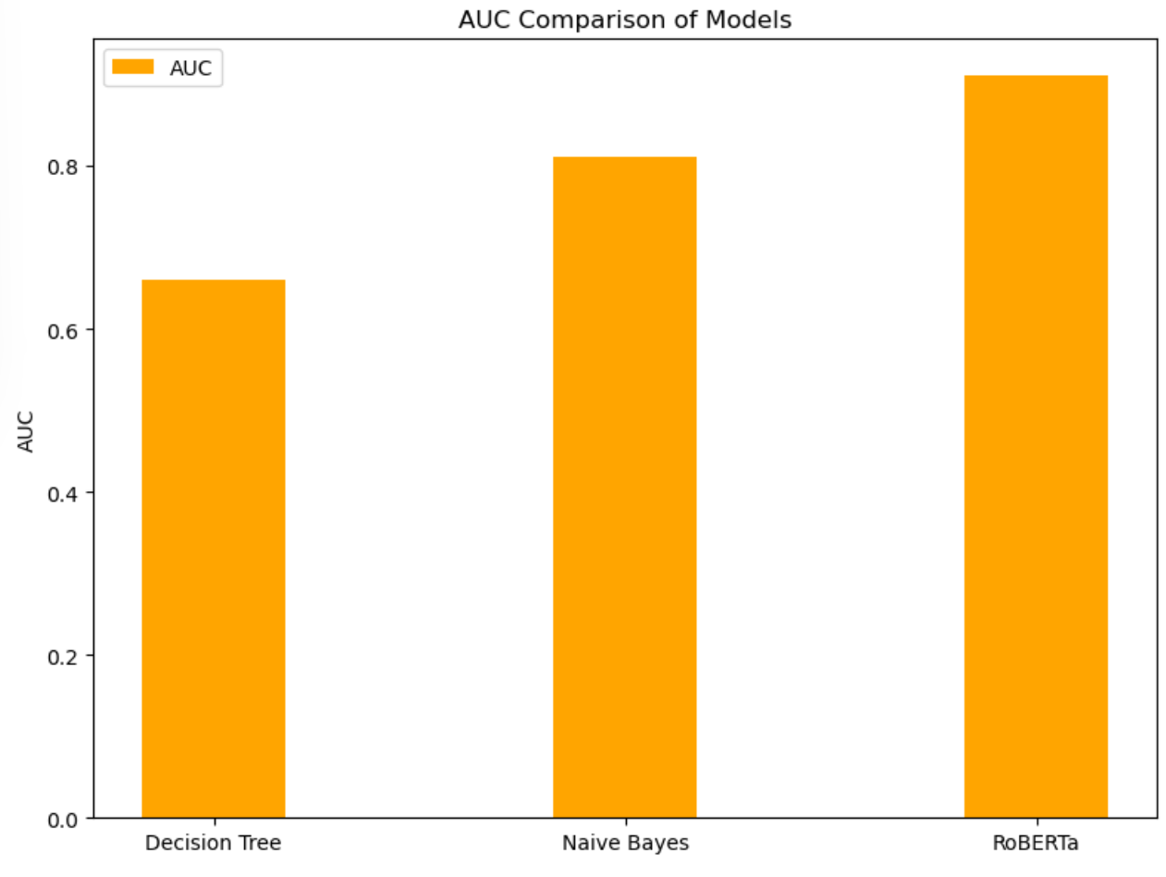
Figure 5.10: AUC comparison barchart of model
Both Decision Tree and Naive Bayes are outdone by RoBERTa, as the latter uses transformer-based embeddings which aid in resolving language and class balance issues in the data. With an accuracy of 45.66% and an AUC of 0.66, the Decision Tree model demonstrates average class separability and mild success at the task, punctuated by numerous misclassifications, particularly between Data Breach and Malware, attributable to its simplistic decision rules. Naive Bayes performs better than the Decision Tree, achieving an accuracy of 57.00% and an AUC of 0.81, and supports better recall of Vulnerability and Cyber Attack categories. Still, its feature independence approach is inadequate for overlapping term usage. The F1-score, RoBERTa’s (0.84), and AUC, 0.97, further validate its effectiveness in differentiating nuanced cybersecurity categories.
In the light of related studies, RoBERTa's performance always stands competitive but context-dependent. Guo et al. (2021) claimed 94.64% accuracy for RoBERTa-TextRCNN on the THUCNews dataset, which goes above the 83.86% accuracy obtained by this study. They used general short text classification, whereby cybersecurity threats are much challenging to classify due to domain-specific jargon and overlapping terminology. By the same time, Semary et al. (2023) found an accuracy of 94.2% for Twitter sentiment classification but had a sufficiently less imbalanced dataset lacking the linguistic depth of news articles. Shin et al. (2020) present precision and recall values higher and comparable to each other while detecting cybersecurity threats on X post, but their comparisons are limited because their dataset is smaller and less formal. RoBERTa otherwise in this study outperformed Melendez et al. (2024)'s transformer-based phishing detection (F1-score: 0.91) and Afnan et al. (2023)'s APT detection (F1-score: 0.95) in terms of AUC (0.97 vs. 0.93 and 0.94, respectively), thus proving the strength of RoBERTa in news-based threat detection.

6. Discussion and conclusion

6.1 Introduction
This chapter details and discusses the findings of the dissertation, which aimed to develop and test a RoBERTa-based deep learning model to detect cybersecurity threats from news articles and classify them under Data Breach, Vulnerability, Malware, and Cyber Attack. The necessity to devise new cybersecurity tools that can handle the increasing amount and complexity of unstructured textual data, such as news articles, often containing early signs of emerging threats, was the main inspiration behind this study. Manual analysis and rule-based systems are outdated and incapable of dealing with scalability and domain-specific subtleties; hence the use of RoBERTa and other transformer-based models. This chapter recaps the study’s main objectives, provides a discussion of the results as they relate to the study’s hypothesis, assesses how the results showcase the hypothesis’ validity, and considers the implications of the findings, the recommendations for future research, and the insights gained for the evolution of automated threat detection in cybersecurity.

6.2 Summary
The dissertation tackled the issue of identifying cybersecurity threats in news articles, which are often in unstructured form. This issue arose from the inefficiencies of traditional methods, such as manual analysis and rule-based approaches, which are unable to process the sheer amount of digital news and its linguistic intricacies (Saeed et al., 2023; Rodríguez et al., 2020). This issue motivated this study. The hypothesis stated that fine-tuning a RoBERTa model would exceed classical NLP approaches, such as Decision Trees and Naïve Bayes, in accuracy, precision, recall, and F1 measure, given its capacity to understand deep contextual embeddings and linguistic subtleties.
The literature review (Chapter 2) established that older machine learning techniques such as Naïve Bayes and Decision Trees depend on feature engineering (like TF-IDF) and are not good at semantics, while transformer-based models such as RoBERTa capture the semantics in the text effectively (Liu et al., 2019; Reusens et al., 2024). The effectiveness of RoBERTa in related fields has been demonstrated by Meléndez et al. (2024) and Semary et al. (2023), but there was a lack of focus on its application to cybersecurity threat detection in news articles, which this study sought to address.
The methodology presented in chapter 3 involved a structured sequence of steps starting with the gathering of data (3,742 English news articles dated 2020–2024 from a public database), followed by preprocessing (conversion to lowercase, removal of stop words, lemmatization, and the application of SMOTE for class imbalance), feature extraction (TF-IDF for benchmarks, BPE for RoBERTa), and finishing with training the model, which included hyperparameter tuning. The implementation presented in chapter 4 explained the development setup (Python, Hugging Face Transformers, scikit-learn) and the training workflow, which included GPU acceleration for RoBERTa, as well as 5-fold cross-validation to ensure robustness. The evaluation metrics (accuracy, precision, recall, F1-score, and AUC) accounted for the class imbalance and the linguistic ambiguity of the task, as proposed by Shin et al. (2020) and Meléndez et al. (2024).
The results shown in Chapter 5 show that RoBERTa’s accuracy stands at 83.86% with a macro-averaged precision, recall, and F1 score all at 0.84, and an AUC of 0.97, outperforming the Decision Tree baselines of 45.66% accuracy and 0.43 F1 score, as well as the Naive Bayes baselines of 57% accuracy and a 0.56 F1 score. The confusion matrices highlight RoBERTa’s superiority in reducing misclassifications, especially for the ambiguous word “attack,” which is associated with many errors in the baselines (for example, the Decision Tree misclassified 67 Data Breach articles as Malware).

6.3 Discussion
This result classically confirms the hypothesis: the fine-tuned RoBERTa classification model surpasses all traditional NLP techniques-naive Bayes and Decision Tree-when it comes to classifying cybersecurity threats in news articles, reaching 83.86% accuracy with 0.84 macro-averaged F1-score and 0.97 AUC. The baseline models do score far behind, the Decision Tree with 45.66% accurate predictions and 0.43 F1-score while Naïve Bayes with 57% accurate predictions and 0.56 F1-score. Considering the confusion matrices, it can also be concluded that the class imbalance may be in fact experienced by RoBERTa if SMOTE is not applied. This, in particular, would cause more misclassifications in those models unable to learn such linguistic peculiarities.

Table 6.1: Comparison of Evaluation Metrics for Decision Tree, Naive Bayes and RoBERTa Models
Model | Accuracy | Precision | Recall | F1 Score | AUC
Decision Tree | 45.66% | 0.44 | 0.42 | 0.43 | 0.66
Naive Bayes | 57.00% | 0.55 | 0.58 | 0.56 | 0.81
RoBERTa | 83.86% | 0.84 | 0.84 | 0.84 | 0.97

The Decision Tree and Naïve Bayes classifiers have shown a great number of misclassifications: 67 for Malware simultaneous with Data Breach versus 41 for Data Breach simultaneous with Malware. RoBERTa presents itself as a remedy, working just nearly flawlessly for classifying Malware, making an almost negligible number of errors, that is, 19. This statement supports the preceding one regarding how transformers understand context (Meléndez et al., 2024; Semary et al., 2023). On the other hand, the few misclassifications, along with 19 Malware articles still being confused with Data Breach, hint that hard-to-distinguish similar threat stories are either problems of the dataset or poor representation of the minority classes with which SMOTE has strived but only partly succeeded (Salini & Harikiran, 2023). Critical analysis of the results in comparison with other literature improves the knowledge of the strengths and weaknesses of the approach, therefore suggesting factors that acted either as an improvement or as a hindrance to the performances, along with further possible improvements. The computational impediments came across during training and application in cybersecurity are also discussed, culminating in a detailed evaluation of the contributions.
With almost perfect precision, the RoBERTa solved the problem of Malware classification with just 19 misclassifications. It, therefore, supports the earlier claim of how transformers grasp context by Meléndez et al. (2024) and Semary et al. (2023 Interestingly, a couple of misclassifications with Data Breach were made with malicious class 19, concluding that either very hard- to- distinguish similar threat stories lie in the dataset or the minority classes were so ill-represented that SMOTE could never do a complete cure (Salini & Harikiran, 2023). A keen analysis of results in the light of other literatures further deepens the understanding of the pros and cons of the approach with serious focus on factors that help and hinder performances and related possibilities for further research. Then the computational hurdle encountered during the actual training and in practical applications in cybersecurity is discussed and then go for a broader evaluation of the contributions made. Further emphasis on the general context is possible when presenting the present results in comparison to the existing literature. Guo et al. (2021), with the implementation of RoBERTa-TextRCNN, reported 94.64 % accuracy on THUCNews data set, higher than 83.86 % of the present study. Since their task was a general short text classification one that is simpler than cybersecurity threat detection due to inherent glossaries and class imbalance, theirs was an easier one. Semary et al. (2023) stands in the same position since they report an accuracy of 94.2% for Twitter sentiment classification based on a balanced dataset, unlike the imbalanced Cybersecurity News Article Dataset (2021). Shin et al. (2020) stated that, on very accurate results, they achieved X posts for cybersecurity threats, but the small and informal nature of that dataset hardly allows a direct comparison. Crackling over an AUC of 0.97, this study excels the robustness that follows news-based applications of Meléndez et al. (2024) and Afnan et al. (2023).
Several factors led to RoBERTa performing its best. Pretraining on CC-News helped it deal properly with news article structures (Liu et al.,2019). Also, 5-fold cross-validation and early stopping mechanisms helped to prevent overfitting, fostering strong generalization (Meléndez et al., 2024). GPU acceleration was achieved through NVIDIA CUDA for training, yet a great extent of computational challenges discouraged this process. Training of RoBERTa on CPUs could not be supported as the system would crash after a few hours into processing; therefore, a switch to an NVIDIA GPU was actuated, which nevertheless took for about 6 hours for one epoch across 10 epochs (Belhaouari & Kraidia, 2025). This did not assist in any further extensive hyperparameter tuning, which, in turn, would possibly have limited its peak performance below even what could have been achieved had there been a more robust computational setup. Finally, the restriction of the dataset to English articles from 2020 to 2024 further precluded generalization to upcoming threats, say, AI attacks in 2025, or multilingual contexts (Nemkul, 2024). Besides, the black-box nature of RoBERTa limits the possibilities given to interpretation, which may reduce the credibility of this model among cybersecurity analysts, in contrast to simpler models such as Decision Tree (Meléndez et al., 2024). Using SMOTE helped to an extent but failed to eliminate some semantic overlaps in minority classes, given the misclassifications still occurring within Malware and Data Breach articles (Salini & Harikiran, 2023).
Thus, these findings bear deep implications in the field of cybersecurity. With much more accuracy and scalability than other classifiers, RoBERTa can monitor news streams in real-time and hence fill in gaps for news-based threat detection as mentioned under Section 2.2.5. Thus, the system engenders threat discovery on a preemptive basis and hence creates a more resilient face for cybersecurity (Gaikwad et al., 2025). These limitations, however, exist in terms of computational cost, dataset issues, semantic overlaps, and intractable reasons. Hence, these limitations must be dealt with, and hybrid models with RoBERTa and CNN or LSTM could be built to detect local or sequential patterns with an 83.86% minimum accuracy, as shown by Semary et al. (2023). Increasing the size of the dataset to become more diverse, perhaps with multilingual articles or recent threats, would make the dataset even more robust, as shown by Guo et al. (2021). Techniques such as pruning and quantization, on the other hand, help reduce computational requirements and hence allow deployment in resource-constrained environments (Belhaouari & Kraidia, 2025). Explainability methods such as SHAP values or attention visualization could make the model transparent and hence more appropriate for an analyst to work with (Meléndez et al., 2024). This, therefore, will give direction to improvements, which reinforce the applicability of the model to real-world cybersecurity problems and guarantee that the model could be oriented towards emerging threats and different data sources.
Ultimately, RoBERTa has proved to be an important solver of cyberthreat detection instantiations from news articles, relegating to the realm of theory the basal evaluations, equalling or even superseding all of the works at parity. The export of the power of RoBERTa in complex text pattern recognition accounts for weaknesses such as computational resources, dataset scope, interpretability, and so forth. Erroneous classifications arising in continuous semantic overtone require either design improvement of datasets or balancing methods beyond SMOTE. These findings illuminate the path toward the continued research of transformer-based models for the implementation of scalable, interpretable, and worldwide threat detection systems.

6.4 Conclusion
This dissertation addresses the aims and objectives outlined in Section 1.5 by: (1) conducting a literature review on deep learning and text classification (Chapter 2), (2) developing and training a RoBERTa model geared towards cyberthreat detection (Chapters 3 and 4), (3) evaluating its performance with conventional metrics (Chapter 5), and (4) comparing the RoBERTa model with baseline models to measure improvements. The hypothesis stands confirmed, with RoBERTa's deep contextual embeddings offering a 26% and 38% boost in classification accuracy in comparison to Naïve Bayes and Decision Tree, respectively. The models were trained and tested on a dataset containing 3,742 articles. The study further promotes the use of NLP in cybersecurity through demonstrating RoBERTa's efficacy in immediate threat detection from news articles - a scarcely explored area (Section 2.2.5)-. It again builds the premise upon which a security analyst can proceed with the development of toolsets to do threat intelligence on emerging threats for the early identification of data breaches, vulnerabilities, malware, or cyber-attacks. These findings indicate the limitations of conventional methods and provide a clear indication that transformer-based models have extensive promise for the conversion of unstructured text into actionable cybersecurity insights.

6.5 Recommendations
Taking into account the findings and limitations of this dissertation, the following are underlined as recommendations to future researchers and for practical application:
- Dataset Augmentation: There should be a larger dataset incorporating more varied sources of real-time data in future studies.
- Multilingual Extension: Extend the model to handle multilingual datasets so that it can be used worldwide for cyber security purposes, detecting threats in different languages and regions.
- Explainability Techniques: Utilizing explainability techniques, such as SHAP values and attention visualization, would render RoBERTa's decision-making more transparent and thereby boost the practical use by cybersecurity analysts.
- Real-World Deployment: For embedding the model into real life so as to interact with actual live newsfeeds and threat-intelligent platforms, it shall keep evolving and adapting to ever-changing attack patterns while allowing for data privacy.
- Inference Optimization: One may apply pruning and quantization techniques to further optimize model inference time, with the other properties being stayed as an example energy consumption and deployment over low energy hardware.
.

References
Afnan, S., Sadia, M., Iqbal, S., & Iqbal, A. (2023). LogShield: A Transformer-based APT Detection System Leveraging Self-Attention. ArXiv (Cornell University). https://doi.org/10.48550/arxiv.2311.05733
Aghaei, E., Niu, X., Shadid, W., & Al-Shaer, E. (2023). SecureBERT: A Domain-Specific Language Model for Cybersecurity. Lecture Notes of the Institute for Computer Sciences, Social Informatics and Telecommunications Engineering, 39–56. https://doi.org/10.1007/978-3-031-25538-0_3
Alenazi, F. S., Khalil El Hindi, & AsSadhan, B. (2023). Complement-Class Harmonized Naïve Bayes Classifier. Applied Sciences, 13(8), 4852–4852. https://doi.org/10.3390/app13084852
Ali, Z., Cassioli, D., Tiberti, W., & Marotta, A. (2024). Empowering Network Security: BERT Transformer Learning Approach and MLP for Intrusion Detection in Imbalanced Network Traffic. IEEE Access, 12, 137618–137633. https://doi.org/10.1109/access.2024.3465045
Ameer, I., Bölücü, N., Siddiqui, M. H. F., Can, B., Sidorov, G., & Gelbukh, A. (2023). Multi-label emotion classification in texts using transfer learning. Expert Systems with Applications, 213, 118534. https://doi.org/10.1016/j.eswa.2022.118534
Arthi B & S, J. K., (2023). Phishing URL detection by leveraging RoBERTa for feature extraction and LSTM for classification. 2023 Second International Conference on Augmented Intelligence and Sustainable Systems (ICAISS),. https://doi.org/10.1109/icaiss58487.2023.10250684
Bauwens, T., & Pieter Delobelle. (2024). BPE-knockout: Pruning Pre-existing BPE Tokenisers with Backwards-compatible Morphological Semi-supervision. 5810–5832. https://doi.org/10.18653/v1/2024.naacl-long.324
Becerra-Suarez, F. L., Tuesta-Monteza, V. A., Mejia-Cabrera, H. I., & Arcila-Diaz, J. (2024). Performance Evaluation of Deep Learning Models for Classifying Cybersecurity Attacks in IoT Networks. Informatics, 11(2), 32–32. https://doi.org/10.3390/informatics11020032
Belhaouari, S. B., & Kraidia, I. (2025). Efficient self-attention with smart pruning for sustainable large language models. Scientific Reports, 15(1). https://doi.org/10.1038/s41598-025-92586-5
Boholm, M. (2021). Twenty-five years of cyber threats in the news: a study of Swedish newspaper coverage (1995–2019). Journal of Cybersecurity, 7(1). https://doi.org/10.1093/cybsec/tyab016
Botunac, I., Brkić Bakarić, M., & Matetić, M. (2024). Comparing Fine-Tuning and Prompt Engineering for Multi-Class Classification in Hospitality Review Analysis. Applied Sciences, 14(14), 6254. https://doi.org/10.3390/app14146254
Chai, C. P. (2022). Comparison of text preprocessing methods. Natural Language Engineering, 29(3), 1–45. https://doi.org/10.1017/s1351324922000213
Chauhan, U., Shah, S., Dharati Shiroya, Solanki, D., Patel, Z., Bhatia, J., Sudeep Tanwar, Sharma, R., Marina, V., & Maria Simona Raboaca. (2023). Modeling Topics in DFA-Based Lemmatized Gujarati Text. Sensors, 23(5), 2708–2708. https://doi.org/10.3390/s23052708
Gaikwad, N., Ohatkar, S., & Dixit, M. (2025). Harnessing AI and NLP for Enhanced Cybersecurity: A Strategic Approach to Mitigating Cybercrime. 2025 1st International Conference on AIML-Applications for Engineering & Technology (ICAET), 1–6. https://doi.org/10.1109/icaet63349.2025.10932251
Guo, Z., Zhu, L., & Han, L. (2021, September 1). Research on Short Text Classification Based on RoBERTa-TextRCNN. IEEE Xplore. https://doi.org/10.1109/CISAI54367.2021.00171
HaCohen-Kerner, Y., Miller, D., & Yigal, Y. (2020). The influence of preprocessing on text classification using a bag-of-words representation. PLOS ONE, 15(5), e0232525. https://doi.org/10.1371/journal.pone.0232525
Kumar Abhishek. (2022). News Article Classification using a Transfer Learning Approach. 2022 10th International Conference on Reliability, Infocom Technologies and Optimization (Trends and Future Directions) (ICRITO). https://doi.org/10.1109/icrito56286.2022.9965142
Liao, W., Zeng, B., Wei, P., & Yin, X. (2020). An improved aspect-category sentiment analysis model for text sentiment analysis based on RoBERTa. Applied Intelligence, 51(6), 3522–3533. https://doi.org/10.1007/s10489-020-01964-1
Liu, Y., Ott, M., Goyal, N., Du, J., Joshi, M., Chen, D., Levy, O., Lewis, M., Zettlemoyer, L., & Stoyanov, V. (2019, July 26). RoBERTa: A Robustly Optimized BERT Pretraining Approach. ArXiv.org. https://arxiv.org/abs/1907.11692
Lv, S., Dong, J., Wang, C., Wang, X., & Bao, Z. (2024). RB-GAT: A Text Classification Model Based on RoBERTa-BiGRU with Graph ATtention Network. Sensors, 24(11), 3365–3365. https://doi.org/10.3390/s24113365
Manon Reusens, Stevens, A., Tonglet, J., Johannes De Smedt, Verbeke, W., Seppe vanden Broucke, & Baesens, B. (2024). Evaluating text classification: A benchmark study. Expert Systems with Applications, 254, 124302–124302. https://doi.org/10.1016/j.eswa.2024.124302
Meléndez, R., Ptaszynski, M., & Masui, F. (2024). Comparative Investigation of Traditional Machine-Learning Models and Transformer Models for Phishing Email Detection. Electronics, 13(24), 4877. https://doi.org/10.3390/electronics13244877
Mohamed Amine Ferrag, Mthandazo Ndhlovu, Tihanyi, N., Cordeiro, L. C., Merouane Debbah, Thierry Lestable, & Narinderjit Singh Thandi. (2024). Revolutionizing Cyber Threat Detection with Large Language Models: A privacy-preserving BERT-based Lightweight Model for IoT/IIoT Devices. IEEE Access, 1–1. https://doi.org/10.1109/access.2024.3363469
Nemkul, K. (2024). Use of Bidirectional Encoder Representations from Transformers (BERT) and Robustly Optimized Bert Pretraining Approach (RoBERTa) for Nepali News Classification. Tribhuvan University Journal, 39(1), 124–137. https://doi.org/10.3126/tuj.v39i1.66679
Obi, J. C. (2023). A comparative study of several classification metrics and their performances on data. World Journal of Advanced Engineering Technology and Sciences, 8(1), 308–314. https://doi.org/10.30574/wjaets.2023.8.1.0054
Pal, A. A., Mondal, S., Kumar, C. A., & Kumar, C. J. (2025). A Transformer-Based Approach for Fake News and Spam Detection in Social Media Using RoBERTa. 2025 International Conference on Multi-Agent Systems for Collaborative Intelligence (ICMSCI), 1256–1263. https://doi.org/10.1109/icmsci62561.2025.10894342
Peng, Y., Shakeel, M., Sudo, Y., & Watanabe, S. (2024). OWSM-CTC: An Open Encoder-Only Speech Foundation Model for Speech Recognition, Translation, and Language Identification. 10192–10209. https://doi.org/10.18653/v1/2024.acl-long.549
Piegorsch, W. W. (2020). Confusion Matrix. Wiley StatsRef: Statistics Reference Online, 1–4. https://doi.org/10.1002/9781118445112.stat08244
Rodríguez, G. E., Torres, J. G., Flores, P., & Benavides, D. E. (2020). Cross-site scripting (XSS) attacks and mitigation: A survey. Computer Networks, 166, 106960. https://doi.org/10.1016/j.comnet.2019.106960
Saeed, S., Altamimi, S. A., Alkayyal, N. A., Alshehri, E., & Alabbad, D. A. (2023). Digital Transformation and Cybersecurity Challenges for Businesses Resilience: Issues and Recommendations. Sensors, 23(15). https://doi.org/10.3390/s23156666
Salimkan Fatma Taskiran, Bahaeddin Turkoglu, Kaya, E., & Tunc Asuroglu. (2025). A comprehensive evaluation of oversampling techniques for enhancing text classification performance. Scientific Reports, 15(1). https://doi.org/10.1038/s41598-025-05791-7
Salini, Y., & Harikiran, J. (2023). Multiplicative Vector Fusion Model for Detecting Deepfake News in Social Media. Applied Sciences, 13(7), 4207. https://doi.org/10.3390/app13074207
Samadi, M., Mousavian, M., & Momtazi, S. (2021). Deep contextualized text representation and learning for fake news detection. Information Processing & Management, 58(6), 102723. https://doi.org/10.1016/j.ipm.2021.102723
Semary, N. A., Ahmed, W., Amin, K., Pławiak, P., & Hammad, M. (2023). Improving sentiment classification using a RoBERTa-based hybrid model. Frontiers in Human Neuroscience, 17, 1292010. https://doi.org/10.3389/fnhum.2023.1292010
Shin, H.-S., Kwon, H.-Y., & Ryu, S.-J. (2020). A New Text Classification Model Based on Contrastive Word Embedding for Detecting Cybersecurity Intelligence in Twitter. Electronics, 9(9), 1527. https://doi.org/10.3390/electronics9091527
Tabassum, I., & Nunavath, V. (2024). A Hybrid Deep Learning Approach for Multi-Class Cyberbullying Classification Using Multi-Modal Social Media Data. Applied Sciences, 14(24), 12007. https://doi.org/10.3390/app142412007
Ullah, F., Naeem, H., Jabbar, S., Khalid, S., Latif, M. A., Al-turjman, F., & Mostarda, L. (2019). Cyber Security Threats Detection in Internet of Things Using Deep Learning Approach. IEEE Access, 7, 124379–124389. https://doi.org/10.1109/access.2019.2937347
Vaswani, A., Brain, G., Shazeer, N., Parmar, N., Uszkoreit, J., Jones, L., Gomez, A., Kaiser, Ł., & Polosukhin, I. (2017). Attention Is All You Need. https://papers.nips.cc/paper/2017/file/3f5ee243547dee91fbd053c1c4a845aa-Paper.pdf
Zhen, Z., & Gao, J. (2023). Chinese Cyber Threat Intelligence Named Entity Recognition via RoBERTa-wwm-RDCNN-CRF. Computers, Materials & Continua, 0(0), 1–25. https://doi.org/10.32604/cmc.2023.042090

Appendix A

Exploratory Data Analysis (EDA)
Step 1: Install & Import Required Libraries
Use Pandas for data handling, Seaborn/Matplotlib for visualization,
And spaCy for NLP tasks (tokenization, stopwords, lemmatization).

# Import the necessary libraries
import pandas as pd
import numpy as np
import matplotlib.pyplot as plt
import seaborn as sns
from wordcloud import WordCloud
import spacy
from collections import Counter
from sklearn.feature_extraction.text import CountVectorizer
import os

Step 2: Load Dataset
Load the dataset from a CSV file and inspect its structure.

# Load spaCy model (ensure you've installed it via: `python -m spacy download en_core_web_sm`)
nlp = spacy.load("en_core_web_sm")

# Set plot style
sns.set_style("whitegrid")

# Load dataset
df = pd.read_csv("/Users/ndubuisiobioha/Desktop/Documents/Dissertation/Dissertation Code/cybersecurity_news.csv")

# Display first few rows
df.head()

Step 3: Basic Data Overview
Check the dataset’s structure, missing values, and duplicate entries.
# Check dataset info
df.info()

# Check for missing values
df.isnull().sum()

# Check for duplicate rows
df.duplicated().sum()

Step 4: Data Cleaning with spaCy
- Convert text to lowercase
- Remove punctuation, extra space, and numbers
- Tokenize text and remove stopwords
- Apply lemmatization (convert words to their base form)

# Function to clean text using spaCy
def preprocess_text(text):
doc = nlp(text.lower().strip()) # Convert to lowercase
tokens = [token.lemma_ for token in doc if token.is_alpha and not token.is_stop] # Lemmatization & stopword removal
return " ".join(tokens)

# Apply text preprocessing to the 'Article' column
df["cleaned_article"] = df["Article"].astype(str).apply(preprocess_text)

# Display first 20 rows of the cleaned data
df.head(20)

Step 5: Threat Category Distribution
Visualize the number of articles per threat category using a bar plot

plt.figure(figsize=(8,5))
sns.countplot(x=df["Label"], palette="viridis", order=df["Label"].value_counts().index)
plt.title("Distribution of Cybersecurity Threat Categories")
plt.xlabel("Threat Category")
plt.ylabel("Count")
plt.xticks(rotation=45)
plt.show()

Step 6: Generate Word Cloud for Each Category
Create word clouds to visualize frequently occurring words in each cybersecurity threat category.

def plot_wordcloud(category):
text = " ".join(df[df["Label"] == category]["cleaned_article"])
wordcloud = WordCloud(width=800, height=400, background_color="black").generate(text)

plt.figure(figsize=(10,5))
plt.imshow(wordcloud, interpolation="bilinear")
plt.axis("off")
plt.title(f"Word Cloud - {category}", fontsize=14)
plt.show()

# Generate word clouds for each category
for label in df["Label"].unique():
plot_wordcloud(label)

Step 7: Most Common Words per Category
Extract the top 10 most frequently used words in each category.
def get_most_common_words(category, n=10):
def get_most_common_words(category, n=10):
words = " ".join(df[df["Label"] == category]["cleaned_article"]).split()
word_freq = Counter(words)
return word_freq.most_common(n)

for label in df["Label"].unique():
print(f"\nMost common words in {label}:")
print(get_most_common_words(label))

Step 8: Bigrams & Trigrams Analysis
Extract the most common word pairs (bigrams) and word triplets (trigrams).

def get_top_ngrams(corpus, ngram_range=(2,2), n=10):
vec = CountVectorizer(ngram_range=ngram_range, stop_words="english").fit(corpus)
bag_of_words = vec.transform(corpus)
sum_words = bag_of_words.sum(axis=0)
words_freq = [(word, sum_words[0, idx]) for word, idx in vec.vocabulary_.items()]
words_freq = sorted(words_freq, key = lambda x: x[1], reverse=True)
return words_freq[:n]

bigrams = get_top_ngrams(df["cleaned_article"], (2,2), 10)
trigrams = get_top_ngrams(df["cleaned_article"], (3,3), 10)

print("\nTop Bigrams:\n", bigrams)
print("\nTop Trigrams:\n", trigrams)

Data Preprocessing
Preprocessing Cybersecurity Threat News Dataset
This notebook covers the processing steps for our cybersecurity news dataset. Start:
- Load the dataset
- Clean and normalize text
- Tokenize text using RoBERTa
- Encode labels
- Split data into training & testing sets
- Save the processed dataset for model training
- Visualize label distribution

Step 1: Import Required Libraries
Start by importing the necessary libraries for data preprocessing

# Basic Libraries
import pandas as pd
import numpy as np
import matplotlib.pyplot as plt
import seaborn as sns

# NLP Libraries
import re
import torch
from transformers import RobertaTokenizer
from sklearn.model_selection import train_test_split
from sklearn.preprocessing import LabelEncoder

# Ignore Warnings
import warnings
warnings.filterwarnings("ignore")

# Load RoBERTa Tokenizer
tokenizer = RobertaTokenizer.from_pretrained("roberta-base")

Step 2: Load the Dataset
Load the dataset and display the first few rows to understand its structure.

# Load the dataset
file_path = "/Users/ndubuisiobioha/Desktop/Documents/Dissertation/Dissertation Code/cybersecurity_news.csv" # Change this to your actual file path
df = pd.read_csv(file_path)

# Display first 20 rows
df.head(20)

Step 3: Data Cleaning & Normalization
Text data may contain unwanted elements like URLs, special characters, and extra spaces, Clean and normalize the text.

def clean_text(text):
"""
Function to clean and normalize text data.
Steps:
- Remove URLs
- Remove special characters
- Convert text to lowercase
- Remove extra spaces
"""
text = re.sub(r"http\S+|www\S+|https\S+", '', text, flags=re.MULTILINE) # Remove URLs
text = re.sub(r'\W', ' ', text) # Remove special characters
text = re.sub(r'\s+', ' ', text).strip() # Remove extra spaces
text = text.lower() # Convert to lowercase
return text

# Apply cleaning to 'Article' column
df['cleaned_text'] = df['Article'].astype(str).apply(clean_text)

# Display first 20 rows of the cleaned text
df[['Article', 'cleaned_text']].head(20)

Step 4: Tokenization Using RoBERTa
Since RoBERTa is been used, tokenize text to prepare it for the model.

# Tokenize and pad sequences
MAX_LEN = 512 # RoBERTa max token length

def tokenize_text(text):
return tokenizer(text, truncation=True, padding="max_length", max_length=MAX_LEN, return_tensors="pt")

df['tokens'] = df['cleaned_text'].apply(tokenize_text)

# Show tokenized data
df['tokens'].head()

Step 5: Label Encoding
The model needs numerical labels. Convert threat categories into numerical values.

# Encode labels
label_encoder = LabelEncoder()
df['label_encoded'] = label_encoder.fit_transform(df['Label'])

# Show label mapping
label_mapping = dict(zip(label_encoder.classes_, label_encoder.transform(label_encoder.classes_)))
print("Label Mapping:", label_mapping)

# Show encoded labels
df[['Label', 'label_encoded']].head(20)

Step 6: Save Processed Data as a Single File
Save the entire processed dataset.

# Convert tokenized data to tensors
df['input_ids'] = df['tokens'].apply(lambda x: x['input_ids'].squeeze().tolist())

# Select relevant columns for saving
processed_df = df[['cleaned_text', 'input_ids', 'label_encoded']]

# Save as a single file
processed_df.to_csv("/Users/ndubuisiobioha/Desktop/Documents/Dissertation/Dissertation Code/preprocessed_cybersecurity_news.csv", index=False)

print("Processed dataset saved successfully as a single file!")

Step 7: Data Visualization
Visualize the distribution of that threat categories in the dataset.
plt.figure(figsize=(8, 5))
sns.countplot(x=df['Label'], palette='viridis')
plt.xticks(rotation=45)
plt.title("Cybersecurity Threat Categories Distribution")
plt.xlabel("Threat Type")
plt.ylabel("Count")
plt.show()

Decision Tree Model Training
1. Importing Required Libraries
This section loads the core libraries needed for data handling, NLP, machine learning, and visualization.
- pandas, numpy → For dataset handling and numerical operations.
- spaCy → Tokenization and word embeddings (`en_core_web_md`).
- Counter → Vocabulary building.
- scikit-learn → Training and evaluating the Decision Tree classifier.
- matplotlib, seaborn → Visualization of evaluation metrics.
- pickle → Saving trained models and vocabulary.
- sys, warnings → Environment checks and warning suppression.

# Import the necessary libraries
import pandas as pd
import numpy as np
import spacy
from collections import Counter
from sklearn.tree import DecisionTreeClassifier
from sklearn.metrics import classification_report, accuracy_score, confusion_matrix
%matplotlib inline

import matplotlib.pyplot as plt
import seaborn as sns
import pickle
import sys
import warnings

2. Environment Check
Warnings was suppressed for cleaner output and print the Python/NumPy versions to ensure reproducibility.
This step ensures the runtime environment is consistent with the project requirements.

warnings.filterwarnings("ignore")

print("Python Version:", sys.version)
print("NumPy Version:", np.__version__)

4. Load Dataset
The preprocessed cybersecurity news dataset was imported.
If the file path is incorrect or missing, the script exits gracefully with an error message.
This ensures portability and prevents execution failures on other systems.

file_path = "/Users/ndubuisiobioha/Desktop/Documents/Dissertation/Dissertation Code/Preprocessed/preprocessed_cybersecurity_news.csv"
try:
df = pd.read_csv(file_path)
except FileNotFoundError:
print(f"ERROR: File not found at {file_path}")
sys.exit(1)

5. Tokenization with spaCy
Custom function was defined to tokenize text:
- Converts text to lowercase.
- Removes punctuation and extra spaces.
- Splits text into individual tokens.

The resulting tokenized sequences were stored in a new DataFrame column `tokens`.

def tokenize_text(text):
doc = nlp(str(text).lower(), disable=["parser", "ner"])
return [token.text for token in doc if not token.is_punct and not token.is_space]

df['tokens'] = df['cleaned_text'].apply(tokenize_text)

6. Vocabulary Construction
Vocabulary based on token frequency was built:
- Collect all tokens across the dataset.
- Retain the top 20,000 most frequent tokens.
- Assign a unique integer index to each token.
- Reserve index `0` for the `<PAD>` token, used for sequence padding.

max_vocab_size = 20000
all_tokens = [token for tokens in df['tokens'] for token in tokens]
vocab = Counter(all_tokens)
vocab = {word: idx + 1 for idx, (word, _) in enumerate(vocab.most_common(max_vocab_size))}
vocab['<PAD>'] = 0

7. Token-to-Index Conversion
Each tokenized sentence was converted into a sequence of indices:
- Maps tokens to integers using the vocabulary.
- Truncates sequences longer than `512` tokens.
- Unknown words are replaced with `0`.

This prepares text data for embedding lookup.

max_len = 512
def tokens_to_indices(tokens, vocab, max_len=max_len):
indices = [vocab.get(token, 0) for token in tokens][:max_len]
return indices

df['indices'] = df['tokens'].apply(lambda x: tokens_to_indices(x, vocab))

8. Custom Padding Function
Since ML models require inputs of equal length, then it pad sequences:
- All sequences are fixed to a length of `512`.
- Padding is added at the end (`post-padding`).
- The `<PAD>` token (`0`) is used for padding.

This ensures uniform input dimensions across the dataset.

def custom_pad_sequences(sequences, maxlen, padding='post', value=0):
padded = np.full((len(sequences), maxlen), value, dtype=np.int32)
for i, seq in enumerate(sequences):
seq_len = min(len(seq), maxlen)
if padding == 'post':
padded[i, :seq_len] = seq[:seq_len]
else:
padded[i, -seq_len:] = seq[:seq_len]
return padded

sequences = custom_pad_sequences(df['indices'].tolist(), maxlen=max_len, padding='post', value=0)
labels = df['label_encoded'].values

9. Label Validation and Remapping
Distribution of class labels was checked:

- Prints label counts to identify potential imbalance.
- Remaps labels to a continuous integer range `[0, n_classes-1]`.

This is required since ML models expect labels in numeric format.

print("Label value counts:", pd.Series(labels).value_counts())
print("Min label:", labels.min(), "Max label:", labels.max())
label_map = {label: idx for idx, label in enumerate(sorted(np.unique(labels)))}
labels = np.array([label_map[label] for label in labels], dtype=np.int32)
print("Remapped label value counts:", pd.Series(labels).value_counts())

10. Embedding Matrix with spaCy
An embedding matrix was created where:

- Each row corresponds to a word vector from spaCy.
- Embedding dimension = `300`.
- Invalid or missing embeddings are replaced with zeros.

This matrix allows us to map tokens to dense numerical representations.

def create_embedding_matrix(vocab, nlp, embedding_dim=300):
embedding_matrix = np.zeros((len(vocab) + 1, embedding_dim))
for i, word in enumerate(vocab, 1):
embedding_matrix[i] = nlp(word).vector
return embedding_matrix

embedding_matrix = create_embedding_matrix(list(vocab.keys()), nlp, embedding_dim=300)
embedding_matrix = np.nan_to_num(embedding_matrix, nan=0.0, posinf=0.0, neginf=0.0)

11. Sequence to Document Embeddings
Each document is represented as the mean of its word embeddings:

This produces a fixed-size (300-dimensional) representation for each news article.

def sequence_to_embedding(sequence, embedding_matrix, max_len=512):
valid_indices = sequence[sequence != 0]
if len(valid_indices) == 0:
return np.zeros(embedding_matrix.shape[1])
embeddings = embedding_matrix[valid_indices]
return np.mean(embeddings, axis=0)

X = np.array([sequence_to_embedding(seq, embedding_matrix, max_len) for seq in sequences])
y = labels

12. Dataset Splitting
The dataset got splitted into:

- Training set (80%)
- Validation set (20%)

This ensures the model is trained on one portion of the data and evaluated on unseen data.

from sklearn.model_selection import train_test_split
X_train, X_val, y_train, y_val = train_test_split(X, y, test_size=0.2, random_state=42)

13. Train Decision Tree Classifier
it is then initialize and train a Decision Tree Classifier:
- `max_depth=10` → Limits tree depth to avoid overfitting.
- `min_samples_split=5` → Ensures splits happen only with enough samples.
- `random_state=42` → Guarantees reproducibility.

The classifier is trained on the averaged document embeddings.

dt_model = DecisionTreeClassifier(max_depth=10, min_samples_split=5, random_state=42)
dt_model.fit(X_train, y_train)

14. Model Evaluation
Evaluate the trained model on both training and validation sets:
- Predictions are generated for the sets.
- A classification report shows precision, recall, and F1-score.

This allows us to check whether the model generalizes well or is overfitting.

y_pred_train = dt_model.predict(X_train)
y_pred_val = dt_model.predict(X_val)

label2id = {label: idx for idx, label in enumerate(sorted(np.unique(labels)))}
id2label = {idx: label for label, idx in label2id.items()}
target_names = [str(id2label[i]) for i in sorted(id2label.keys())]

print("Classification Report (Decison Tree):")
print(classification_report(y_val, y_pred_val, target_names=target_names))

train_accuracy = accuracy_score(y_train, y_pred_train)
val_accuracy = accuracy_score(y_val, y_pred_val)

print(f"Accuracy: {val_accuracy:.4f}")

15. Confusion Matrix
The confusion matrix was plotted to visualize class-wise performance**:
- Rows = actual labels.
- Columns = predicted labels.
- Diagonal values = correctly classified samples.

The heatmap helps identify which classes are commonly misclassified.

cm = confusion_matrix(y_val, y_pred_val)
plt.figure(figsize=(8, 6))
sns.heatmap(cm, annot=True, fmt="d", cmap="Blues",
xticklabels=target_names, yticklabels=target_names)
plt.xlabel("Predicted")
plt.ylabel("Actual")
plt.title("Confusion Matrix (Decision Tree)")
plt.show()

from sklearn.preprocessing import label_binarize
from sklearn.metrics import roc_curve, auc
from itertools import cycle
import matplotlib.pyplot as plt

# Binarize labels (One-vs-Rest)
y_val_bin = label_binarize(y_val, classes=sorted(np.unique(labels)))
n_classes = y_val_bin.shape[1]

# Get predicted probabilities
y_pred_proba = dt_model.predict_proba(X_val)

# Compute ROC curve and AUC for each class
fpr, tpr, roc_auc = dict(), dict(), dict()
for i in range(n_classes):
fpr[i], tpr[i], _ = roc_curve(y_val_bin[:, i], y_pred_proba[:, i])
roc_auc[i] = auc(fpr[i], tpr[i])

# Compute micro-average ROC
fpr["micro"], tpr["micro"], _ = roc_curve(y_val_bin.ravel(), y_pred_proba.ravel())
roc_auc["micro"] = auc(fpr["micro"], tpr["micro"])

# Plot ROC curves
plt.figure(figsize=(10, 8))
colors = cycle(["blue", "red", "green", "orange", "purple", "brown"])

for i, color in zip(range(n_classes), colors):
plt.plot(fpr[i], tpr[i], color=color, lw=2,
label=f"Class {id2label[i]} (AUC = {roc_auc[i]:.2f})")

# Micro-average ROC
plt.plot(fpr["micro"], tpr["micro"], color="black", lw=2, linestyle="--",
label=f"Micro-average (AUC = {roc_auc['micro']:.2f})")

# Random guess line
plt.plot([0, 1], [0, 1], "k--", lw=1)

plt.xlim([0.0, 1.0])
plt.ylim([0.0, 1.05])
plt.xlabel("False Positive Rate")
plt.ylabel("True Positive Rate")
plt.title("ROC Curve - Decision Tree Classifier")
plt.legend(loc="lower right")
plt.show()

16. Save Model and Vocabulary
The model and vocabulary using pickle:

- The trained Decision Tree model is saved.
- The vocabulary dictionary is saved.

This allows reusing the model later for inference without retraining.

with open("/Users/ndubuisiobioha/Desktop/Documents/Dissertation/Dissertation Code/models/decision_tree_cybersecurity.pkl", 'wb') as f:
pickle.dump(dt_model, f)
with open("/Users/ndubuisiobioha/Desktop/Documents/Dissertation/Dissertation Code/models/vocab.pkl", 'wb') as f:
pickle.dump(vocab, f)
print("Model and vocabulary saved successfully! ✅")

Naive Bayes Model Training
Baseline Model: Naive Bayes with spaCy Embeddings

Before applying deep learning with RoBERTa, a baseline was established using Naive Bayes with spaCy word embeddings.
This provides a classical benchmark for text classification, allowing us to compare performance with more advanced models later.

# Imports and setup
import pandas as pd
import numpy as np
import spacy
from collections import Counter
from sklearn.naive_bayes import GaussianNB
from sklearn.metrics import classification_report, accuracy_score, confusion_matrix, roc_auc_score
from sklearn.preprocessing import label_binarize
%matplotlib inline

import matplotlib.pyplot as plt
import seaborn as sns
import pickle
import sys
import warnings

# Suppress warnings
warnings.filterwarnings("ignore")

# Check environment
print("Python Version:", sys.version)
print("NumPy Version:", np.__version__)

Load Dataset and spaCy Model
the preprocessed cybersecurity news dataset was used and tokenize text using spaCy's medium English model.

!python -m spacy download en_core_web_md

# Load spaCy model
nlp = spacy.load("en_core_web_md")

# Load dataset
file_path = "/Users/ndubuisiobioha/Desktop/Documents/Dissertation/Dissertation Code/Preprocessed/preprocessed_cybersecurity_news.csv"
try:
df = pd.read_csv(file_path)
except FileNotFoundError:
print(f"ERROR: File not found at {file_path}")
sys.exit(1)

# Tokenization
def tokenize_text(text):
doc = nlp(str(text).lower(), disable=["parser", "ner"])
return [token.text for token in doc if not token.is_punct and not token.is_space]

df['tokens'] = df['cleaned_text'].apply(tokenize_text)

Build Vocabulary and Sequences
We create a vocabulary limited to the 20,000 most common tokens and map each token to an index.
Sequences are padded to a maximum length of 512 tokens.

# Build vocabulary
max_vocab_size = 20000
all_tokens = [token for tokens in df['tokens'] for token in tokens]
vocab = Counter(all_tokens)
vocab = {word: idx + 1 for idx, (word, _) in enumerate(vocab.most_common(max_vocab_size))}
vocab['<PAD>'] = 0

# Convert tokens to indices
max_len = 512
def tokens_to_indices(tokens, vocab, max_len=max_len):
indices = [vocab.get(token, 0) for token in tokens][:max_len]
return indices

df['indices'] = df['tokens'].apply(lambda x: tokens_to_indices(x, vocab))

# Padding
def custom_pad_sequences(sequences, maxlen, padding='post', value=0):
padded = np.full((len(sequences), maxlen), value, dtype=np.int32)
for i, seq in enumerate(sequences):
seq_len = min(len(seq), maxlen)
if padding == 'post':
padded[i, :seq_len] = seq[:seq_len]
else:
padded[i, -seq_len:] = seq[:seq_len]
return padded

sequences = custom_pad_sequences(df['indices'].tolist(), maxlen=max_len, padding='post', value=0)
labels = df['label_encoded'].values

Create Embedding Matrix and Feature Representation
An embedding matrix was built using spaCy’s pre-trained vectors.
Each news article is represented by the average embedding of its tokens.
# Validate labels
print("Label value counts:", pd.Series(labels).value_counts())
print("Min label:", labels.min(), "Max label:", labels.max())
label_map = {label: idx for idx, label in enumerate(sorted(np.unique(labels)))}
labels = np.array([label_map[label] for label in labels], dtype=np.int32)
print("Remapped label value counts:", pd.Series(labels).value_counts())

# Create embedding matrix
def create_embedding_matrix(vocab, nlp, embedding_dim=300):
embedding_matrix = np.zeros((len(vocab) + 1, embedding_dim)) # +1 for padding token
for i, word in enumerate(vocab, 1):
embedding_matrix[i] = nlp(word).vector
return embedding_matrix

embedding_matrix = create_embedding_matrix(list(vocab.keys()), nlp, embedding_dim=300)
embedding_matrix = np.nan_to_num(embedding_matrix, nan=0.0, posinf=0.0, neginf=0.0)

# Convert sequences to averaged embeddings
def sequence_to_embedding(sequence, embedding_matrix, max_len=512):
valid_indices = sequence[sequence != 0] # Exclude padding
if len(valid_indices) == 0:
return np.zeros(embedding_matrix.shape[1])
embeddings = embedding_matrix[valid_indices]
return np.mean(embeddings, axis=0)

X = np.array([sequence_to_embedding(seq, embedding_matrix, max_len) for seq in sequences])
y = labels

print("Features shape:", X.shape)
print("Labels shape:", y.shape)
print("Vocabulary size:", len(vocab) + 1)

Train Naive Bayes Classifier
training of Gaussian Naive Bayes classifier on the averaged embeddings and evaluate on a validation set.

from sklearn.model_selection import train_test_split

# Split dataset
X_train, X_val, y_train, y_val = train_test_split(X, y, test_size=0.2, random_state=42)

# Initialize and train Naive Bayes
nb_model = GaussianNB()
nb_model.fit(X_train, y_train)

# Predictions
y_pred_train = nb_model.predict(X_train)
y_pred_val = nb_model.predict(X_val)

Evaluation Results
The model was asssesed with:
- Classification Report
- AUC-ROC Score (macro-averaged)
- Confusion Matrix Visualization

# Reports
label2id = {label: idx for idx, label in enumerate(sorted(np.unique(labels)))}
id2label = {idx: label for label, idx in label2id.items()}
target_names = [str(id2label[i]) for i in sorted(id2label.keys())]

print("Classification Report (Naive Bayes):")
print(classification_report(y_val, y_pred_val, target_names=target_names))

# Accuracy
train_accuracy = accuracy_score(y_train, y_pred_train)
val_accuracy = accuracy_score(y_val, y_pred_val)
print(f"Accuracy: {val_accuracy:.4f}")

# Confusion Matrix
cm = confusion_matrix(y_val, y_pred_val)
plt.figure(figsize=(8, 6))
sns.heatmap(cm, annot=True, fmt="d", cmap="Blues",
xticklabels=target_names, yticklabels=target_names)
plt.xlabel("Predicted")
plt.ylabel("Actual")
plt.title("Confusion Matrix (Naive Bayes)")
plt.show()

y_val_bin = label_binarize(y_val, classes=sorted(np.unique(labels)))
n_classes = y_val_bin.shape[1]

# Probabilities
y_pred_proba = nb_model.predict_proba(X_val)

# Compute ROC for each class
fpr, tpr, roc_auc = dict(), dict(), dict()
for i in range(n_classes):
fpr[i], tpr[i], _ = roc_curve(y_val_bin[:, i], y_pred_proba[:, i])
roc_auc[i] = auc(fpr[i], tpr[i])

# Micro-average ROC
fpr["micro"], tpr["micro"], _ = roc_curve(y_val_bin.ravel(), y_pred_proba.ravel())
roc_auc["micro"] = auc(fpr["micro"], tpr["micro"])

# Plot
plt.figure(figsize=(10, 8))
colors = cycle(["blue", "red", "green", "orange", "purple", "brown"])
for i, color in zip(range(n_classes), colors):
plt.plot(fpr[i], tpr[i], color=color, lw=2,
label=f"Class {id2label[i]} (AUC = {roc_auc[i]:.2f})")

plt.plot(fpr["micro"], tpr["micro"], color="black", lw=2, linestyle="--",
label=f"Micro-average (AUC = {roc_auc['micro']:.2f})")

plt.plot([0, 1], [0, 1], "k--", lw=1)
plt.xlim([0.0, 1.0])
plt.ylim([0.0, 1.05])
plt.xlabel("False Positive Rate")
plt.ylabel("True Positive Rate")
plt.title("ROC Curve - Naive Bayes Classifier")
plt.legend(loc="lower right")
plt.show()

Save Model and Vocabulary
The trained Naive Bayes model and vocabulary was saved for reuse during inference.

# Save model and vocabulary
with open("/Users/ndubuisiobioha/Desktop/Documents/Dissertation/Dissertation Code/models/naive_bayes_cybersecurity.pkl", 'wb') as f:
pickle.dump(nb_model, f)
with open("/Users/ndubuisiobioha/Desktop/Documents/Dissertation/Dissertation Code/models/vocab.pkl", 'wb') as f:
pickle.dump(vocab, f)
print("Model and vocabulary saved successfully!")

RoBERTa Model Training
This notebook covers the model training phase for classifying cybersecurity news article into four threat categories: Data Breach – Vulnerability – Malware – Cyber Attack

We will:
- Load the preprocessed dataset
- Prepare data for training
- Fine-tune RoBERTa for classification
- Evaluate the model
- Save the trained model

Step 1: Import Required Libraries
We import the necessary libraries for training and evaluating the model
# Import fix (must come before all other imports)
import sys
from unittest.mock import MagicMock
sys.modules['transformers.utils.import_utils.importlib_metadata'] = MagicMock()

# Basic Libraries
import pandas as pd
import numpy as np
import torch
from torch.utils.data import Dataset, DataLoader
import torch.nn as nn
import torch.optim as optim
from torch.optim import AdamW

# Hugging Face Transformers (now safe to import)
from transformers import RobertaTokenizer, RobertaForSequenceClassification

# Sklearn for Evaluation
from sklearn.metrics import classification_report, accuracy_score

# Ignore Warnings
import warnings
warnings.filterwarnings("ignore")

# Check if GPU is available
device = torch.device("cuda" if torch.cuda.is_available() else "cpu")
print("Using device:", device)

Step 2: Load the Preprocessed Dataset
We load the preprocessed dataset and prepare it for training

#Load the preprocessed dataset
file_path = r"C:\Users\USER\Machine_Learning_CyberThreats\data\preprocessed\preprocessed_cybersecurity_news.csv"
df = pd.read_csv(file_path)

# Display first few rows
df.head()

Step 3: Convert Data into PyTorch Dataset Format
We need to create a custom PyTorch dataset for handling our tokenized inputs
class CybersecurityDataset(Dataset):
def __init__(self, data):
self.input_ids = data["input_ids"].apply(eval).tolist()
self.labels = data["label_encoded"].tolist()

def __len__(self):
return len(self.input_ids)

def __getitem__(self, idx):
return {
"input_ids": torch.tensor(self.input_ids[idx], dtype=torch.long),
"label": torch.tensor(self.labels[idx], dtype=torch.long)
}

# Create dataset instance
dataset = CybersecurityDataset(df)

# Define DataLoader
batch_size = 8
train_loader = DataLoader(dataset, batch_size=batch_size, shuffle=True)

print("DataLoader is ready for training!")

Step 4: Define RoBERTa Model for Classification
We use RobertaForSequenceClassification, which includes a classification head

# Load RoBERTa model for classification
num_labels = df['label_encoded'].nunique() # Get number of unique categories
model = RobertaForSequenceClassification.from_pretrained("roberta-base", num_labels=num_labels)
model.to(device)

Step 5: Define Loss Function & Optimizer
We set up AdamW optimizer and cross-entropy loss for training
# Define Loss and Optimizer
criterion = nn.CrossEntropyLoss()
optimizer = AdamW(model.parameters(), lr=2e-5)

# Number of training epochs
num_epochs = 10

Step 6: Train the Model
We train the model using PyTorch’s training loop
# Training Loop
model.train()

for epoch in range(num_epochs):
total_loss = 0
correct_predictions = 0
total_samples = 0

for batch in train_loader:
optimizer.zero_grad()

input_ids = batch["input_ids"].to(device)
labels = batch["label"].to(device)

# Generate attention mask (1s for real tokens, 0s for padding)
attention_mask = (input_ids != 0).long()

# Forward pass with attention mask
outputs = model(input_ids, attention_mask=attention_mask, labels=labels)
loss = outputs.loss
logits = outputs.logits

loss.backward()
optimizer.step()

total_loss += loss.item()
preds = torch.argmax(logits, dim=1)
correct_predictions += (preds == labels).sum().item()
total_samples += labels.size(0)

avg_loss = total_loss / len(train_loader)
accuracy = correct_predictions / total_samples

print(f"Epoch {epoch+1}/{num_epochs}, Loss: {avg_loss:.4f}, Accuracy: {accuracy:.4f}")

print("Training Completed!")

Step 7: Evaluate the Model
We evaluate the trained model on the same dataset since we are not spitting it.
# Create label ↔️ id mapping
label2id = {label: idx for idx, label in enumerate(sorted(df["label_encoded"].unique()))}
id2label = {idx: label for label, idx in label2id.items()}

# Switch model to evaluation mode
model.eval()

true_labels = []
pred_labels = []

with torch.no_grad():
for batch in train_loader:
input_ids = batch["input_ids"].to(device)
labels = batch["label"].to(device)

attention_mask = (input_ids != 0).long()

outputs = model(input_ids, attention_mask=attention_mask)
logits = outputs.logits
preds = torch.argmax(logits, dim=1)

true_labels.extend(labels.cpu().numpy())
pred_labels.extend(preds.cpu().numpy())

# Classification Report
from sklearn.metrics import classification_report, accuracy_score

# Ensure the target names are strings
target_names = [str(id2label[i]) for i in sorted(id2label.keys())]

print(classification_report(
true_labels,
pred_labels,
target_names=target_names
))

# Final Accuracy
accuracy = accuracy_score(true_labels, pred_labels)
print(f"Final Model Accuracy: {accuracy:.4f}")

AUC ROC
# Unset MPLBACKEND to avoid invalid backend error
import os
os.environ.pop('MPLBACKEND', None) # Remove MPLBACKEND if it exists

# Import required libraries
from sklearn.preprocessing import label_binarize
from sklearn.metrics import roc_curve, roc_auc_score
import numpy as np
import matplotlib.pyplot as plt
import torch

# Explicitly set a valid Matplotlib backend
plt.switch_backend('Agg') # Use 'Agg' for non-interactive plotting, or 'QtAgg' for interactive

# Assuming label2id, id2label, true_labels, pred_labels are already defined from your working code
# Create label ↔️ id mapping (already in your working code)
label2id = {label: idx for idx, label in enumerate(sorted(df["label_encoded"].unique()))}
id2label = {idx: label for label, idx in label2id.items()}

# Switch model to evaluation mode
model.eval()

true_labels = []
pred_labels = []
pred_probs = [] # To store prediction probabilities

with torch.no_grad():
for batch in train_loader:
input_ids = batch["input_ids"].to(device)
labels = batch["label"].to(device)

attention_mask = (input_ids != 0).long()

outputs = model(input_ids, attention_mask=attention_mask)
logits = outputs.logits
probs = torch.softmax(logits, dim=1) # Convert logits to probabilities
preds = torch.argmax(logits, dim=1)

true_labels.extend(labels.cpu().numpy())
pred_labels.extend(preds.cpu().numpy())
pred_probs.extend(probs.cpu().numpy()) # Store probabilities

# Convert pred_probs to numpy array
pred_probs = np.array(pred_probs)

# Prepare data for ROC curve
n_classes = len(label2id)
y_true_bin = label_binarize(true_labels, classes=list(range(n_classes))) if n_classes > 2 else np.array(true_labels)

# Initialize Plotly
plt.figure(figsize=(8, 6))

# Colors for different classes
colors = ['blue', 'red', 'green', 'orange', 'purple'] # Adjust based on number of classes

# Calculate and plot ROC curve
if n_classes == 2:
# Binary classification
fpr, tpr, _ = roc_curve(y_true_bin, pred_probs[:, 1]) # Use probability of positive class
auc = roc_auc_score(y_true_bin, pred_probs[:, 1])
plt.plot(fpr, tpr, color=colors[0], label=f'ROC curve (AUC = {auc:.2f})')
else:
# Multi-class classification (One-vs-Rest)
for i in range(n_classes):
fpr, tpr, _ = roc_curve(y_true_bin[:, i], pred_probs[:, i])
auc = roc_auc_score(y_true_bin[:, i], pred_probs[:, i])
plt.plot(fpr, tpr, color=colors[i % len(colors)], label=f'Class {id2label[i]} (AUC = {auc:.2f})')

# Macro-average ROC curve
all_fpr = np.unique(np.concatenate([roc_curve(y_true_bin[:, i], pred_probs[:, i])[0] for i in range(n_classes)]))
mean_tpr = np.zeros_like(all_fpr)
for i in range(n_classes):
mean_tpr += np.interp(all_fpr, roc_curve(y_true_bin[:, i], pred_probs[:, i])[0], roc_curve(y_true_bin[:, i], pred_probs[:, i])[1])
mean_tpr /= n_classes
auc_macro = roc_auc_score(y_true_bin, pred_probs, average="macro")
plt.plot(all_fpr, mean_tpr, color='black', linestyle='--', label=f'Macro-average (AUC = {auc_macro:.2f})')

# Plot chance line
plt.plot([0, 1], [0, 1], color='gray', linestyle='--', label='Chance')

# Customize plot
plt.xlim([0.0, 1.0])
plt.ylim([0.0, 1.05])
plt.xlabel('False Positive Rate')
plt.ylabel('True Positive Rate')
plt.title('Receiver Operating Characteristic (ROC) Curve - RoBERTa Model')
plt.legend(loc="lower right")
plt.grid(True)
plt.show()

# Unset MPLBACKEND to avoid any Matplotlib interference
import os
os.environ.pop('MPLBACKEND', None)

# Import required libraries
from sklearn.preprocessing import label_binarize
from sklearn.metrics import roc_curve, roc_auc_score
import numpy as np
import plotly.graph_objects as go
import plotly.io as pio
import torch

# Set Plotly renderer (adjust based on your environment)
pio.renderers.default = 'jupyterlab' # Use 'browser' for terminal, 'vscode' for VS Code, or 'notebook' for classic Jupyter

# Assuming label2id, id2label, true_labels, pred_labels are already defined
label2id = {label: idx for idx, label in enumerate(sorted(df["label_encoded"].unique()))}
id2label = {idx: label for label, idx in label2id.items()}

# Switch model to evaluation mode
model.eval()

true_labels = []
pred_labels = []
pred_probs = []

with torch.no_grad():
for batch in train_loader:
input_ids = batch["input_ids"].to(device)
labels = batch["label"].to(device)
attention_mask = (input_ids != 0).long()
outputs = model(input_ids, attention_mask=attention_mask)
logits = outputs.logits
probs = torch.softmax(logits, dim=1)
preds = torch.argmax(logits, dim=1)
true_labels.extend(labels.cpu().numpy())
pred_labels.extend(preds.cpu().numpy())
pred_probs.extend(probs.cpu().numpy())

# Convert pred_probs to numpy array
pred_probs = np.array(pred_probs)

# Prepare data for ROC curve
n_classes = len(label2id)
y_true_bin = label_binarize(true_labels, classes=list(range(n_classes))) if n_classes > 2 else np.array(true_labels)

# Initialize Plotly figure
fig = go.Figure()

# Colors for different classes
colors = ['#1f77b4', '#ff7f0e', '#2ca02c', '#d62728', '#9467bd']

# Calculate and plot ROC curve
if n_classes == 2:
fpr, tpr, _ = roc_curve(y_true_bin, pred_probs[:, 1])
auc = roc_auc_score(y_true_bin, pred_probs[:, 1])
fig.add_trace(go.Scatter(
x=fpr, y=tpr,
mode='lines',
name=f'ROC curve (AUC = {auc:.2f})',
line=dict(color=colors[0], width=2)
))
else:
for i in range(n_classes):
fpr, tpr, _ = roc_curve(y_true_bin[:, i], pred_probs[:, i])
auc = roc_auc_score(y_true_bin[:, i], pred_probs[:, i])
fig.add_trace(go.Scatter(
x=fpr, y=tpr,
mode='lines',
name=f'Class {id2label[i]} (AUC = {auc:.2f})',
line=dict(color=colors[i % len(colors)], width=2)
))

# Macro-average ROC curve
all_fpr = np.unique(np.concatenate([roc_curve(y_true_bin[:, i], pred_probs[:, i])[0] for i in range(n_classes)]))
mean_tpr = np.zeros_like(all_fpr)
for i in range(n_classes):
mean_tpr += np.interp(all_fpr, roc_curve(y_true_bin[:, i], pred_probs[:, i])[0], roc_curve(y_true_bin[:, i], pred_probs[:, i])[1])
mean_tpr /= n_classes
auc_macro = roc_auc_score(y_true_bin, pred_probs, average="macro")
fig.add_trace(go.Scatter(
x=all_fpr, y=mean_tpr,
mode='lines',
name=f'Macro-average (AUC = {auc_macro:.2f})',
line=dict(color='black', dash='dash', width=2)
))

# Plot chance line
fig.add_trace(go.Scatter(
x=[0, 1], y=[0, 1],
mode='lines',
name='Chance',
line=dict(color='gray', dash='dash', width=1.5)
))

# Customize layout
fig.update_layout(
title='Receiver Operating Characteristic (ROC) Curve - RoBERTa Model',
xaxis_title='False Positive Rate',
yaxis_title='True Positive Rate',
xaxis=dict(range=[0.0, 1.0]),
yaxis=dict(range=[0.0, 1.05]),
legend=dict(x=0.7, y=0.1),
showlegend=True,
width=800,
height=600,
template='plotly_white'
)

# Save or display the plot
try:
fig.write_image('roc_curve.png')
print("Plot saved as 'roc_curve.png'")
except Exception as e:
print(f"Error saving plot: {e}")
print("Falling back to HTML output...")
fig.write_html('roc_curve.html')
print("Plot saved as 'roc_curve.html' (open in a browser)")

try:
fig.show()
except Exception as e:
print(f"Error displaying plot: {e}")
print("Please check 'roc_curve.html' or ensure your environment supports interactive display.")

!pip install --upgrade kaleido

Step 8: Save the Trained Model

from transformers import RobertaTokenizer

tokenizer = RobertaTokenizer.from_pretrained('roberta-base')

# Save model and tokenizer
model.save_pretrained(r"C:\Users\USER\Machine_Learning_CyberThreats\models\10_roberta_cybersecurity (3epcoch)")
tokenizer.save_pretrained(r"C:\Users\USER\Machine_Learning_CyberThreats\models\10_roberta_cybersecurity (3epcoch)")

print("Model saved successfully! ✅")

import transformers
print(transformers.__version__)
import matplotlib.pyplot as plt
import seaborn as sns
from sklearn.metrics import confusion_matrix

# Compute confusion matrix
cm = confusion_matrix(true_labels, pred_labels)

# Plot
plt.figure(figsize=(8, 6))
sns.heatmap(cm, annot=True, fmt="d", cmap="Blues",
xticklabels=[id2label[i] for i in sorted(id2label.keys())],
yticklabels=[id2label[i] for i in sorted(id2label.keys())])
plt.xlabel("Predicted")
plt.ylabel("Actual")
plt.title("Confusion Matrix")
plt.show()

import numpy as np
print(np.__version__)
print(np.array([1, 2, 3]))

Appendix B

Ethical Approval Form
Faculty of Science, Business & Enterprise
Science & Engineering Research Project Form - Student

Please type your responses below and email to SciEng-REC@chester.ac.uk
Handwritten copies will not be accepted.

Your Name: | Ndubuisi Valentine Obioha
Your student number: | 2421149
Email Address: | 2421149@chester.ac.uk
Programme of Study: | Data Science
Name of Principal Supervisor: | Paul Underhill
Title of Research Project: | Deep Learning-Based Detection of Cybersecurity Threats in News Data
Start date of project: 1st May 2025 | Anticipated end date of project: 9th Oct 2025

Please explain why you want to carry out this research and what your proposed method will be (no more than 100 words):
Rapid growth in digital news content has made extracting insights out of unstructured text an important challenge. This research aims to automate the detection of cybersecurity threats in news content using an advanced deep learning algorithm noted for its contextual understanding ability. Unlike keyword-oriented methodologies, RoBERTa can follow the dynamic nature of language and successfully capture semantic complexities. This research covers extensive literature, development of the model, fine-tuning on dedicated cybersecurity datasets, and evaluation in comparison with traditional models like Naïve Bayes and SVM using metrics such as precision and F1-score. The aim is to achieve accurate adaptive classification of threat content in realistic textual contexts.

Please respond to the following questions:
Question | Response
Will your research be based on reviewing existing literature? | Entirely ☐ Partly x Not at all ☐  Not sure at this stage ☐
Will your research involve mathematical work? | Yes x No ☐ Not sure at this stage ☐
Are you planning to develop or test any computer system or piece of hardware or software? | Yes x No ☐ Not sure at this stage ☐
Will your research involve you carrying out testing using an isolated network or virtual machine? | Yes ☐ No ☒ Not sure at this stage ☐
Are you intending to use research data available from an online source? | Yes ☒ No ☐ Not sure at this stage ☐
If yes, have you checked that there are no copyright or data protection issues involved in you working with and reproducing this data? | Yes, I’ve checked and there are no issues ☐x  Yes, I’ve checked and there are issues ☐ No, I haven’t checked ☐
Will your research involve work carried out in a science laboratory? | Yes ☐ No ☒ Not sure at this stage ☐
Will your research involve fieldwork? | Yes ☐ No ☒ Not sure at this stage ☐
If you have answered ‘yes’ to either of these, have you carried out a Risk Assessment? | Yes ☐ No ☐ Not sure at this stage ☐
Risk assessment reference number:
Will you need to liaise with the Laboratory Manager regarding any special requirements to be observed in addition to standard lab procedures and PPE? | Yes ☐ No ☒ x
Will your project involve you having contact with human participants, e.g. through interviews, focus groups, data gathering via questionnaires, surveys on social media, etc.? | Yes ☐ No ☒ Not sure at this stage ☐
Will your project involve you having contact with animals or animal tissues? | Yes ☐ No ☒ Not sure at this stage ☐
If you are not working directly with animals, or animal tissues, are you using research data about these which has collected by another person or organisation? | Yes ☐ No ☒ Not sure at this stage ☐
Is permission needed to use this data? | Yes, permission is needed and I have got permission ☐  No permission is required ☐x  I haven’t checked ☐
Does your project involve the NHS in any way? | Yes ☐ No ☒ Not sure at this stage ☐
Is your project likely to engage with the natural environment, e.g. by utilising samples collected from nature, producing hazardous chemical by-products, creating noise pollution, etc.? | Yes ☐ No ☒ Not sure at this stage ☐
Will your project, including data-gathering or collaborative activities, involve research outside of England? | Yes ☐ No ☒ Not sure at this stage ☐
If you are likely to travel outside of England to conduct research, where are you intending to go? | Please provide details:
Are you aware of any risks to you in travelling to the destinations named above? | Yes ☐ No ☒
Do you think this project might need ethical approval? | Yes ☒ No ☐
Have you discussed this with your supervisor? | Yes ☒ No ☐

Your signature:

Supervisor’s Signature: | 
Comments from the Science & Engineering Research Ethics Committee

Signature of the Chair of the Science & Engineering Research Ethics Committee:

Date:

Appendix C
Below is the access link to the raw/preprocessed datasets and the interactive Jupyter Notebook with all the codes used in this dissertation work.
My DIssertation Datasets and Codes

