Лабораторная работа №4
Реализация форм передачи данных и взаимосвязи с серверной частью.
Ход выполнения работы:
- Создадим форму регистрации для передачи данных в базу c помощью html/css. Код приведен в листинге 1.
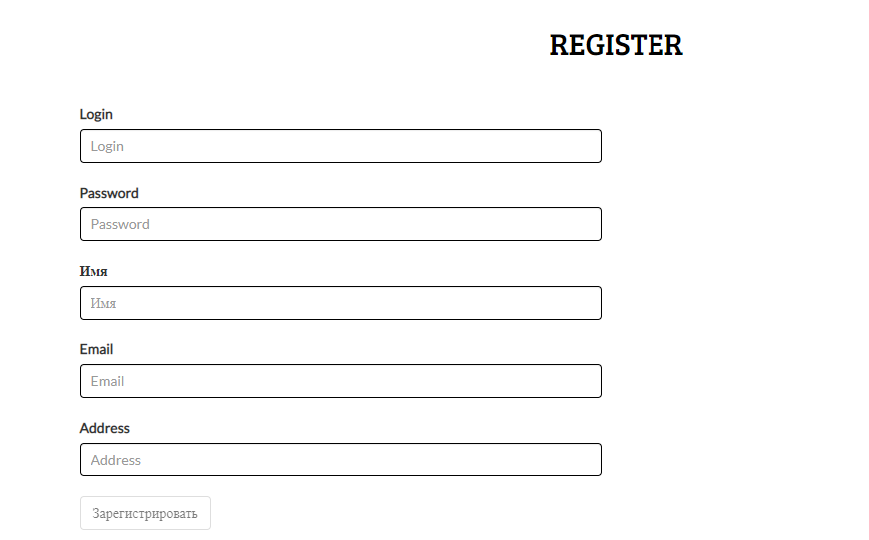
- Напишем обработчик для этой формы для передачи данных в базу. Рисунок 1. Полный листинг представлен в Листинг1.
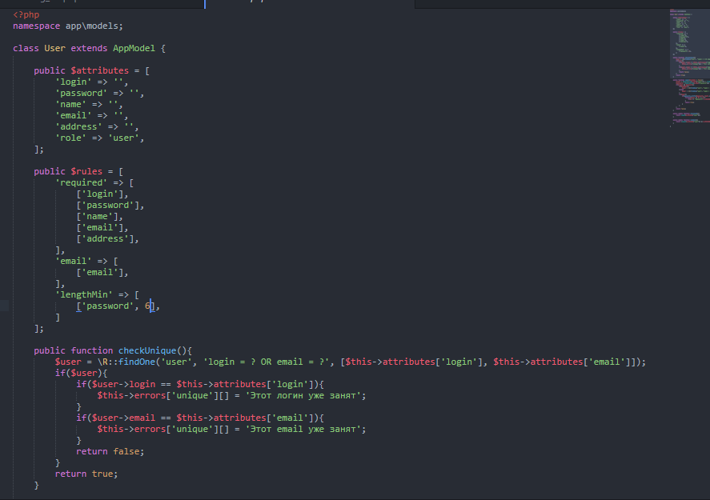
Рисунок 1- обработчик формы

Листинг 1:
<!--start-breadcrumbs-->
<div class="breadcrumbs">
<div class="container">
<div class="breadcrumbs-main">
<ol class="breadcrumb">
<li><a href="<?= PATH ?>">Главная</a></li>
<li>Регистрация</li>
</ol>
</div>
</div>
</div>
<!--end-breadcrumbs-->
<!--prdt-starts-->
<div class="prdt">
<div class="container">
<div class="prdt-top">
<div class="col-md-12">
<div class="product-one signup">
<div class="register-top heading">
<h2>REGISTER</h2>
</div>

<div class="register-main">
<div class="col-md-6 account-left">
<form method="post" action="user/signup" id="signup" role="form" data-toggle="validator">
<div class="form-group has-feedback">
<label for="login">Login</label>
<input type="text" name="login" class="form-control" id="login" placeholder="Login" value="<?=isset($_SESSION['form_data']['login']) ? h($_SESSION['form_data']['login']) : '';?>" required>
<span class="glyphicon form-control-feedback" aria-hidden="true"></span>
</div>
<div class="form-group has-feedback">
<label for="pasword">Password</label>
<input type="password" name="password" class="form-control" id="pasword" placeholder="Password" data-error="Пароль должен включать не менее 6 символов" data-minlength="6" value="<?=isset($_SESSION['form_data']['password']) ? h($_SESSION['form_data']['password']) : '';?>" required>
<span class="glyphicon form-control-feedback" aria-hidden="true"></span>
<div class="help-block with-errors"></div>
</div>
<div class="form-group has-feedback">
<label for="name">Имя</label>
<input type="text" name="name" class="form-control" id="name" placeholder="Имя" value="<?=isset($_SESSION['form_data']['name']) ? h($_SESSION['form_data']['name']) : '';?>" required>
<span class="glyphicon form-control-feedback" aria-hidden="true"></span>
</div>
<div class="form-group has-feedback">
<label for="email">Email</label>
<input type="email" name="email" class="form-control" id="email" placeholder="Email" value="<?=isset($_SESSION['form_data']['email']) ? h($_SESSION['form_data']['email']) : '';?>" required>
<span class="glyphicon form-control-feedback" aria-hidden="true"></span>
</div>
<div class="form-group has-feedback">
<label for="address">Address</label>
<input type="text" name="address" class="form-control" id="address" placeholder="Address" value="<?=isset($_SESSION['form_data']['address']) ? h($_SESSION['form_data']['address']) : '';?>" required>
<span class="glyphicon form-control-feedback" aria-hidden="true"></span>
</div>
<button type="submit" class="btn btn-default">Зарегистрировать</button>
</form>
<?php if(isset($_SESSION['form_data'])) unset($_SESSION['form_data']); ?>
</div>
</div>
</div>
</div>
</div>
</div>
</div>
<!--product-end-->
<?php
namespace app\models;

class User extends AppModel {

public $attributes = [
'login' => '',
'password' => '',
'name' => '',
'email' => '',
'address' => '',
'role' => 'user',
];

public $rules = [
'required' => [
['login'],
['password'],
['name'],
['email'],
['address'],
],
'email' => [
['email'],
],
'lengthMin' => [
['password', 6],
]
];

public function checkUnique(){
$user = \R::findOne('user', 'login = ? OR email = ?', [$this->attributes['login'], $this->attributes['email']]);
if($user){
if($user->login == $this->attributes['login']){
$this->errors['unique'][] = 'Этот логин уже занят';
}
if($user->email == $this->attributes['email']){
$this->errors['unique'][] = 'Этот email уже занят';
}
return false;
}
return true;
}

public function login($isAdmin = false){
$login = !empty(trim($_POST['login'])) ? trim($_POST['login']) : null;
$password = !empty(trim($_POST['password'])) ? trim($_POST['password']) : null;
if($login && $password){
if($isAdmin){
$user = \R::findOne('user', "login = ? AND role = 'admin'", [$login]);
}else{
$user = \R::findOne('user', "login = ?", [$login]);
}
if($user){
if(password_verify($password, $user->password)){
foreach($user as $k => $v){
if($k != 'password') $_SESSION['user'][$k] = $v;
}
return true;
}
}
}
return false;
}

public static function checkAuth(){
return isset($_SESSION['user']);
}

public static function isAdmin(){
return (isset($_SESSION['user']) && $_SESSION['user']['role'] == 'admin');
}

