Poker Dice
Valentinno Cruz
CSC 5
Fall 2018
47952

Introduction:

Dice Poker
Dice Poker is a simple game with a quick drift to events. The game is inspired by the well-known card version of Poker. Dice Poker is played with five dice, which have different figures. The goal of the game is to roll the highest combination possible. Compared to the card version of Poker there is no element of bluffing.

The Rules of Dice Poker
The number of players of the Dice Poker is not limited. Each player wagers the same amount of money, the highest poker combination/hand takes it all. The first player rolls five dice. If the player likes the hand he or she may decide to keep up with just one roll. Then the other players have also only one attempt.

It may happen in the situation when the first player thinks it is going to be difficult for other players to overcome his or her dice Poker combination. Generally the number of rolls is set according to the first player.

The first player can keep a specific hand if he or she is satisfied – for example three kings, then he or she rolls the remaining two dice. After the player finishes the round he or she hands over the dice to the next player. The variation with two rounds is the most usual. However the players can agree upon the third roll. Again the highest hand wins.

If two or more players have an equal combination, then the winner is determined by the next roll with five dice.

How do you score?
The dice hands rank as follows (from highest to lowest):
- Five of a kind
- Four of a kind
- Full house (Three of a kind and a pair)
- Three of a kind
- Two pair
- One pair
- High card
Note: Straights do not count, and since there are no suits, there can be no flush.
Aces are high, then sixes, fives, etc.
And that's it. The player with the highest hand wins the game!

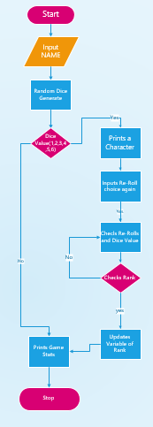
FLOWCHART

Checklist:
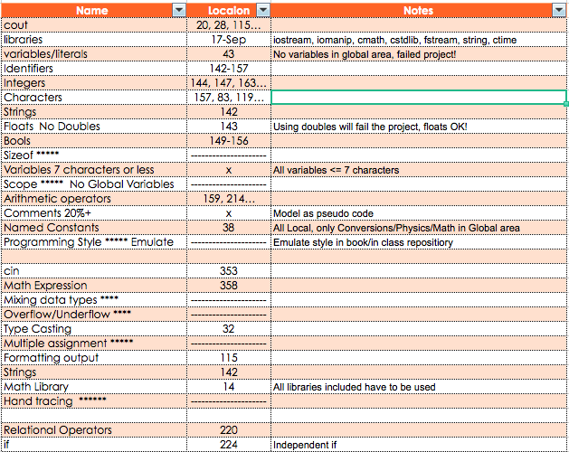
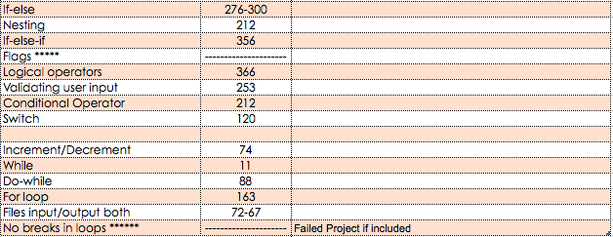

Proof Of Working Code:
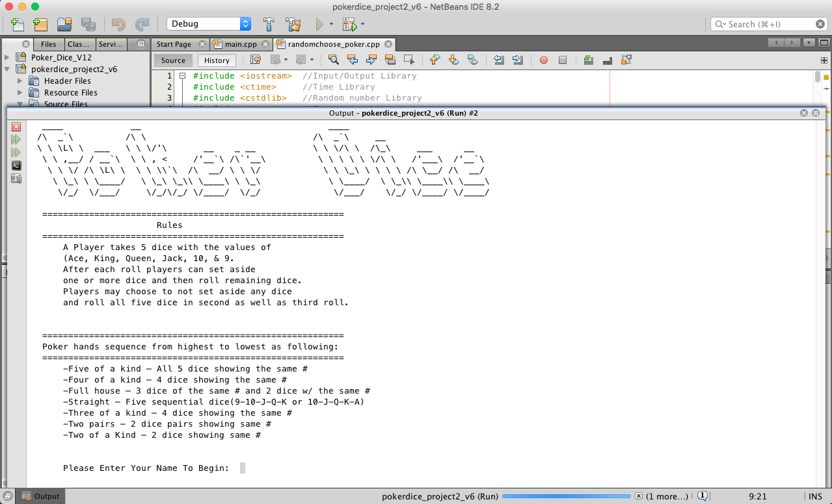

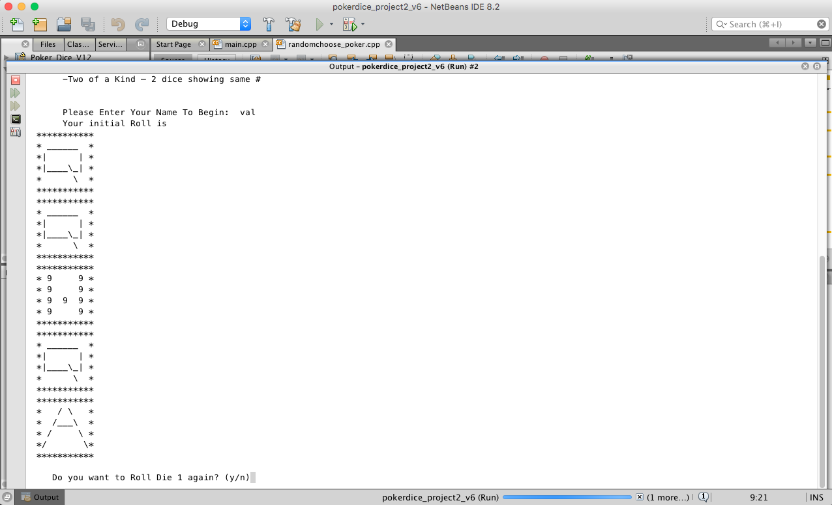
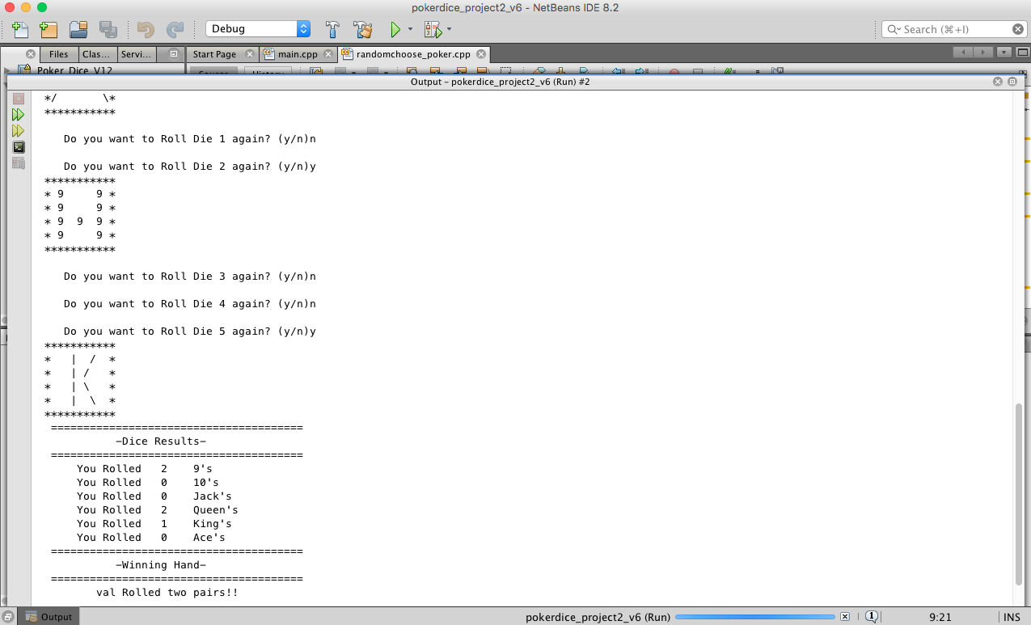
Program:

#include <iostream> //Input/Output Library
#include <ctime> //Time Library
#include <cstdlib> //Random number Library
#include <iomanip> //Formatting Library
#include <cstring> //Strin Library
#include <cmath> //Math Library
#include <fstream> //File Stream Operator
#include <string> // String library
using namespace std;

void print_J() {
cout << " ***********\n"
<< " * ______ *\n"
<< " * | *\n"
<< " * | *\n"
<< " * |___| *\n"
<< " ***********\n";
}
void print_Q() {
cout << " ***********\n"
<< " * ______ *\n"
<< " *| | *\n"
<< " *|____\\_| *\n"
<< " * \\ *\n"
<< " ***********\n";
}
void print_K() {
cout << " ***********\n"
<< " * | / *\n"
<< " * | / *\n"
<< " * | \\ *\n"
<< " * | \\ *\n"
<< " ***********\n";
}
void print_A() {
cout << " ***********\n"
<< " * / \\ *\n"
<< " * /___\\ *\n"
<< " * / \\ *\n"
<< " */ \\*\n"
<< " ***********\n";
}
void print_H() {
cout << " ***********\n"
<< " * 9 9 *\n"
<< " * 9 9 *\n"
<< " * 9 9 9 *\n"
<< " * 9 9 *\n"
<< " ***********\n";
}
void print_M() {
cout << " ***********\n"
<< " * x x *\n"
<< " * x x x *\n"
<< " * x x x *\n"
<< " * x x *\n"
<< " ***********\n";
}
string getDie(int nLines) {
//Declare variables
fstream in;
string die;
//Initialize variables
in.open("die.dat");
//Look through file to find the random Die Value
for (int line = 1; line <= nLines; line++) {
in >> die;
}
//Close the file
in.close();
//Return the random Die

return die;
}
void dice_again(char Die,char choice,bool re) {
cin >> choice;

// If user opts in to change die
if (choice == 'y' || choice == 'Y') {
do {
Die = rand() % 6 + 1; // generate a new die for die

//Possible outcomes of Die
if (Die == 1) {
print_H();
}
if (Die == 2) {
print_M();
}
if (Die == 3) {
print_J();
}
if (Die == 4) {
print_Q();
}
if (Die == 5) {
print_K();
}
if (Die == 6) {
print_A();
}
else { re = false; }
} while ((re) && (choice == 'y'));
}
}
void input_choice(int no) {
cout << fixed << setprecision(2) << showpoint << endl;
cout << " Do you want to Roll Die " << no;
cout << " again? (y/n)";
}
void determine_possible(char Die,char re,int Num[]) {
switch (Die) { // If die 1 was not re-rolled its value would be determined here
case 1: {
if (re == false) Num[0] += 1; }break;
case 2: {
if (re == false) Num[1] += 1; } break;
case 3: {
if (re == false) Num[2] += 1; } break;
case 4: {
if (re == false) Num[3] += 1; }break;
case 5: {
if (re == false) Num[4] += 1; } break;
case 6: {
if (re == false) Num[5] += 1; } break;
}
}

//Program Execution Begins Here
int main() {
//Initialize the random number function
srand(static_cast<unsigned int>(time(0)));

//Test out the Dice Shuffle and pick 5 unique Die & Declare variables
string name; //String names for Die
float nHands = 1; //Number of tosses
int NumOF1s = 0, NumOF2s = 0, //sum of values of die
NumOF3s = 0, NumOF4s = 0,
NumOF5s = 0, NumOF6s = 0;
int NumOF[6];
unsigned char Die[5];
bool TwoOAK = false; //Two of a kind boolean statement
bool ThreeOAK = false; //Three of a kind boolean statement
bool FourOAK = false; //Four of a kind boolean statement
bool FiveOAK = false; //Five of a kind boolean statement
bool TwoPairs = false; //Two pairs boolean statement
bool Str8 = false; //Straight boolean statement
bool FullH = false; //Full House boolean statement
bool re[5];
char choice[5];

for (int i = 0; i < 5; i++) {
re[i] = false;
}

for (int i = 0; i <= 5; i++) {
NumOF[i] = 0;
}
// Welcome Header
cout << " ____ __ ____ " << endl;
cout << " /\\ _`\\ /\\ \\ /\\ _`\\ __ " << endl;
cout << " \\ \\ \\L\\ \\ ___ \\ \\ \\/'\\ __ _ __ \\ \\ \\/\\ \\ /\\_\\ ___ __ " << endl;
cout << " \\ \\ ,__/ / __`\\ \\ \\ , < /'__`\\ /\\`'__\\ \\ \\ \\ \\ \\ \\/\\ \\ /'___\\ /'__`\\ " << endl;
cout << " \\ \\ \\/ /\\ \\L\\ \\ \\ \\ \\\\`\\ /\\ __/ \\ \\ \\/ \\ \\ \\_\\ \\ \\ \\ \\ /\\ \\__/ /\\ __/ " << endl;
cout << " \\ \\_\\ \\ \\____/ \\ \\_\\ \\_\\\\ \\____\\ \\ \\_\\ \\ \\____/ \\ \\_\\\\ \\____\\\\ \\____\\ " << endl;
cout << " \\/_/ \\/___/ \\/_/\\/_/ \\/____/ \\/_/ \\/___/ \\/_/ \\/____/ \\/____/ " << endl;
cout << "" << endl;

//Rules
cout << " ==========================================================" << endl;
cout << setw(30);
cout << " Rules" << endl;
cout << " ==========================================================" << endl;
cout << " A Player takes 5 dice with the values of " << endl;
cout << " (Ace, King, Queen, Jack, 10, & 9." << endl;
cout << " After each roll players can set aside " << endl;
cout << " one or more dice and then roll remaining dice. " << endl;
cout << " Players may choose to not set aside any dice " << endl;
cout << " and roll all five dice in second as well as third roll." << endl;
cout << "" << endl;
cout << "" << endl;

//Winning Hands
cout << " ==========================================================" << endl;
cout << " Poker hands sequence from highest to lowest as following:" << endl;
cout << " ==========================================================" << endl;
cout << " -Five of a kind – All 5 dice showing the same #" << endl;
cout << " -Four of a kind – 4 dice showing the same #" << endl;
cout << " -Full house – 3 dice of the same # and 2 dice w/ the same #" << endl;
cout << " -Straight – Five sequential dice(9-10-J-Q-K or 10-J-Q-K-A)" << endl;
cout << " -Three of a kind – 4 dice showing the same #" << endl;
cout << " -Two pairs – 2 dice pairs showing same #" << endl;
cout << " -Two of a Kind – 2 dice showing same #" << endl;
cout << "" << endl;
cout << "" << endl;

//Initiate Game
cout << " Please Enter Your Name To Begin: ";
cin >> name;
cout << " Your initial Roll is" << endl;

//Randomly generated value applied to individual die
for (int hand = 1; hand <= nHands; hand++) {
// declare the dice
for (int i = 0; i < 5; i++)
{
Die[i]= rand() % 6 + 1;
}

for(int i=0;i<5;i++)
{
//Output the 5 unique dice
if (Die[i] == 1) { //symbol applied to die with given value
print_H();
NumOF1s++;
}
if (Die[i] == 2) { //symbol applied to die with given value
print_M();
NumOF2s++;
}
if (Die[i] == 3) { //symbol applied to die with given value
print_J();
NumOF3s++;
}
if (Die[i] == 4) { //symbol applied to die with given value
print_Q();
NumOF4s++;
}
if (Die[i] == 5) { //symbol applied to die with given value
print_K();
NumOF5s++;
}
if (Die[i] == 6) { //symbol applied to die with given value
print_A();
NumOF6s++;
}
}

for (int i = 0; i < 5; i++)
{
input_choice(i+1);
// dice_again(Die[i], choice[i], re[i]);
cin >> choice[i];

// If user opts in to change die
if (choice[i] == 'y' || choice[i] == 'Y') {
// do {
if (Die[i] == 1) {
NumOF1s--;
}
if (Die[i] == 2) {
NumOF2s--;
}
if (Die[i] == 3) {
NumOF3s--;
}
if (Die[i] == 4) {
NumOF4s--;
}
if (Die[i] == 5) {
NumOF5s--;
}
if (Die[i] == 6) {
NumOF6s--;
}
Die[i] = rand() % 6 + 1; // generate a new die for die

//Possible outcomes of Die
if (Die[i] == 1) {
print_H();
NumOF1s++;
}
if (Die[i] == 2) {
print_M();
NumOF2s++;
}
if (Die[i] == 3) {
print_J();
NumOF3s++;
}
if (Die[i] == 4) {
print_Q();
NumOF4s++;
}
if (Die[i] == 5) {
print_K();
NumOF5s++;
}
if (Die[i] == 6) {
print_A();
NumOF6s++;
}
else { re[i] = false; }
// } while ((re[i]) && (choice[i] == 'y'));
}
}

//Determine the possible hands of tossed dice if user did not choose to Re-Roll
for (int i = 0; i < 5; i++)
{
determine_possible(Die[i], re[i], NumOF);

}

// Roll Results
cout << " =======================================" << endl;
cout << setw(27);
cout << "-Dice Results-" << right << endl;
cout << " =======================================" << endl;
cout << " You Rolled " << NumOF1s << " 9's" << endl; // sum of 9's rolled or Re-rolled
cout << " You Rolled " << NumOF2s << " 10's" << endl; // sum of 10's rolled or Re-rolled
cout << " You Rolled " << NumOF3s << " Jack's" << endl; // sum of jack's rolled or Re-rolled
cout << " You Rolled " << NumOF4s << " Queen's" << endl; // sum of queen's rolled or Re-rolled
cout << " You Rolled " << NumOF5s << " King's" << endl; // sum of king's rolled or Re-rolled
cout << " You Rolled " << NumOF6s << " Ace's" << endl; // sum of ace's rolled or Re-rolled
cout << " =======================================" << endl;
cout << setw(27);
cout << "-Winning Hand-" << right << endl;
cout << " =======================================" << endl;

//Determine if a five of a kind was rolled
if (NumOF1s == 5 || NumOF2s == 5 || NumOF3s == 5 || NumOF4s == 5 ||
NumOF5s == 5 || NumOF6s == 5 )
{
cout<<setw(13);
cout <<name<< "Rolled five of a kind!!!!!"<<right<< endl;
FiveOAK =true;
}

//Determine how many four of a kinds are in given
if (((NumOF1s == 4) || (NumOF2s == 4) || (NumOF3s ==4) || (NumOF4s ==4)
|| (NumOF5s == 4) || (NumOF6s == 4)) && (FiveOAK==false))
{
cout<<setw(13);
cout <<name<< "Rolled four of a kind!!!!" <<right<< endl;
FourOAK=true;
}

//Determine if a straight was rolled
if (((NumOF1s >= 1 && NumOF1s < 6) && (NumOF2s >= 1 && NumOF2s < 6)&&
(NumOF3s >= 1 && NumOF3s < 6) && (NumOF4s >= 1 && NumOF4s < 6) &&
(NumOF5s >= 1 && NumOF5s < 6)) && (NumOF1s != NumOF2s && NumOF2s !=
NumOF3s && NumOF3s != NumOF4s && NumOF4s != NumOF5s))
{
cout<<setw(13);
cout <<name<< " Rolled a straight!!!" <<right<< endl;
}
else if (((NumOF1s > 1 && NumOF1s <= 6) && (NumOF2s > 1 && NumOF2s <=6)
&& (NumOF3s > 1 && NumOF3s <= 6) && (NumOF4s > 1 && NumOF4s <= 6)&&
(NumOF5s > 1 && NumOF5s <= 6)) && (NumOF1s != NumOF2s && NumOF2s !=
NumOF3s && NumOF3s != NumOF4s && NumOF4s != NumOF5s))
{
cout<<setw(13);
cout <<name<< " Rolled a straight!!!!" <<right<< endl;
}

//Determine if a full house was rolled
if ((TwoOAK == true||TwoPairs == true) && (ThreeOAK == true))
{
cout<<setw(13);
cout <<name<< " Rolled a full house!!!!" <<right<< endl;
FullH = true;
}

//Determine if a three of a kind was rolled
if ((NumOF1s == 3 || NumOF2s == 3 || NumOF3s == 3 || NumOF4s == 3 ||
NumOF5s == 3 || NumOF6s == 3)
&& (FiveOAK == false && FourOAK == false))
{
cout<<setw(13);
cout << name<<" Rolled three of a kind!!!"<<right << endl;
ThreeOAK = true;
}

//Determine if two pairs was rolled
if (((NumOF1s == 2) && (NumOF2s ==2 || NumOF3s==2||NumOF4s==2 ||
NumOF5s==2 ||NumOF6s==2)) && (FourOAK == false
&& ThreeOAK ==false && FiveOAK == false && FullH == false))
{
cout<<setw(13);
cout<<name<< " Rolled two pairs!!"<<right<<endl;
TwoPairs = true;
}

//Determine if two pairs was rolled
if (((NumOF2s==2) && (NumOF3s==2||NumOF4s==2|| NumOF5s==2 ||NumOF6s==2))
&& (FourOAK == false &&ThreeOAK ==false
&& FiveOAK == false && FullH == false))
{
cout<<setw(13);
cout<< name<<" Rolled two pairs!!"<<right<<endl;
TwoPairs = true;
}

//Determine if two pairs was rolled
if (((NumOF3s==2) && (NumOF4s==2|| NumOF5s==2 || NumOF6s==2))
&& (FourOAK == false &&ThreeOAK ==false
&& FiveOAK == false && FullH == false))
{
cout<<setw(13);
cout<<name<< " Rolled two pairs!!!"<<right<<endl;
TwoPairs = true;
}

//Determine if two pairs was rolled
if (((NumOF4s==2) && (NumOF5s==2 || NumOF6s==2))
&& (FourOAK == false &&ThreeOAK ==false
&& FiveOAK == false && FullH == false))
{
cout<<setw(13);
cout<<name<< " Rolled two pairs!!!"<<right<<endl;
TwoPairs = true;
}
if (((NumOF5s==2) && (NumOF6s==2)) && (FourOAK == false
&& ThreeOAK ==false && FiveOAK == false && FullH == false))
{
cout<<setw(13);
cout<<name<< " Rolled two pairs!!!"<<right<<endl;
TwoPairs = true;
}

//Determine how many two of a kinds are in given hand
if ((NumOF1s == 2 || NumOF2s == 2 || NumOF3s == 2 ||
NumOF4s == 2 || NumOF5s == 2 || NumOF6s == 2)
&& (TwoPairs==false))
{
cout<<setw(13);
cout<<name<<" Rolled two of a kind!!"<<right<<endl;
TwoOAK = true;
}
}
system("pause>null"); }

