Databases Project – Spring 2019
Team No:
Names: Valentyna Pavliv , Yann Gaboud , Nazli Deniz Uzuner
Contents
Contents 1
Deliverable 1 2
Assumptions 2
Entity Relationship Schema 2
Schema 2
Description 2
Relational Schema 2
ER schema to Relational schema 2
DDL 3
General Comments 3
Deliverable 2 4
Assumptions 4
Data Loading 4
Query Implementation 4
Query a: 4
Description of logic: 4
SQL statement 4
Interface 4
Design logic Description 4
Screenshots 4
General Comments 4
Deliverable 3 5
Assumptions 5
Query Implementation 5
Query a: 5
Description of logic: 5
SQL statement 5
Query Analysis 5
Selected Queries (and why) 5
Query 1 5
Query 2 5
Query 3 5
Interface 6
Design logic Description 6
Screenshots 6
General Comments 6

Deliverable 1

Assumptions

- Each listing has a host.
- Id ‘s of entities such as host_id, reviewer_id, listings_id are unique.
- Each location(represented by latitude and longitude) has one listing
- Given a date and a listing we could have one pricing and availability information.

Entity Relationship Schema

Schema

Description
- USER : User is an entity that represents users reviewing and hosting in Airbnb. Each user may or may not have one or more than one review but each review has one and only one user.
- HOST : A host is a user since it has a unique id and a name. Each listing has one host but each host can host more than one listings. A host’s existance doesn’t depend on listing.
- REVIEW SCORES : Review scores is not a weak entity since it hasn’t got a unique id and since it could only be presented but an id of another entity. Each review score has one listing and each review score has one listing
- PRICING : Pricing is a weak entity for the same reason as review scores. This weak entity represent payment informations such as price , cleaning fee ...Each listing has one pricing and each pricing has one listing . If a listing is removed from the database the pricing information related to that listing should also be removed.
- BOOKING POLICY : Booking policy is also a weak entity because of the same reasons given above(it has no unique id , it could only be presented by a unique id of another entity). Each listing has one booking policy and each booking policy has one listing. If a listing is removed from the database the relevant booking information should also be removed.
- LOCATION : Location is an entity representing location of the listing. It is an entity since it is a real world object, unlike pricing and booking policy a location has a unique id that could differ it from other locations : combination of latitude, longitude. Each listing has one location and each location has one listing(since we can’t have two listings in the same location)
- HOUSE : House is a weak entity since houses doesn’t have their own key. If the listing no longer exists the house will no longer exist sincee each house has one listing.Each location has one house and each house has one location. If a location is removed from the database the house on that location should also be removed.
- CALENDAR : Calendar is an entity representing the avalabilities and pricing of a listing on a given date. Calender’s key is a combination of (date, listing_id) . Each Calendar has one and only listing but a listing may have multiple date informations.
- AMENITIES : Amenities is a weak entity representing the amenities of a given listing. Amenities has two attributes ,amenities and access , and a foreign key : listing_id. If a listing_id is removed from the database the amenities should also be removed. Each listing has exactly one amenity and an amenitiy has exactly one listing.

Relational Schema

ER schema to Relational schema
TABLES:
- USER : User entity has an user_id as a primary key and a name as an attribute.
- HOST : Host has a primary key host_id ( = user_id since host is a user)and has attributes such as name , url, response time and rate, picture url, since( The date that the host has started working with Airbnb) , thumbnail_url, host_neighbourhood and verifications. HOST IS A USER since each host is a user of Airbnb that is caractarized by an id(host_id) and each host has a name .
- REVIEW : Each review has a unique id which is the primary key of Review. Review has two foreign keys ,one of them is the reviewer id and the other one is the listings id. Both of these attributes are the principal keys of other entities : Reviewer and Listings.
- AMENITIES : Table that represents weak entity Amenities that has a foreign key , id of the listing, and 2 other attributes named amenities and access.
- BOOKING POLICY : Table that represents weak entity booking policy. It has a foreign key, id of listing that it belongs to, and other attributes such as extra_people, is_business_travel_ready, require_guest_profile_picture, maximum_nights, minimum_nights, cancellation_policy and guests_included. We combined these attributes since they have a point in commun : they are all a part of the booking policy. They posses information about booking requirements and pricing.
- CALENDAR : Table Calendar represents the table of entity Calendar. It contains a combination of an attribute and a foreign key as a primary key : (date, listing_id). Since we assumed that for a given date a listing can have one entry on database . For a given date a listing can have one price and availability information.
- Date informations : Date informations represents the relation between entities Calendar and Listings. It has two attributes : date and id.
- Hosts : Hosts represents the relation between a host and a listing. It contains two foreign keys such as id of the listings and id of the host.
- HOUSE : Table house represents the weak entity House. It has a combination of two attributes as a foreign key (latitude, longitude) which is the primary key of entity Location. It contains attributes giving information about house such as : neighbourhood, beds, space, property_type, room_type, bed_type, house_rules, accomodates, square_feet, bathrooms, bedrooms

DDL
<Provide the DDL>

General Comments
<In this section write general comments about your deliverable (comments and work allocation between team members>

Deliverable 2
Changes

Note: words in uppercase are entities.

1) The review entity is now a relation between user USER and LISTINGS.
2) The review table has now three attributes as primary key id_user, id_listings and id_review so that a user can post multiple reviews on a listing.
3) Attributes response_time, verification_type, amenity, property_type, room_type and bed_type are no more stored as attribute of an entity but are now stored in specific tables. These tables are a predefined set of categorical values (normalization).
4) Availability is now a relation between LISTINGS and CALENDAR.
5) The location has been remade. LOCATIONS stored the country, the country_code and the city. LOCATIONS has a week entity storing the neighborhood. With this implementation we have a better hierarchy for location-address.

Assumptions
1) a user can post multiple reviews on a listing
2) an host can have multiple listings

Data Loading
TODO

Query Implementation

Query a:

Description of logic:
Compute the average price of a listing with 8 bedrooms.
<how do I decide to solve it>

SQL statement
SELECT AVG(p.price)
FROM pricing p, house h
WHERE h.bedrooms >= 8 AND p.pricing_listings_fk = h.listings_id;

Query b:

Description of logic:
Compute the average cleaning review score for listings with TV
<how do I decide to solve it>

SQL statement
SELECT AVG(review_scores.rating)
FROM review_scores rs, amenities a, listings l, has_amenities ra
WHERE (a.amenity LIKE '%TV%'
OR a.amenity LIKE '%Television%'
OR l.summary LIKE '%TV%'
OR l.summary LIKE '%Television%')
AND ( (a.amenity,rs.review_scores_listings_fk) =ra.has_amenities_pk
OR l.id = rs.review_scores_listings_fk);

Query c:

Description of logic:
Print all the hosts who have an available property between date 03.2019 and 09.2019
<how do I decide to solve it>

SQL statement
SELECT h.*
FROM hosts h, calendar c, date_informations d
WHERE h.hosts_listings_fk = d.date_informations_listings_fk
AND c.calendar_pk = d.calendar_listing_id
AND YEAR(c."date") = 2019 AND 3<=MONTH(c."date")<=9;

Query d:

Description of logic:
Print how many listings items exist that are posted by two different hosts but the hosts have the same name.
<how do I decide to solve it>

SQL statement
SELECT COUNT(h1.id_listings)
FROM "USER" u1, "USER" u2, hosts h1
WHERE u1.name = u2.name AND u1.id != u2.id AND (h1.id_user = u1.id OR h1.id_user = u2.id);

Query e:

Description of logic:
Print all the dates that ‘Viajes Eco’ has available accommodations for rent
<how do I decide to solve it>

SQL statement
SELECT c."date"
FROM calendar c, date_informations d, listings l, hosts h
WHERE h.url LIKE '%Viajes Eco%'
AND h.id_listings = c.listing_id
AND c.available = 't';

Query f:

Description of logic:
Find all hosts having only one listing.
<how do I decide to solve it>

SQL statement
SELECT (u.id_user, u.name)
FROM "USER" u,
(SELECT h.id
FROM hosts h, "USER" u
GROUP BY h.id_user
HAVING COUNT(*) = 1
)h
WHERE u.id = h.id;

Query g:

Description of logic:
Compute average difference of listings with and without wifi
<how do I decide to solve it>

SQL statement
SELECT withWifi - withoutWifi
FROM (SELECT AVG(p.price)
FROM pricing p, amenities a, has_amenities ha
WHERE (a.amenity LIKE '%Wifi%'
OR a.amenity LIKE '%WIFI%')
AND ha.amenity = a.amenity AND ha.listing_id = p.pricing_listings_fk) withWifi ,
(SELECT AVG(p.price)
FROM pricing p, amenities a, has_amenities ha
WHERE (NOT a.amenity LIKE '%Wifi%'
AND NOT a.amenity LIKE '%WIFI%')
AND ha.amenity = a.amenity AND ha.listing_id = p.pricing_listings_fk) withoutWifi;

Query h:

Description of logic:
Compute the difference of price of a listings of 8 beds in Berlin and in Madrid
<how do I decide to solve it>

SQL statement
SELECT madridPricing - berlinPricing
FROM (SELECT AVG(p.price)
FROM pricing p,
house h,
location l
WHERE h.beds = 8
AND l.city LIKE '%Madrid%'
AND l.location_listings_fk = h.listings_id
AND p.pricing_listings_fk = h.listings_id
)madridPricing ,
(SELECT AVG(p.price)
FROM pricing p,
house h,
location l
WHERE h.beds = 8
AND l.city LIKE '%Berlin%'
AND l.location_listings_fk = h.listings_id
AND p.pricing_listings_fk = h.listings_id
)berlinPricing;

Query i:

Description of logic:
Compute the top-10 of hosts having the biggest number of listings in Spain
<how do I decide to solve it>

SQL statement
SELECT(u.id_user, u.name)
FROM users u
INNER JOIN (SELECT hosts_user_fk, count(hosts_user_fk) as cnt
FROM hosts
GROUP BY hosts_user_fk) cou ON u.id_user = cou.hosts_user_fk
ORDER BY cnt DESC ;

Query j:

Description of logic:
Compute the top-10 rated apartments in Barcelona.
<how do I decide to solve it>

SQL statement
SELECT (l.id_listing, l.name)
FROM listings l
RIGHT JOIN (SELECT id_listing FROM review_scores rs) s ON l.id_listing = s.id_listing
INNER JOIN (SELECT review_scores_listings_fk, count(review_scores_listings_fk) as cnt
FROM review_scores
GROUP BY review_scores_listings_fk) cou ON rs.id_listing = cou.review_scores_listings_fk
ORDER BY cnt DESC;

Interface

Design logic Description
There are three tabs : Search, Predefined Queries and Insert / Delete.
The search tab is used to perform keyword-based search. The user can simply enter keyword and lists (one for each tab) of matching entry will be printed. It is possible to restrain the search by checking boxes.
The predefined queries tab contains pre-implemented and optimized queries. For some queries it will be possible to provide some fields such as the name or the city. The user simply have to select which query he wants to execute, enters the needed fields (default value will be used if the user doesn’t provide it) and finally press search. Then the result will be pretty printed below.
Finally the insert, delete tab allows the user to add and remove entry in tables. He simply has to select the table he wants to modify, fill the needed field end press insert or delete. In the future the user will maybe be able to delete range of entries by providing keyword.
We use Scene Builder to generate the interface. The application is powered with javaFX and we use the java postgre library to communicate with the database.

Screenshots

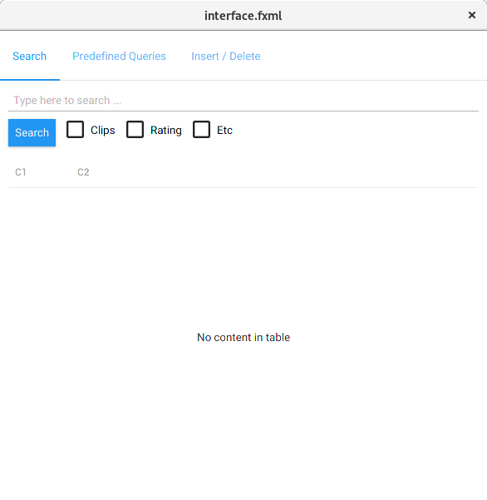
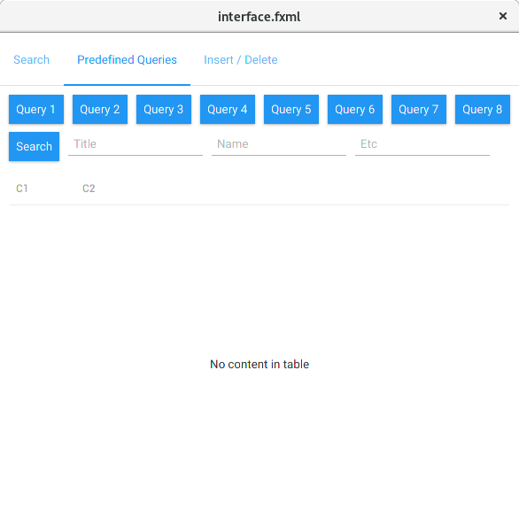

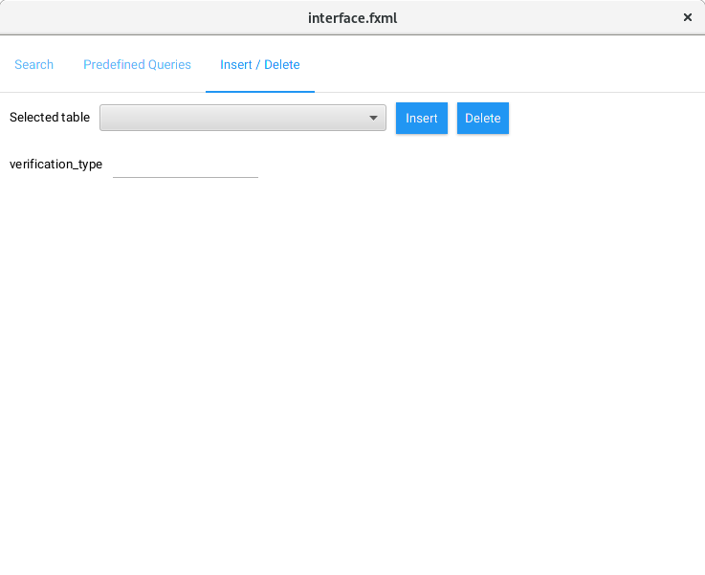

General Comments
<In this section write general comments about your deliverable (comments and work allocation between team members>
-

Deliverable 3

Assumptions
<In this section write down the assumptions you made about the data. Write a sentence for each assumption you made>

Query Implementation
<For each query>

Query a:

Description of logic:
<What does the query do and how do I decide to solve it>

SQL statement
<The SQL statement>

Query Analysis

Selected Queries (and why)

Query 1
<Initial Running time:
Optimized Running time:
Explain the improvement:
Initial plan
Improved plan>

Query 2
<Initial Running time:
Optimized Running time:
Explain the improvement:
Initial plan
Improved plan>

Query 3
<Initial Running time:
Optimized Running time:
Explain the improvement:
Initial plan
Improved plan>

Interface

Design logic Description

Screenshots

General Comments
<In this section write general comments about your deliverable (comments and work allocation between team members>

