Name: _______________________________________ Date: ________________

Your HTML file’s URL:

Image 1 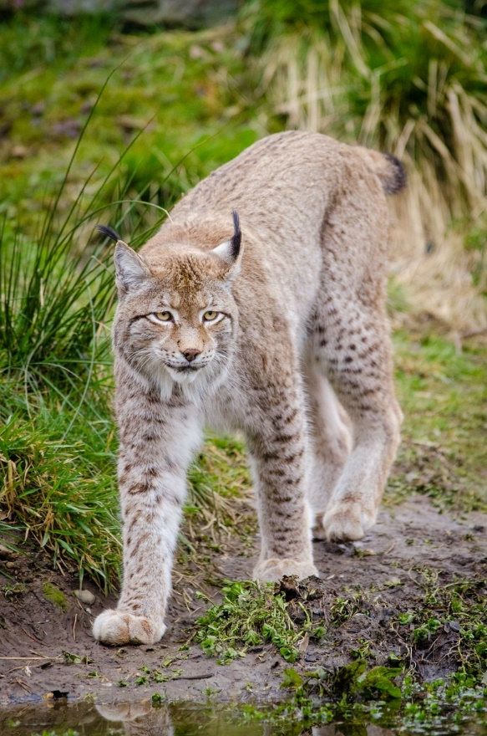
Source page URL:
https://openverse.org/image/76d20883-086f-4f0b-969c-fffa33a8dc7b?q=wild+cats&p=11

Public domain or Creative Commons? (List any reserved rights)

Public domain

Image 2 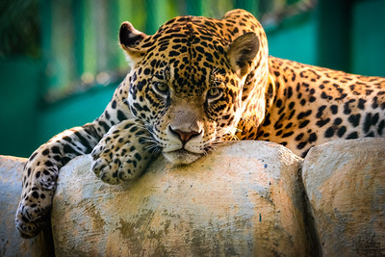
Source page URL:
https://openverse.org/image/36a80b9d-15eb-4172-8665-bdb789b5c58b?q=wild+cats&p=10

Public domain or Creative Commons? (List any reserved rights)

Creative Commons

Image 3 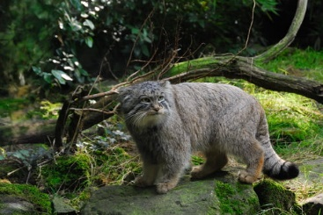
Source page URL:
https://openverse.org/image/e657adc3-a1de-430f-9168-031ca49bccd6?q=wild+cats&p=15

Public domain or Creative Commons? (List any reserved rights)

Creative Commons

