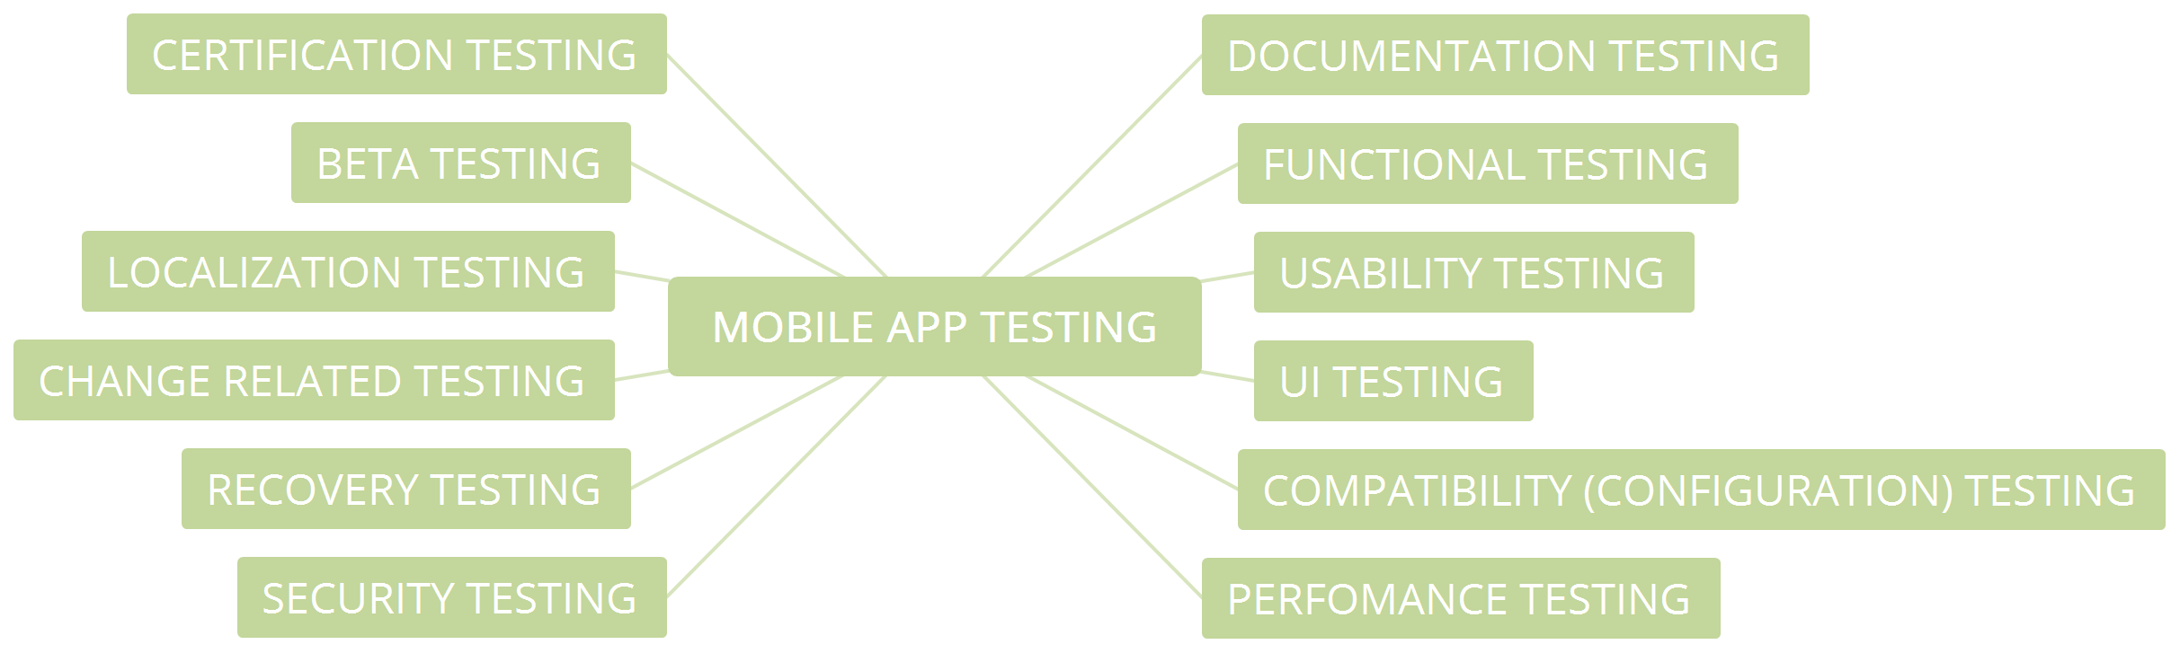

1. **Documentation testing.**
2. **Functional testing:**

* Install and run the application
* Installing the application should be done without significant errors if the device meets the system requirements.
* Make sure the application automatically starts correctly.
* Make sure the user manual is available.
* Make sure that the operation of the application during startup / exit meets the basic requirements.

Field testing:

* Check the correct functioning of the required fields.
* Make sure that the required and optional fields are displayed differently.

Functionality testing:

* Make sure that the stated price and content match the information received by the user.
* Make sure that the user can perform typical operations: buying, adding items to the cart, ordering items, etc.
* Make sure that the application supports payment transactions through payment systems such as Visa, Mastercard, Paypal, etc.
* Check the purchase recovery regardless of the device, but with reference to the account.

Interrupt testing:

* Incoming and outgoing calls, SMS and MMS.
* Discharge / removal of the battery.
* Disconnect and connect network / Wi-Fi.
* Disconnect and connect SD card.
* Charging device.

Continuous testing of user reviews:

* Message loading
* Statistics.
* The corresponding button response when pressed.
* Network access error messages.
* Attempt to delete important informational messages.
* Availability and synchronization of sound, vibration and visual notifications.
* The appearance of the screen (message) at the end of the process (game).

Testing update:

* All user data is saved after updates.
* Verify that the update progress is displayed correctly.
* Ensure that updates are supported by older operating systems.
* Testing various ways to install updates (Wi-Fi, Bluetooth, USB)

Testing device resources:

* Lack of space to install or run the application.
* Memory leak. Pay attention to the windows with a lot of information and tasks with a long workflow.
* Install / replace the application on the SD card.
* The lack of some features supported by the application (3G, SD card).
* Make sure that the installed application does not interfere with the normal operation of other applications and does not use their memory.

Additional testing:

* Testing the correctness of the connection / disconnection of players, connecting players through different networks.
* Make sure the error messages are correct and appropriate.
* Check connectivity to analytics tools such as Google Analytics.
* Energy Testing.
* Check the necessary parameters for proper work with social networks - “Share”, “Publish”, “Navigation”.

1. **Usability Testing**

* Make sure that the buttons are of normal size and placed in one area of ​​the screen.
* Make sure the application is multitasking when necessary.
* Check out the navigation of important application modules.
* Make sure the icons and images look natural in the application environment.
* Make sure that the color of the buttons that perform the same function is the same.
* The text should be simple, clear and visible to the user. You can read short sentences and paragraphs.
* Determine the optimal font size.
* Ensure the correct operation of the Zoom-in and Zoom-out system.
* Check that the context menus are not overloaded.
* Make sure that the application can be interrupted by any state and that it resumes working in the same state.
* Ensure that application components are synchronized with user actions.
* Make sure that the user can return or cancel the action if he pressed the wrong button.
* Make sure the item’s response rate is high enough.

1. **User Interface Testing:**

* Comply with user interface standards. Compliance with standard screen resolutions: 640 × 480, 800 × 600, 1024 × 768, 1280 × 800, 1366 × 768, 1400 × 900, 1680 × 1050.
* Test the performance of applications on different devices.
* Check out the basic design elements: buttons, icons, colors, links, fonts, font sizes, layout, text fields, text formatting, shortcuts, captions, buttons, lists, etc.
* Make sure that the ad does not overlap the application management buttons.
* Make sure the ad has an available close button.
* Check the display of all elements with a portrait and landscape page orientation.

1. **Compatibility testing**

* OS configuration
* Browser configuration
* Database configuration
* Device configuration
* Network configuration

1. **Performance testing:**

* Check the response time of the application to different types of requests to make sure that the application works in accordance with the requirements for the user to load normally. (Stress Testing).
* Testing the performance of the application with loads that exceed the number of users several times. (Stress testing).
* Examine the performance of the application for long-term work under normal load. (Stability).
* Check for work in an “extended” database at normal times. (Volume testing).
* Determine the number of users who can simultaneously work with the application. (Parallel testing).
* Determine if the application is running in different network conditions.
* Find those areas of the application that reduce application performance.
* Assess the ability of the application to cope with certain volumes of load.
* Make sure that the response time of the application meets the requirements.
* Check the stability of the application under heavy load conditions.
* Ensure application performance, if it works in a non-permanent Internet connection.

1. **Security testing:**

* Make sure that the application users' data (logins, passwords, bank card numbers) are protected from network attacks of automated systems.
* Make sure that the application security system requires a strong password and does not allow an attacker to get other users' passwords.
* Ensure that the application does not provide access to sensitive content or features without proper authentication.
* Protect the application and network from DoS Attacks.
* Protect the application from malicious attacks on clients.
* Prevent possible malicious effects of file caching.
* Examine the files of users and prevent their possible negative consequences.
* Analysis of the interaction of system files, identifying and fixing vulnerabilities.

1. **Recovery testing:**

* Check for effective application recovery after unexpected emergencies.
* Ensure the process of data recovery after a break in the connection.
* Check for system recovery and transaction failure recovery.
* Check the application's ability to process transactions in the event of a power failure (low battery, improper closing of the application, etc.).

1. **Localization testing**

* Identify the languages ​​supported by the application.
* Ensure correct translation.
* Check the correctness of the translation in accordance with the theme of the application.
* Check the date formats.
* Check the delimiters in numbers.

1. **Change testing:**

* Make sure that your team has successfully corrected any errors found (re-testing or confirmation testing). Simply put, the test cases, the errors originally found, are run again. And this time they need to go without errors.
* Make sure that the new changes did not lead to new errors. (Regression testing).

1. **Beta testing:**

* A number of participants in the test.
* The duration of the test.
* Demographic coverage
* Cost of testing.

1. **Certification testing:**

Android:

* The installation file for the application (.apk) complies with the program policies.
* The app meets UIG requirements.
* There are no viruses in the application. The Android market semi-automatically checks the application for viruses and can block your account if it detects them.
* You must follow the order of version control when publishing an updated version of your application.

IOS:

* The application complies with the requirements of the User Interface Guide.
* The application must have a unique name.
* You need to provide a link for feedback to the developer.
* The application must be placed in a specific category.
* The App Store checks the application for compatibility.
* The application does not contain prohibited materials, unforeseen delays in work or repetition of existing functions.

Windows Phone:

* The application meets the requirements for application certification requirements.
* A clear description of hardware and network requirements.
* The functions mentioned in the description or shown in the screenshots are fully implemented.