

**UNIVERSIDAD PERUANA DE CIENCIAS APLICADAS**

**FACULTAD DE INGENIERÍA**

**Hito 01**

**CURSO:** Programación II

**DOCENTE:** Ricardo Eugenio Gonzalez Valenzuela

**Integrantes:**

* Tinoco Ricapa, Nadia Lorena - U202012868
* Ortiz Asencio, Valeria Karina - U202013478
* Puppi Lazo, Stephanie Beatriz - U202011924

2020-02

Diagrama de clases

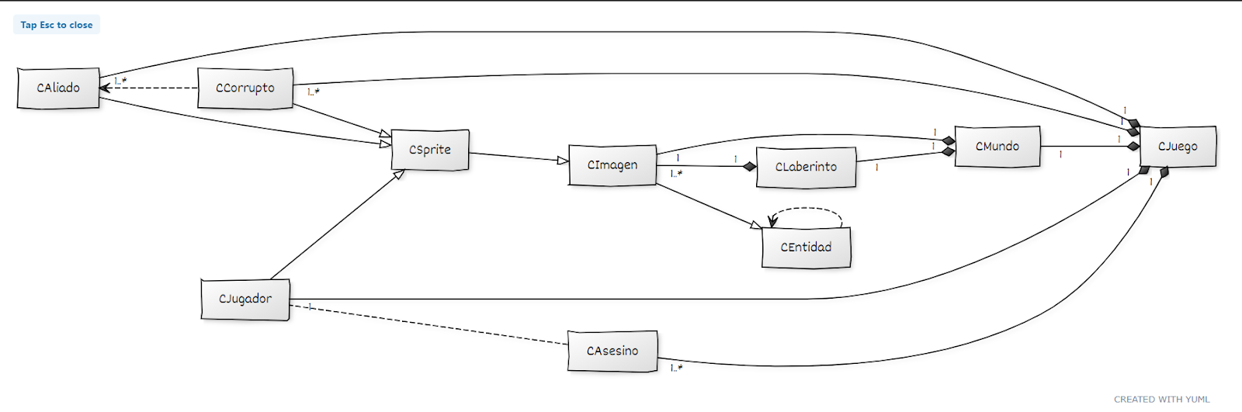

Código del diagrama de clases en YUML

[CLaberinto]1++-1..*[CImagen]

[CMundo]1++-1[CLaberinto]

[CMundo]1++-1[CImagen]

[CCorrupto]-.->[CAliado]

[CAsesino]-.-[CJugador]

[CJuego]1++-1[CMundo]

[CJuego]1++-1..*[CAsesino]

[CJuego]1++-1[CJugador]

[CJuego]1++-1..*[CAliado]

[CJuego]1++-1..*[CCorrupto]

[CSprite]^-[CJugador]

[CSprite]^-[CAliado]

[CSprite]^-[CCorrupto]

[CEntidad]-.->[CEntidad]

[CEntidad]^-[CImagen]

[CImagen]^-[CSprite]

[CEntidad| #area_dibujo:Rectangle|+CEntidad(area:Rectangle);+Mostrar(Graphics g):virtual void;+Colision(CEntidad otro):bool]

[CImagen|#img: Bitmap; -imagen_propia:bool|+CImagen(ruta:String,area_dibujo:Rectangle);+CImagen(img:Bitmap, area_dibujo:Rectangle);+~CImagen();+Mostrar(Graphics g):void]

[CSprite|-dy:short;-dx:short;-n_filas:short;-n_columnas:short;-indicec:short;-indicef:short|+CSprite(ruta:String, area_dibujo:Rectangle,n_f:short, n_c:short,dx:short,dy:short);+CSprite(imagen:Bitmap, area_dibujo:Rectangle,n_f:short, n_c:short);+Animar(Graphics g):void;+SetUbicacion(x:short, y:short):void;#Mostrar():void;#Mover():virtual void;-AreadeRecorte():Rectangle]

[CLaberinto|celdas:List\<CImagen\>|+CLaberinto();+Mostrar():void]

[CMundo|-fondo:CImagen;-laberinto:CLaberinto|+Mostrar(Graphics g):void]

[CJugador|-n_vidas:short|CJugador(vidas:short);+GetVidas():short]

[CAliado||+CAlidado(); +Mover(x:short,y:short):void]

[CCorrupto||+CCorrupto(); +Mover(x:short,y:short):void]

[CAsesino||+CAsesino();+Mover(x:short,y:short):void]

[CJuego|-principal: CJugador;-asesino: :List\<CAsesino\>;-aliados::List\<CAliado\>;-corrupto::List\<CCorrupto\>;-monedas:List\<CImagen\>;-puntos:int|+ Juego();+~Juego();+Jugar():bool;+GetPuntos():int]

|  |  |  |  |  |  |  |  |  |  |  |  |  |  |  |  |  |  |  |  |  |  |  |  |  |  |  |  |  |
| --- | --- | --- | --- | --- | --- | --- | --- | --- | --- | --- | --- | --- | --- | --- | --- | --- | --- | --- | --- | --- | --- | --- | --- | --- | --- | --- | --- | --- |
| ítem | Hito 1 | | | | | | **Plan de Actividades** | | | | | | | Hito 2 | | | | | | |  | | | | | | Hito 3 | Responsable |
| Semana 11 | | | | | | Semana 12 | | | | | | | Semana 13 | | | | | | | Semana 14 | | | | | | Semana 15 |
| Lun | Mar | Mie | Jue | Vier | Sab | Lun | Mar | Mie | Jue | Vier | Sab | Lun | | Mar | Mie | Jue | Vier | Sab | Lun | | Mar | Mie | Jue | Vier | Sab | Lunes |  |
| Diagrama de clases |  |  |  |  |  | X | X |  |  |  |  |  |  | |  |  |  |  |  |  | |  |  |  |  |  | Enviar TF | Stephanie Puppi |
| Sprites |  |  | X |  |  |  | X |  |  |  |  |  | X | |  |  |  |  |  |  | | X |  |  |  |  | Enviar TF | Valeria Ortiz |
| Programar ventana principal/menú |  |  |  |  |  |  |  |  | X |  |  | X |  | |  | X |  |  | X |  | |  | X |  |  |  | Enviar TF | Valeria Ortiz |
| Programar laberinto |  |  |  |  |  |  | X | X |  | X |  | X |  | |  |  |  |  |  |  | |  |  |  |  |  |  | Nadia Tinoco |
| Programar movimiento del personaje principal |  |  |  |  |  |  |  |  |  |  | X |  |  | |  |  |  |  |  |  | |  |  |  |  |  |  | Nadia Tinoco |
| Programar movimiento de los aliados, “corrupts” y “assassins” |  |  |  |  |  |  | X |  | X |  |  | X | X | |  |  |  |  |  |  | |  |  |  |  |  |  | Stephanie Puppi |
| Programar colisión de personajes |  |  |  |  |  |  |  |  |  |  |  |  |  | |  | X |  |  | X |  | |  |  |  |  |  |  | Stephanie Puppi |
| Programar los portales |  |  |  |  |  |  |  |  |  | X |  |  |  | |  |  |  |  |  |  | |  |  |  |  |  |  | Nadia Tinoco |
| **Funcionalidad adicional:** Recoger monedas |  |  |  |  |  |  |  |  |  |  |  |  |  | |  | X |  |  | X |  | |  |  |  |  |  |  | Nadia Tinoco |
| Programar ventana de Presentación |  |  |  |  |  |  |  |  |  |  |  |  |  | |  | X |  |  | X |  | |  | X |  |  | X |  | Valeria Ortiz |
| Programar ventana de negociación |  |  |  |  |  |  |  |  | X |  |  |  |  | |  |  |  |  |  |  | |  |  |  |  |  |  | Nadia Tinoco |
| Programar ventana de “YOU WIN” y “GAME OVER” |  |  |  |  |  |  |  |  |  |  |  |  |  | |  | X |  |  | X |  | |  | X | X |  | X |  | Valeria Ortiz |
| Programar ventana de “CREDITS” |  |  |  |  |  |  |  |  |  |  |  |  |  | |  | X |  |  | X |  | |  | X |  | X | X |  | Valeria Ortiz |