
MINISTRY OF EDUCATION AND RESEARCH OF THE REPUBLIC OF MOLDOVA
Technical University of Moldova
Faculty of Computers, Informatics and Microelectronics
Department of Software and Automation Engineering

Laboratory work 3: Polyalphabetic Ciphers
of the "Cryptography and Security" course

Checked:
asist. univ. Maia Zaica
Department of Software and Automation Engineering,
FCIM Faculty, UTM
Postica Valeria, FAF-243

1. Laboratory Objective
The objective of this laboratory work is to implement the Vigenère polyalphabetic substitution cipher adapted for the Romanian alphabet (31 letters indexed from 0 to 30). The program must handle strict input data validation, removal of whitespaces, uppercase conversion, and enforcement of a minimum key length requirement (at least 7 characters).

2. Mathematical Model of the Vigenère Cipher
The Romanian alphabet consists of $N=31$ letters mapped to the numeric set:
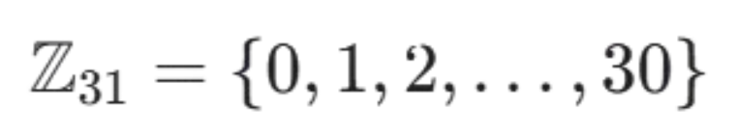
Alphabet Character-to-Index Encoding Table:
- A $→$ 0, Ă $→$ 1, Â $→$ 2, B $→$ 3, C $→$ 4, D $→$ 5, E $→$ 6, F $→$ 7, G $→$ 8, H $→$ 9, I $→$ 10, Î $→$ 11, J $→$ 12, K $→$ 13, L $→$ 14, M $→$ 15, N $→$ 16, O $→$ 17, P $→$ 18, Q $→$ 19, R $→$ 20, S $→$ 21, Ș $→$ 22, T $→$ 23, Ț $→$ 24, U $→$ 25, V $→$ 26, W $→$ 27, X $→$ 28, Y $→$ 29, Z $→$ 30.

Mathematical Equations:
Let $m_{i}$ be the numeric value of the plaintext letter at index $i$, $k_{i}$ be the numeric value of the key letter at index i mod length(K), and $c_{i}$ be the numeric value of the resulting ciphertext letter.
- Encryption Equation:
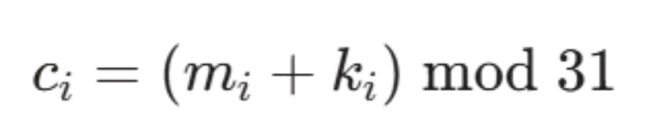
- Decryption Equation:
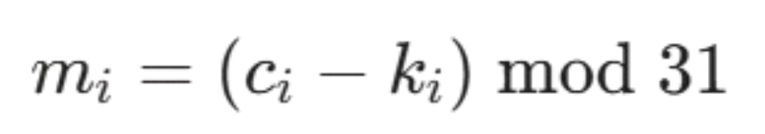

3. Algorithm and Implementation Details
The program was developed in Python and operates through the following steps:
- Preprocessing and Data Validation:
  - Removes all whitespace characters from both plaintext and secret key.
  - Automatically converts lowercase characters to uppercase (including Romanian diacritics: ă, â, î, ș, ț).
  - Validates every character. If any non-alphabetic character (numbers, punctuation marks, special symbols) is detected, the program raises a detailed exception prompting the user with the allowed range.
- Key Length Verification:
  - Verifies that the processed key length is greater than or equal to 7 characters (length >=7).
- User Interaction:
  - Provides an interactive CLI menu enabling the user to choose between encryption, decryption, or exiting the application.

4. Test Cases and Execution Results

Example 1: Encryption Mode
- Original Plaintext: Securitatea informatiei este importanta
- Secret Key: criptografie (length: 12 $≥$ 7)
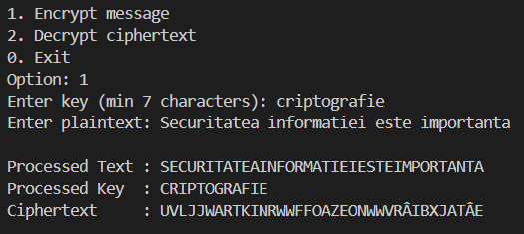
Figure 4.1 - Encryption Mode

Preprocessing Output:
- Processed Plaintext: SECURITATEAINFORMATIEIESTEIMPORTANTA
- Processed Key: CRIPTOGRAFIE
Step-by-step Numeric Transformations:
- S (21) + C (4) = 25 mod 31 $→$ U
- E (6) + R (20) = 26 mod 31 $→$ V
- C (4) + I (10) = 14 mod 31 $→$ L …
Resulting Ciphertext: UVLJJWARTKINRWWFFOAZEONWWVRÂIBXJATÂE
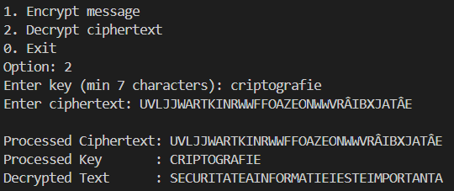
Figure 4.2 - Decryption Mode

Example 2: Error Handling & Validation
- Key Length Error Test:
  - Input Key: CHEIE (5 letters)
  - Console Output: [ERROR] Key length must be at least 7 characters long!
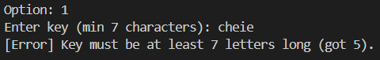
Figure 4.3 - Key Length Error Test
- Invalid Character Test:
  - Input Plaintext: Hello123
  - Console Output: [ERROR] Invalid character '1' found in Plaintext...
Figure 4.4 - Invalid Character Test

5. Conclusions
In this laboratory task, the Vigenère polyalphabetic cipher was successfully adapted and implemented for the 31-letter Romanian alphabet. Expanding the standard 26-letter Latin alphabet to 31 characters shifts the mathematical modulus to mod31. The polyalphabetic substitution mechanism flattens character frequency distribution, providing enhanced cryptographic protection compared to monoalphabetic ciphers.

