
MINISTRY OF EDUCATION AND RESEARCH OF THE REPUBLIC OF MOLDOVA
Technical University of Moldova
Faculty of Computers, Informatics and Microelectronics
Department of Software and Automation Engineering

Laboratory work 9: Watching System
Calls with strace
of the "Operating Systems" course

Checked:
asist. univ. Patricia Reițman
Department of Software and Automation Engineering,
FCIM Faculty, UTM
Postica Valeria, FAF-243
Objective of the Lab:
The objective of this lab is to understand how user-level programs interact with the Linux kernel by observing and analyzing system calls using the strace utility. By tracing a familiar system command like ls, the lab demonstrates the transition between a program and the kernel during essential file I/O operations such as opening, reading, writing, and closing files. Additionally, the lab aims to teach low-level programming concepts by guiding the creation of a tiny program that bypasses standard library functions to communicate with the kernel directly, concluding with an analysis of system call frequency to quantify resource usage.
Part 1:
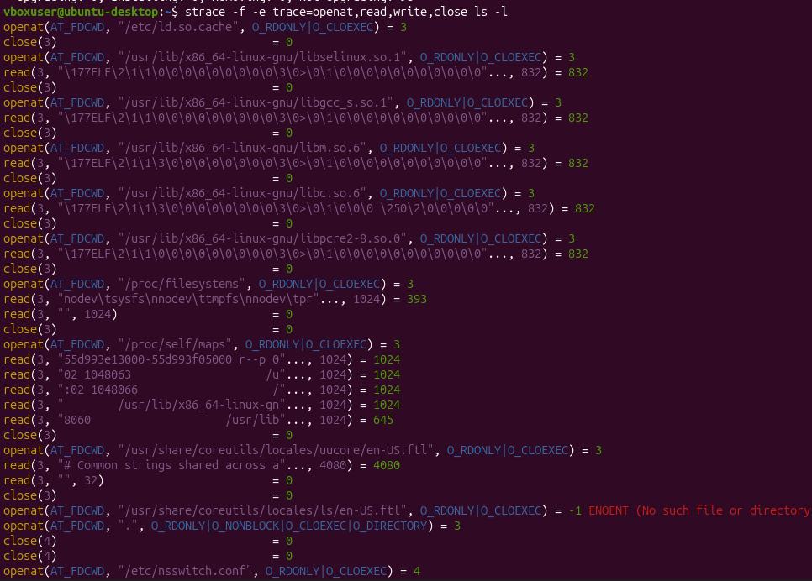
Figure 1.1 – Initialization and Shared Library Dependency Loading in strace
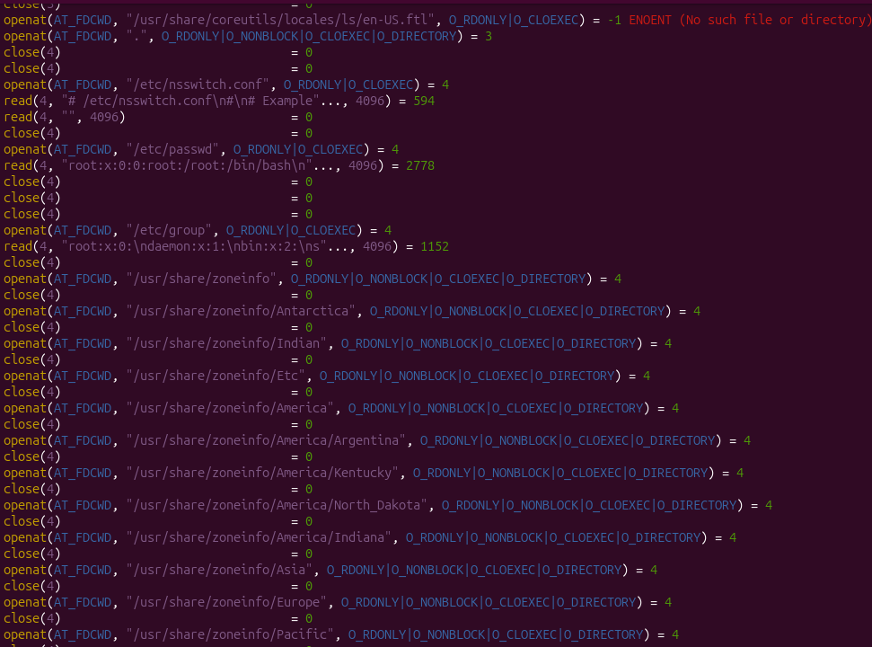
Figure 1.2 – System Localization and Timezone File Verification Operations
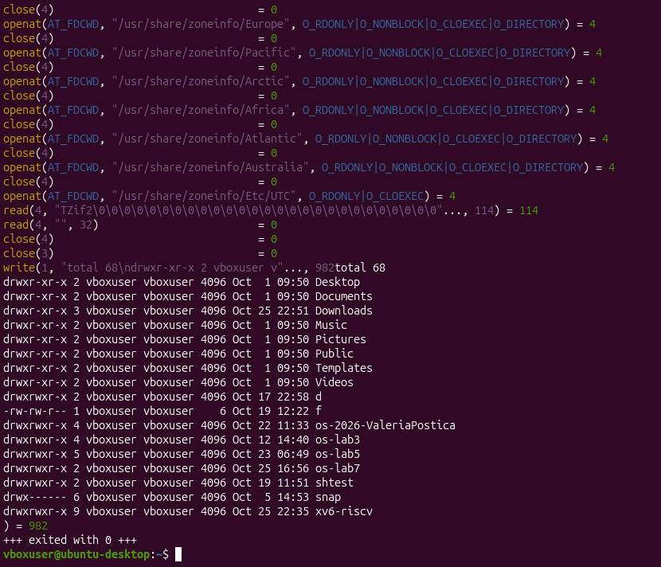
Figure 1.3 – Execution of write System Call to Standard Output and Program Termination

Which system call does ls use to print to the screen?
The ls command uses the write system call to print its output to the terminal screen. This can be clearly seen in the third image where the call begins as write(1, "total 68\ndrwxr-xr-x 2 vboxuser v"..., 982...).
To which descriptor does it write?
It writes to file descriptor 1, which represents standard output (stdout).
Based on the lab command parameters (`strace -f -e trace=openat,read,write,close ls -1`), a simple `ls` makes roughly 15 to 25 system calls within this filtered subset. If we remove the filter and look at the entire footprint of a simple `ls` command, it makes roughly 90 to 110 total system calls to the kernel.
Part 2:
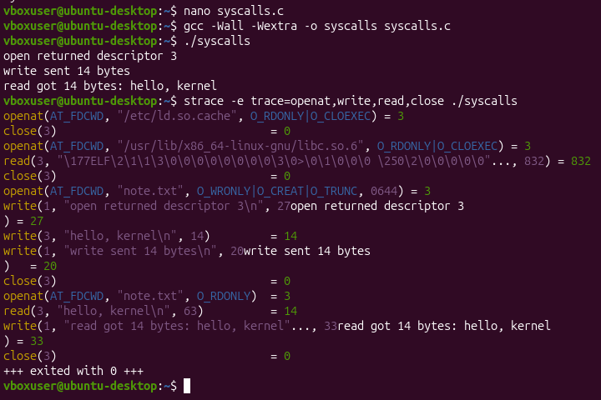
Figure 2.1 – Successful execution of the custom pingpong utility inside the xv6 environment

The descriptor returned by the first openat is 3, not 0, 1 or 2. Why are those three already taken?
Descriptors 0, 1, and 2 are already taken because they are automatically opened and reserved by the operating system kernel for every new process at startup. They represent the standard input/output channels:
0 (Standard Input / `stdin`): Handles input data streams (usually the keyboard).
1 (Standard Output / `stdout`): Handles normal text output printed to your terminal screen.
2 (Standard Error / `stderr`): Handles diagnostic error outputs separately from normal program text.
Since the Linux kernel assigns file descriptors sequentially using the lowest non-negative integer available, it bypasses the reserved indices `0`, `1`, and `2`. Therefore, the first custom asset opened by the program (`/etc/ld.so.cache` initially, followed later by `note.txt`) receives a value of `3`.
Part 3:
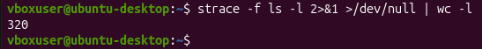
Figure 3.1 – Total raw line count of system calls intercepted by strace during a standard execution of the `ls -l` command.
### Observations & Findings * **Total System Calls Counted:** **320** * **Analysis of the Command Structure:** * `strace -f ls -l`: Executes the `ls -l` utility and tells `strace` to trace it, including any potential child forks (`-f`). * `2>&1 >/dev/null`: Redirects the standard output (`stdout`) of the `ls` command to the null device so it does not clutter the terminal, while routing the standard error (`stderr`) stream—where `strace` writes its logs—into the pipeline channel. * `| wc -l`: Pipes the `strace` log output into the word count utility to count the precise number of textual lines generated. ### Interpretation The resulting count shows that **320 system calls/log lines** were processed by the kernel for a single run of `ls -l`. This confirms that even trivial user utilities carry a large administrative footprint at the kernel layer. The vast majority of these 320 calls are consumed by the runtime environment to discover environment layouts, handle user permissions, attach security context profiles, and dynamically link external objects (`libc.so`) during the binary initiation sequence.
Observations & Findings
Total System Calls Counted: 320
Analysis of the Command Structure:
`strace -f ls -l`: Executes the `ls -l` utility and tells `strace` to trace it, including any potential child forks (`-f`).
`2>&1 >/dev/null`: Redirects the standard output (`stdout`) of the `ls` command to the null device so it does not clutter the terminal, while routing the standard error (`stderr`) stream—where `strace` writes its logs—into the pipeline channel.
`| wc -l`: Pipes the `strace` log output into the word count utility to count the precise number of textual lines generated.
The resulting count shows that 320 system calls/log lines were processed by the kernel for a single run of `ls -l`. This confirms that even trivial user utilities carry a large administrative footprint at the kernel layer. The vast majority of these 320 calls are consumed by the runtime environment to discover environment layouts, handle user permissions, attach security context profiles, and dynamically link external objects (`libc.so`) during the binary initiation sequence.
Conclusion:
This lab successfully demonstrated the interface layer that bridges user-space application binaries and the low-level Linux operating system kernel via system calls. By tracing processing streams using `strace`, we verified that both primitive system utilities (like `ls`) and custom user executables built from C source code rely on identical fundamental building blocks (`openat`, `read`, `write`, `close`) to drop protection layers and switch execution rings into kernel space.
Our quantitative findings highlighted that even trivial user-space programs demand massive administrative actions at the kernel layer. For instance, executing a standard `ls -l` command triggered 320 total system calls (Figure 3.1). The vast majority of these operations are consumed early on by the runtime environment to discover environment maps, verify privileges, and link dynamic libraries (such as `libc.so`).
Additionally, the lab illustrated how the operating system dynamically tracks and isolates these files and processes via the file descriptor indexing subsystem. Because file descriptors `0`, `1`, and `2` are strictly pre-allocated for standard system streams (`stdin`, `stdout`, `stderr`), the kernel manages resources safely by incrementing to index `3` for subsequent user operations. Ultimately, these experiments provided a comprehensive look at process lifecycles, showing how standard text environments and direct memory subsystems depend entirely on kernel communication.

