
MINISTRY OF EDUCATION AND RESEARCH OF THE REPUBLIC OF MOLDOVA
Technical University of Moldova
Faculty of Computers, Informatics and Microelectronics
Department of Software and Automation Engineering

Laboratory work 1, 2: The OS as a Resource Manager, Meet the OS You Will Build (xv6)
of the "Operating Systems" course

Checked:
asist. univ. Patricia Reițman
Department of Software and Automation Engineering,
FCIM Faculty, UTM
Postica Valeria, FAF-243

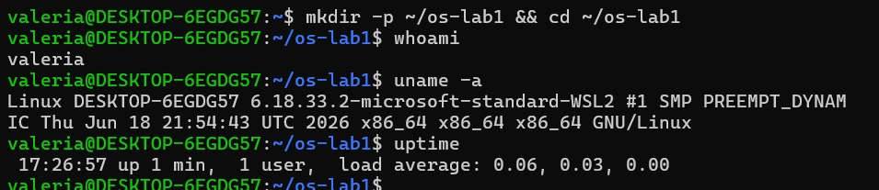

Part 1. Files and directories (File management)

Observations & Answers:
- Who owns the files you just created, and which group?
  - Answer: Both the owner user and the owner group for the created file (note.txt) are valeria:valeria.
- What do the ten characters at the start of ls -l mean for note.txt after chmod 600?
  - Answer: The string -rw------- represents the file type and access permissions:
    - 1st char (-): Regular file.
    - 2nd-4th chars (rw-): Owner permissions (Read and Write enabled, Execute disabled).
    - 5th-7th chars (---): Group permissions (None).
    - 8th-10th chars (---): Others permissions (None).
- Name two directories directly under / and say, in one line each, what they hold:
  - /etc: Holds system-wide configuration files and program settings.
  - /proc: A pseudo-filesystem exposing live kernel parameters and runtime process information.

Selected Terminal Output:
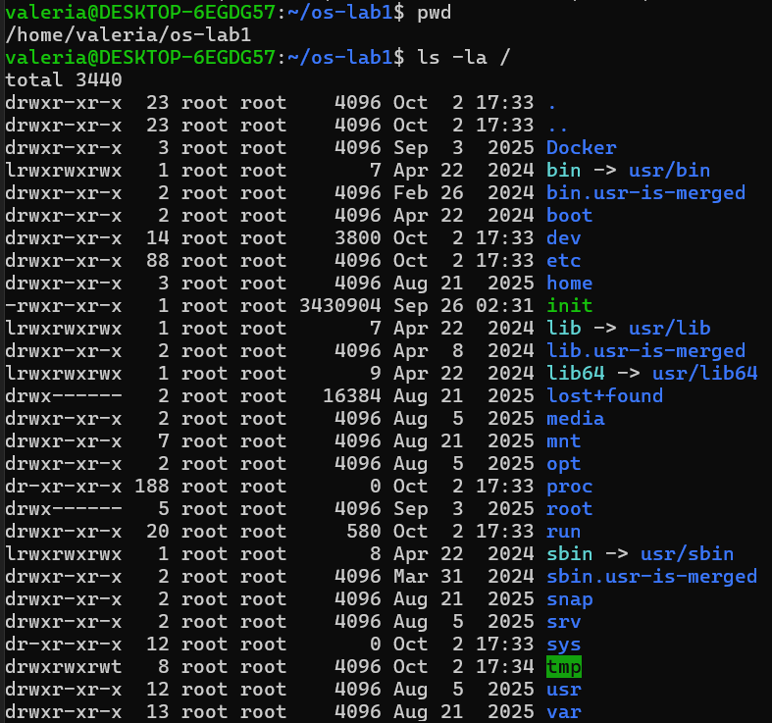
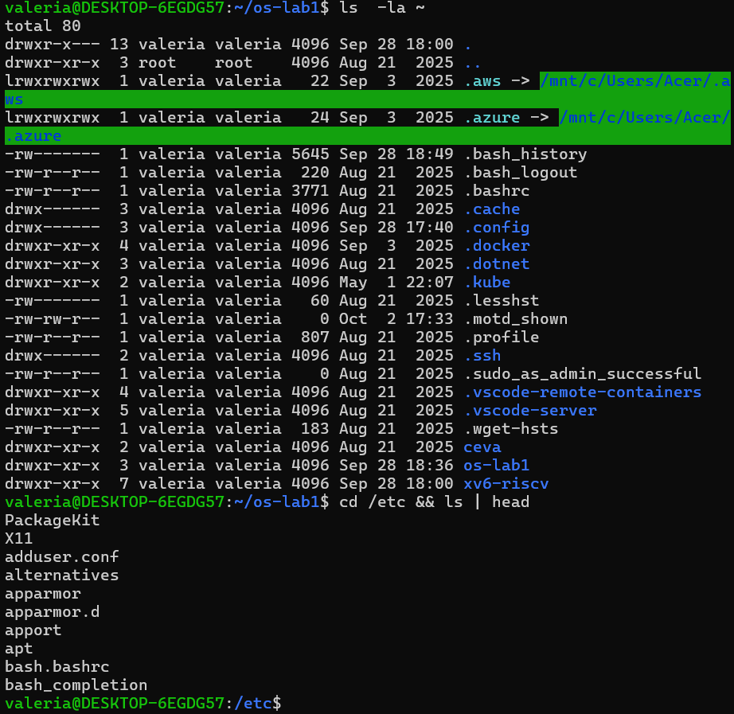
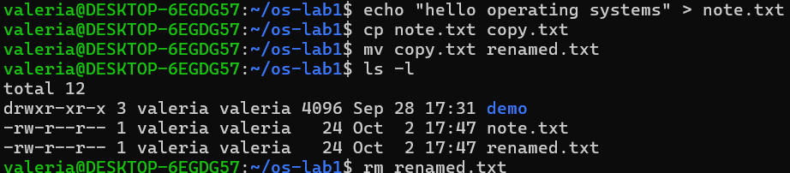
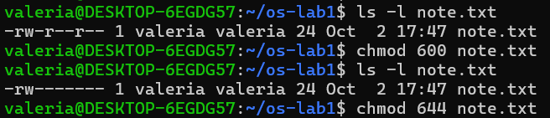

Part 2. Processes (Process management)

Observations & Answers:
- What is the PID of process number 1, and what is it?
  - Answer: Process ID 1 is /usr/lib/systemd/systemd. It is the systemd init system—the first user-space process started by the kernel, responsible for bootstrapping and managing system services.
- Roughly how many processes were running on your idle VM?
  - Answer: 25 lines (including header), meaning 24 processes running
- From /proc/<pid>/status, what does the "State:" line say for your sleeping process?
  - Answer: It says State: S (sleeping), indicating that the process is in an interruptible sleep state while waiting for the timer event to elapse.

Selected Terminal Output:
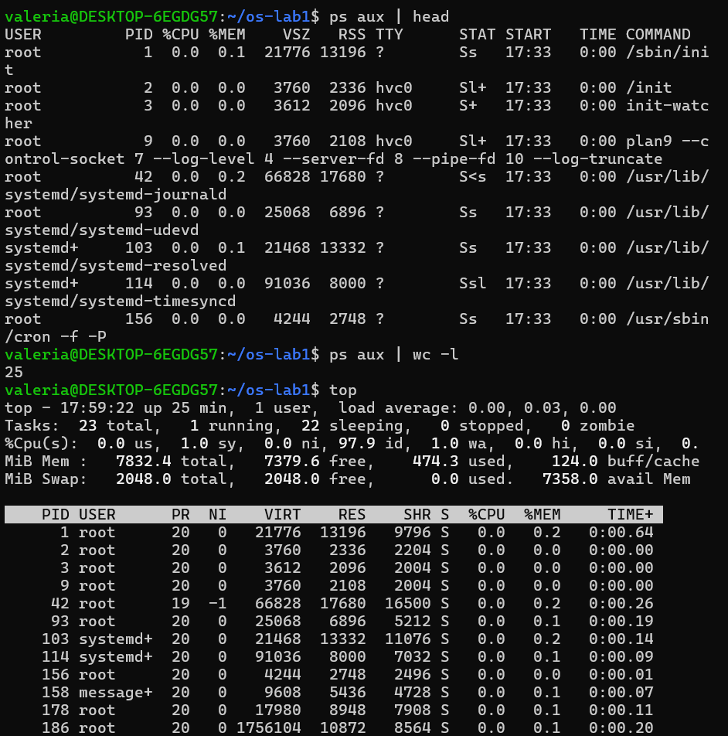
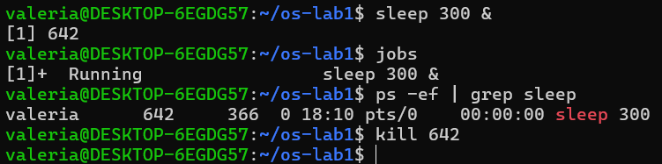
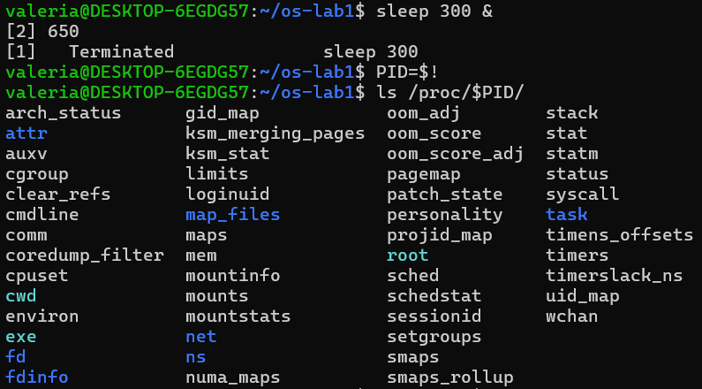
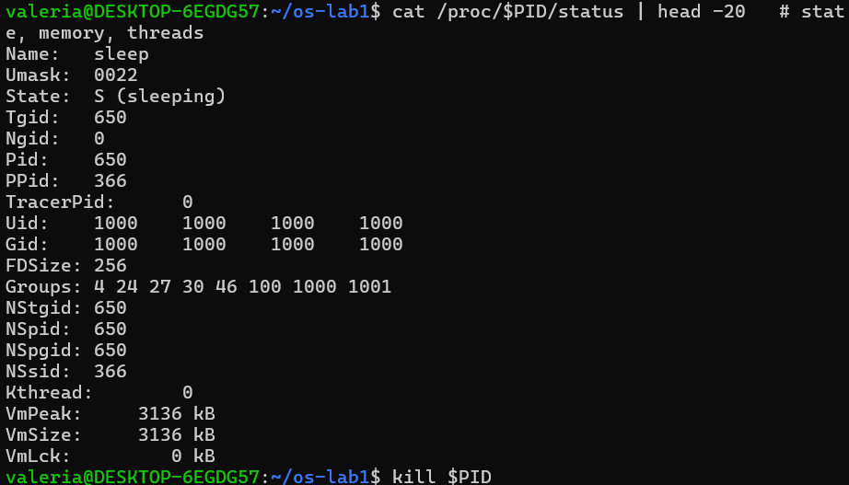

Part 3. Memory (Memory management)

Observations & Answers:
- How much total RAM does the VM have, and how much is free?
  - Answer: Total RAM is 7.6 GiB, and free RAM is 7.1 GiB .
- What is swap, and how much is configured?
  - Answer: Swap is dedicated disk space used as virtual memory extension when physical RAM fills up. The VM has 2.0 GiB of swap memory configured.
- How much resident memory (VmRSS) does a bare sleep process use, and does that surprise you?
  - Answer: The bare sleep process uses 1972 kB (~1.97 MB) of physical RAM. This is minimal because the executable only dynamically links core C libraries (glibc) to register a kernel timer.

Selected Terminal Output:
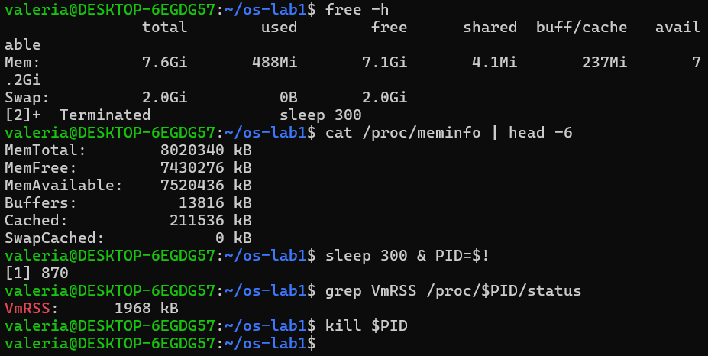

Part 4. Devices and storage (I/O management)

Observations & Answers:
- Which device is your root filesystem "/" mounted on?
  - Answer: The root filesystem / is mounted on virtual block device /dev/sdd (formatted with an ext4 filesystem).
- Give one entry from /dev and say what real thing it stands for:
  - /dev/sda: Represents the primary virtual disk device provided by WSL2/Hyper-V.
- In one sentence: what does "everything is a file" mean, based on what you saw?
  - Answer: "Everything is a file" means the OS exposes hardware devices (/dev), process interfaces (/proc), and storage systems through a unified stream interface (read/write/open) abstraction.

Selected Terminal Output:
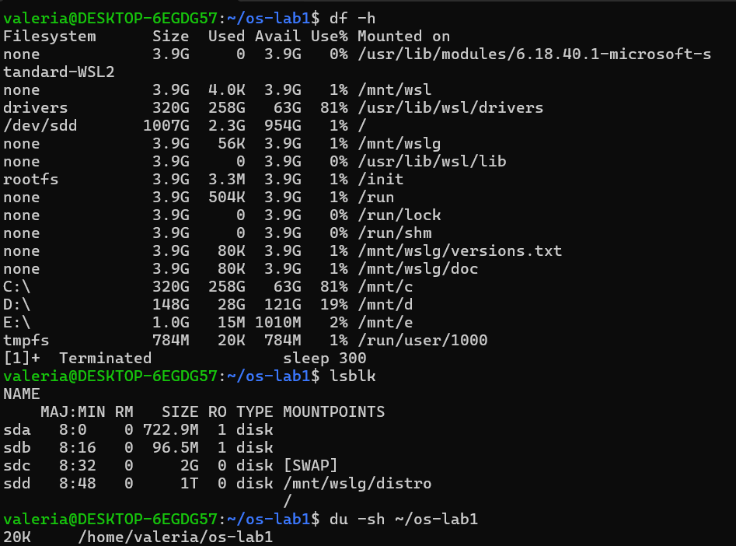
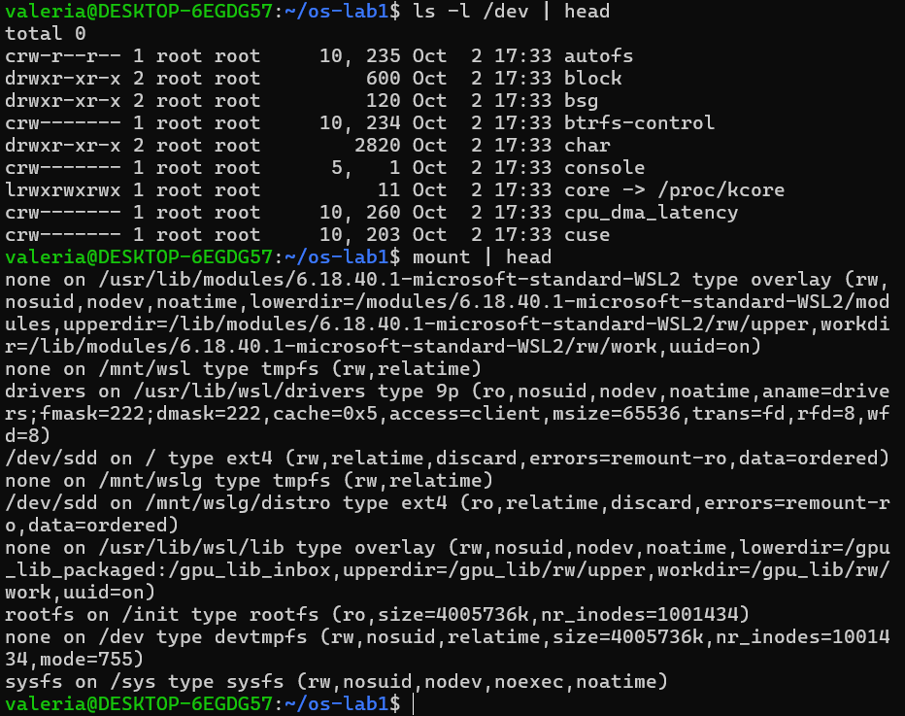

Wrap-up and Deliverable (Closing Synthesis)

Closing Summary:
An operating system acts as the central resource manager that coordinates execution, hardware abstraction, and memory allocation across applications. The four primary resources managed by the OS are:
- File System / Storage Management: Inspected using ls -la to navigate directory hierarchies and examine file access permissions.
- Process Management: Inspected using ps aux to view running processes, process IDs, and CPU/memory statuses.
- Memory Management: Monitored using free -h to measure physical RAM consumption and Swap memory allocations.
- Device & I/O Management: Observed using lsblk to view attached storage block devices and mount points.

Part 1 & 2. Build, Boot & Use xv6
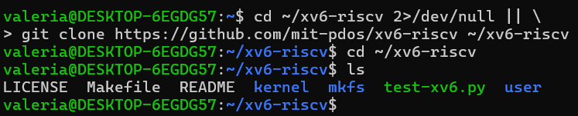
Part 1

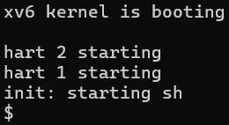

Part 2 Observations & Answers:
- List three programs xv6 ships with:
  - Answer: ls, cat, and grep (also echo, wc, sh).
- You just used a pipe (|) inside xv6. Which two OS features must exist for a pipe to work?
  - Answer:
    - Process Management / Creation (fork & scheduling): The OS must be able to run multiple processes concurrently (the writer process and the reader process).
    - Inter-Process Communication (IPC) & File Abstraction: The OS must provide a shared kernel buffer mechanism (pipe system call) that connects standard output of one process to standard input of another using standard file descriptor read/write interfaces.
- In one sentence: how does the xv6 shell compare to the Linux shell from Lab 1?
  - Answer: The xv6 shell is a minimalistic Unix shell (~145 lines of code) that supports fundamental commands, redirection (>), and pipes (|), whereas the Linux shell (Bash) is a full-featured, complex command processor supporting environment variables, scripting features, job control, and extensive autocompletion.
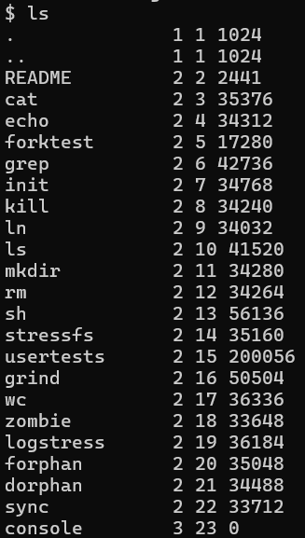
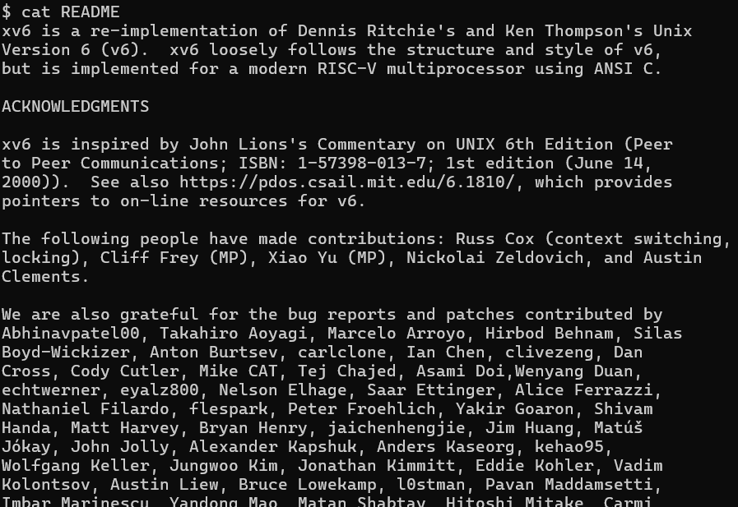
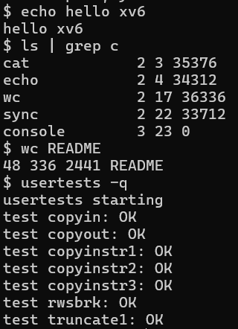

Part 3. Read the Source (Observe Answers)

Part 3 Observations & Answers:
- Which system calls does user/cat.c use, and what does each one ask the kernel to do?
  - Answer:
    - open(filename, O_RDONLY): Requests the kernel to open a file and return a file descriptor.
    - read(fd, buf, sizeof(buf)): Requests the kernel to read raw bytes from the file descriptor into a user-space buffer.
    - write(1, buf, n): Requests the kernel to write bytes from the buffer to standard output (file descriptor 1).
    - close(fd): Requests the kernel to release and close the file descriptor.
    - exit(0): Requests the kernel to terminate the calling process and reclaim its resources.
- In which kernel file, and on which line, is sys_read implemented?
  - Answer: sys_read is implemented in kernel/sysfile.c around line 57 (uint64 sys_read(void)).
- In one sentence: what is the difference between the code in kernel/ and the code in user/?
  - Answer: Code in kernel/ runs in privileged Kernel Mode with direct, unrestricted access to physical hardware and CPU instructions, while code in user/ runs in unprivileged User Mode, isolated in a virtual address space and forced to use system calls to request kernel services.
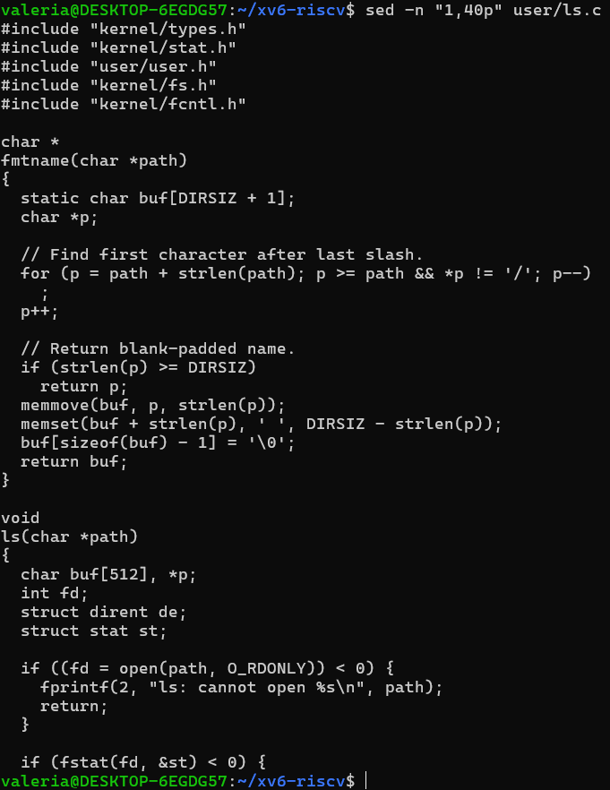
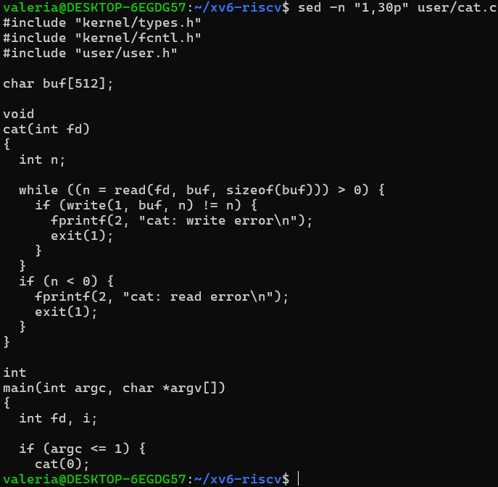
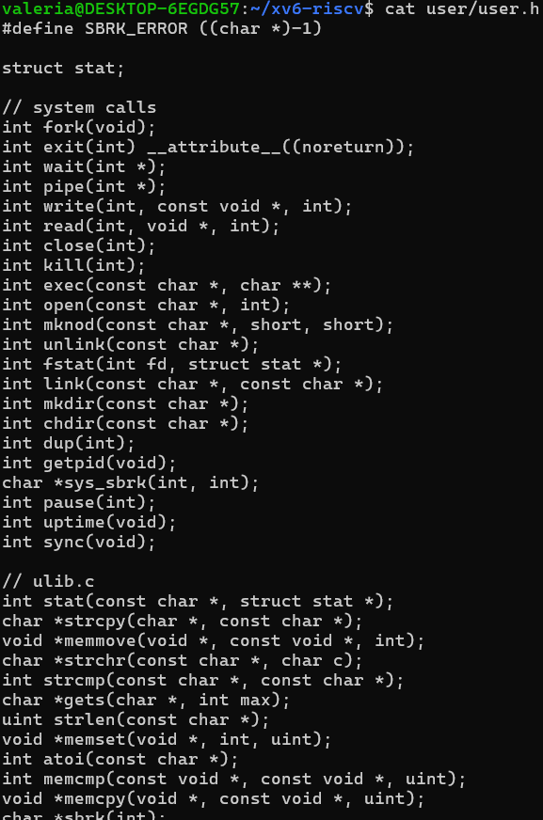

Part 4. Write Your First xv6 Program (user/sleep.c)

1. Source Code (user/sleep.c)
#include "kernel/types.h"
#include "user/user.h"
int
main(int argc, char *argv[])
{
if(argc != 2){
fprintf(2, "usage: sleep <ticks>\n");
exit(1);
}
sleep(atoi(argv[1])); // system call into the kernel
exit(0);
}

2. Makefile Modification
Added $U/_sleep\ to the UPROGS list in the Makefile:
Makefile
UPROGS=\
$U/_cat\
$U/_echo\
$U/_sleep\
$U/_forktest\
$U/_grep\
$U/_init\
$U/_kill\
$U/_ln\
$U/_ls\
$U/_mkdir\
$U/_rm\
$U/_sh\
$U/_stressfs\
$U/_usertests\
$U/_grind\
$U/_wc\

3. Verification inside QEMU (make qemu)
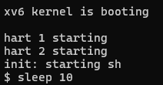

Conclusion
Through these two laboratory works, I explored the operating system from both an external operational perspective (Linux/WSL2) and an internal architectural perspective (xv6 on RISC-V).
In Laboratory 1, I observed the operating system in its primary role as a central Resource Manager. I directly monitored and interacted with the four fundamental pillars of OS resource management:
- File System Management: Explored directory hierarchies and permission bits (chmod, ls -la).
- Process Management: Observed process isolation, PIDs, and execution states (ps aux, top, /proc).
- Memory Management: Analyzed virtual memory, physical RAM allocation, and swap utilization (free -h, VmRSS).
- Device & I/O Management: Examined block device abstractions and file system mounting (lsblk, df -h, /dev).
In Laboratory 2, I bridged the gap between user-space applications and kernel-space execution by building and booting xv6 inside QEMU. By analyzing the source separation between user/ (unprivileged user mode) and kernel/ (privileged supervisor mode), I examined how system calls like read(), write(), and sleep() act as the secure boundary interface between application requests and hardware execution. Finally, by engineering a custom user/sleep.c utility and updating the Makefile build pipeline, I successfully integrated a user application that issues direct system calls to our compiled kernel.

