
MINISTRY OF EDUCATION AND RESEARCH OF THE REPUBLIC OF MOLDOVA
Technical University of Moldova
Faculty of Computers, Informatics and Microelectronics
Department of Software and Automation Engineering

Laboratory work 7: Three Small Programs: Processes, Redirection, a Pipe
of the "Operating Systems" course

Checked:
asist. univ. Patricia Reițman
Department of Software and Automation Engineering,
FCIM Faculty, UTM
Postica Valeria, FAF-243
Objective of the Lab:
The purpose of this laboratory work is to explore core operating system concepts by building and analyzing low-level C programs on Linux. It demonstrates the fundamental mechanics of process creation via the fork() system call, program execution through execlp(), and synchronization using waitpid(). Additionally, the lab covers how the shell manages input/output redirection and establishes inter-process communication using system-level pipes.

Part 1:
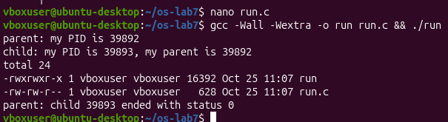
Figure 1.1 – Compilation and successful execution of the ls -l command in the child process

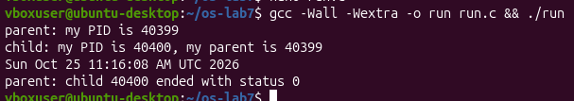
Figure 1.2 – Execution output of the child process modified to launch the system date utility

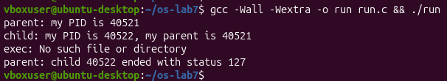
Figure 1.3 – Error output and exit status 127 when attempting to execute the non-existent nosuchprog

1. The line perror("exec") is in the child, right after execlp. Why is it printed only with nosuchprog?
The perror("exec") function prints only for nosuchprog because execlp() completely overwrites the child process memory upon a successful execution. When ls or date runs successfully, the subsequent lines of code are erased and never reached. For nosuchprog, the system call fails and returns control, allowing the child to execute the error message.
2. Which number does the child print as "my parent", and whose PID is it?
The "my parent" number printed by the child is the unique Process ID (PID) of the parent process that called fork(). This PID is 39892 in the first run, 40399 for date, and 40521 for nosuchprog.
3. What status does the parent see with ls, and what status with nosuchprog?
The parent process receives a termination status of 0 for ls, indicating a successful execution without errors. For nosuchprog, it receives a status of 127, which is the explicit value returned by exit(127) inside the child process when the execution fails.

Part 2:
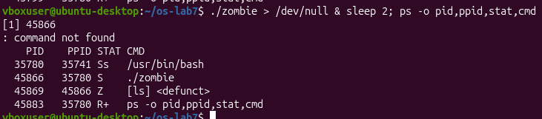
Figure 2.1 – Process table output showing the child process [ls] in the Zombie (Z) state while the parent
zombie process is sleeping

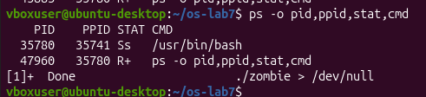
Figure 2.2 – Process table output after 20 seconds showing that the zombie process was successfully
cleaned up and removed

1. Which letter does ls have in the STAT column, and what does it mean?
The ls child process has the letter Z in the STAT column, which stands for Zombie (or defunct). This means that the child process has completed its execution, but its exit status has not yet been collected or reaped by the sleeping parent process.
2. After 20 seconds, is the [ls] <defunct> line still there? Which line of zombie.c made it disappear?
After 20 seconds, the [ls] <defunct> process line is no longer there. The specific line in zombie.c that made it disappear is waitpid(pid, &status, 0); because it reads the child's termination status, allowing the operating system to completely clean up and remove the process from the process table.

Part 3:
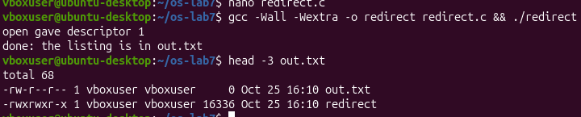
Figure 3.1 – Compilation and execution of redirect.c showing file descriptor 1 allocation
and standard output redirection to out.txt
1. Which number did open give, and why exactly that one?
The open() system call returned descriptor 1. It chose exactly this number because close(1) was executed right before it, making 1 the lowest-numbered unused file descriptor available in the process table.
2. ls was not changed at all. Why does its listing not appear on the screen?
The listing does not appear on the screen because file descriptor 1 (which normally points to standard output / the screen) was replaced by the file descriptor for out.txt. Since ls inherently writes its output to descriptor 1, all its data was redirected into the file instead of the terminal.
3. To redirect the errors instead (like 2> err.txt), which descriptor would you close before open?
To redirect standard errors instead (like 2> err.txt), you would close file descriptor 2 (stderr) right before calling open().

Part 4:
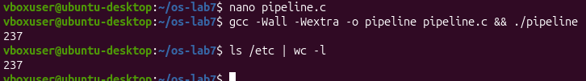
Figure 4.1 – Execution output verifying that the custom C pipeline implementation
matches the native shell pipeline output perfectly
1. Did ./pipeline and ls /etc | wc -l give the same number?
Yes, both ./pipeline and ls /etc | wc -l yielded the exact same number, which is 237.
2. After the change, which of the two children never ends, ls or wc?
After commenting out close(p[1]); in the parent process, the wc child process never ends.
3. Why, in one sentence: what is wc waiting for?
The wc process is waiting indefinitely for an End-of-File (EOF) signal, which never arrives because the parent process still keeps the write end of the pipe (p[1]) open.

Optional Task: Three-Stage Pipeline:
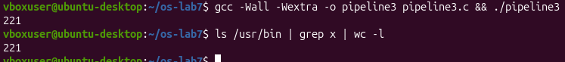
Figure 5.1 – Execution log verifying matching outputs between the custom three-stage
C pipeline implementation and the terminal shell execution

The optional task was successfully completed by implementing pipeline3.c to replicate the three-stage shell command ls /usr/bin | grep x | wc -l. By initializing two independent pipes and managing three distinct child processes, the standard outputs and standard inputs were sequentially linked together via file descriptor duplication using dup(). To prevent deadlocks, all unused pipe endpoints were meticulously closed within each child branch as well as in the parent process. Execution testing confirmed perfect behavior, as both the custom C program and the native shell execution returned the identical value of 221.

Conclusion:
Through this laboratory work, I successfully gained a practical understanding of how low-level Unix system calls control process lifecycles and input/output redirection. By working directly with fork(), execlp(), and waitpid(), I managed to demystify the internal operations of a standard command-line shell, observing firsthand how child processes are spawned, executed, and reaped. Additionally, implementing both the single and multi-stage pipelines allowed me to understand the critical mechanics of file descriptor manipulation and inter-process communication using pipes. Ultimately, this hands-on experience solidified my knowledge of process states, resource cleanups, and the fundamental constraints required to prevent deadlocks in system-level programming.

