
MINISTRY OF EDUCATION AND RESEARCH OF THE REPUBLIC OF MOLDOVA
Technical University of Moldova
Faculty of Computers, Informatics and Microelectronics
Department of Software and Automation Engineering

Laboratory work 5: The File System with
Your Own Hands
of the "Operating Systems" course

Checked:
asist. univ. Patricia Reițman
Department of Software and Automation Engineering,
FCIM Faculty, UTM
Postica Valeria, FAF-243
Part 1: The tree and the file types
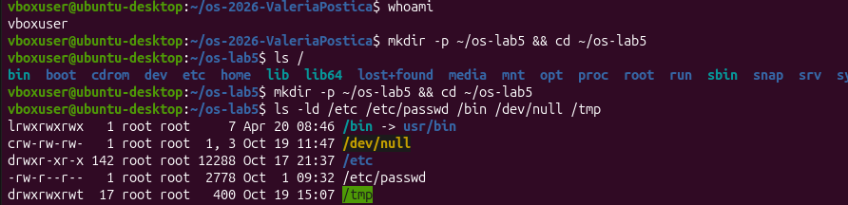
Figure 1.1 – Directory tree listing and path file types
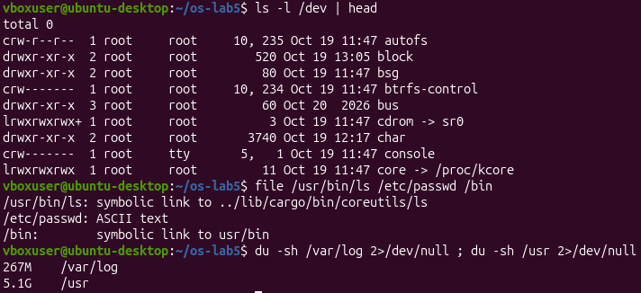
Figure 1.2 – Device inspection, file classification, and directory storage usage
1. For each path in the second line, write its type from the first letter of ls -l
For each requested path, the leading character in the permissions string defines its type: /etc is a directory (d), /etc/passwd is a regular file (-), /bin is a symbolic link (l), /dev/null is a character device (c), and /tmp is a directory with a sticky bit (d with t).
2.What is /bin on your system: a directory or a link, and to where?
On this system, /bin is a symbolic link pointing to usr/bin, following the modern Linux usrmerge directory structure.
3. Find one character device and one block device in /dev
Found in /dev: /dev/null is a character device (c) that handles unbuffered character-stream I/O. In the head output, no block device starting with 'b' appears directly because head limits output to 10 lines; however, /dev/cdrom points to sr0, which is a block device (b) managing buffered fixed-block data transfer.
4. Which is bigger on your laptop, /var/log or /usr, and by roughly how much?
/usr (5.1 GB) is significantly larger than /var/log (267 MB) by approximately 4.83 GB, as /usr contains system-wide binaries, shared libraries, and user programs, whereas /var/log stores system runtime log files.
Part 2: Inodes and links
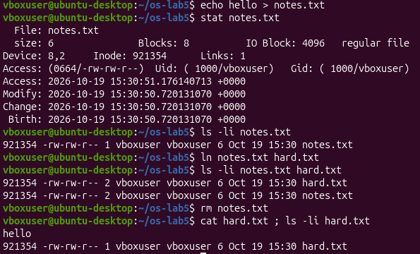
Figure 2.1 – Inode inspection, hard link creation, and original file unlinking
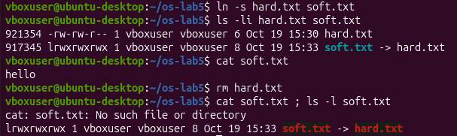
Figure 2.2 – Symbolic link behavior and dangling pointer resolution
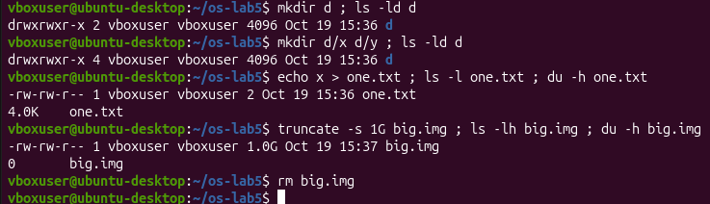
Figure 2.3 – Directory link counts, sparse file allocation, and storage block sizing
1.Which number in stat is the inode, and which tells how many names the file has?
In the stat output, Inode: 921354 indicates the inode number metadata index, while Links: 1 specifies the reference count of directory hard links pointing to that inode.
2. After rm notes.txt, why could you still read hard.txt? What does rm really remove?
After running rm notes.txt, hard.txt remains readable because hard links point directly to the inode rather than the filename. The rm command only removes the directory entry name mapping and decrements the link count; physical data is deallocated only when the link count reaches zero.
3. Why did cat soft.txt fail at the end, although soft.txt still exists? How big is soft.txt and why exactly that size?
Reading soft.txt failed after deleting hard.txt because symbolic links store the target path string ('hard.txt'). Deleting the target produces a dangling pointer. The link file size is exactly 8 bytes because the target string length of 'hard.txt' is 8 characters.
4. A new directory has 2 links, and 4 after you create two subdirectories. Explain where each link comes from.
A newly created directory starts with 2 links: its parent directory entry (d) and its internal self-reference (.). Adding subdirectories d/x and d/y increases the count to 4 because each child directory includes a parent reference link (..) pointing back to d.
5. Why does a 2-byte file use 4.0K, and a 1 GB file use 0?
A 2-byte file occupies 4.0 KB of disk space because file systems allocate storage in minimum block sizes (typically 4096 bytes). Conversely, a 1 GB sparse file created via truncate occupies 0 bytes on disk because metadata records unallocated space holes without assigning physical blocks until actual data is written.
Part 3: Permissions
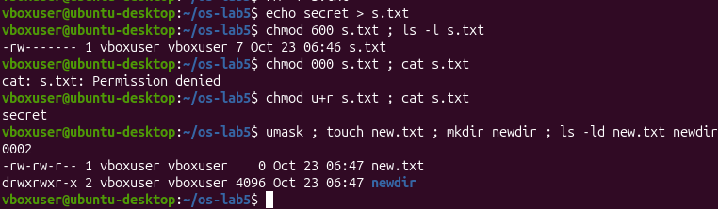
Figure 3.1 – File permission modifications, owner access restriction, and umask evaluation
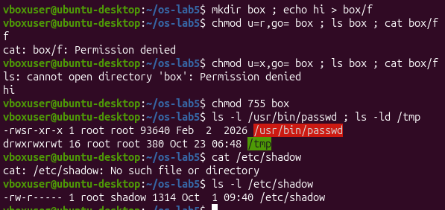
Figure 3.2 – Directory permission execution tests and special permission bits (SetUID / Sticky Bit)
1. Write 600, 644, 755 and 700 as rwx strings, and give one real use for each
600 (rw-------) for private keys (~/.ssh/id_rsa); 644 (rw-r--r--) for public configuration files (/etc/passwd); 755 (rwxr-xr-x) for system binaries (/usr/bin/ls); 700 (rwx------) for private directories (~/.gnupg).
2. With chmod 000 you own the file but cannot read it. Why does ownership not help?
When permissions are set to 000, the open system call fails because permission checks evaluate active read/write bits. Ownership allows changing file permissions via chmod, but does not override missing access bits.
3. What is your umask, and how does it explain the permissions of new.txt and newdir?
The active umask is 0002.
4. Explain the box experiment: what does r allow on a directory, and what does x allow
Directory read (r) permission allows listing file names within the directory (ls box works), but prevents accessing file content without execute permission (cat box/f fails). Directory execute (x) permission allows traversing the path and reading file contents (cat box/f works), but prevents directory listing (ls box fails).
5. What do the s in /usr/bin/passwd and the t in /tmp mean, and why does passwd need the s?
The SetUID bit (s) on /usr/bin/passwd allows standard users to run the binary with root privileges to update /etc/shadow. The sticky bit (t) on /tmp prevents users from deleting or renaming files owned by others in a shared world-writable directory.
Part 4: Disks and the kernel as files
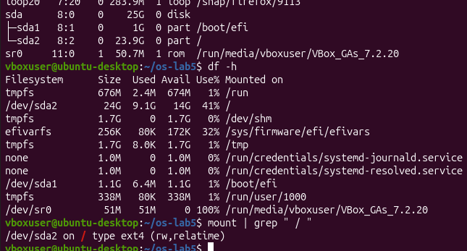
Figure 4.1 – Disk layout, file system usage, and mount configurations
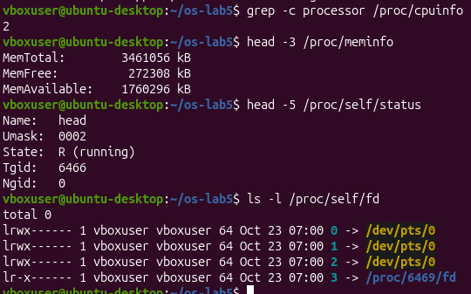
Figure 4.2 – Hardware inspection and process descriptor links via /proc virtual file system
1. Draw your disk: disk name, partitions, which one is mounted at / and with what file system type
• Disk Name: sda
• Partitions: sda1 and sda2
• Partition mounted at /: /dev/sda2
• File System Type: ext4 (as shown in the mount | grep " / " string)
2. How full is your root file system?
According to the df -h entry for /dev/sda2:
Disk usage percentage: The root file system is 41% full.
Storage allocation metrics: It has utilized 9.1G out of its total 24G capacity, leaving 14G of space free.
3. How many CPU cores and how much RAM does your laptop have,
according to /proc?
Number of CPU Cores: 2 (extracted via the grep -c processor /proc/cpuinfo counter).
Total System RAM: 3461056 kB (which corresponds to roughly 3.3 GB of total RAM allocated to your virtual system environment, as verified by the MemTotal string in /proc/meminfo).
4. /proc/self/status showed the name of a program. Which one, and why that one?
Program name shown: head
Reason for this behavior: The path /proc/self/ is a dynamic kernel context link that automatically resolves to whichever running process is currently inspecting it. Because you typed and executed the head -5 /proc/self/status script string, the physical binary utility making the dynamic kernel request was head. As a direct consequence, the status file reported back metadata describing the head pipeline process execution space itself.
Conclusion:

In this laboratory work, a thorough exploration of the Linux Virtual File System (VFS) architecture was completed through hands-on terminal observation and analysis. The practical tests confirmed the functional separation between directory entries and underlying numerical inodes, demonstrating how hard links manage shared file access and how symbolic links function as target path pointers. Permission experiments illustrated the distinct requirements for directory listing (read) versus traversal (execute), while special permission bits (SetUID and Sticky Bit) showed how elevated executable privileges and shared directory protections are enforced. Finally, inspecting the /proc virtual file system and disk partition tables provided insight into how kernel runtime states and physical hardware devices are uniformly presented under Unix file system abstractions.

