
MINISTRY OF EDUCATION AND RESEARCH OF THE REPUBLIC OF MOLDOVA
Technical University of Moldova
Faculty of Computers, Informatics and Microelectronics
Department of Software and Automation Engineering

Laboratory work 4: The xv6 Shell from
the Outside
of the "Operating Systems" course

Checked:
asist. univ. Patricia Reițman
Department of Software and Automation Engineering,
FCIM Faculty, UTM
Postica Valeria, FAF-243

Part 1:
Figure 1.1 – The grep result in user.h
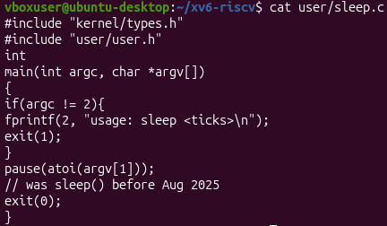
Figure 1.2 – The updated sleep.c
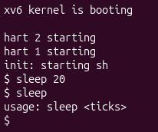
Figure 1.3 – sleep running in xv6, with and without an argument
In Part 1 of the assignment, the system call name update was first verified by searching the user header file to confirm that the legacy function had been renamed. The source code in user/sleep.c was then modified to replace the previous sleep call with the updated pause function while preserving the command line argument handling logic. Next, the project Makefile was updated by adding the sleep utility to the user programs compilation list, taking care to maintain the precise tab indentation and line continuation syntax required by the build system. Finally, the operating system environment was compiled and launched inside the QEMU emulator to successfully test and verify the execution behavior of the sleep application under both standard and error conditions.

Part 2:
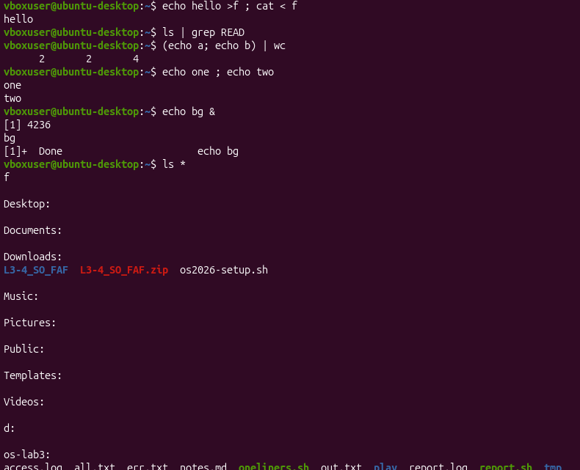
Figure 2.1 – The commands run in bash

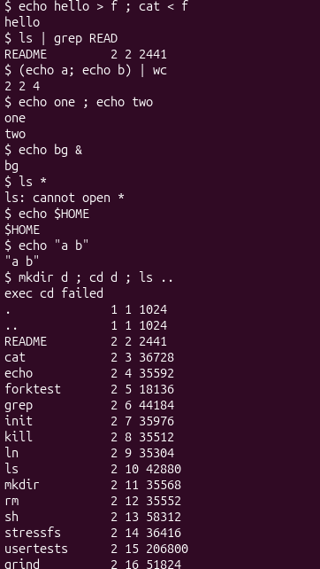
Figure 2.2 – The same commands run in xv6

Command | Tests | bash | xv6
echo hello > f ; cat < f | redirection | Prints hello | Prints hello
ls | grep READ | pipe | Prints nothing | Prints README 2 2 2441
(echo a; echo b) | wc | grouping, list | Prints 2 2 4 | Prints 2 2 4
echo one ; echo two | sequence | Prints  one  two | Prints  one  two
echo bg & | background | Prints  [1] 4236  Bg  [1]+ Done | Prints bg
ls * | globbing | Lists contents of all top-level directories in the active workspace | Prints  ls: cannot open *
echo $HOME | variables | /home/vboxuser | Prints $HOME
echo "a b" | quotes | Prints a b | Prints “a b”
mkdir d ; cd d ; ls .. | PATH | Creates d, changes into it, lists the parent directory | Lists the parent directory
arrow up, Tab, Ctrl+R | history, completion | Recalls history, autocompletes text, searches past commands | Does nothing

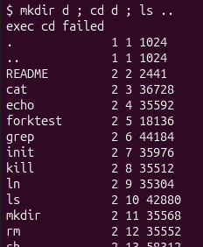
Figure 2.3 – ls failing after cd d, and the working alternative

1. Features both shells have vs. features only bash has
- Features both shells have: Both shells support basic input and output redirection (<, >), pipeline processing (|) to connect commands, and background process execution (&).
- Features only bash has: bash uniquely supports command sequencing with semicolons (;), subshell process grouping with parentheses (()), wildcard filename expansion or globbing (*), environment variables expansion ($), parameter quoting/argument grouping (""), global execution paths (PATH), and interactive line editing with command history and tab completion.
2. Why ls stops working after cd d in xv6 and how to run it anyway
- Why it stops working: The xv6 shell does not implement a PATH environment variable mechanism. When a command like ls is typed, the shell searches for that executable strictly inside the current working directory. When you use cd d to enter the newly created directory d, the directory is completely empty, causing the shell to throw an unknown command error because ls does not exist there.
Working alternative: All user programs and compiled binaries in xv6 live directly inside the root directory (/). Therefore, you can bypass the empty local directory search and run ls from inside d by specifying its absolute path or its relative path back to the root directory using either of these commands:
bash
/ls
# OR
../ls
3. Missing feature analysis
- Most missed feature in daily work: Command history (using the Arrow-Up key) and Tab auto-completion would be missed the most. Without these interactive terminal line-editing components, working becomes highly inefficient since every command and long path has to be typed manually and perfectly every single time.
- Easiest feature to add: Command sequencing using a semicolon (;) would be the easiest feature to add. This could be implemented by modifying the shell source code to parse the input command string for semicolons, split it into separate command segments, and then run them sequentially inside a simple execution loop.
Part 3:
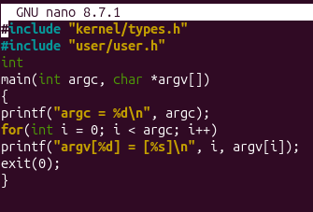
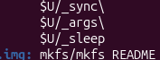
Figure 3.1 – args.c and the UPROGS line

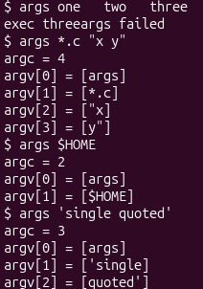
Figure 3.2 – args output in xv6
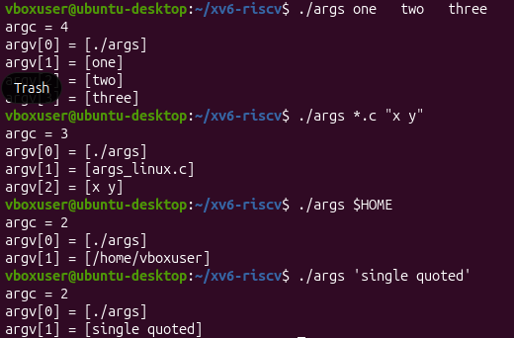
Figure 3.3 – args_linux output in bash

1. Outputs for args *.c "x y" & Argument Count
- In bash (Linux):
  - argc count: It will be at least 3 or more (depending on how many .c files live in that folder).
  - Why: bash expands *.c into a separated list of all matching files (e.g., args_linux.c, sleep.c, etc.), counting each file as its own separate argument. It strips the quotes from "x y" and passes it as a single combined argument.
- In xv6:
  - argc count: Exactly 4.
  - Why: xv6 does not expand wildcards or handle quotes. It passes the literal string *.c as argv[1], the string "x and y” as argv[2] and argv[3].
2. Who turns *.c into file names and removes quotes?
- The shell (bash) does this transformation.
- Explanation: The expansion (globbing) and quote removal happen completely inside the shell before the program is even launched. The kernel and the compiled program binary never see the original * or the outer quotation marks; they only receive the final, cleaned array of arguments processed by bash.
3. What happened to the extra spaces in args one two three?
- The extra whitespace characters are completely ignored and removed by the shell.
- Explanation: The shell treats any sequence of consecutive spaces as a simple argument delimiter (separator). Therefore, one, two, and three are parsed cleanly as three distinct arguments, and the extra spacing between them is discarded before being passed to argv.
Part 4:
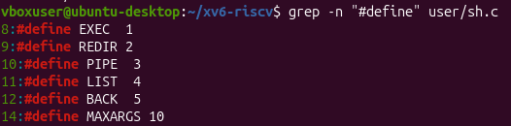
Figure 4.1 – The command kinds defined in sh.c
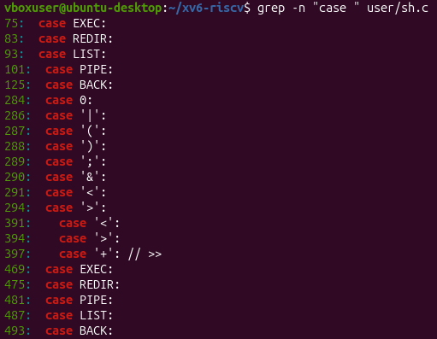
Figure 4.2 Where each kind is run
Figure 4.3 – The code that handles cd
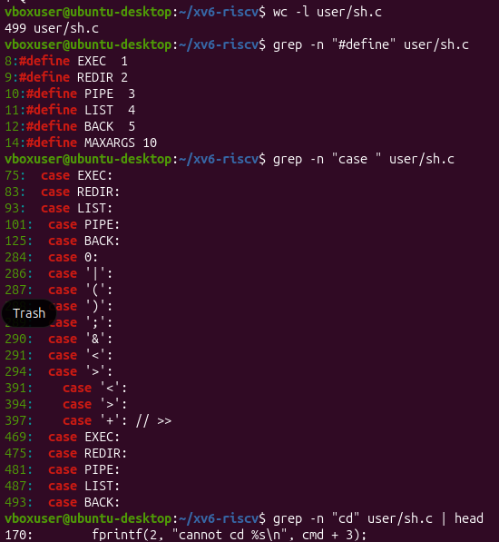
Figure 4.4 – All commands

1. The Five Kinds of Commands in the xv6 Shell
By looking at the #define lines in user/sh.c, the five types of commands and their corresponding triggering characters are:
- EXEC (Executable): Triggered by standard text input containing program names and standard arguments (no unique symbol).
- REDIR (Redirection): Triggered by the < (input redirection) or > (output redirection) characters.
- PIPE (Pipeline): Triggered by the | character.
- LIST (Sequential List): Triggered by the ; character (or structural line breaks).
- BACK (Background Job): Triggered by the & character.
2. Handling of the cd Command
- Where it is handled: The cd command is checked and intercepted directly inside the shell's main() function execution loop before any sub-process is spawned, where it directly executes the chdir() system call.
- Why it is not run as a separate program: If cd were an independent, external executable binary, the shell would have to use fork() to spawn a child process to run it. While that child process would successfully change its own active directory, the change would immediately be lost as soon as the child process finished executing and exited. The parent shell's working directory would remain completely unaffected. Therefore, cd must be built directly into the main shell process.
3. Wildcard (*) and Environment Variable ($) Handling
- Search result: Searching through user/sh.c reveals that there is completely no code inside the parsing or tokenizing systems designed to intercept or handle * or $.
- Explanation for Part 2: This finding explains the exact differences noticed during Part 2 testing matrix. Because the minimal xv6 shell completely lacks parser code for filename globbing (*) and environment variable expansions ($), it treats these characters as completely standard, literal text strings and passes them directly to programs verbatim.

Conclusion:
In this lab, a thorough analysis of the inner workings and limitations of a basic command-line interpreter was completed using the xv6 operating system.
In the first part, debugging the sleep.c program and adapting it to the updated pause() system call highlighted the importance of aligning user-space utilities with the interfaces provided by the kernel, as well as the strict syntactic rigor required when configuring build automation files (Makefile).
By constructing the comparative matrix in the second part, the major structural differences between a minimalist shell (xv6) and a production-grade one (bash) were directly observed. The practical tests demonstrated that advanced functionalities—such as wildcard expansion (globbing), environment variable management, and quote stripping—are not implemented at the kernel level. Instead, they are processed entirely by the shell before programs are launched. This characteristic was definitively confirmed in the final part of the lab, where analyzing the user/sh.c source code revealed the complete absence of parsing logic for the special characters * and $. It also illustrated how built-in commands (like cd) must be executed natively within the parent process to maintain working directory states, and how the five fundamental command types are architected.
In conclusion, the experiments provided a clear understanding of the modular design inherent in Unix-like operating systems. They illustrated how a minimalist interface can successfully manage complex redirection operations and process pipelines, while leaving parameter expansion and advanced interactive features to the responsibility of a robust shell.

