
MINISTRY OF EDUCATION AND RESEARCH OF THE REPUBLIC OF MOLDOVA
Technical University of Moldova
Faculty of Computers, Informatics and Microelectronics
Department of Software and Automation Engineering

Laboratory work 3: The Command Line: Shell, Pipes and Text Filters
of the "Operating Systems" course

Checked:
asist. univ. Patricia Reițman
Department of Software and Automation Engineering,
FCIM Faculty, UTM
Postica Valeria, FAF-243

Part 1:
Figure 1.1 – Tab completion
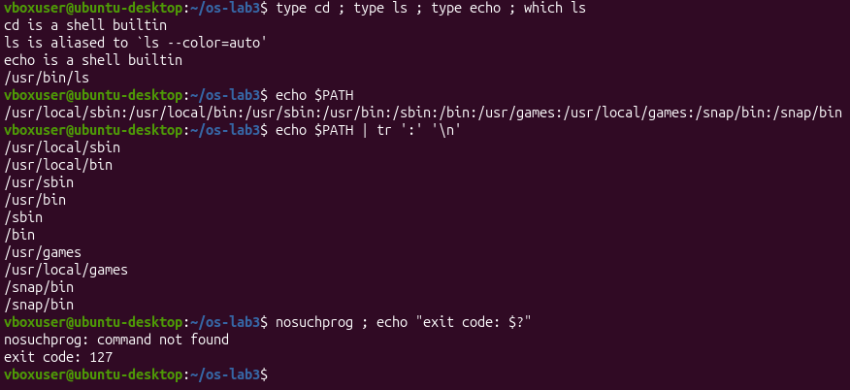
Figure 1.2 – Output of type and which
Figure 1.3 – The directories in PATH
Figure 1.4 – Exit code of a missing command
1. Which of cd, ls, echo are built-ins, and why MUST cd be one?
cd and echo are built-ins. ls is an external command.
cd must be a built-in because it changes the shell's current working directory. An external program runs in a separate child process and cannot change the directory of the parent shell.
2. How many directories are in your PATH, and in which one is ls?
There are 9 directories listed in my $PATH output.
The ls command is located in the /usr/bin directory (as shown by which ls).
3. What exit code does a command that is not found return?
It returns exit code 127 (as shown by your nosuchprog test).
4. Which option of ls sorts by modification time?
The -t option sorts files by modification time (newest first).
Figure 1.5 – Sorting by modification time
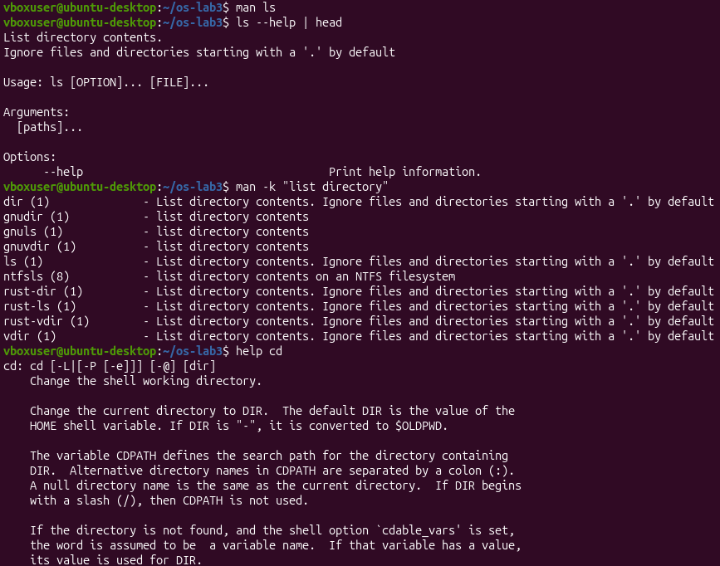
Figure 1.6 – Finding help without a browser

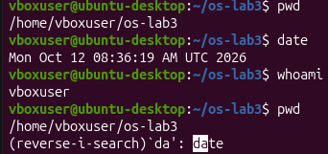
Figure 1.7 – Ctrl + R

Part 2:
Figure 2.1 – Files created in the play directory
1. For each line: your prediction, the real output, and one sentence if they differ
Command | My prediction | Real output | Explanation (if different)
echo *.c | a.c b.c | a.c b.c
echo file?.txt | file1.txt file2.txt | file1.txt file2.txt
echo [a-b]* | a.c alfa beta.txt b.c | a.c alfa beta.txt b.c
echo *.xyz | *.xyz | *.xyz
ls alfa beta.txt | error | ls: cannot access 'alfa': No such file or directory  ls: cannot access 'beta.txt': No such file or directory | Couldn’t remember the whole error
ls "alfa beta.txt" | alfa beta.txt | ‘alfa beta.txt’ | Without ‘’
echo '$HOME'"$HOME" \$HOME | $HOME /home/vboxuser $HOME | $HOME /home/vboxuser $HOME
echo {1..5} ; echo $((7 * 6)) | 1 2 3 4 5  42 | 1 2 3 4 5  42
echo "today is $(date +%A), I am $(whoami) “ | today is Monday, I am vboxuser | today is Monday, I am vboxuser
touch log{1..3}.txt && ls log* | log1.txt log2.txt log3.txt | log1.txt log2.txt log3.txt

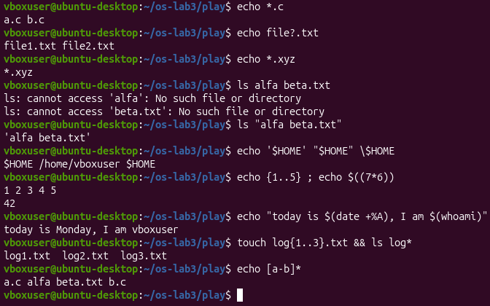
Figure 2.2 Globbing results
Figure 2.3 – The ls error on a name with a space, and the fix
Figure 2.4 - Single quotes, double quotes and backslash
Figure 2.5 – All commands

2. echo knows nothing about files, yet echo *.c printed file names. Who produced them?
The shell (Bash) produced them through a process called globbing (or filename expansion). Before the echo command is even executed, the shell scans the current directory for files matching the pattern *.c, expands the wildcard into a space-separated list of those filenames (a.c b.c), and passes that list to echo as arguments.
3. Why did ls alfa beta.txt fail? Give two different ways to fix it.
It failed because the shell uses spaces as argument separators. Without quotes, the shell interpreted alfa and beta.txt as two completely separate files, neither of which exists.
Two ways to fix it:
- Quoting: Wrap the entire filename in double quotes: ls "alfa beta.txt"
- Escaping: Use a backslash to escape the space character so the shell treats it as part of the filename: ls alfa\ beta.txt
4. What is the difference between single and double quotes?
• Single quotes (' ') prevent all expansion. They preserve the literal value of every single character inside them ('$HOME' prints literally as $HOME).
• Double quotes (" ") preserve most literal characters but allow shell expansions, such as variable expansion ($HOME turns into /home/vboxuser) and command substitution ($())
Note: ls may show the file with a space as 'alfa beta.txt' (in quotes). Explain why it does that.
Modern versions of ls automatically wrap filenames containing spaces in single quotes when printing to a terminal. It does this as a safety and clarity feature to clearly show the user that the space belongs inside a single filename, preventing confusion with multiple separate files.

Part 3:
1. Which file got the error message, and which got the listing?
err.txt received the error message (ls: cannot access '/nope': No such file or directory), while out.txt received the successful folder listing of /etc.
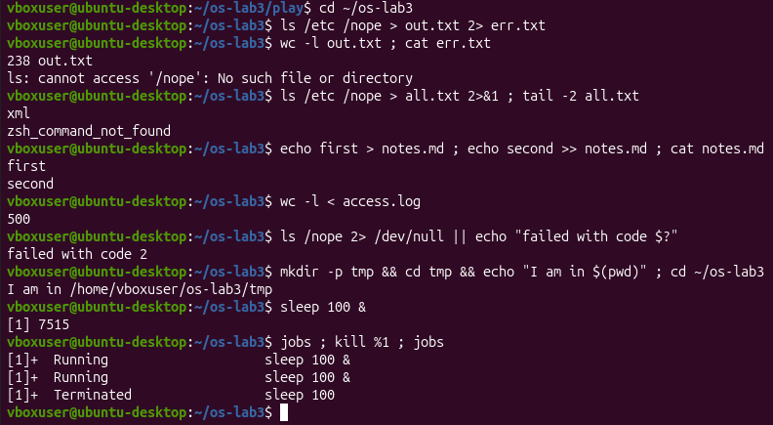
Figure 3.1 - stdout and stderr in separate files
2. What is the difference between > all.txt 2>&1 and 2>&1 > all.txt? Explain why the result differs.
Redirections are evaluated by the shell from left to right:
> all.txt 2>&1: First redirects stdout to all.txt, then redirects stderr to match stdout. Both outputs are successfully merged into the file.
2>&1 > all.txt: First redirects stderr to where stdout is currently pointing (the terminal screen), then redirects stdout to all.txt. As a result, errors still print to the screen instead of being saved in the file.
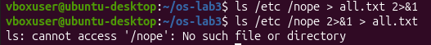
Figure 3.2 - Comparing the order of redirections
3. Why does wc -l < access.log print only a number, while wc -l access.log also prints the file name?
When passing the filename as an argument (wc -l access.log), the command opens the file itself and prints its name along with the count for clarity. When using input redirection (< access.log), the shell feeds the raw file contents directly into the command's standard input stream, meaning wc has no knowledge of the file's name and can only count the lines of incoming text.
4. Explain each operator in one sentence: ; && ||.
• ; (Semicolon): Executes the next command sequentially, regardless of whether the previous command succeeded or failed.
• && (Logical AND): Executes the next command only if the preceding command completed successfully (returned an exit code of 0).
• || (Logical OR): Executes the next command only if the preceding command failed or encountered an error (returned a non-zero exit code).
Figure 3.3 - The ; && || operators

Figure 3.4 - Running a background job and stopping it.

Figure 3.5 - All commands

Part 4:
# Q1. How many requests failed?
grep 'FAIL' access.log | wc -l

# Q2. How many different pages were requested, and which?
cut -d' ' -f5 access.log | sort -u

# Q3. How many requests did each page get?
cut -d' ' -f5 access.log | sort | uniq -c

# Q4. Which user or users have the most failed requests, and how many?
grep 'FAIL' access.log | cut -d' ' -f3 | sort | uniq -c | sort -rn | head -n 2

# Q5. How many requests did user3 make, and how many of them failed?
grep 'user3' access.log | cut -d' ' -f4 | sort | uniq -c

# Q6. Print the last 3 failed requests, showing only time and user.
grep 'FAIL' access.log | tail -n 3 | cut -d' ' -f2,3

# Q7. Which login shells appear in /etc/passwd, and how many accounts use each? (field 7, separator :)
cut -d':' -f7 /etc/passwd | sort | uniq -c

# Bonus (+1): with grep -E, print only the lines where the minute ends in 0 (10:00, 10:10, ...) and the request failed. How many are there?
grep 'FAIL' access.log | grep -E '10:[0-5]0'
Figure 4.1 – Number of failed requests
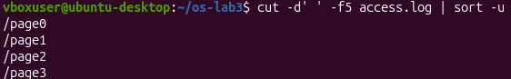
Figure 4.2 – Different pages
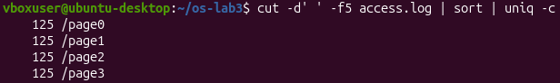
Figure 4.3 – Requests that each page got
Figure 4.4 – Users with the most failed requests
Figure 4.5 – How many requests had user3
Figure 4.6 – Last 3 failed requests
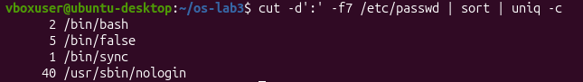
Figure 4.7 – Which login shells appear in /etc/passwd, and how many
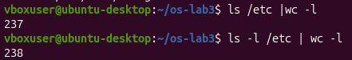
Figure 4.8 – The difference
Q8 Explanation
The Difference: ls -l /etc | wc -l will return a number that is exactly 1 higher than ls /etc | wc -l.
Why it happens: When ls is piped into another command (like wc -l), it automatically outputs files one-per-line, making ls /etc output exactly the number of files/folders. However, the long-format command ls -l prints an extra header line at the very top displaying the disk block allocation (e.g., total 124). wc -l counts this header string as an extra line, causing the single-line discrepancy.
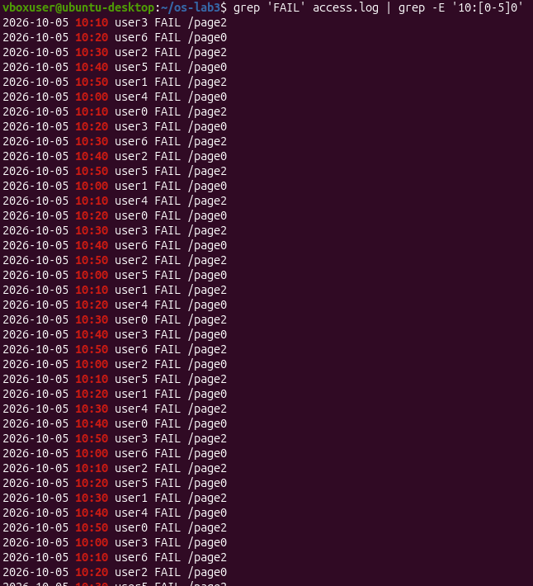
Figure 4.9 – Bonus

Part 5:
Answers to Observations
1. What does the first line #!/bin/bash do, and what happens if you run before chmod +x ?
#!/bin/bash function: This is called a shebang. It specifies that the system must use the Bash shell interpreter to execute this script.
Running before chmod +x will receive a "Permission denied" error because the script lacks execution privileges.
2. Why must you type ./report.sh and not just report.sh?
The current directory (.) is not included in your $PATH environment variable by default for security reasons. The ./ explicitly directs the shell to look inside the current folder.
3. Why does the script write the error with >&2 and end with exit 1?
• Purpose of >&2: It redirects the message to the standard error stream (stderr) instead of standard output (stdout), ensuring errors are properly logged separately from normal script output.
• Purpose of exit 1: It terminates the program with a non-zero exit status, signaling to the operating system or parent process that the script encountered an error.
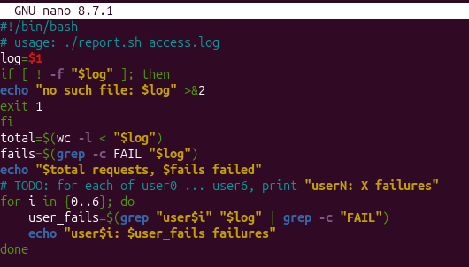
Figure 5.1 – Contents of report.sh
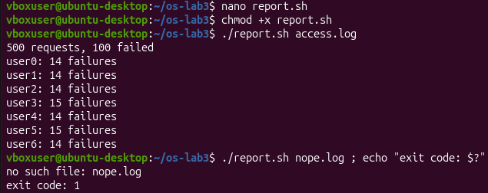
Figure 5.2 – Running the script on access.log
Figure 5.3 – Error handling for a missing file

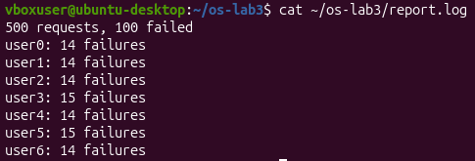
Figure 5.4 – Bonus Crontab
Figure 5.5 – Crontab contents

Conclusion:
In this lab, I successfully designed and implemented an automated log analysis tool using Bash shell scripting. Through the development of report.sh, I gained practical proficiency in text processing utilities like grep and wc. I also mastered standard error redirection (>&2) and control flow structures such as loops and conditionals.
Key Takeaways:
• Automated Log Parsing: I built an efficient script to filter text data dynamically.
• Robust Error Handling: I leveraged exit status codes to flag invalid inputs securely.
• Task Automation: I configured time-based execution schedules using system cron utilities.
• Stream Optimization: I combined modular commands via terminal piping to minimize overhead. Ultimately, these exercises demonstrated to me how simple shell scripts can effectively replace tedious manual data verification. This lab established a solid foundational framework for my future work in system administration and automated monitoring.

