
MINISTRY OF EDUCATION AND RESEARCH OF THE REPUBLIC OF MOLDOVA
Technical University of Moldova
Faculty of Computers, Informatics and Microelectronics
Department of Software and Automation Engineering

Laboratory work 8: The Same Calls, Inside
Your Own OS
of the "Operating Systems" course

Checked:
asist. univ. Patricia Reițman
Department of Software and Automation Engineering,
FCIM Faculty, UTM
Postica Valeria, FAF-243
Objective of the Lab:
The objective of this laboratory work is to transition from using Unix-like system calls in a standard Linux environment to executing them within a custom-built, minimalist operating system, xv6. By compiling the kernel and adding user-level applications, this lab aims to demonstrate that fundamental core system calls—such as fork(), exec(), and wait()—remain identical across different OS architectures. Furthermore, this lab focuses on implementing a bidirectional inter-process communication mechanism (a ping-pong exchange) using separate system-level pipes to manage synchronization and data flow between parent and child processes.

Part 1:
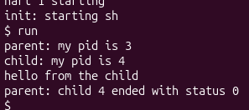
Figure 1.1 – Running the run utility inside xv6 successfully loading the echo process

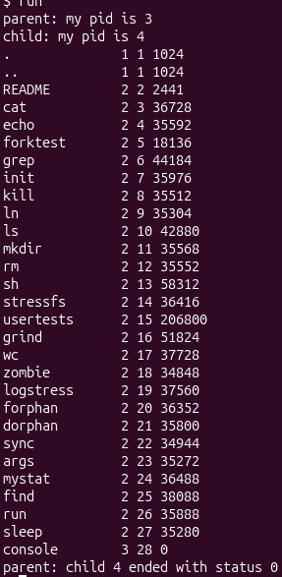
Figure 1.2 – Modified run script successfully executing the internal xv6 ls listing utility

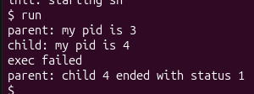
Figure 1.3 – Error handling confirmation inside xv6 showing execution failure and exit status 1

1. Write the three calls that run.c uses in xv6 and the three calls run.c used on Linux in Lab 7. What is the same?
The three system calls used by run.c in xv6 are fork(), exec(), and wait(). On Linux in Lab 7, the program used fork(), execlp(), and waitpid(). The conceptual mechanism and sequencing of creating a process, replacing its memory image, and synchronizing with the parent are completely identical across both operating systems.
2. Who prints "hello from the child": the code of run, or echo?
The text "hello from the child" is printed by the echo program code, not by run. The exec() call replaces the entire memory image of the child process with the echo executable, which handles standard output printing.
3. Why is the status 1 here and 127 on Linux? (Look at the exit line after exec in both programs.)
The exit status is 1 here because the child process explicitly invokes exit(1) in user/run.c right after the exec failure print statement. On Linux, the program was written to explicitly invoke exit(127) inside that same branch.

Part 2:
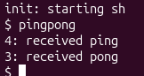
Figure 2.1 – Successful execution of the custom pingpong utility inside the xv6 environment

1. Why do you need TWO pipes, and not one for both directions?
Two separate pipes are required to establish this bidirectional communication because a single system pipe is strictly unidirectional. Using only one pipe would cause a race condition where a process could instantly read back the exact same byte it just wrote, failing to pass it across the process boundary.
2. Nothing in your code says "wait until the child has replied". Which call makes the parent wait?
The parent process is forced to block and wait automatically due to the read(c2p[0], &b, 1) call. It remains suspended until the child process actively writes the response byte into the write end of that specific pipe.

Conclusion:
In conclusion, completing this laboratory assignment provided me with a comprehensive understanding of low-level process management, inter-process communication, and operating system architectures. By exploring these paradigms on both a production-grade Linux kernel and the educational, minimalist xv6 environment, I observed firsthand that foundational system calls—such as fork(), exec(), and wait()—remain conceptually identical and consistent across different environments. Designing unidirectional and bidirectional pipelines using system-level pipes highlighted the critical importance of file descriptor allocation, proper stream synchronization, and defensive error checking to eliminate deadlocks. Ultimately, bridging the gap between high-level Unix applications and custom kernel development has significantly strengthened my systems programming capabilities and demystified the underlying relationship between user-space programs and the operating system kernel.

