
MINISTRY OF EDUCATION AND RESEARCH OF THE REPUBLIC OF MOLDOVA
Technical University of Moldova
Faculty of Computers, Informatics and Microelectronics
Department of Software and Automation Engineering

Laboratory work 6: Inside the xv6 File System
of the "Operating Systems" course

Checked:
asist. univ. Patricia Reițman
Department of Software and Automation Engineering,
FCIM Faculty, UTM
Postica Valeria, FAF-243
Part 1: Read what xv6 shows you
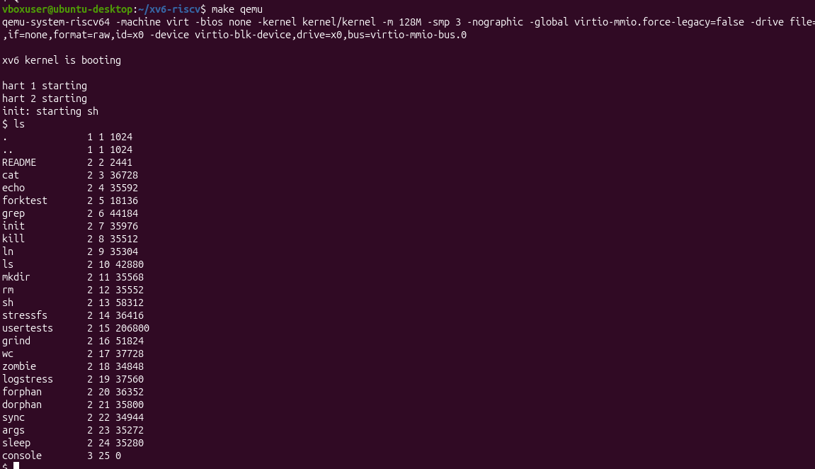
Figure 1.1 – xv6 shell invocation, initial directory listing, and directory creation
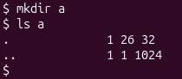
Figure 1.2 – Creating directory a
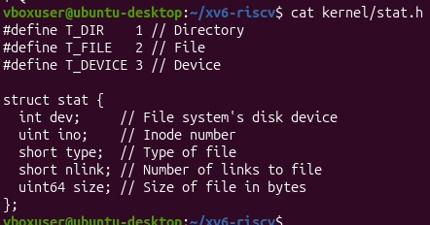
Figure 1.3 – kernel/stat.h
1. What do types 1, 2 and 3 mean (kernel/stat.h)?
• Type 1 (T_DIR): Represents a directory (e.g., . and ..).
• Type 2 (T_FILE): Represents a regular file (e.g., README, cat, echo).
• Type 3 (T_DEVICE): Represents a device file (e.g., console).
2. Which inode number does the root directory have, and why are . and .. the same there?
Inode Number: The root directory has inode number 1 (as seen in the first column for . and ..).
Why they are the same: The . entry refers to the current directory, and .. refers to the parent directory. Because the root directory is the absolute top level of the xv6 file system, it has no parent above it. Therefore, both pointers link back to the root directory itself (inode 1).
3. An empty directory has a size 32. A directory entry has a fixed size. How big is one entry, and which two entries does a contain?
Size of one entry: One directory entry in xv6 is exactly 16 bytes long (2 bytes for the inode number + 14 bytes for the filename character array).
Entries in directory a: The directory a contains exactly two entries:
• . (pointing to itself)
• .. (pointing to its parent, which is the root directory)
Calculation: Since it contains exactly 2 entries, its total size is 32 bytes (2 × 16 = 32).

Part 2: Write mystat
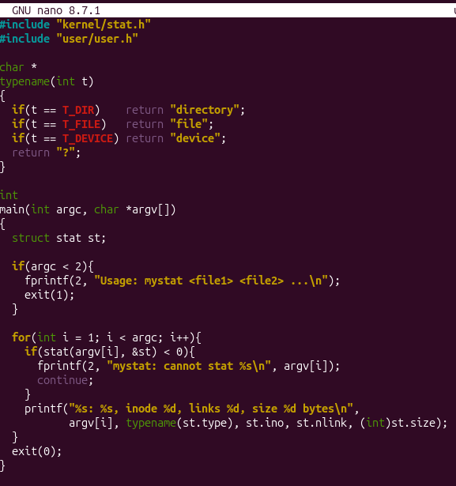
Figure 2.1 – kernel/stat.h

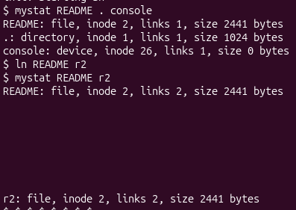
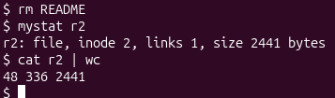
Figure 2.2 – Inspection of file metadata and hard link reference count tracking via mystat
1. Paste the outputs after ln and after rm. What changed and what did not?
Exact outputs from the terminal:

What changed:
• After running ln README r2, the link count (links) for both files increased from 1 to
• After running rm README, the README file entry was removed, and the link count for r2 decreased from 2 back to 1.
What did not change:
The file inode number (2) and size (2441 bytes) remained exactly the same throughout the entire process. Running cat r2 | wc shows that all data blocks containing the 2441 bytes remained completely intact and accessible through the alternative path r2.
2. Find the line in kernel/sysfile.c (sys_unlink) that decrements the link count. When are the data blocks freed?
The line in code: Inside kernel/sysfile.c, within the sys_unlink(void) function, the link count is decremented by this line:
ip->nlink--;
When data blocks are freed: Data blocks on the disk are only freed when the hard link count reaches zero (ip->nlink == 0) AND no active running processes hold an open file descriptor reference to that file in memory (ip->ref == 0).
3. xv6 has no symbolic links and no permissions. Look at struct dinode in kernel/fs.h: which fields does an xv6 inode have?
Inside kernel/fs.h, struct dinode contains the following fields:
struct dinode {
short type; // File type (Directory, File, or Device)
short major; // Major device number (only for T_DEVICE)
short minor; // Minor device number (only for T_DEVICE)
short nlink; // Number of hard links pointing to this inode
uint size; // Size of file in bytes
uint addrs[NDIRECT+1]; // Data block addresses on the disk
};

Part 3: Measure the limits
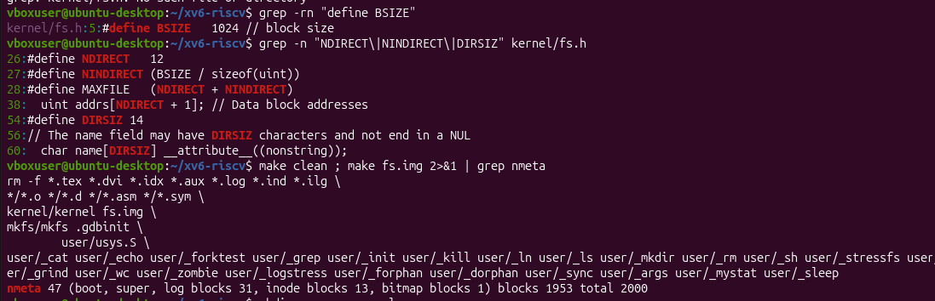
Figure 3.1 – Inspection of kernel fs.h parameters, disk layout (make fs.img)
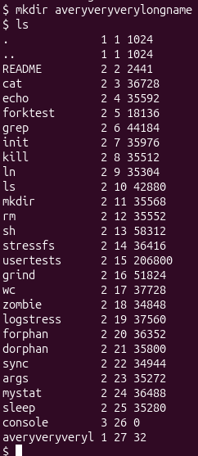
Figure 3.2 – directory and filename length truncation

1. What does ls show for averyveryverylongname, and which constant explains it?
The 'ls' command in xv6 truncates the name down to 14 characters: 'averyveryveryl'.
This limit is explained by the constant 'DIRSIZ', which is defined as 14 on line 54 of 'kernel/fs.h' (#define DIRSIZ 14).
2. Compute the largest file xv6 can hold: 12 direct blocks plus one indirect block that holds block numbers of 4 bytes each, blocks of BSIZE bytes. Show the calculation.
From my terminal output, BSIZE = 1024 bytes and NDIRECT = 12 blocks.
One indirect block can hold: 1024 bytes / 4 bytes per block address = 256 block addresses (NINDIRECT).
Total blocks for a file = 12 (direct) + 256 (indirect) = 268 blocks.
Maximum file size = 268 blocks * 1024 bytes/block = 274,432 bytes (or 268 KB).
3. From the nmeta line: how many blocks does the whole disk have, and how many are for the log, the inodes, and the data?
Based on my exact 'nmeta' output line:
- Whole disk: 2000 blocks total
- Log blocks: 31 blocks (blocks 2 to 32)
- Inode blocks: 13 blocks
- Data blocks: 1953 blocks

Part 4: Write find
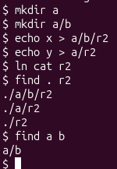
Figure 4.1 – Execution of recursive find utility matching target file path entries
Conclusion
In this laboratory work, I completed a detailed examination of MIT's xv6 RISC-V operating system file system architecture. Through practical code development and terminal observation, I verified how on-disk structures (struct dinode and struct dirent) organize file metadata and directory table entries in 16-byte units. By creating the 'mystat' utility, I tracked inode reference counts and verified kernel unlinking mechanics in sys_unlink(). Evaluating fs.h structural constants established the 274,432-byte maximum file size limit and 14-character filename truncation threshold. Finally, constructing the recursive 'find' utility demonstrated directory tree traversal, file descriptor resource management, and inode reference resolution in C.

