Saint Columban College
COLLEGE OF COMPUTING STUDIES
Pagadian City

FOCUSFLOW: An On-Device Gaze-Based Attention Profiling System for Personalized Learning Recommendations on Android

This study is a partial requirement of the degree
Bachelor of Science in Computer Science

CS Group: Thread.Sleepers (3)

Group Members:

Rhezann Claire C. Pacaña - Project Manager
Valerie Joy Intong - System Developer
Kenrick Dawang - System QA

Chapter 01

INTRODUCTION

Project Context
ADHD is among the most prevalent neurodevelopmental conditions worldwide (Salari et al., 2023), and its management typically combines pharmacological treatment with behavioral strategies and technology-mediated interventions delivered through games and structured digital tasks (Doulou et al., 2025; Kollins et al., 2020). Determining whether a given strategy is working for a particular person, however, still depends largely on subjective impression and recall gathered long after the fact.
This creates a practical problem distinct from the well-documented question of diagnostic accuracy. Even where attention difficulties are already recognized, the individual still has to decide what to actually work with day to day: which kinds of content hold their attention, and which lose it within seconds. In practice that decision is made by guesswork. Study advice is dispensed generically — read the chapter, take notes, avoid distractions with no reference to how a particular person's attention actually behaves, and the information needed to personalize it is generated in ordinary use, over hours rather than minutes, in the setting where the studying will actually happen.
Ocular behavior offers a non-invasive route to this information, and device-embedded cameras have been validated for eye-tracking-based cognitive assessment (Bott et al., 2018). Existing work in this area, however, is directed overwhelmingly at classification — distinguishing affected from unaffected individuals (Liu et al., 2024; Loh et al., 2022). Comparatively little attention has been directed at using the same sensing capability to tell an individual something actionable about their own attention, and to translate that into how they study. FocusFlow addresses that narrower but more tractable problem.

Purpose and Description
The purpose of this study is to design, implement, and evaluate FocusFlow, a self-contained Android application that profiles a user's attentional response to categorized media using only the hardware already present on a consumer smartphone or tablet, and converts that profile into personalized learning-style recommendations, study techniques, and weekly goals that the user can act on directly.
The system is composed of four integrated parts. First, an on-device computer-vision pipeline binds the front-facing camera through CameraX ImageAnalysis and runs the MediaPipe Face Landmarker on every frame, recovering 478 facial landmarks including ten iris points, eight gaze-direction blendshape coefficients, and head orientation. A per-frame decision combines eye-gaze deflection with head yaw and pitch to determine whether the user is oriented toward the screen, and a temporal layer tracks screen-attention proportion, gaze shifts, blink count, and time to first sustained lapse, ending a clip early when attention has dropped for long enough. Second, a curated stimulus library delivers short video clips from nine content categories — Music, Gaming, Cartoon, Science Fiction, Education, Horror, Sadness, Melodrama, and Romance — through an embedded player using fixed, manually verified content identifiers, in randomized category order and under a per-clip duration cap; after each clip the user provides two short self-reported ratings.
Third, a scoring engine reduces the per-frame signals and ratings to a per-category attention score on a 0–100 scale as a documented weighted combination of screen attention, distraction delay, gaze stability, blink consistency, and the two self-reports, redistributing the self-report weight proportionally across the gaze-based components when ratings are unavailable; a session rule generates a profile only after five successful assessments, with bounded skip handling that retires a category after a second skip and terminates gracefully once the category pool is exhausted. Fourth, a recommendation engine ranks the categories, aggregates the trait clusters shared by the user's strongest categories, infers a dominant learning style, and generates study techniques, recommended content formats, and weekly goals, presented on a dashboard and exportable as a PDF report. Scored sessions are persisted locally; account, profile, and an optional diagnosis document are held in a managed backend. Camera frames are processed in memory on the device and are never stored or transmitted — only derived numerical metrics are retained. FocusFlow is an assistive self-reflection and study-habits tool intended to inform, not replace, professional judgement; it does not diagnose, screen for, or classify ADHD.

Objectives of the Study
The general objective of this study is to design and implement a self-contained mobile computing system that profiles a user's attentional response to categorized media on-device and converts that profile into personalized, actionable learning-style recommendations. Specifically, the study aims to:
a. implement an Android application capable of capturing per-frame ocular and head-orientation features from the front-facing camera without blocking media playback;
b. implement a camera setup and calibration step that verifies stable face and iris acquisition before an assessment is allowed to begin;
c. formulate and implement the 0–100 attention score as a documented weighted combination of screen attention, distraction delay, gaze stability, blink consistency, and self-reported ratings, with an accompanying sensitivity analysis over plausible weight vectors;
d. construct a local persistence layer and a session-success rule that generates a profile only after five successful assessments, including bounded handling of skipped and exhausted categories;
e. derive a learning style, study techniques, and weekly goals from the ranked category profile, and present them on a dashboard and as an exportable PDF report the user controls; and
f. evaluate system performance in terms of analysis frame rate across devices, interface usability, and the stability of category rankings under varied score weightings.

Scope and Limitations
This study covers the development of a self-contained Android application in Kotlin and Jetpack Compose, following an MVVM architecture with a repository layer and targeting Android 8.0 (API level 26) and above. The scope includes on-device acquisition and feature extraction from the front-facing camera using CameraX and the MediaPipe Face Landmarker; a per-frame attention decision combining eye-gaze deflection with head yaw and pitch; a temporal layer measuring screen-attention proportion, gaze shifts, blink count, and time to first sustained lapse; computation of a per-category attention score on a 0–100 scale; a curated stimulus library of nine content categories with randomized presentation order and a per-clip duration cap; a session rule requiring five successful assessments with bounded skip handling; inference of a dominant learning style with recommended study techniques, content formats, and weekly goals; and account management, onboarding, local relational persistence of scored sessions, and export of the resulting report as a PDF.
The system is evaluated on team-owned Android devices in ordinary study settings; it is operated by the user directly and requires no specialist supervision, with minors expected to use it under guardian involvement during account setup and the camera setup step. Age-appropriate filtering of the stimulus categories is not implemented in the current build, so all nine categories are presented to every user regardless of age; this is a known limitation carried into the next iteration. In the absence of an external criterion measure of attention, the attention-score component weights are a stated design prior rather than empirically calibrated values. The approved system measures gaze deflection rather than calibrated point-of-regard; as a post-approval enhancement, the current build additionally incorporates the iTracker model (Krafka et al., 2016) with a short per-user calibration to provide an approximate, centimetre-level estimate of screen position, used only when the calibration fit is within tolerance and falling back automatically to the deflection-based pipeline otherwise. The iTracker model is used under a research-only licence.
The following are outside the scope of this study: diagnostic classification or screening for ADHD — the system characterizes content preference and attention patterns, not diagnostic status; any external sensor, microcontroller, or hardware peripheral, since all sensing is performed by the device's own front-facing camera; transmission of video frames, facial landmarks, or any derived per-frame feature off the device, with remote services limited to authentication, the user profile record, optional diagnosis-document storage, and streaming of the stimulus videos; native iOS or web-based companion versions during the initial project term; and prescription of treatment.

Significance of the Study
The results of this study are expected to benefit the following:
Individuals aged 5 to 30 who want to understand their own attention patterns. Whether or not they have an ADHD diagnosis, they gain a non-invasive, self-administered way to learn which kinds of content sustain their attention and to receive study techniques and weekly goals grounded in their own measured behaviour rather than generic advice.
Guardians of minors. Guardians who supervise account setup and the camera setup step receive an observational profile of a child's content preferences that can inform how study material is chosen and framed at home.
Educators, tutors, and clinicians. Those with whom a user chooses to share the exported report gain supplementary observational context about content preference and attention behaviour — never a diagnostic instrument — to complement their own professional judgement.
Future researchers and students. The study provides a documented reference for combining on-device face-landmark inference with temporal attention measurement and a transparent, sensitivity-checked scoring design, and a foundation for extending the work with age-appropriate content filtering, empirical weight calibration, and validation against external criterion measures.

Definition of Terms
Attention Score – A bounded per-category value on a 0–100 scale formed as a weighted combination of screen-attention proportion, distraction delay, gaze stability, blink consistency, and two self-reported ratings, used to rank categories against one another.
Attentional Profiling – The characterization of which categories of media content sustain an individual's engagement, as distinct from diagnostic classification.
Blendshape – A per-frame coefficient between 0 and 1 describing the degree to which a particular facial expression is present. Eight of these coefficients describe eye-gaze direction and form the primary gaze signal used by the system.
Camera Setup Step – The pre-assessment stage in which the front camera is bound and the user positions themselves until a face and both irises are detected stably, gating the start of an assessment.
Face Landmarker – The on-device computer-vision model that returns 478 facial landmarks per frame — 468 mesh points plus ten iris points — together with blendshape coefficients and a facial transformation matrix.
Gaze Deviation – The measured deflection of the eyes away from centre, derived from the gaze blendshapes and evaluated together with head yaw and pitch to decide whether the user is looking at the screen.
Learning Style – The dominant mode of engagement inferred from the trait clusters shared by a user's highest-scoring categories, expressed as auditory, visual, interactive, narrative, structured, or multimodal.
Stimulus – A single curated video clip in the library, identified by a stable identifier and a manually verified content identifier, belonging to exactly one of the nine content categories and subject to a per-clip duration cap.
Successful Assessment – A category session in which the clip plays to completion with attention maintained and post-clip ratings are collected. Five successful assessments are required before a profile is generated.
Sustained Attention Drop – A lapse in on-screen attention long enough, or frequent enough within a rolling recent-history window, to end the current clip early and rotate to a different category.
Trait Cluster – The broad grouping — auditory, visual, interactive, narrative, or textual — to which a category's attention traits belong; cluster weights tallied across a user's best categories determine the inferred learning style.

Chapter 02

THEORETICAL FRAMEWORK

Review of Related Literature
Taken together, the reviewed literature shows three mature but separate streams: computer-vision work that makes gaze measurable with ordinary device cameras; clinical and epidemiological work that establishes ocular behaviour as an attention-related signal and quantifies the population concerned; and digital-intervention work that delivers attention support through games and structured tasks. No reviewed system closes the loop by using a consumer phone's own camera to profile which categories of content sustain an individual's attention and translating that profile into study recommendations. This study addresses that gap.

2.0 Gaze Estimation with Device-Embedded Cameras
Estimating where a person is looking traditionally required dedicated infrared eye trackers, and toolboxes such as PyGaze (Dalmaijer, Mathôt, & Van der Stigchel, 2014) standardised experiment programming around such hardware. Krafka et al. (2016) demonstrated that a convolutional network trained on a large crowdsourced dataset can estimate point of regard from a phone or tablet front camera alone, establishing that consumer devices carry sufficient sensing capability. Kartynnik, Ablavatski, Grishchenko, and Grundmann (2019) showed that a dense facial surface can be recovered from monocular video in real time on mobile GPUs — the model underlying the MediaPipe Face Landmarker used in this study. Bott et al. (2018) validated eye-tracking measures from device-embedded cameras against established cognitive composites, and Park et al. (2025) showed that correcting for head motion materially improves gaze accuracy, which is why FocusFlow evaluates eye-gaze deflection together with head yaw and pitch rather than in isolation. These works make gaze measurable on ordinary devices, but they stop at measurement; none asks what the measured attention means for how a particular person should study.

2.1 Ocular Behaviour as an Attention-Related Signal
A second stream connects ocular measures to attention in populations with ADHD. Groen, Borger, Koerts, Thome, and Tucha (2017) examined blink rate and blink timing in children with ADHD, motivating blink behaviour as a soft, indirect attention correlate — which is why blink consistency enters the FocusFlow score with the smallest weight. Lee, Yeung, Sze, and Chan (2021) showed that eye-tracking-based training improves inhibitory control, indicating that ocular measures are not merely descriptive but actionable. Liu et al. (2024) demonstrated that eye-tracking-derived digital biomarkers can distinguish ADHD from control groups, and Loh et al. (2022) reviewed automated detection approaches across modalities. Across this stream the consistent orientation is diagnostic classification; the same signals are rarely turned back toward the individual as feedback about their own engagement with particular content.

2.1.1 Self-Report as a Complementary Signal
Behavioural sensing is not the only informative input. Christiansen et al. (2020) applied machine learning to structured self-report rating scales for adult ADHD, showing that short, structured self-reports carry usable signal. FocusFlow collects two brief post-clip ratings for the same reason, but treats them as a complement to the gaze-based measures rather than a substitute: they carry a small, documented weight, and when they are unavailable that weight is redistributed proportionally across the objective components so that a session without ratings is not silently scored on a smaller scale.

2.2 Digital Interventions and Objective Measurement
A third stream delivers attention support through technology. Doulou, Pergantis, Drigas, and Skianis (2025) systematically reviewed serious games for managing ADHD symptoms, and Kollins et al. (2020) reported a randomised controlled trial of a game-delivered digital intervention with measurable attention outcomes; Davis, Bower, and Kollins (2018) established the feasibility of delivering such an intervention at home. Luo, Zhang, Xia, and Zhou (2023) combined behavioural training with EEG biofeedback, and Ouyang et al. (2026) used an instrumented chair to measure movement objectively in a simulated classroom, both illustrating the demand for objective rather than recall-based measures. These interventions are effective but are prescribed generically: whether a given format suits a given individual is not itself measured, and the objective-measurement approaches depend on specialised hardware unavailable in everyday study settings. Salari et al. (2023) quantify the scale of the population for whom this matters.

2.3 Synthesis
The gap between these streams is the one FocusFlow occupies. Gaze can be measured on a consumer phone; ocular behaviour is an established attention correlate; and digital interventions work but are not personalised to the individual's measured attention. FocusFlow combines on-device face-landmark inference with a temporal attention layer and a transparent, sensitivity-checked scoring design to profile which of nine content categories sustain a user's attention, and converts that profile into learning-style recommendations, study techniques, and weekly goals — while explicitly declining to diagnose, screen for, or classify ADHD, and while keeping every camera frame on the device.

Literature Table
Table 2 Literature Table
Title / Authors / Year | Brief Description / Advantages/Features | Issues/ Problems / Disadvantages/For Improvements
1. Eye Tracking for Everyone / Krafka, Khosla, Kellnhofer, Kannan, Bhandarkar, Matusik & Torralba / 2016 | Introduces GazeCapture, a large-scale mobile gaze dataset, and iTracker, a convolutional network that estimates point of regard from a phone or tablet front camera without dedicated hardware. | Trained on iOS devices; accuracy is coarse (centimetre-level) without per-user calibration. Research-only licence restricts commercial use of any derived model.
2. Device-embedded cameras for eye tracking-based cognitive assessment / Bott et al. / 2018 | Validates eye-tracking measures captured by device-embedded cameras against paper-pencil and computerized cognitive composites. | Targets cognitive assessment in a clinical-research setting; does not translate measures into individual study recommendations.
3. Real-time facial surface geometry from monocular video on mobile GPUs / Kartynnik, Ablavatski, Grishchenko & Grundmann / 2019 | Describes the dense face-mesh model underlying MediaPipe Face Landmarker, producing a 3D facial surface in real time on mobile GPUs from a single camera. | A perception building block only; provides landmarks and pose, not an attention decision or temporal analysis.
4. Motion-corrected eye tracking (MoCET) improves gaze accuracy during visual fMRI experiments [Preprint] / Park, Jeon, Kim, Kay & Shim / 2025 | Shows that correcting for head motion materially improves gaze accuracy, supporting FocusFlow's combination of eye-gaze signals with head yaw and pitch. | Preprint in an fMRI context with specialised equipment; not peer-reviewed at time of writing.
5. PyGaze: An open-source, cross-platform toolbox for eye-tracking experiments / Dalmaijer, Mathôt & Van der Stigchel / 2014 | Provides a programming toolbox for eye-tracking experiments, standardising how gaze data are collected and analysed in research. | Desktop and laboratory eye-tracker oriented; not a mobile, camera-only solution.
6. Blink rate and blink timing in children with ADHD and the influence of stimulant medication / Groen, Borger, Koerts, Thome & Tucha / 2017 | Examines blink rate and timing as ocular correlates of attention in children with ADHD, motivating blink behaviour as a soft attention-related signal. | Clinical population and laboratory measurement; blink measures alone are not a robust attention indicator, hence their small weight in FocusFlow.
7. Eye-tracking training improves inhibitory control in children with ADHD / Lee, Yeung, Sze & Chan / 2021 | Shows eye-tracking-based training can improve inhibitory control, illustrating that ocular measures are both informative and actionable. | Intervention study with specialized equipment; not an at-home profiling tool.
8. Auxiliary diagnosis of children with ADHD using eye-tracking and digital biomarkers: Case-control study / Liu et al. / 2024 | Demonstrates that eye-tracking-derived digital biomarkers can distinguish ADHD from control groups. | Directed at diagnostic classification, which FocusFlow explicitly excludes; provides no per-content attention profile.
9. Automated detection of ADHD: Current trends and future perspective / Loh, Ooi, Barua, Palmer, Molinari & Acharya / 2022 | Reviews automated ADHD detection approaches across signal modalities and machine-learning methods. | Classification-centric; individual, content-specific attention feedback is largely absent from the reviewed work.
10. Use of machine learning to classify adult ADHD based on the Conners' Adult ADHD Rating Scales / Christiansen et al. / 2020 | Applies machine learning to self-report rating scales, illustrating the value of structured self-report as an input signal. | Self-report used for diagnosis rather than as a complement to behavioural sensing; no objective ocular measures.
11. The global prevalence of ADHD in children and adolescents: A systematic review and meta-analysis / Salari et al. / 2023 | Quantifies ADHD prevalence worldwide, establishing the size of the population for whom attention-aware study support is relevant. | Epidemiological; offers no intervention or tooling.
12. Managing ADHD symptoms in children through technology-driven serious games: A systematic review / Doulou, Pergantis, Drigas & Skianis / 2025 | Reviews serious games and structured digital tasks used as technology-mediated interventions for ADHD symptom management. | Interventions are prescribed generically; whether a given format suits a given individual is not measured.
13. A novel digital intervention for actively reducing severity of paediatric ADHD (STARS-ADHD): A randomised controlled trial / Kollins et al. / 2020 | Randomised trial of a game-delivered digital intervention showing measurable effects on attention outcomes. | Delivers a fixed intervention; does not profile which content categories sustain a particular user's attention.
14. Proof-of-concept study of an at-home, engaging, digital intervention for pediatric ADHD / Davis, Bower & Kollins / 2018 | Demonstrates feasibility of an at-home digital intervention, supporting the premise that useful attention-related data can be gathered where studying actually happens. | Focused on symptom reduction; no gaze sensing and no learning-style output.
15. Efficacy of behavior modification training combined with EEG biofeedback therapy for ADHD in children: A randomized controlled trial / Luo, Zhang, Xia & Zhou / 2023 | Evaluates combined behavioural training and EEG biofeedback, showing objective physiological signals can support attention interventions. | Requires EEG hardware and clinical supervision; not deployable on a consumer phone.
16. Objective evaluation of ADHD medication effects using a load-cell-embedded chair in a simulated classroom / Ouyang, Wu, Chiu, Yang & Lin / 2026 | Uses an instrumented chair to measure movement objectively as an attention-related outcome, illustrating demand for objective rather than recall-based measures. | Depends on purpose-built furniture; measures motor activity rather than visual attention to content.

Concept Map
Figure 1 Concept Map
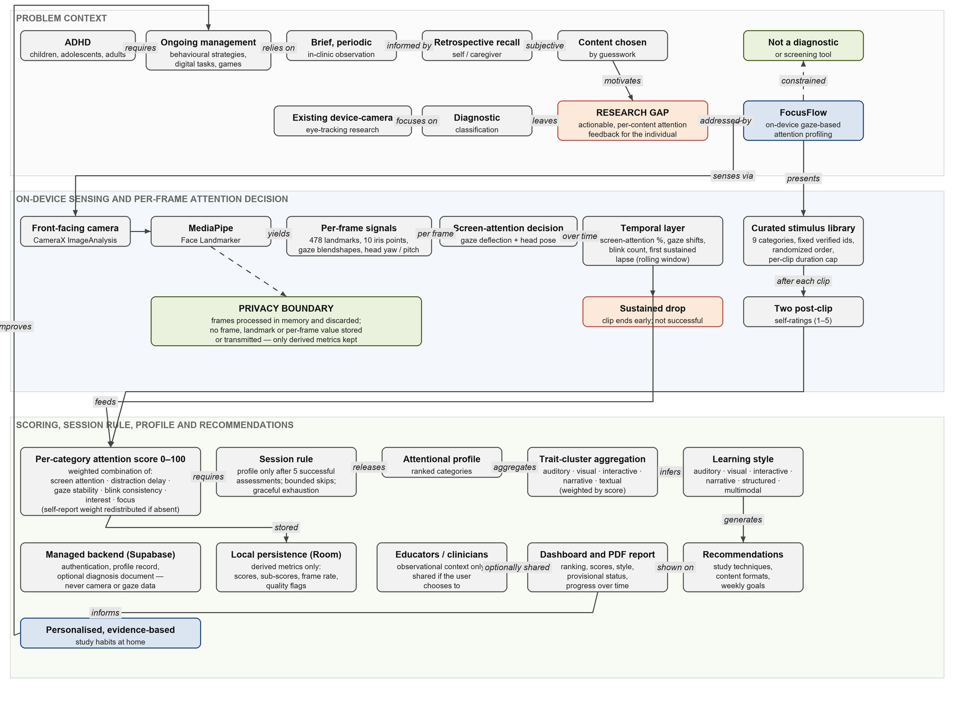
Figure 1 situates FocusFlow in its problem space and traces its pipeline. Ongoing ADHD management relies on brief in-clinic observation and retrospective recall, so day-to-day content is chosen by guesswork; existing device-camera eye-tracking research, meanwhile, is directed at diagnostic classification. Together these leave the research gap the system addresses: actionable, per-content attention feedback for the individual. FocusFlow senses through the front camera, processes every frame on the device with the MediaPipe Face Landmarker, and combines gaze deflection with head pose into a per-frame screen-attention decision; a temporal layer measures screen-attention proportion, gaze shifts, blink count, and time to first sustained lapse, ending a clip early on a sustained drop. Clips come from a curated nine-category library in randomized order, each followed by two self-ratings. These feed a six-component per-category score, released as a ranked profile only after five successful assessments; trait clusters aggregated across the strongest categories yield a learning style, from which study techniques, content formats, and weekly goals are generated for the dashboard and PDF report, which the user may share as observational context. Derived metrics are kept locally and only account data remotely; the privacy boundary — frames processed in memory and discarded — bounds the whole pipeline, and the system is explicitly not a diagnostic or screening tool.

