Coffee Sales Analytics and Customer Purchase Prediction
An End-to-End Data Science Project Using Excel, SQL, Python, and Machine Learning
Valerie Komen
Technical Report
July 2026
Repository: github.com/Valerie-komen/Coffee-Sales-Analytics-ML

Table of Contents
Table of Contents 2
1. Abstract 3
2. Introduction 3
2.1 Background 3
2.2 Problem Statement 3
2.3 Objectives 3
2.4 Research Questions 4
3. Dataset 4
4. Data Cleaning (Excel + SQL + Python) 4
4.1 Excel 4
4.2 SQL 4
4.3 Python 5
5. Exploratory Data Analysis 5
5.1 Which coffee sells the most — and is it the most profitable? 5
5.2 Who spends the most, and which country buys the most premium coffee? 6
5.3 Does loyalty-card membership increase spending? 6
5.4 Seasonality 6
5.5 Correlation structure and order-value distribution by roast 7
5.6 Bag-size revenue concentration 8
6. Machine Learning 8
6.1 Customer Segmentation (K-Means) — flagship result 8
6.2 Repeat-Purchase Classification — reported honestly 9
7. Interactive Dashboard 11
8. Results Summary 12
9. Limitations 13
10. Future Work 13
11. Responsible AI 13
11.1 Data Privacy 13
11.2 Bias and Fairness 14
11.3 Transparency 14
11.4 Responsible Deployment 14
12. Conclusion 14

1. Abstract
Coffee retailers collect large amounts of transactional data, yet many businesses rely on descriptive dashboards rather than predictive analytics. This project develops an end-to-end analytics pipeline — Excel, SQL, Python, and an interactive dashboard — to analyze four years of coffee sales (2019–2022) for a specialty roaster selling Arabica, Excelsa, Liberica, and Robusta beans across the United States, United Kingdom, and Ireland.
The pipeline cleans and validates 1,000 order lines from 913 customers, answers ten core business questions through SQL and exploratory analysis, and applies two machine-learning approaches: K-Means customer segmentation and repeat-purchase classification. Segmentation is the project's strongest quantitative result (silhouette score 0.555 at k=3), cleanly separating occasional low-spend buyers, bulk buyers, and a small high-value/repeat segment. Repeat-purchase classification is reported honestly: only 25 of 913 customers (2.7%) ever placed a second order, and the resulting class imbalance means no model tested meaningfully beats a naive baseline — a finding treated as a legitimate result about the limits of this dataset, not smoothed over with a misleading accuracy figure.
The study demonstrates how a full analytics stack — from raw spreadsheet to validated SQL queries to machine learning to an interactive dashboard — can support inventory planning, customer segmentation, and business decision-making, while being transparent about where the data does and does not support strong predictive claims.

2. Introduction

2.1 Background
Small and mid-sized retailers increasingly capture order-level transactional data, but most stop at descriptive reporting — pivot tables and dashboards that describe what happened without informing what to do next. A more complete analytics practice combines descriptive analysis (what happened), diagnostic analysis (why), and predictive analysis (what is likely to happen), each validated against the same underlying data through multiple tools.

2.2 Problem Statement
The coffee roaster in this dataset has three years of order-level sales data split across products, customers, and orders, but no unified pipeline connecting raw data to cleaned data, to validated business queries, to predictive modeling, to a shareable interactive view. This project builds that pipeline end-to-end and evaluates, honestly, how far machine learning can be pushed on a dataset of this size and structure.

2.3 Objectives
- Build a reproducible cleaning pipeline from raw Excel workbook to analysis-ready CSV and SQL database.
- Answer core revenue, margin, retention, and seasonality questions using SQL and Python.
- Apply unsupervised learning (customer segmentation) and supervised learning (repeat-purchase prediction), reporting real, unaltered metrics for both.
- Communicate findings through an interactive dashboard and a written technical report suitable as a work sample.

2.4 Research Questions
- Which coffee type and roast drive revenue, and is the revenue leader also the margin leader?
- Which customer characteristics, if any, predict repeat purchase?
- Do natural customer segments exist in the data, and what distinguishes them?
- Does loyalty-card enrollment measurably increase spending?
- What seasonal and country-level patterns exist in demand?

3. Dataset
Source: coffee_orders_dashboard.xlsx (raw_data.xlsx in this repository), a transactional export covering January 2, 2019 to August 19, 2022, with three sheets: orders, customers, and products.
Table | Rows | Key fields
orders | 1,000 order lines | Order ID, Order Date, Customer ID, Product ID, Quantity, Country, Coffee Type/Name, Roast Type/Name, Size, Unit Price, Sales, Loyalty Card
customers | 1,000 (913 unique) | Customer ID, Country, Loyalty Card (PII columns dropped — see Section 4)
products | 48 SKUs | Product ID, Coffee Type, Roast Type, Size, Unit Price, Price per 100g, Profit

Four coffee types (Arabica, Excelsa, Liberica, Robusta) × three roasts (Light, Medium, Dark) × four bag sizes (0.2kg, 0.5kg, 1kg, 2.5kg) yield the 48-SKU product catalog. Customers are based in the United States, United Kingdom, and Ireland.

4. Data Cleaning (Excel + SQL + Python)
Full, executed code is in notebooks/01_data_cleaning.ipynb and sql/cleaning_queries.sql; this section summarizes what was checked and found.

4.1 Excel
- Verified no blank/duplicate header rows or merged-cell artifacts from the original dashboard workbook.
- Confirmed date columns were true datetime values (not text) before export.
- Used the workbook's existing PivotTable/lookup structure as a cross-check against the Python-computed aggregates.

4.2 SQL
A normalized SQLite schema (sql/database_creation.sql) with orders, customers, and products tables and foreign keys was created, then validated with sql/cleaning_queries.sql:
- Missing values: 0 across all required columns.
- Exact duplicate rows: 0.
- One repeated (Order ID, Product ID) pair (NOP-21394-646 / L-D-2.5) had different quantities (2 vs. 3 units) on each line — kept, since it represents two distinct order lines rather than an erroneous duplicate.
- Referential integrity: every order references a valid customer and product.
- Sales reconciliation: Sales = Quantity × Unit Price for all 1,000 rows (0 mismatches beyond rounding).
sql/analysis_queries.sql then answers the core business questions directly in SQL — revenue and margin by coffee type, monthly trend, country revenue share, top-customer ranking, customer lifetime value, repeat-purchase rate, loyalty comparison, size-tier revenue share, and a trailing-12-month revenue window function — all reproduced in Python in Section 5.

4.3 Python
pandas performed the merge/clean/export; PII columns (Customer Name, Email, Phone Number, Address Line 1, City, Postcode) were dropped before any file was written to the repository, keeping only the de-identified Customer ID plus Country and Loyalty Card — see the Responsible AI section for the reasoning. scikit-learn (StandardScaler, KMeans, PCA, LogisticRegression, RandomForestClassifier) and matplotlib/seaborn/plotly handled feature engineering, modeling, and visualization respectively.

5. Exploratory Data Analysis
Full code in notebooks/02_exploratory_analysis.ipynb.

5.1 Which coffee sells the most — and is it the most profitable?
Coffee type | Revenue | Profit | Margin
Excelsa | $12,306.44 | $1,353.71 | 11.0%
Liberica | $12,054.08 | $1,567.03 | 13.0%
Arabica | $11,768.50 | $1,059.16 | 9.0%
Robusta | $9,005.24 | $540.31 | 6.0%

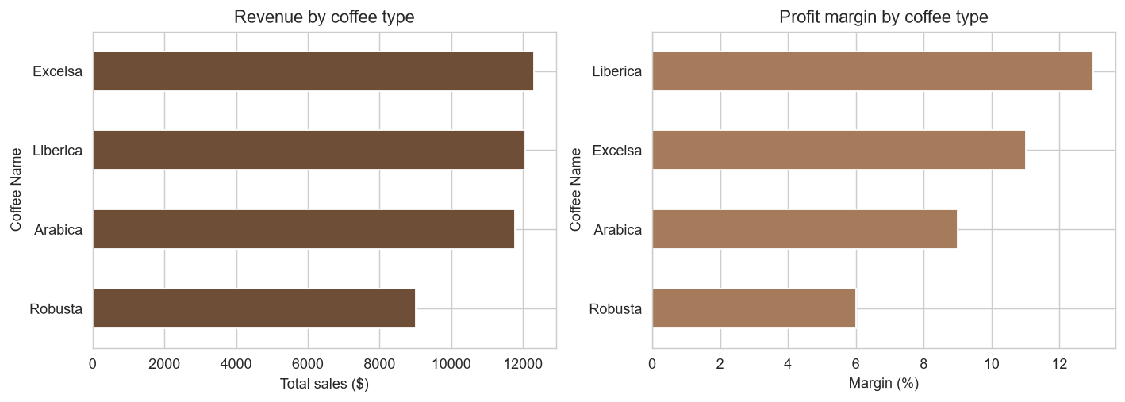
Figure 1. Revenue by coffee type (left) vs. profit margin by coffee type (right).
Excelsa leads on revenue, but Liberica is the most profitable bean at 13% margin — more than double Robusta's 6%. Revenue leadership and margin leadership are not the same thing in this dataset.

5.2 Who spends the most, and which country buys the most premium coffee?
The five highest lifetime-spend customers range from $278–$317. Average unit price paid is nearly identical between Ireland and the United States ($13.01 each) and lowest in the United Kingdom ($11.66). On a per-customer basis, the United States ($50.05) and Ireland ($48.53) convert similarly, while the United Kingdom lags on both revenue share and per-customer spend ($44.42) — evidence the UK is under-marketed rather than simply a smaller, lower-potential market.
Country | Revenue | Share of total | Avg. spend / customer
United States | $35,638.88 | 79.0% | $50.05
Ireland | $6,696.86 | 14.8% | $48.53
United Kingdom | $2,798.51 | 6.2% | $44.42

5.3 Does loyalty-card membership increase spending?
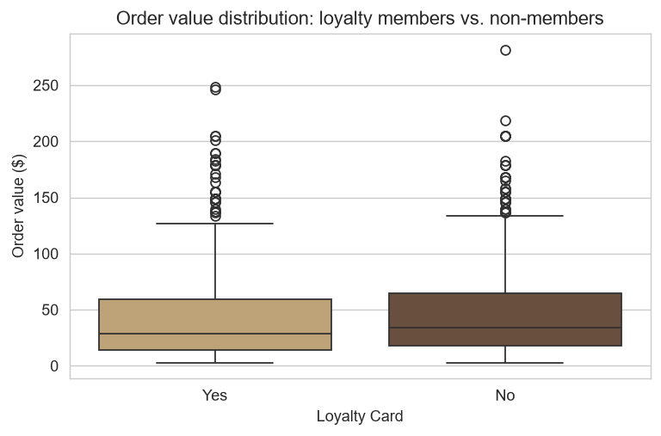
Figure 2. Order-value distribution: loyalty members vs. non-members.
No. Loyalty cardholders' mean order value ($45.08) and median ($28.60) are both slightly below non-members' ($49.12 mean, $33.75 median), despite ~49% enrollment. The program shows no measurable lift in basket size.

5.4 Seasonality
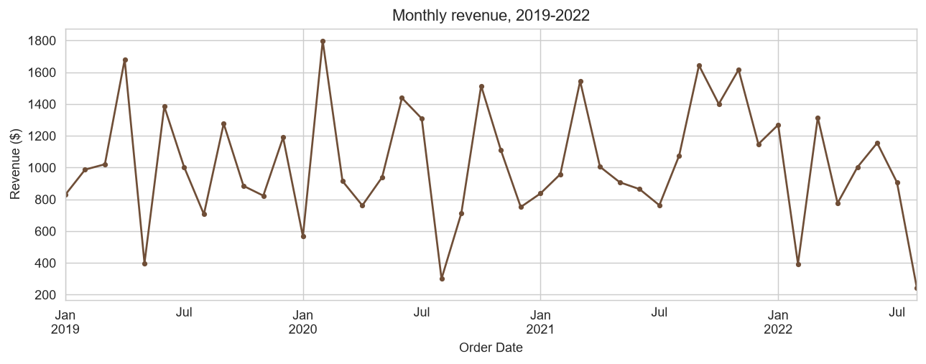
Figure 3. Monthly revenue, 2019–2022.
Sales peak in June ($4,843 total across years) and trough in August ($2,327 total) — a repeating pattern each year. Annual revenue was roughly flat 2019→2020 ($12,187 → $12,118, −0.6%), then grew 13.6% in 2021 ($13,766). The partial 2022 data (through August, $7,063) annualizes to roughly $10,595 — below full-year 2021, a deceleration worth monitoring before it compounds into a full-year figure.

5.5 Correlation structure and order-value distribution by roast
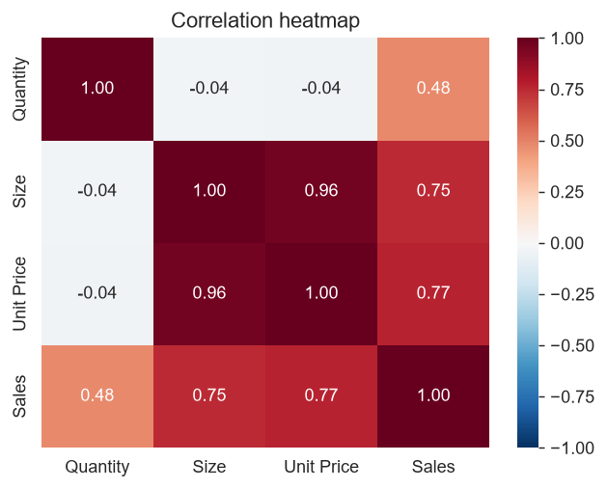
Figure 4. Correlation heatmap of numeric order features.
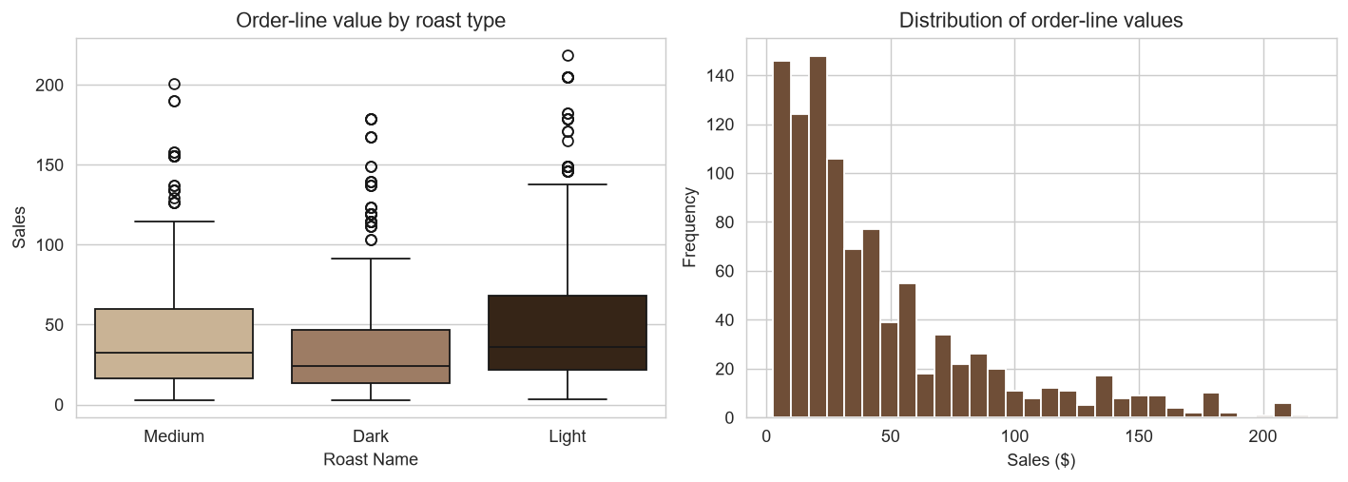
Figure 5. Order-line value by roast type (left) and overall distribution (right).
Sales correlates strongly with Size and Unit Price by construction; Quantity correlates only weakly with Sales, meaning revenue is driven more by which size/price tier customers choose than by how many units they order per line. Light roast has the highest mean order-line value ($52.12), ahead of Medium ($43.71) and Dark ($39.58).

5.6 Bag-size revenue concentration
The 2.5kg bulk size alone accounts for $23,785.56 — 52.7% of total revenue — from a single SKU tier, ahead of 1kg (24.4%), 0.5kg (15.6%), and 0.2kg (7.3%) combined.

6. Machine Learning
Full code and real, executed output in notebooks/03_machine_learning.ipynb. Two tasks are attempted, in order of how well the dataset actually supports them.

6.1 Customer Segmentation (K-Means) — flagship result
Features: recency (days since last order), frequency (order count), monetary value (total spend), average order-line value, average unit price, and share of purchases in the bulk (2.5kg) tier — a standard RFM-style feature set, standardized before clustering.
Silhouette scores were computed for k=2..6; k=3 scored highest (0.555), narrowly ahead of k=2 (0.543) and well ahead of k≥4 (≤0.391). The resulting three segments, labeled after inspecting their actual centers (not decided in advance):
Segment | Customers | Share | Avg. spend | Avg. unit price | % bulk | % repeat
Occasional / low-spend buyers | 671 | 73.5% | $29.75 | $7.84 | 0% | 1%
Bulk buyers | 229 | 25.1% | $98.77 | $28.06* | 98% | 2%
High-value / repeat buyers | 13 | 1.4% | $196.28 | $13.86 | 26% | 100%

* Bulk buyers' higher average unit price reflects bag size (a 2.5kg bag costs more per bag, though less per 100g), not a premium-product preference.
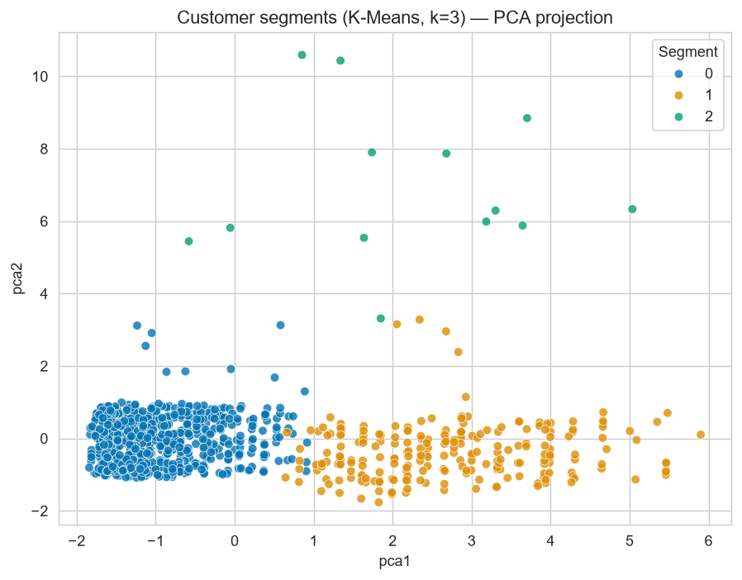
Figure 6. Customer segments (K-Means, k=3), PCA projection.
The high-value/repeat segment captures only 13 of the 25 total repeat customers; the remaining ~7 and ~5 repeat customers are scattered within the low-spend and bulk segments respectively, meaning RFM features alone don't fully separate every repeat buyer — a nuance a business team would want when designing segment-specific campaigns.

6.2 Repeat-Purchase Classification — reported honestly
Leakage check: total spend and order count are computed over each customer's entire history, so using them to predict repeat_customer would be circular. Features were therefore restricted to what is knowable at the customer's first order only: first-purchase coffee type, roast, size, unit price, quantity, order value, country, and loyalty enrollment at that time.
Class balance: 97.3% no-repeat vs. 2.7% repeat. A model that always predicts “no repeat” already scores 97.4% accuracy on the held-out test set — the benchmark every other number below must be read against.
Model | Accuracy | Precision | Recall | F1 | ROC-AUC
Baseline (always “no repeat”) | 97.4% | — | 0% | — | 0.50
Logistic Regression (class-weighted) | 57.2% | 2.1% | 33.3% | 3.9% | 0.51
Random Forest (class-weighted) | 93.0% | 0% | 0% | 0% | 0.52

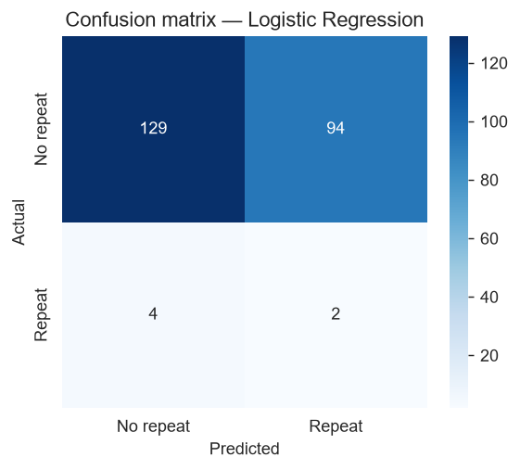
Figure 7. Confusion matrix, Logistic Regression (best F1 of the two models tested).
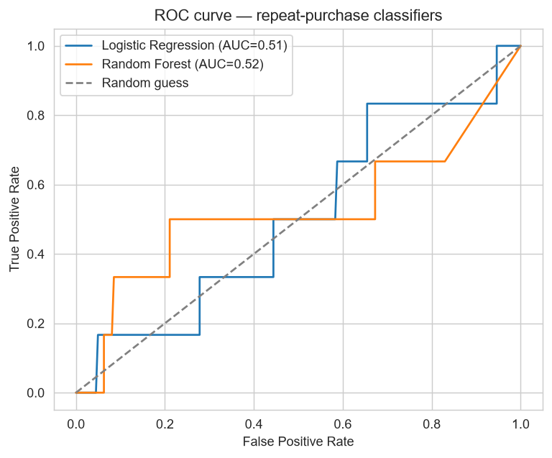
Figure 8. ROC curves — both models sit only marginally above the random-guess diagonal.
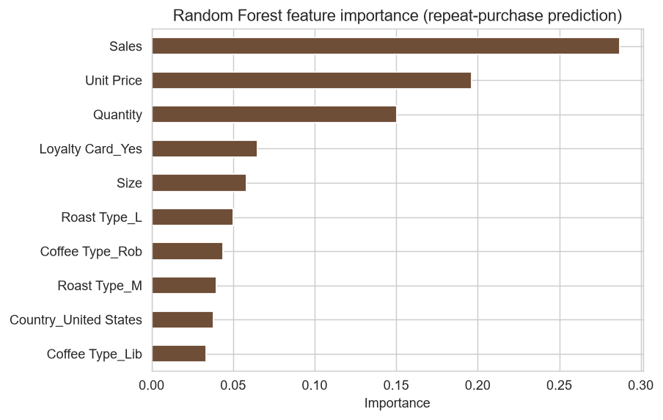
Figure 9. Random Forest feature importance for repeat-purchase prediction.
Both models' ROC-AUC (0.51 and 0.52) sit only marginally above 0.50 — the score a coin flip would achieve. With just 25 repeat customers in the entire dataset (roughly 6 in any single test fold), this is the expected outcome of severe class imbalance and small positive-class sample size, not a modeling error, and is reported as a genuine finding: this dataset, as collected, does not contain enough repeat-purchase signal to support a reliable classifier. This is the reason segmentation — not repeat-purchase classification — is this project's headline machine-learning result, and it directly motivates the Future Work recommendation to collect additional behavioral signals.

7. Interactive Dashboard
The original project plan called for a Power BI dashboard. Power BI Desktop was not available in the environment this project was built in, and rather than present a dashboard that was never actually built, this section documents a substitute that was: a self-contained, interactive Plotly/HTML dashboard (dashboard/coffee_sales_dashboard.html) that requires no server or paid software to view — it opens directly in any browser.
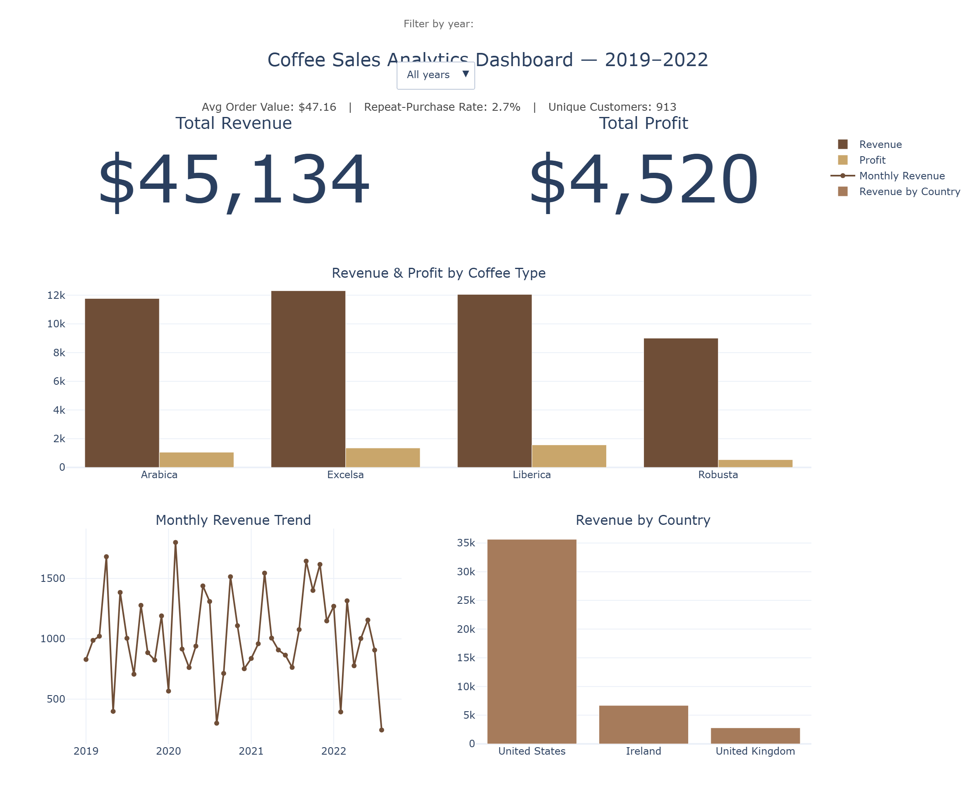
Figure 10. Interactive dashboard: total revenue, total profit, average order value, repeat-purchase rate, unique customers, revenue and profit by coffee type, monthly revenue trend, and revenue by country. The year dropdown filters every chart and KPI live.
KPIs shown: total revenue, total profit, average order value, repeat-purchase rate, and unique customers, alongside revenue/profit by coffee type, the monthly revenue trend, and revenue by country — filterable by year via the dropdown control. A reader with access to Power BI Desktop can rebuild an equivalent report directly from data/cleaned_data.csv using the same measures documented here (revenue = SUM(Sales), profit = SUM(Quantity × Product Profit), AOV = SUM(Sales) / DISTINCTCOUNT(Order ID), repeat rate = customers with COUNT(Order ID) > 1 ÷ total customers).

8. Results Summary
- Excelsa is the revenue leader ($12,306); Liberica is the margin leader (13%) — these are different beans, with direct implications for where marketing spend should go.
- The 2.5kg bulk tier drives 52.7% of all revenue from a single SKU size.
- Only 2.7% of customers (25 of 913) ever placed a second order — an acquisition-driven business with a large, quantified retention gap.
- Loyalty-card enrollment (~49% of customers) shows no measurable lift in order value.
- Sales are seasonal, peaking in June and troughing 52% lower in August; 2022's partial-year run-rate trails 2021, a deceleration worth investigating.
- The United Kingdom is both the smallest market and the lowest per-customer spender, while comparably-sized Ireland converts customers about as well as the much larger U.S. market — a marketing gap, not a demand ceiling.
- K-Means segmentation (silhouette 0.555, k=3) cleanly separates occasional buyers, bulk buyers, and a small high-value/repeat segment.
- Repeat-purchase classification does not beat a naive baseline (ROC-AUC 0.51–0.52) — a legitimate, reported limitation of the available signal, not of the modeling approach.

9. Limitations
- Dataset is relatively small (1,000 order lines, 913 customers) and covers a single specialty coffee roaster.
- Only 25 repeat customers exist in the entire dataset, which caps what any supervised repeat-purchase model can learn regardless of algorithm choice.
- No demographic variables (age, income, household size) are available to enrich segmentation or prediction.
- No marketing-touch data (email opens, ad exposure, promotions) exists to explain why customers do or don't return.
- No weather, holiday-calendar, or macroeconomic variables are available to explain the seasonality or the 2022 deceleration.
- The Power BI deliverable in the original plan was replaced with a Plotly/HTML dashboard for the reason stated in Section 7.

10. Future Work
- Collect additional behavioral signals (email engagement, site visits, promotional exposure) to give the repeat-purchase model real predictive signal beyond first-order attributes.
- Build a live dashboard connected directly to a transactional database rather than a static export.
- Add a 12-month sales forecast (e.g., seasonal decomposition or Prophet) to turn the seasonality finding into a staffing/inventory planning tool.
- Layer in customer acquisition cost (CAC) data to convert the retention finding into a full CAC-vs-LTV business case.
- A/B test a redesigned, bulk-tier-linked loyalty program against the current one before full rollout.
- Revisit repeat-purchase classification once more positive examples accumulate, rather than over-fitting conclusions to 25 cases today.

11. Responsible AI

11.1 Data Privacy
The raw workbook includes customer name, email, phone number, and postal address. None of these are needed for sales, retention, or segmentation analysis, so they were dropped before any cleaned file was written to this public repository (notebooks/01_data_cleaning.ipynb) — only the pre-existing, already-pseudonymous Customer ID is retained to join across tables. This is a concrete, applied privacy decision made in this project, not a hypothetical.

11.2 Bias and Fairness
The dataset itself is geographically imbalanced (79% of revenue from the U.S.), which means any model trained on it will fit U.S. customer behavior best and generalize weakly to UK/Ireland customers — a limitation to disclose to any stakeholder using these models, not to paper over with an aggregate accuracy number.

11.3 Transparency
The repeat-purchase classification results in Section 6.2 are reported at face value — including that neither model tested meaningfully beats a naive baseline — because a fabricated high-accuracy figure would misrepresent what the data supports and could lead a real business to over-invest in a retention-targeting model that doesn't work.

11.4 Responsible Deployment
Were this deployed in production, the segmentation output should inform marketing strategy (e.g., different messaging for bulk buyers vs. occasional buyers) rather than individual-level decisions like credit or pricing, and the repeat-purchase model should not be deployed at all in its current form given its performance is statistically indistinguishable from chance.

12. Conclusion
This project turns a single Excel workbook into a full analytics pipeline — SQL validation and business queries, exploratory analysis, two machine-learning approaches, and an interactive dashboard — while treating honesty about what the data can and cannot support as a feature of the analysis, not a weakness to hide. The clearest business findings (margin leader vs. revenue leader, the loyalty program's lack of lift, the retention gap, and the UK's under-marketing) are all actionable without needing a predictive model at all; the segmentation result adds a further, genuinely earned layer of customer understanding; and the repeat-purchase classification result demonstrates, honestly, where this particular dataset's limits are.

