Signal & System Theory (CSD:5224)

Instructor: Shawn S. Goodman, Ph.D.

**Assignment 2**

Sampling

Consider the graphical representation of a discrete sinusoid, shown below. The broken, thick gray line shows the original, continuous sinusoid. The black circles show the actual samples obtained. Assume this sequence was sampled at a rate of *fs* = 10 Hz. The sampling period, *Ts*, is the reciprocal of the sampling rate.

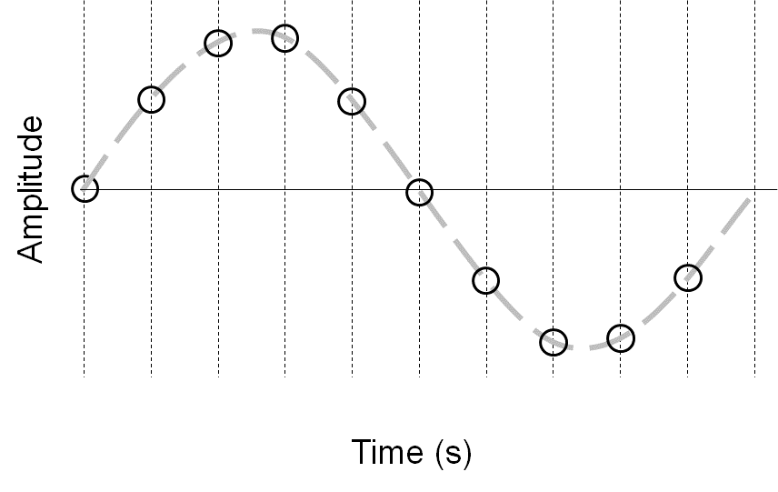

0.9

0.8

0.7

0.6

0.5

0.4

0.3

0.2

0.1

0

1) Write the time values (in seconds) along the x-axis. There should be one time value for each sample. Time always starts at zero, unless otherwise specified.

2) What is the total duration of the sinusoid (in seconds)?

1 second

3) What is the frequency of the sinusoid (in Hz)?

1 Hz

Consider the graphical representation of a discrete sinusoid, shown below. The broken, thick gray line shows the original, continuous sinusoid. The black circles show the actual samples obtained.

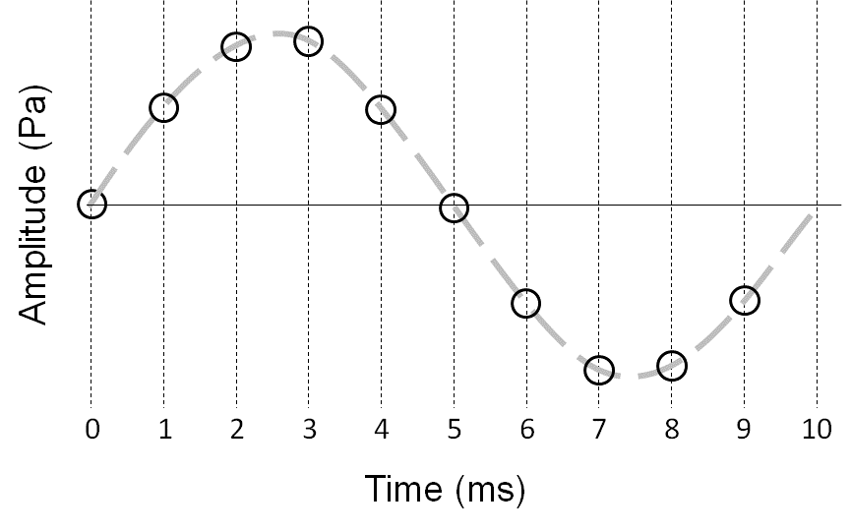

4) What was the sampling rate?

1000 Hz

5) Assuming that the sampling theorem was followed, what was the frequency of the original sinusoid?

100 Hz

6) Now assume the sampling theorem was not necessarily followed, because the antialiasing filter applied before sampling mistakenly had a cutoff frequency of 1500 Hz. In this case, the collection of sampled amplitudes (shown by the open circles in the figure) might equally well represent what sinusoidal frequencies?

-900 Hz, 1100 Hz

7) Write the Sampling Theorem in your own words.

In order to properly sample a signal, it is necessary that the sampling rate be at least twice as high as the highest frequency present in the signal. This generates enough samples to prevent aliasing, an issue where high frequencies become indistinguishable from low frequencies in your recording.

8) Consider the four graphical representations below, labeled A-D. Each shows an original, continuous sinusoid (broken gray line) and a sampled version (black circles). For each representation, tell whether or not the Sampling Theorem was followed when taking the samples.

8a) Yes

8b) Yes

8c) No

8d) No

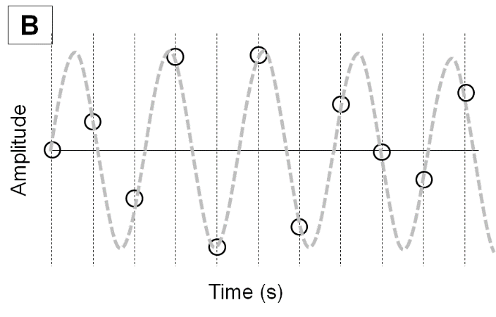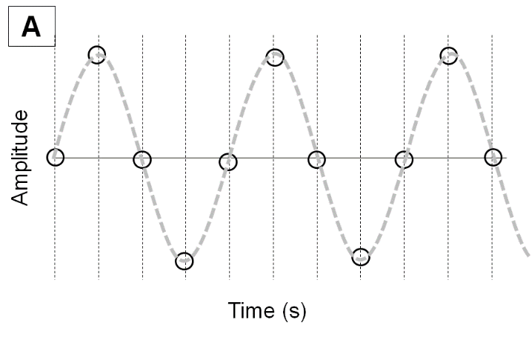

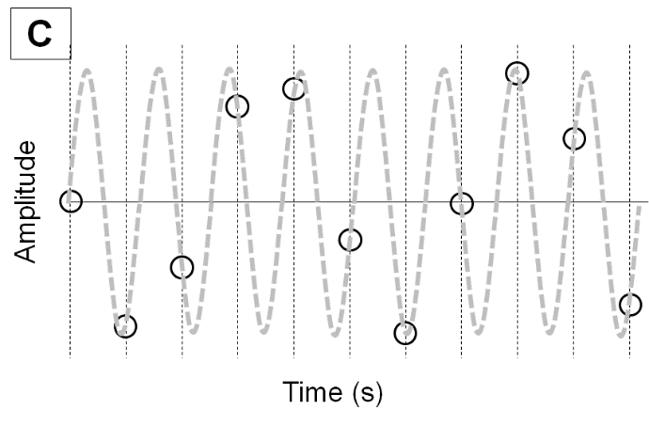

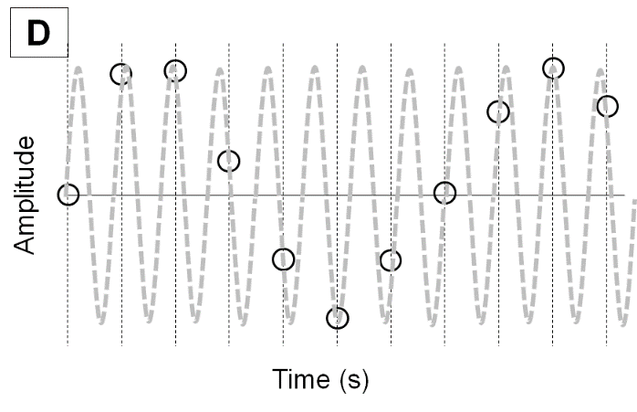

9) Briefly explain how you arrived at your answers to Question 8.

In order for the Sampling Theorem to have been followed, there need to be at least two samples taken for each cycle of the signal. In A and B we can see that is the case, while in C and D, some or all of the cycles have only one (or no!) samples taken.