Signal & System Theory (CSD:5224)

Instructor: Shawn S. Goodman, Ph.D.

**Assignment 3**

Systems

Consider the Input Output plots of two different systems, shown in the left column. Ignore the fact that I have only shown you two points for each, and assume that the systems behave consistently as shown. (I showed only two points for ease of computation on your end.)

1) For each system, plot the associated gain function on the graph to the right. The gain values on the y-axis are missing, so you will need to write them in.

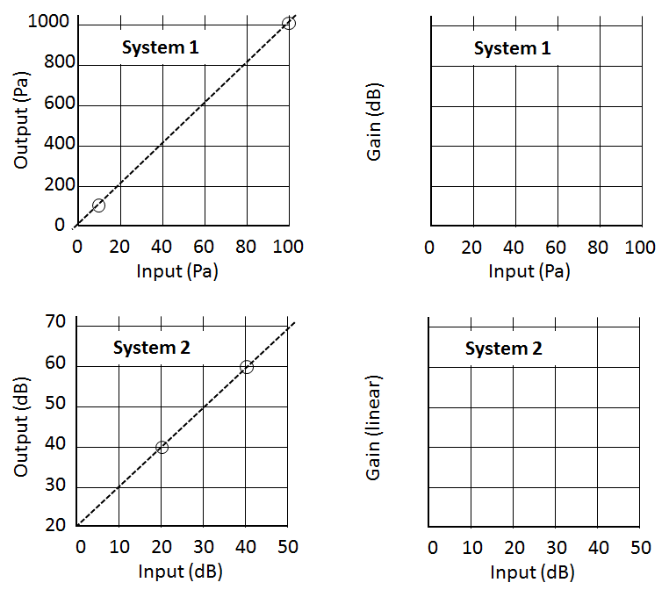



**2) Compare the behavior of the two systems.**

These systems behave equivalently. Both have a constant gain of 10, or 20 dB depending on whether you use linear or log units.

**Consider the following I/O functions for the four different systems shown below. For each, tell whether the system is linear or not. Justify your answer.**

1. Not linear. This system is not homogeneous, as the difference between the input and output in log units is not constant. For example, 1 dB in yields 2 dB out (1 dB gain) but 2 dB in yields 4 dB out (2 dB gain).
2. Linear. This graph shows a straight line through the origin in a linear/linear I/O plot, which is indicative of constant gain and homogeneity.
3. Linear. This graph shows a straight line with slope of 1 in a log/log I/O plot. This indicates a constant dB difference between input and output, which is means there is constant gain and homogeneity.
4. Not linear. Although this graph is of a straight line in a linear/linear space, it does not pass through the origin. This means the ratio between input and output will not be constant, and homogeneity is not achieved.

**B**

**A**

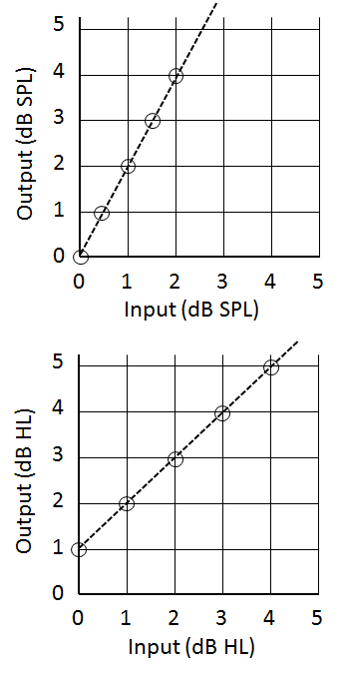

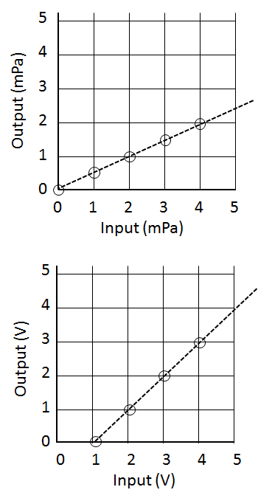

**C**

**D**