Signal & System Theory (CSD:5224)

Instructor: Shawn S. Goodman, Ph.D.

**Assignment 8**

Group Delay

Consider the waveform shown below.



1) Think about what you expect the FFT to look like. Do not actually calculate the FFT, just consider what it should look like based on what you know.

1a. Draw a sketch of the raw DFT magnitude spectrum. Include frequency in Hz on the x-axis.

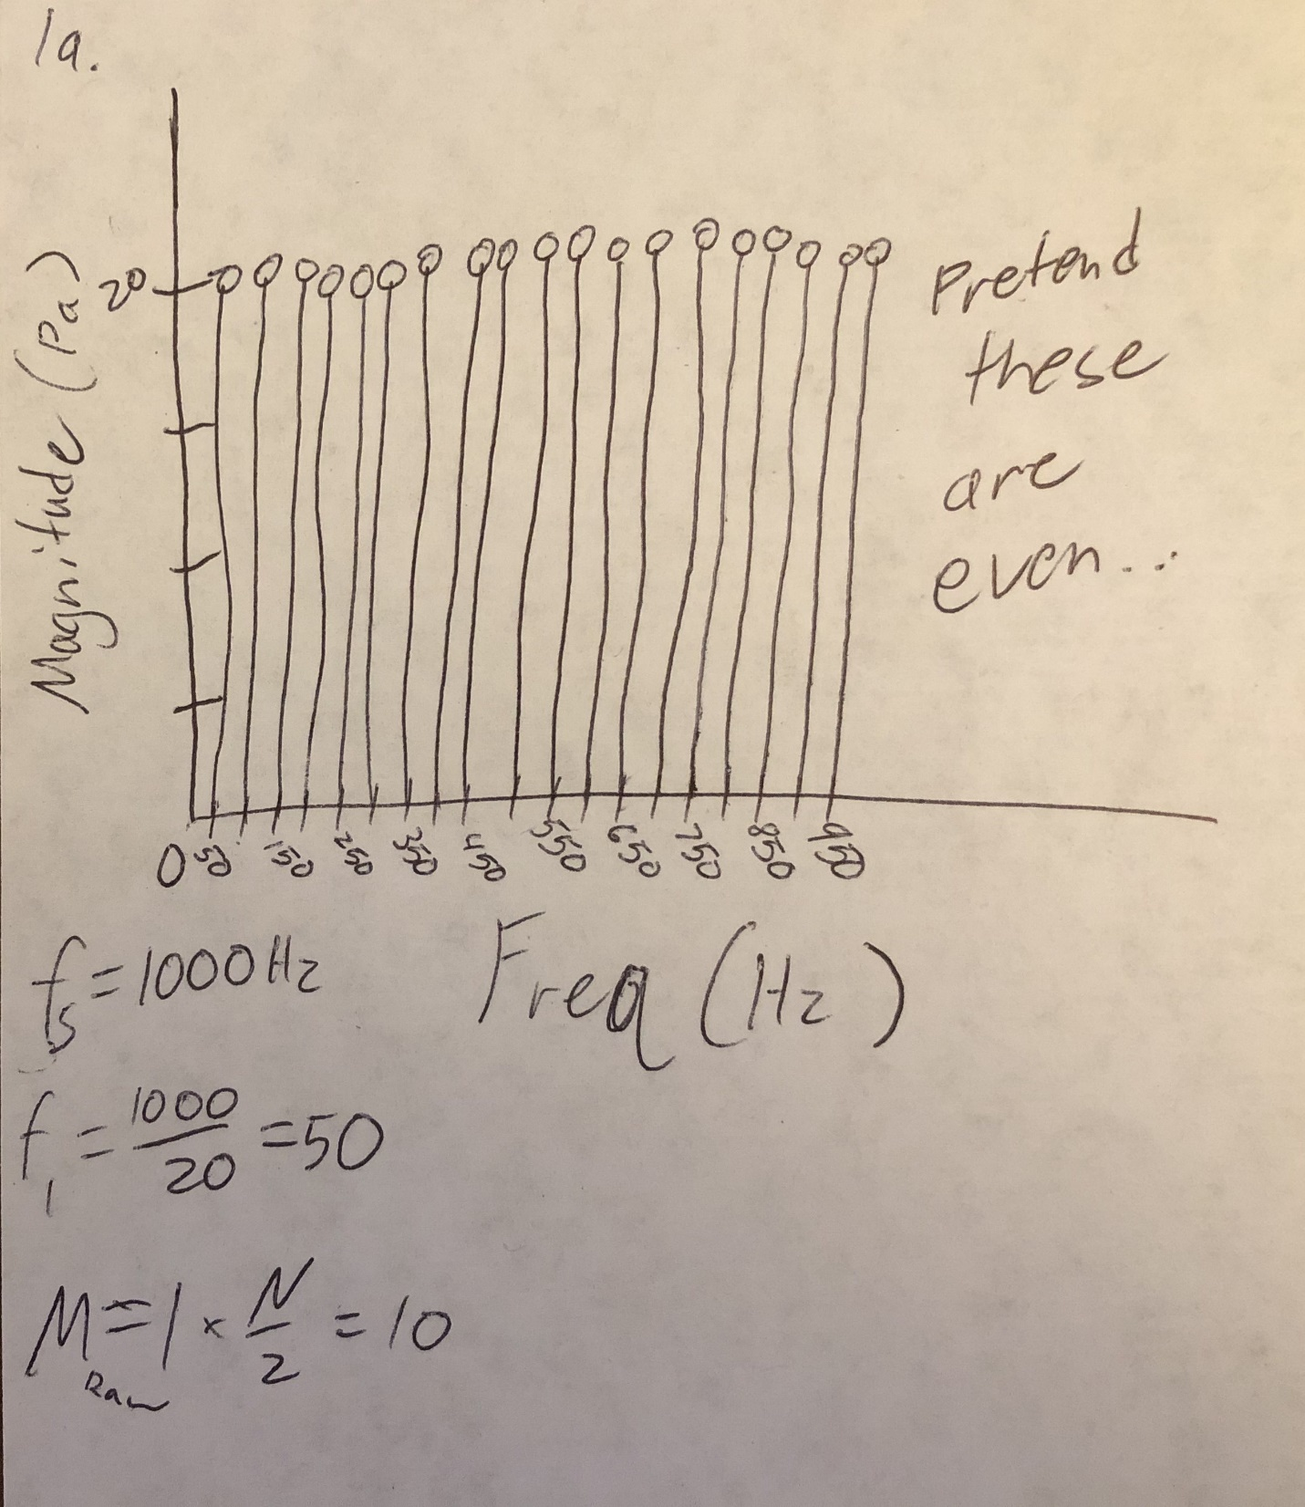

1b. Draw a sketch of the real part of the DFT spectrum. Include frequency in Hz on the x-axis.

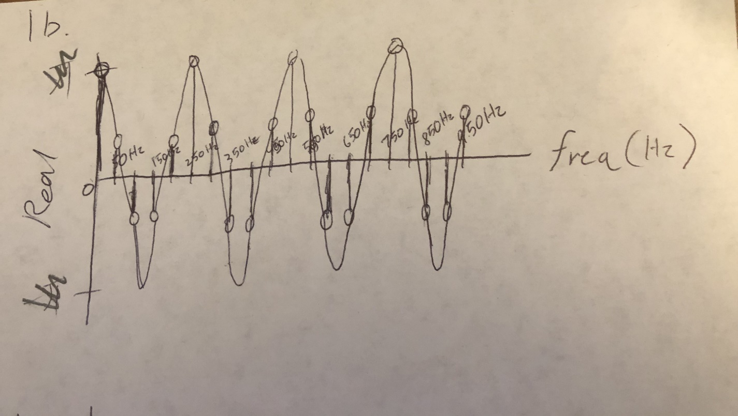

1c. Draw a sketch of the raw DFT phase spectrum. Include frequency in Hz on the x-axis. Hint: there is an interesting link between what you drew in 1b to what you should draw in 1c.

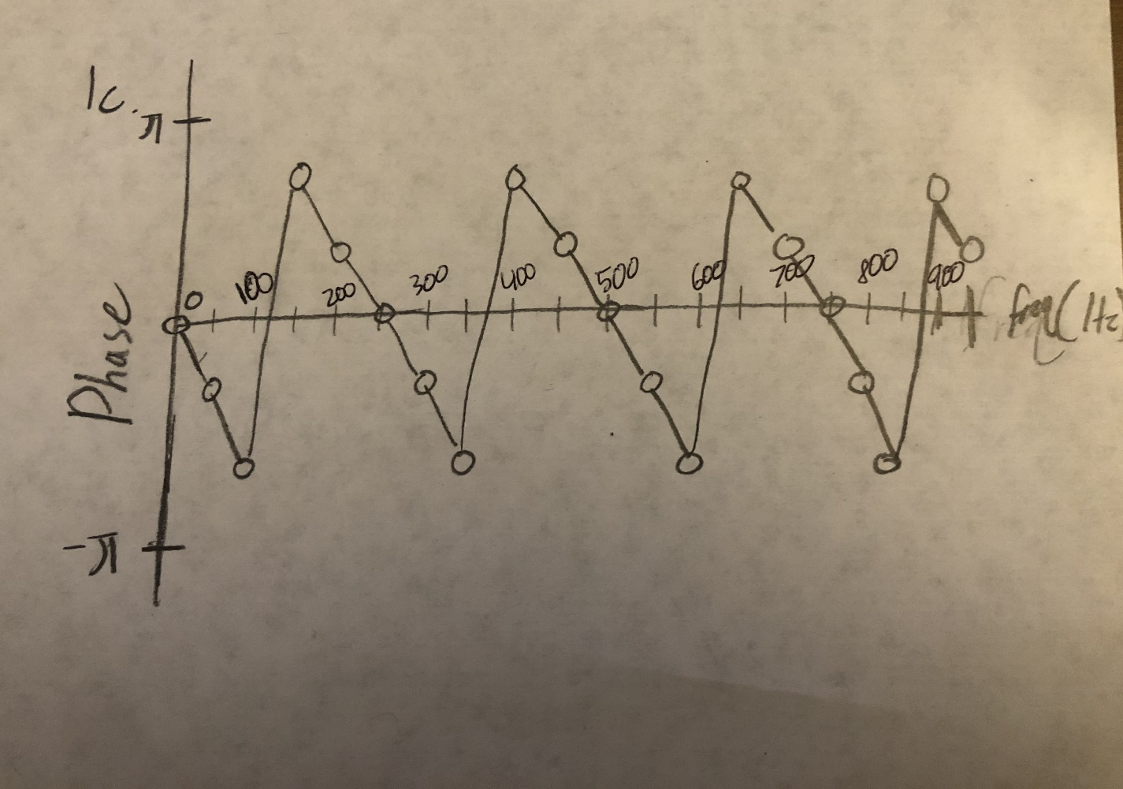

2) The “group delay” (usually denoted **) of a signal is the delay of each frequency. All of the frequencies in a signal can have the same delay, or they can have different delays.

**2a. Based on the waveform at the top of the page, do you expect all of the frequencies in this signal to have the same delay or different delays? Why?**

I would expect all of the frequencies to have the same delay because this is an impulse sound, so all energy is present in the same extremely small time window. Because the signal starts and ends immediately there is no “space” for the different frequencies to have a different delay; they must occur at the same time, or they would not occur at all.

**2b. Based on the waveform at the top of the page, what value(s) of ** do you expect?**

4 ms

**3) Group delay is defined as ** = –**/**, where * *is unwrapped phase in radians and ** is radian (angular) frequency.**

3a. The first step to calculating ** is to unwrap the phase. The raw (wrapped) phase is of the DFT of the waveform above is given below. First, calculate the difference between each raw phase value and the one before it. (This operation is called “taking the first-order difference”.) Next, identify each absolute first order difference that is larger than **. Number these in ascending order. Finally, use the numbered jumps to subtract the correct integer times 2** from the raw phases. Write the values of the unwrapped phase.

RAW PHASE first-order difference find abs(diff)>** UNWRAPPED PHASE*        *

|  |  |  |  |
| --- | --- | --- | --- |
| 0 | 0 |  | 0 |
| -1.2566 | -1.2566 |  | -1.2566 |
| -2.5133 | -1.2567 |  | -2.5133 |
| 2.5133 | 5.0266 | 1 | -3.7699 |
| 1.2566 | -1.2567 |  | -5.0266 |
| 0 | -1.2566 |  | -6.2832 |
| -1.2566 | -1.2566 |  | -7.5398 |
| -2.5133 | -1.2567 |  | -8.7965 |
| 2.5133 | 5.0266 | 2 | -10.0531 |
| 1.2566 | -1.2567 |  | -11.3098 |
| 0 | -1.2566 |  | -12.5664 |
| -1.2566 | -1.2566 |  | -13.8230 |
| -2.5133 | -1.2567 |  | -15.0797 |
| 2.5133 | 5.0266 | 3 | -16.3363 |
| 1.2566 | -1.2567 |  | -17.5930 |
| 0 | -1.2566 |  | -18.8496 |
| -1.2566 | -1.2566 |  | -20.1062 |
| -2.5133 | -1.2567 |  | -21.3629 |
| 2.5133 | 5.0266 | 4 | -22.6194 |
| 1.2566 | -1.2567 |  | -23.8761 |

**3b. The second step is to calculate radian frequency. In the space below, write each value of **.**

0

100pi

200pi

300pi

400pi

500pi

600pi

700pi

800pi

900pi

1000pi

1100pi

1200pi

1300pi

1400pi

1500pi

1600pi

1700pi

1800pi

1900pi

**3c. In the space below, draw unwrapped phase as a function of radian frequency.**

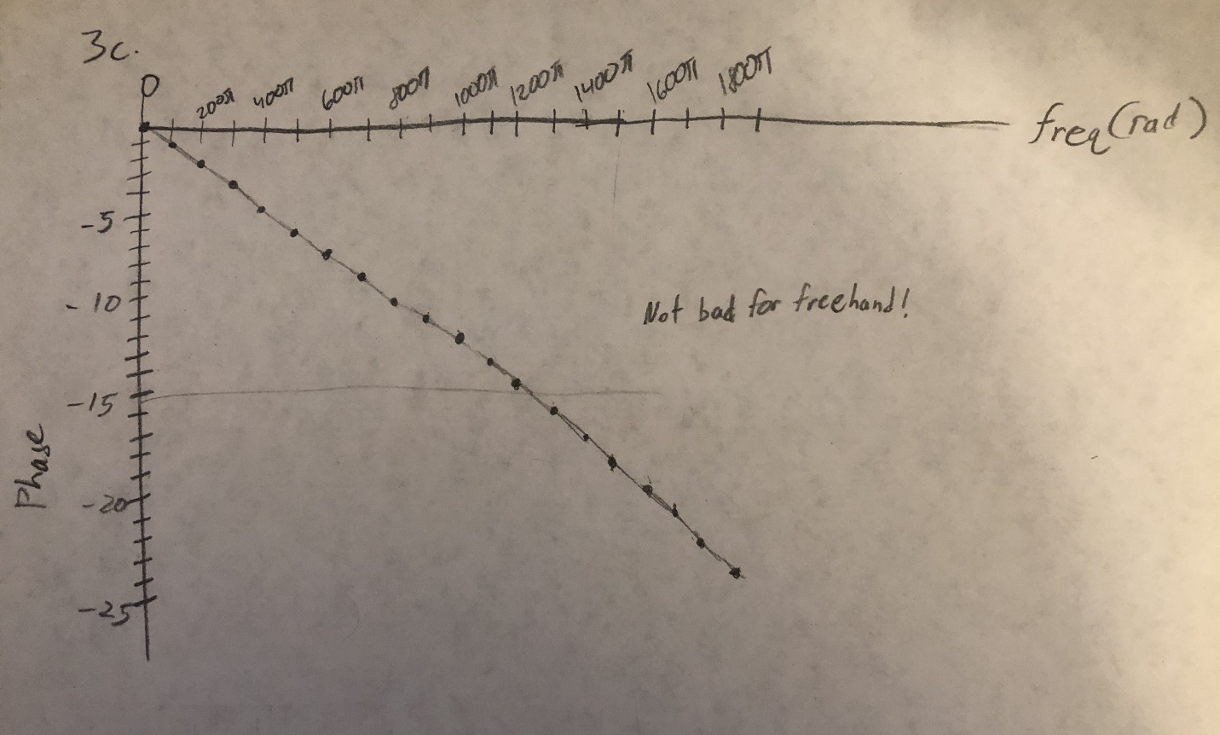

**3d. Finally, calculate ** = –**/**. What is the group delay when calculated this way?**

Delay = -(-1.2567)/100pi = 0.004

4ms!