Signal & System Theory (CSD:5224)

Instructor: Shawn S. Goodman, Ph.D.

**Assignment 1**

Review of Some Basics

The purpose of this assignment is to help you review some basic acoustics concepts. Answering the questions in this assignment should be a refresher regarding decibels, conversion between pascals and dB SPL, different measures of amplitude, and gain. Feel free to use textbooks, internet sources, and your fellow students as you work through this. Also feel free to reach out the instructor. Being comfortable with this material is an important foundation for the rest of the course.

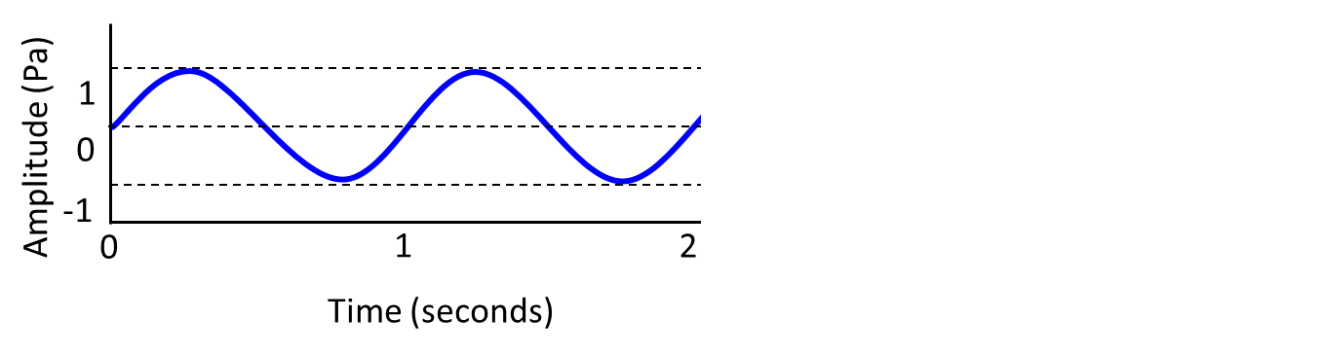

*The following six questions refer to the continuous sinusoid shown above. Show your work whenever you use a mathematical equation to find an answer.*

**1) What is the frequency of the sinusoid in Hz?**

1 Hz

**2) What is the peak-to-peak amplitude of the sinusoid in mPa?**

2000 mPa

**3) What is the peak-to-peak amplitude of the sinusoid in dB SPL?**

20 * log(2000000/20)

20 * log(100000)

20 * 5 = 100 dB SPL

**4) What is the peak amplitude of the sinusoid in dB SPL?**

20 * log(1000000/20)

20 * 4.6989 = 93.98 dB SPL

**5) What is the peak amplitude of the sinusoid in Pa**?

1 Pa

**6) What is the RMS amplitude of the sinusoid in dB SPL?**

Peak in Pa = 0.707

20 * log(707000/20)

20*4.55 = 90.97 dB SPL

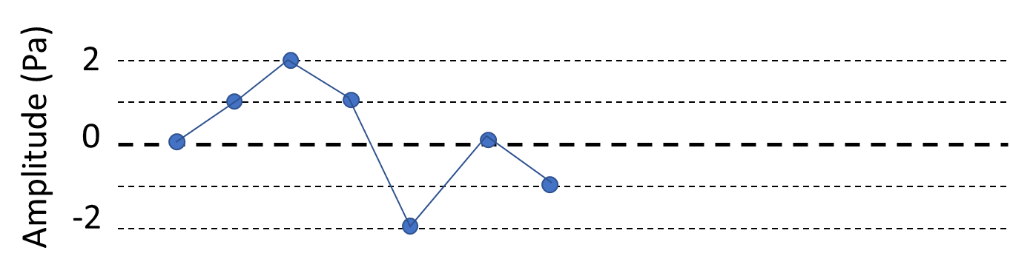

*The following five questions refer to the discrete waveform shown above. The blue circles show the actual recorded/measured samples, and the solid blue connecting lines show an approximation of the underlying waveform. Show your work whenever you use a mathematical equation to find an answer.*

**7) What is the peak-to-peak amplitude of the sinusoid in mPa?**

4000 mPa

**8) What is the peak-to-peak amplitude of the sinusoid in dB SPL?**

20 * log(4000000/20)

20 * 5.301 = 106.02 dB SPL

**9) What is the peak amplitude of the sinusoid in dB SPL?**

20 * log(2000000/20) = 100 dB SPL (see #3)

**10) What is the peak amplitude of the sinusoid in Pa?**

2 Pa

**11) What is the RMS amplitude of the sinusoid in dB SPL?**

sqrt[(0^2 + 1^2 + 2^2 + 1^2 + -2^2 + 0^2 + -1^2) / 7]

sqrt(11/7) = 1.254 Pa

20 * log(1254000 / 20)

20 * 5.797 = 95.94 dB SPL

*Suppose you have a sinusoid X with a peak amplitude of 2 Pa. Answer the following three questions. Show your work whenever you use a mathematical equation to find an answer.*

**12) What is “gain”?**

Gain is a change in the output of system relative to the input.

**13) If sinusoid *X* were passed through a system having a gain of 12 dB, what would the output amplitude be in Pascals?**

Initial peak amplitude: 100 dB SPL (see #9)

Apply gain: 100 + 12 = 112

[10^(112/20)] * 20 = 7962143.41 uPa = 7.96 Pa

**14) If sinusoid *X* were passed through a system having a gain of 0.5, what would the output amplitude be in dB SPL?**

Initial peak: 2 Pa

Apply gain: 2 * .5 = 1

Peak in dB SPL: 93.98 (see #4 and #5)