**Mooc 1.3.1 Futures of learning**

Objective : *Point out the AI-related challenges in education and core competencies required in the AI era.*

*Contributors: Inria Learning Lab*

Artificial Intelligence is already in the classroom

Artificial Intelligence (AI) technologies have the potential to support new teaching and professional practices for the benefit of teachers and pupils. Examples of activities in education domain that are already being experimented in classrooms and supported by AI technologies include:

* Step-by-step personalised learning
* Grouping learners for more effective classwork
* Analysis of student writing and automatic assessment
* Student-support chatbots
* Automatic test generation
* Monitoring of student learning outcomes
* Administrative tasks like class timetabling or answering common queries

To these few examples, could be added a long list of tools now integrated in the teacher and pupil everyday lives when using digital services, like automatic spelling correction, recommendations and suggested reading, email spam filter, automatic voice or face recognition, etc.

If we consider the only specific education-oriented tasks, a set of four needs-based categories of emerging and potential applications have been defined by Fengchun & al.[1]:

* education management and delivery;
* learning and assessment;
* empowering teachers and enhancing teaching;
* and lifelong learning.

Considering this categorisation, Holmes & al.[2] established the different types of current AI-based systems for Education as shown below.

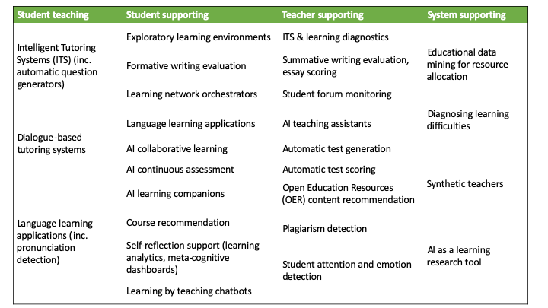

Different types of current AI-based systems for Education (from Holmes & al. 2019).

## AI-related Challenges and Education

These emerging AI-technologies also have to be questioned in the context of education use. To harness the opportunities and mitigate the potential risks of AI in education, the following challenges have been identified in Fengchun & al. UNESCO report, 2021:

1. **How can AI be leveraged to enhance education?**  
   "Over the past decade, the use of AI tools to support or enhance learning has grown exponentially[3]. This has only increased following the COVID-19 school closures. However, evidence remains scarce on how AI can improve learning outcomes and whether it can help learning scientists and practitioners to better understand how effective learning happens[4]. Furthermore, we have yet to explore AI’s potential in the tracking of learning outcomes across different settings as well as assessing competencies, especially those acquired in non-formal and informal contexts.”  
     
   “There is also potential for AI to facilitate new approaches to assessment, such as AI-enabled adaptive and continuous assessment[5]. However, it is important to acknowledge at the outset that the use of AI for learning and assessment also raises various concerns that are yet to be properly addressed. These include concerns about their approach to pedagogy, the lack of robust evidence for their efficacy and potential impact on teachers’ roles, and broader ethical questions[6] [7].”  
     
   “Many teacher-facing AI applications aim to help teachers reduce workloads by automating tasks such as assessment, plagiarism detection, administration and feedback. This, it is often argued, should free up time for teachers to invest in other tasks, such as providing more effective support to individual students.“
2. **How can we ensure the ethical, inclusive and equitable use of AI in education?**  
   “The ethical, inclusive and equitable use of AI in education impacts upon each of the Sustainable Development Goals. There are issues centred on data and algorithms, on pedagogical choices, on inclusion and the ‘digital divide’, on children’s right to privacy, liberty and unhindered development, and on equity in terms of gender, disability, social and economic status, ethnic and cultural background, and geographic location.”
3. **How can education prepare humans to live and work with AI?**  
   “If the world is to ensure that AI does not exacerbate existing inequalities, it will be increasingly important for every citizen to have the opportunity to develop a robust understanding of AI – what it is, how it works, and how it might impact on their lives. This is sometimes called ‘AI literacy’. For this, teachers will play a key role.”  
     
   “Helping students learn how to live effectively in a world increasingly impacted by AI requires a pedagogy that puts more emphasis on human skills (e.g. critical thinking, communication, collaboration and creativity) and the ability to collaborate with pervasive AI tools in life, learning, and work.

## Core Competencies Required in the AI Era

The deployment of AI-based technologies in school raise questions about the impact of the use of such systems on teaching skills, pointed out by the Joint Research Centre (JRC), the European Commission’s science and knowledge service[8]:

* To what extent should the teacher or user be aware of the underlying technology?
* How much knowledge should educators have about AI to allow them to act in an informed and effective way as educators?
* Will today’s emerging technologies impact the teaching professional skills in the future?

The authors of the Joint Research Center report emphasise that, in addition to general pedagogical knowledge, subject-specific knowledge and classroom management skills, educators will need:

* General digital competences to use and apply digital technologies as for any citizen[9] regarding Information and digital literacy, Communication and collaboration, Digital content creation, Safety and Problem solving
* and competences to make valuable educational use of these digital technologies.

A specific challenge of introducing AI in education and preparing students for an AI-powered context was presented by UNESCO in 2019[10] :   
“To prepare teachers for an AI-powered education while preparing AI to understand education, though this must nevertheless be a two-way road: teachers must learn new digital skills to use AI in a pedagogical and meaningful way and AI developers must learn how teachers work and create solutions that are sustainable in real-life environments.”

In the following modules of this online course, we intend to help in understanding what is AI and its underlying technologies, in being aware of benefits and risks to act in an informed and effective way as a teacher and in questioning the impact of AI systems on learning, teaching and education.

1. AI and education: Guidance for policy-makers - Miao Fengchun, Holmes Wayne, Ronghuai Huang, Hui Zhang - ISBN: 978-92-3-100447-6 - UNESCO, 2021
2. Artificial Intelligence In Education: Promises and Implications for Teaching and Learning - Wayne Holmes, Maya Bialik, Charles Fadel - Boston, MA, Center for Curriculum Redesign, 2019
3. Artificial Intelligence In Education: Promises and Implications for Teaching and Learning - Wayne Holmes, Maya Bialik, Charles Fadel - Boston, MA, Center for Curriculum Redesign, 2019
4. Zawacki-Richter, O., Marín, V. I., Bond, M. and Gouverneur, F. 2019. Systematic review of research on artificial intelligence applications in higher education – where are the educators? International Journal of Educational Technology in Higher Education, Vol. 16, No. 1, pp. 1–27.
5. Luckin, R. 2017. Towards artificial intelligence-based assessment systems. Nat Hum Behav 1, 0028.
6. Holmes, W., Bektik, D., Whitelock, D. and Woolf, B. P. 2018b. Ethics in AIED: Who cares? C. Penstein Rosé, R. Martínez- Maldonado, H. U. Hoppe, R. Luckin, M. Mavrikis, K. Porayska-Pomsta, B. McLaren, and B. du Boulay (eds.), Lecture Notes in Computer Science. London, Springer International Publishing, vol. 10948, pp. 551–553.
7. Artificial Intelligence In Education: Promises and Implications for Teaching and Learning - Wayne Holmes, Maya Bialik, Charles Fadel - Boston, MA, Center for Curriculum Redesign, 2019
8. Emerging technologies and the teaching profession: Ethical and pedagogical considerations based on near-future scenarios- Vuorikari Riina, Punie Yves,Marcelino Cabrera - Joint Research Center report - 2020
9. DigComp 2.2: The Digital Competence Framework for Citizens - With new examples of knowledge, skills and attitudes, Vuorikari, R., Kluzer, S. and Punie, Y., EUR 31006 EN, Publications Office of the European Union, Luxembourg, 2022, ISBN 978-92-76-48883-5, doi:10.2760/490274, JRC128415.
10. Artificial intelligence in education: challenges and opportunities for sustainable development- Pedró Francesc, Subosa Miguel, Rivas Axel, Valverde Paula, ED-2019/WS/8, UNESCO, 2019.